Outdoor Scavenger Hunt

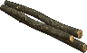
- 1. Find some cool Sticks
This Photo by Unknown Author is licensed under CC BY-SA-NC
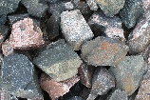
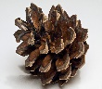
- 2. Find some Pinecones
This Photo by Unknown Author is licensed under CC BY-SA
- 3. Find Rocks different sizes
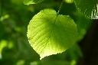
- 4. Find different leaves
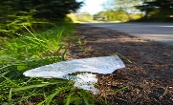
- 5. Find piece of litter
This Photo by Unknown Author is licensed under CC BY-NC-ND

- 6. Find different flowers

- 7. Find different bugs
This Photo by Unknown Author is licensed under CC BY-NC

- 8. Look for cloud shapes
This Photo by Unknown Author is licensed under CC BY-SA
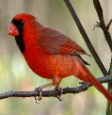
- 9. Hear the Birds Chirping
This Photo by Unknown Author is licensed under CC BY-SA
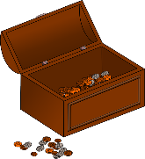
- 10. What kind of treasure did you find on your nature walk?

