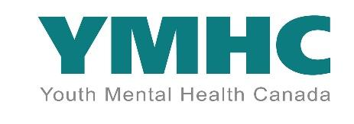
51 Stuart Street
Hamilton, Ontario
L8L 1B5

Make Hope Happen with YMHC Community Service

Dear community partner,

Youth Mental Health Canada will be having:
- A Film Screening and Mental Wellness Community Fair on Saturday, March 25, and
- a Music for Mental Health Night on International Youth Mental Health Day, Thursday, May 4, at the Westdale, 1014 King Street West.

I am writing this letter to request volunteers who require community service hours to help us promote and organize the events. Volunteers will help us distribute event flyers to schools, community organizations, and businesses, secure donations for event swag bags, set up and clean up, welcome people to the event, and promote the event on social media platforms. Interested students should apply at: https://ymhc.ngo/volunteers/event-volunteer/.

About YMHC:
Youth Mental Health Canada is a community-based, youth-led, and driven charitable non-profit organization
focused on mental health education, support, advocacy, and change. To learn more
about YMHC, please go to www.ymhc.ngo, https://edu.ymhc.ngo, and https://schoolphobia.ymhc.ngo. We operate like a social enterprise by giving back to the community from money donated to YMHC. Our Make Hope Happen campaign donates over $50,000 every year. Our office is at 51 Stuart Street in the Workers Arts and Heritage Center.

Goals of the Two Fundraising Events:
- To create opportunities for resource, information, and skills sharing
- To actively engage and involve all community stakeholders in understanding and responding to youth mental health issues.
- To raise awareness about mental health and wellness
- To highlight the support systems available to those who need them.
- To decrease issues of self and societal stigma and normalize the conversation on mental health and wellness.

We are grateful for all support we get to make our event a success! Please let us know if you have any questions.

Sincerely,
Sheryl Boswell
Sheryl Boswell
Executive Director
Phone: 647-952-9642

