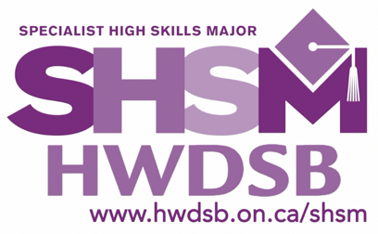
The Specialist High Skills Major Program (SHSM) is a Ministry-approved specialized diploma designation. The SHSM allows students to focus their learning on a specific economic sector while meeting the requirements of the Ontario Secondary School Diploma. This career-focused program is designed to bundle courses, cooperative education experience, and sector specific certifications.
Westmount

I have reviewed the information for the SHSM program of interest, and I am committed to acquiring the necessary requirements with the support of the Westmount SHSM team.

Current Grade Level: 11 or 12 (please circle)

Selected SHSM: Mentoring Teacher:
□ Arts & Culture
□ Construction
□ Environment
□ Health & Wellness
□ Info & Communication Technology
□ Justice, Community Safety, & Emergency Services
Ms. Charters/Ms. Grant (music teacher)
Mr. Scarcelli/Mr. Binotto
Mr. Guagliano
Mr. Kuepfer/Ms. Campanaro/Mr. Pain
Mr. Trink/Mr. Timofejew/Mr. French
Ms. Cope/Ms. Mallory

INTENTION FOR COMPLETING CO-OPERATIVE EDUCATION

It is a requirement for this SHSM to complete a two-credit (two periods) co-op. Please let us know how you intend to complete this requirement.

□ Grade 10 Summer Co-op □ Grade 11 Semester 1 or 2 Co-op
□ Grade 11 Summer Co-op □ Grade 12 Semester 1 or 2 Co-op

S M L XL
____________________________ _________________________________ ____________
Student’s Full Name Student’s Sweatshirt Size (circle) Date

____________________________ _________________________________ ____________
Parent/Guardian’s Full Name Parent/Guardian’s Signature Date

____________________________ _________________________________ ____________
Mentoring Teacher (select from list above) Mentoring Teacher’s Signature Date

*STUDENTS MUST RETURN THIS FORM TO THEIR GUIDANCE COUNSELLOR and are strongly encouraged to follow wmtSHSM on Instagram*

