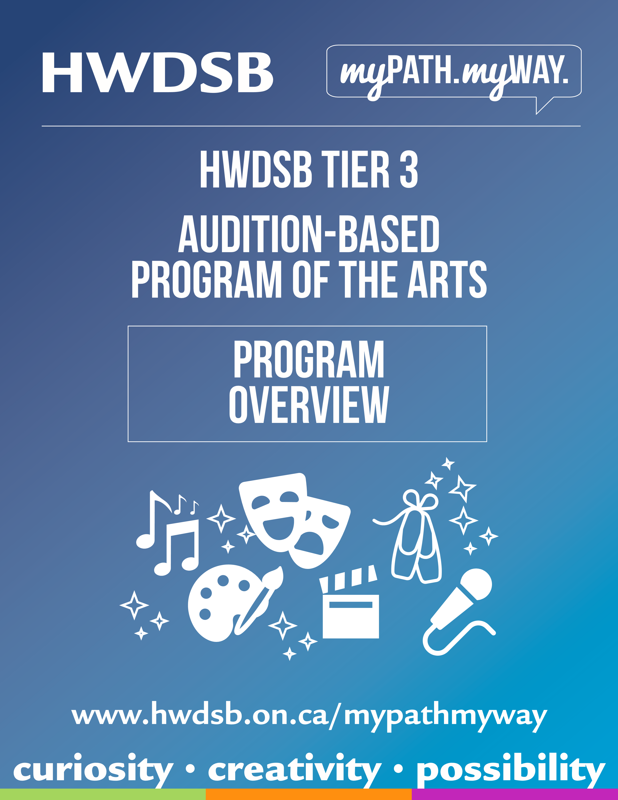

PROGRAM IDENTITY

VISION

The Arts give students a dynamic opportunity to develop personal and artistic identities, to recognize and value the identities of others and to develop creative and critical-thinking skills. Collaborative and creative Arts experiences can enrich our students’ lives now and in the future.

MISSION

We educate and support the training of students in all aspects of the Arts, including
Foundations of Theory and Technique, Individual and Collaborative Creation and Performance as well as Critical Analysis and Appreciation of the Arts.

Together, students, staff and the school community can support and serve as strong advocates for Arts education for all students.

SLOGAN:

Aligning Passion with programming.

PROGRAM SUMMARY

The Hamilton-Wentworth District School Board (HWDSB) Audition-Based Program of the Arts is a Tier 3 Specialized Learning program based at Glendale Secondary School. Students in grades 9 to 12 from across Greater Hamilton Area participate in specialized arts courses in dance, drama performance, production: sound & theatre, instrumental music: band & strings, popular music: drums/electronic/ guitar/piano, vocal music, media arts and visual arts at an advanced level. HWDSB provides transportation for students living 3.2 km or more from the school. It is determined and managed on an individual basis by Hamilton Wentworth Student Transportation Services.
Programs of the Arts staff are often specialists in their field who use their contacts to further enhance their curriculum. Students at each grade level can enter the program and expect to work with guest artists, attend performances and exhibitions and regularly perform or exhibit their own work.
In addition to required credits, students have experiential learning opportunities such as career exploration, professional certification, discipline-specific training, opportunities beyond the classroom and seasonal collaborations on large-scale stage productions, small-scale studio productions/exhibitions and informal studio productions/exhibitions that invite broader school participation.
Graduating students receive an HWDSB Certificate of Recognition (Distinction) in the Arts, in addition to their Ontario Secondary School Diploma (OSSD) and additional qualifications such as industry training, professional résumé, head shot and professional portfolio.
Students may also complete this program in collaboration with HWDSB Tier 3 Strings and the Specialist High Skills Major (SHSM) Arts and Culture programs, also based at Glendale.
The HWDSB Audition-based Program of the Arts supports the needs of all students and pathways, some of whom are exploring the possibility of a career in the arts; others whom are passionate about learning about ‘art for art’s sake.’
Students are continually monitored in this program and if they struggle, they will be identified for a Success Review. We accept students who are on all learning pathways and academic abilities are not a factor in the audition process decision. The ‘Program Success Review’ is a process for ABPA staff to support students: areas of need are identified and a plan to support student success and well-being is put in place. Ultimately, this plan may involve changes to programming at Glendale, or a return to the students’ catchment school.
The program’s safe and caring environment inspires lifelong learning and a desire for personal excellence for all its students.

PROGRAM GOALS

Students will…
- continue to develop the ability to generate ideas and bring them to life, appreciate, think critically, collaborate, explore and experiment, problem solve and reflect (Creative Process)
- develop transferrable skills in observation, analysis, interpretation, and evaluation (Critical Analysis Process).
- broaden their training in various artistic disciplines at a professional level
- deepen their understanding of the role and value of the audience
- demonstrate responsible and ethical practices in all areas of performance
- make connections to their learning in other curriculum areas, including literacy and numeracy
- develop personal identity and self-esteem, values beliefs, well-being, and understanding of self and others in our diverse world
- reflect on personal, group, and cultural identity
➢ deepen skills for self-assessment of learning

Staff will…
- use their unique skills, experiences, and professional training in their disciplines to facilitate learning
- continue their own exploration of relevant works and evolving technologies
- teach professionalism by holding students to high expectations
- know their students and encourage them to pursue their passions and grow as both individuals and artists
- provide ongoing feedback to encourage and facilitate the success and growth of their students

Community will…
➢ Communities provide an essential support in students’ learning by…
- Supporting opportunities and experiences that bring the arts to life in the community and allow for an appreciation and sustainability in our student's lives.
- Supporting ongoing development of partnerships in each of the arts to enrich student learning opportunities (experiential, reach ahead, coop, etc.)
- supporting the success of all students’ academic achievement in school and within the specialized arts program
- encouraging and attending performances as audience members

ADMISSION / AUDITION PROCESS

- Public Meeting for HWDSB Programs of the Arts at Glendale
  - Presentation of HWDSB Audition-Based Programs of the Arts and HWDSB Strings
Wednesday, November 27, 2024, 6pm at Glendale Secondary School
- Application to be completed online (Note the application will go live AFTER the meeting on Nov.27)
- Due: Friday, December 20, 2024, ONLINE
Media and Visual Arts (Fine Arts) Portfolios and Production Creative Project are to be submitted digitally (info on Glendale sites)
    - Applicants will include their full name as part of the title for each file submitted, that includes audio, photo
    - Students perform or present in their major discipline area only (up to two majors)
Friday, January 17, 2025, to mailto:abpa@hwdsb.on.ca
Portfolio(s) and Creative Project can be sent in before the due date
Dance, Drama, and Music (Performing Arts) Talent Previews are done in person at Glendale Secondary School

  - In person Talent Previews will be held at Glendale Secondary School throughout the day and early evening [schedule to be sent out after application deadline]
    - Thursday, January 30, 2025, 9am-9pm

ALL DISCIPLINE APPLICANTS WILL HAVE AN IN-PERSON INTERVIEW JANUARY 30, 2025

➢ Admission Information:
- All applicants -successful or not - will be contacted by the Program Coordinator
Friday, January 31, 2025
- Applicants who were successful need to accept or decline their offer by Friday, February 7, 2025
- Applicants will choose courses and complete their option sheet them at an option sheet night at Glendale – Thursday, February 13, 2025
- Program begins September 2025

PROGRAM PATHWAYS
Students enter a Program/Discipline Stream (with options for additional requirements and flexibility). Options are also available for Specialist High Skills Major and Strings. Students major in one or two of nine disciplines:
- Dance
- Drama – Performance
- Media Arts
- Music – Instrumental (Concert Band – Brass, Percussion, Woodwinds)
- Music - Instrumental (Strings) (collaboration with HWDSB Tier 3 Strings Program)
- Music - Vocal
- Popular Music – (bass, drums, electronic, guitar, piano)
- Production – Theatre and Sound
- Visual Arts

Experiential Learning Opportunities:
- Credit bundles
  - Mandatory core courses + additional requirements: minimum 8
  - Interdisciplinary Ensemble-Based courses available
  - Extracurricular involvement is strongly encouraged
- Participate in career exploration and post-secondary Reach Ahead opportunities
- Professional certifications
- Discipline-specific training workshops
- Experiential learning opportunities beyond the walls of a traditional classroom
- Seasonal collaborations
  - Disciplines come together for a large-scale Mainstage production once a year
  - Small scale studio productions and exhibitions geared to student interest are featured in both semesters
  - Potential for informal studio productions and exhibitions that invite broader school participation (e.g. - Improv Fridays, Move to Your Own Groove, multimedia presentations, pop-up concerts, art gallery exhibitions, student publications, etc.)

Upon Graduation:
- Students will receive…
  - Certificate of Recognition in the Arts
    - For students who complete the Community Pathway for their program
    - For students who complete one (1) or two (2) years of their program
  - Advanced Certificate of Recognition in the Arts
    - For students who complete workplace, apprenticeship, college or university pathways for their programs
    - For students who complete (3) or (4) years of their program
- Additional Qualifications:
    - Further Training Program Opportunities
    - Industry Certifications & Training
    - Professional working resume and headshot
    - Professional portfolio (for postsecondary admissions or professional workplace)

In grades 9 and 10, students will study in their Arts focus area for two of their eight courses. They will join the regular grades 9 and 10 students for their other six required courses.

As the program builds into grades 11 and 12, students will study more in depth in their Arts focus area to complete eight required Arts courses for the Performing Arts Program. Students may also complete additional required courses, including co-op, to support the Specialist High Skills Major designation.

For more information please contact:
HWDSB ABPA
(905) 560-7343 ext. 4677
Twitter: @GPAandSHSM
Email: abpa@hwdsb.on.ca
All information from website links can be found at:
http://www.hwdsb.on.ca/secondary/programs/all/

