Week # 3 Distance Learning with Mr. Minich
Table of Content:
Literacy: * Note: Students should be reading on Epic! Everyday for 15 minutes min
Activity #1: Interview Your Parents! Covid 19 Edition
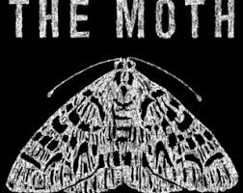
Activity #2: The Moth: Weekly Story Telling
- “The Bad Haircut”
- Written Response Activity
Math:
Activity #1: Alternate between Splash Learn and IXL
- Weekly Practice Focusing on Addition and Perimeter
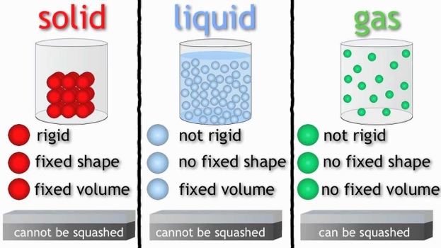
Activity #2: Perimeter Worksheets X 3 on the blog

Science:
Activity #1: Solid, Liquid and Gases Show
Next Week (Week 4): Flow Rate Experiment!

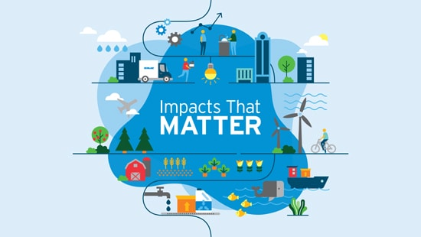
Geography: Sustainability
Activity #1: Sustainability Video
Activity #2: Your Plan Your Planet “stuff”

Shapes Scavenger Hunt Fun: Enjoy

Literacy Activity #1: Interview Your Parents! Covid 19 Edition


Record Parent responses below!
- What has been the biggest change?

- How are you finding homeschooling?

- How many days have you spent inside?

- How are you feeling?

- What are your top 3 moments from this experience?

- What activities/hobbies have you most enjoyed doing?

- What are you thankful for?

Literacy Activity #2: The Moth

“The Bad Haircut” by Alfonso Lacayo

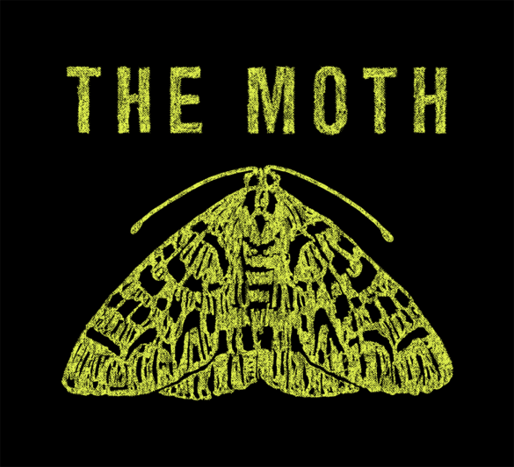

- Begin by going to ‘The Moth’ Blog site. Watch and Listen to “The Bad Haircut” by Alfonso Lacayo: https://themoth.org/dispatches/home-schooled-the-bad-haircut?fbclid=IwAR2ta2M7tNbqxoyJ8EOAi7AdDZ3DwNyaOSPO_WI1lTLXqw0IzhArFJPFJQU

- Questions to Prepare for during MS Teams Meeting (Class Discussion)
- What details do you remember from this story?
- Listening to a story can feel like watching a scene in a movie. What parts of Alfonso’s story could you really see clearly?
- Writing Activity: Answer the questions found on the next page. Student answers can be typed directly on this word document, students may also use speech to text. If students are unable to write in sentences, students may record their answers using their Ipads and sharing the recording with me. Parents may guide students throughout this activity.

The Moth “The Bad Haircut” Questions

- Can you think of a time you trusted a family member or friend (for better or for worse)?

- Can you think of a time you came ‘face to face’ with yourself and saw yourself in a new light?

- Can you think of a time you should have known better?

Mathematics:
Activity #1:
  - Students are to alternate between Splash Learn and IXL everyday

- Students should be spending minimum 15 mins per day using these apps
Activity #2:
- Begin by watching Perimeter video: This will hopefully refresh student understanding: https://www.youtube.com/watch?v=6mopAgqjkVM

- Student Practice: Three Worksheets are on the blog. Answers put directly on worksheet file

- Note: There is also some addition worksheets on the blog for Jesse, Lily, Edan and Amar

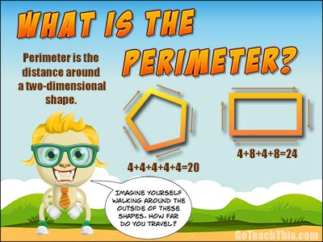

Science: Science Max Show!

Activity #1: Watch Science Max ‘Solid, Liquid, Gas’
- https://www.youtube.com/watch?v=DCcya4GDV_c

Our Goal will be to discuss Solids, Liquids, Gases during MS Team Meets

Next Week: Science Investigation
- Flow Rate Experiment




Geography: Sustainability

Activity #1: What is sustainable development video
- https://www.youtube.com/watch?v=7V8oFI4GYMY
- This video will help students understand what sustainability might look like

Activity #2: Your Plan Your Planet

- Parents: Please do this activity with your child
- Begin by going to the Your Plan.Your Planet. Website: https://yourplanyourplanet.sustainability.google/
- ‘Stuff’ will be our first focal point
- Click on ‘Stuff’ then take informative quiz by clicking ‘continue’
- Next week we will focus on ‘water’

MS Teams Discussion Questions: When our class gets the opportunity to meet, we will have the opportunity to have class discussions
- What is sustainability?
- How might Social Distancing help with sustainability?

Scavenger Hunt Fun!

