Grade 7/8 Math – Measurement Volume of 3D Shapes 5
Name: ___________________
Class:_____

Here are some new questions for volume and space to show your work.

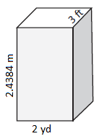
1. Volume?

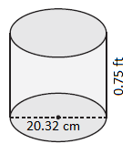
2. Volume?

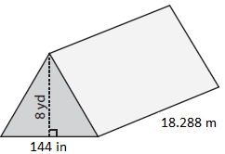
3. Volume?

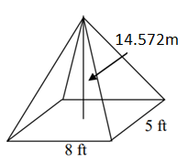
4. Volume?

