Grade 8 Math – Measurement Volume of 3D Shapes 3
Name: ___________________
Class:_____

Here are some new questions for volume and space to show your work.

1. Volume?

2. Volume?

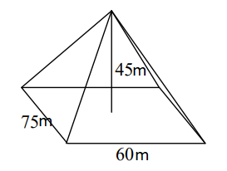
3. Volume?

4. Volume?

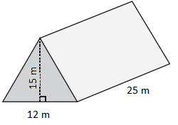
5. Volume?

