Gold Worksheet on Volume of a Right Prism

The Guinness World Record for a manufactured Gold Bar is in the Toi Museum in Japan.

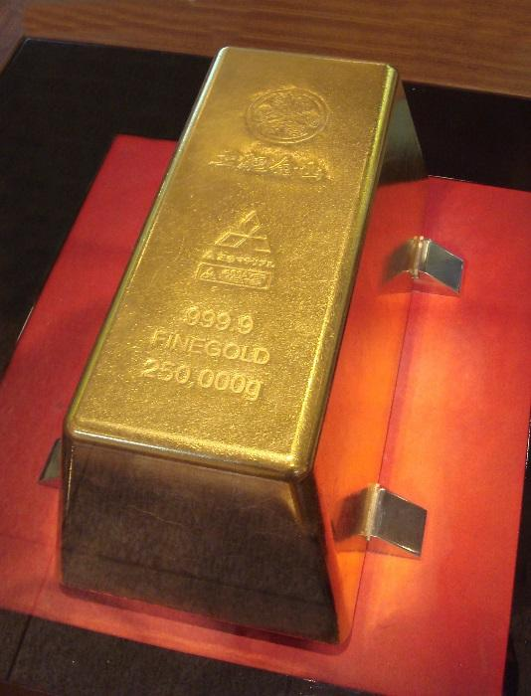
If this gold bar has the following Dimensions:
Front Base – 32 cm
Front Top – 20 cm
Height – 10 cm
Total Volume – 13000 cm³
Weight is on the gold bar in grams. – 250,000 g

#1 Could you lift this gold bar and carry it out of the museum if you were asked to do so? Explain.

#2 What is the length (or depth) of the bar?

#3 What is the Density of the Gold in grams per cm³?

#4 If gold was worth $91 per gram, how much is the gold worth in this bar?

#5 How much water would this gold bar displace in liters?

