Grade 8 Science – Mechanical Advantage of Simple Machines – 2
Name: ___________________________

We have already calculated Mechanical Advantage of Levers but there are 6 other simple machines. Each has the ability to make work easier using mechanical advantage. Your job is to find out through any means, how to calculate mechanical advantage for each of the rest of the machines.

LEVER
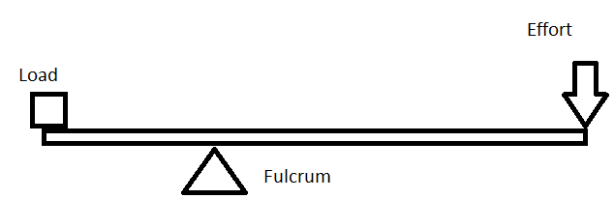

Inclined Plane

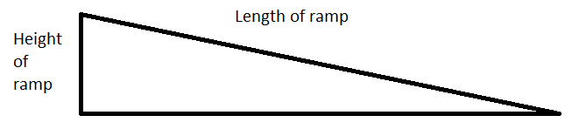

Wedge
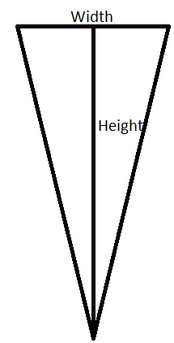
Pully
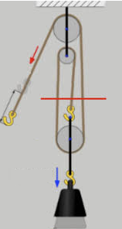

Wheel and Axle
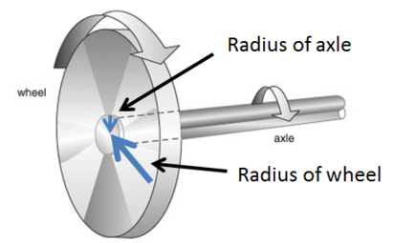

Screw
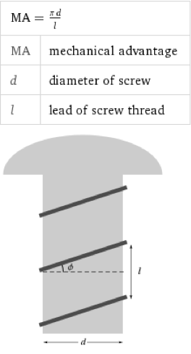

Gears
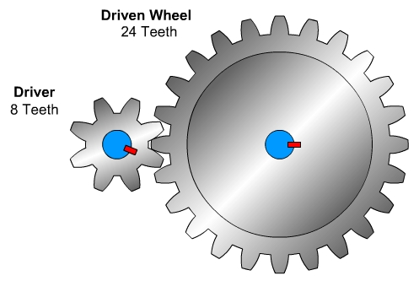

HINT: There are at least two ways for each machine type. One using the measured properties (distance/length/counting) and the other using force.

