Grade 7/8 Math Inequalities And Graphing Review For Test

Name: ___________________________ Class: ______ Date: __________________________

1) x > -3

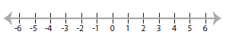

2) -3x + 15 > 27

3) 6(2x – 10) < -12

4) -4/5x < -20

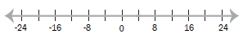

5) 41 – ¾ x < 53

6) 8(5x – 4) – 6(3x + 5) < -7

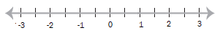

7) 4(7x +3) – (16x – 13) > 17

