Analysing Art 2021 Name___________________________________ Class _________
Part A: Analysis
1. What is the name of the piece of art and who created it?

2. What do you think is happening in this piece of art?

3. What materials do you think the artist used in this piece of art?

4. What does this piece of art remind you of?

5. What questions do you have about this piece of art?
1.
2.
3.
6. Pretend you could go inside this piece of art. What do you smell, what do you see, what do you hear? Explain.

7. Which part of this piece of art is your favourite? Why?

8. If you could change one part of this piece of art, what would you change? Why?

9. If you had to describe this piece of art to a friend, what kind of words would you use?

10. How does this piece of art make you feel? Why do you think it makes you feel this way?

Choose one of the following pieces of art for your analysis.
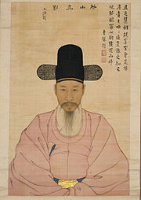
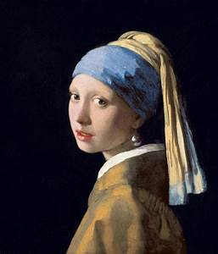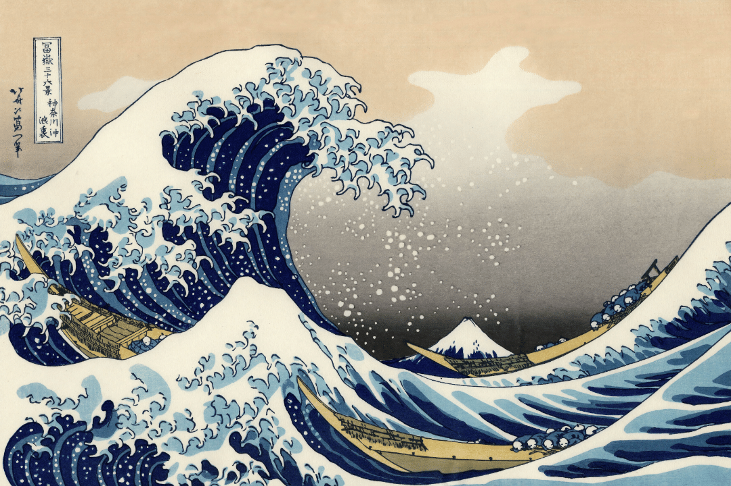

THE GREAT WAVE OFF KANAGAWA - HOKUSAI 1830

The Girl with the Pearl Earring - Johannes Vermeer
1665
Portrait of Kang Io – Yi Jaegwan 1837

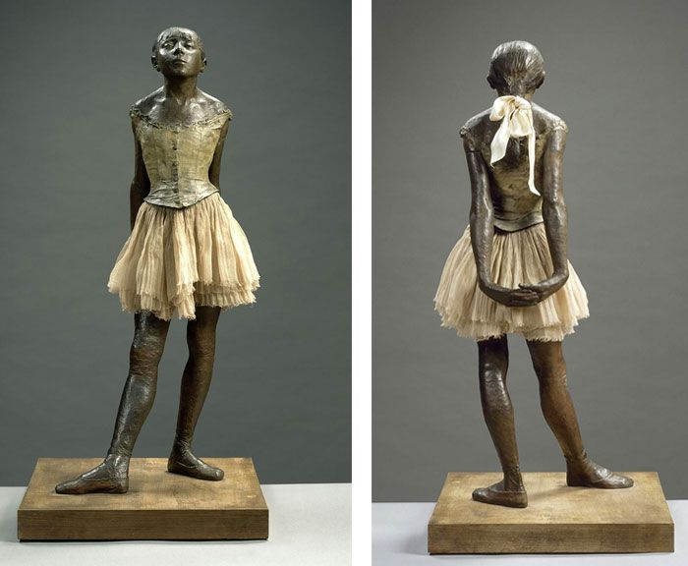
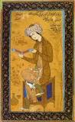
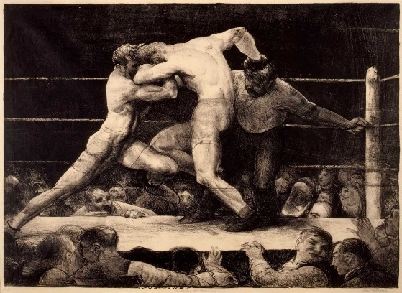
Youth Reading – Reza Abbasi 1626
Little Dancer of Fourteen Years – Edgar Degas 1881
A Stag at Sharkey’s – George Bellows 1917
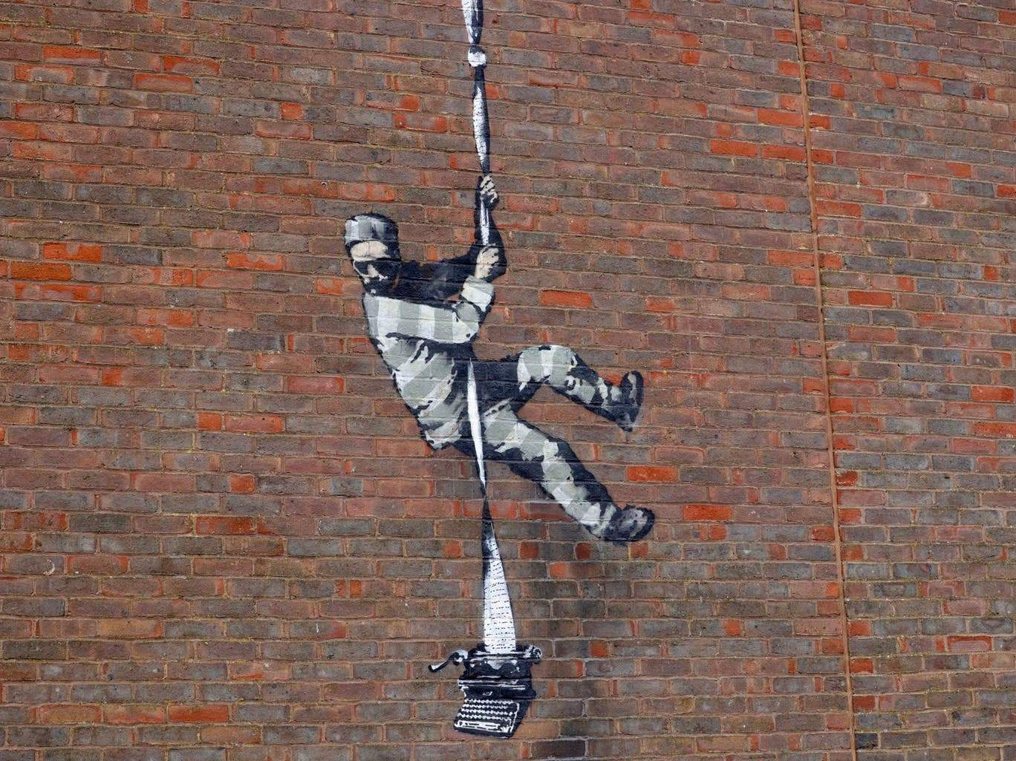
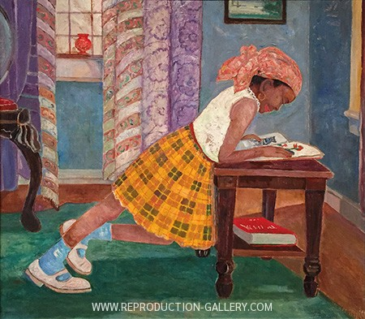
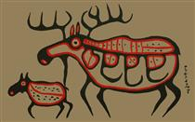

Young Girl Reading – Palmer Hayden 1960
Moose Calf – Norval Morrisseau 1994
Reading Prison Mural – Banksy 2021
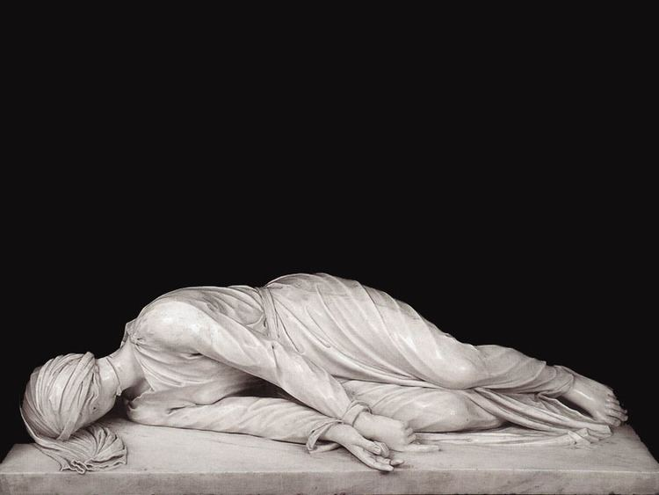
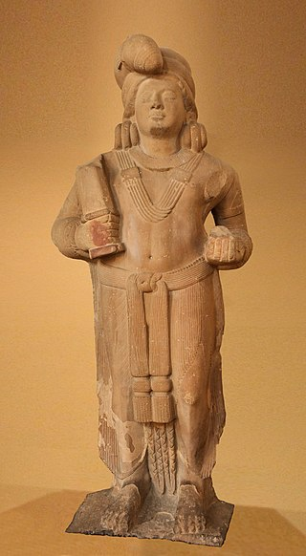

Mudgarpani Yaksha – 100 BCE

St. Cecilia – Stefano Maderno 1600
Part B: Research
Research the artistic period of the piece of art you selected for your analysis and describe two contemporaries from that period.
Name of Artistic Period:

Contemporary Artist #1 | Contemporary Artist #2
Record and describe a piece of the artist’s work.  Title:___________________________________________ | Record and describe a piece of the artist’s work.  Title:___________________________________________

Part C: Drawing
Choose one of the artists you researched and create a sketch of a piece of their work that you admired while conducting your research.

VISUAL ARTS ANALYSIS TASK
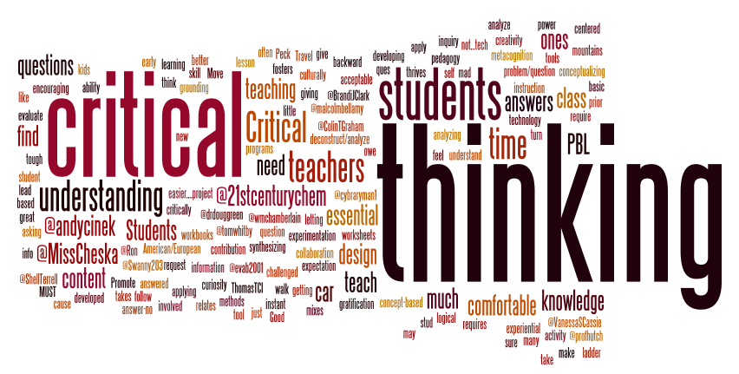
Success Criteria:
- read over all questions before starting your task
- select a piece of art from the images included with your task
- answer all parts of each question fully
- use technology to gather research for Part B of your task and write in your own words what you discover
- complete a pencil sketch of a piece of art you admired while conducting your research
Part A and B
Criteria | Level 1 | Level 2 | Level 3 | Level 4
-your responses are fully developed, logical, and well supported | -with limited effectiveness | -with some effectiveness | -with considerable effectiveness | -with a high degree of effectiveness
-you complete all questions fully | -with limited effectiveness | -with some effectiveness | -with considerable effectiveness | -with a high degree of effectiveness
-your research is accurate and thorough | -not very | -somewhat | -considerably | -highly
-you adhere to writing conventions in your responses (eg. complete sentences, capitalization, punctuation, spelling, grammar) | -with limited effectiveness | -with some effectiveness | -with considerable effectiveness | -with a high degree of effectiveness

Part C
Criteria | Level 1 | Level 2 | Level 3 | Level 4
-your sketch is detailed and well developed | -with limited effectiveness | -with some effectiveness | -with considerable effectiveness | -with a high degree of effectiveness
-care is evident in your final sketch | -not at all evident | -somewhat evident | -clearly evident | -very clearly evident

