Dear Families,

Did you know that speech and language skills are the building blocks for early literacy?

Kindergarten educators develop these skills throughout the day, but you play an important role as well. We have created some fun activities for you to do at home that will provide continued support of your child's speech, language and literacy skills.

Enjoy!

If You Give a Moose a Muffin by Laura Numeroff
Over the next week to two weeks, watch the 2 minute 42 second video of the If You Give a Moose a Muffin book reading on YouTube with your child several times. Reading the same book repeatedly (even if it drives you crazy!) has many benefits including building vocabulary and deeper comprehension of the story’s meaning. Each time you listen to the book with your child, complete one of the following activities.
YouTube link for story: https://www.youtube.com/watch?v=QHiV-qjEJ-Y

Day  1 | After watching the story, you and your child are going to retell the story. When the story is finished, start the video from the beginning and use the pictures in the story (pausing the video on each page) to retell it.  If your child needs support, ask questions to further the story retell.  *Examples of questions to ask:  “What did the boy give to the moose?”  “What did the moose ask for? Why?”  “Whose jam is it?”  “Where do they have to go to buy muffin mix?”  “What did the moose put on when he was cold?”  “What is the Moose going to do with the sock puppets?”  “What does the Moose ask for next?”  “Where does the Moose hang up the sheet to dry?”  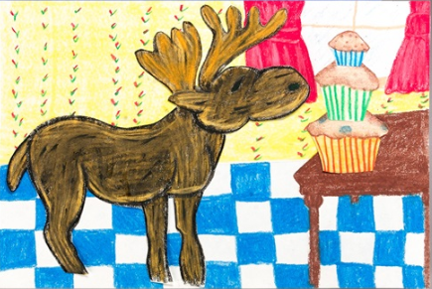  “Where is the blackberry bush?”  After retelling the story, have your child draw their favourite part of the story.
Day  2 | Today, you and your child will practice preposition phrases. Preposition phrases talk about the location of an item (Ex. it is ON the grass).  Target prepositions: on, under, in front of, behind, beside  While watching the story, point out to your child the location of different things in the pictures.  Examples:  “Look, the boy is sitting on the counter!”  “The moose is behind the couch.”  “The moose is under the sheet.”  “The moose put the sock puppets on his hands.”  After watching the story, gather some items from around your house (ex. a spoon, a blanket, toys). Tell your child where to put those items by playing a game of Simon says (ex. “Simon says put the teddy bear under the blanket”, “Simon says put the car behind the chair”). After your child places the item in the location you said, model a preposition phrase for your child and accentuate the preposition (ex. “Great Job! You put the spoon ON the table”, “The teddy bear is hiding UNDER the blanket”).
Day  3 |   Target letter: M  Word List  - Milk  - Money  - Car  - Mail  - Mitten  - Medal  - Sink  - Ball  - Mask  - Mattress  - Paper  - Meat  *Red Words don’t start with M  Sound: ‘mmmm’  After watching the story, you and your child will play a scavenger hunt game. Tell your child to listen carefully to each word and that they are only going to find the words that start with the ‘M’ sound.  Using the word list provided, read each word one at a time to your child. Ask your child “Does this word start with ‘M’ sound?” If the word does start with the ‘M’ sound, have your child find the item in your house. If the word does not start with the ‘M’ sound, point out to your child what sound that word does start with and then continue the game, moving on to the next word.  If you do not have an item on the list in your house, you can skip it or replace it with another word.
Day  4 | As you watch the story, point out to your child the phrase that is repeated throughout the story (“If you give a moose a ____, he will ___).  After you watch the story, both you and your child will draw a picture of what you would give a moose. Take turns talking about your drawings using the repetitive phrase from the story.  Examples of things to draw:  If you give a moose a piece of cake, he will ask for milk.  If you give a moose car keys, he will ask to drive the car.  If you give a moose a pillow and blanket, he will take a nap.
Day  5 | Today’s activity is all about opposites.  While you watch the story, point out the following words when you see pictures of them.  Outside - first picture, the Moose is outside  Inside - first picture, the boy is inside (in the window)  Cold – the Moose thinks it is chilly/cold outside  Asleep – the boy is asleep on the couch  Dirty – the sheet is dirty  Wet – the sheet is wet from being cleaned  When you point out these words, tell your child what the opposite of that word is.  Example:  “The Moose is outside. The opposite of outside is inside. Look! The boy is inside the house.”  “Brr! The Moose opened the door and thinks it is cold outside. The opposite of cold is hot.”  “Yuck! The sheet is dirty. The opposite of dirty is clean. I think the Moose needs to clean that sheet.”  After you watch the story, use the pictures below to help your child label opposite words. Point to each picture and give your child fill in the blank sentences to help them label the opposites (fill in the blank questions are provided beside each picture set). If your child does not know the opposite word, simply repeat the sentence and model the word.
   | Fill in the blank sentences  Opposites: Dirty/Clean  This dog is ____ (dirty).  This dog is ____ (clean)
  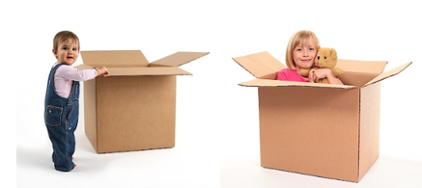 | Opposites: Inside/Outside  She is ____ (inside) the box.  The baby is ___ (outside) the box.
   | Opposites: Hot/Cold  The tea is ___ (hot).  The drink has ice cubes so it is ___ (cold).
   | Opposites: Wet/Dry  This dog is ___ (wet).  This dog is ___ (dry).
   | Opposites: Open/Closed  The lid is off. This jar is ___ (open).  The lid is on. This jar is ___ (closed).
   | Opposites: Asleep/Awake  The boy is ___ (asleep or sleeping).  The girl is ___ (awake).

