Week of June 8-12

Spend time playing with your child

Ask your child to choose a game or activity they enjoy and spend some time playing together.

Head-Toes-Knees-Shoulders
How this helps self-regulation and wellbeing:
Helps children follow instructions, think before they do an action, and staying calm/relaxed when things go wrong.

Instructions:
- Say “touch your head, shoulders, knees and toes. Say the body part out loud when your child touches it.
- Do this again but in a different order (i.e. knees, head, shoulders, toes).
- Do this again but in a different order (i.e toes, head, knees, shoulders).
- Next, say “listen to my words, touch your head” but touch your knees. Your child needs to touch the body part you said out loud “head” not knees!
- Try this again with a 3-5 more body parts.



Calming Bottle

How this helps self-regulation and wellbeing:
Can be a soothing way to calm your child. They can focus on the moving water and the items inside. This can be used when your child feels mad, sad, worried, or even when they just want to relax.

You will need:
- Empty plastic water bottle with a lid that closes
- Water
- 2 tablespoons of glitter glue and or vegetable oil
- 2-3 tablespoons of sparkles, small beads, sequins, pieces of plastic straws cut up, or pom poms.

You can also add (optional):
- 2-3 drops of food colouring

Directions:
- Fill up the bottle almost full with water.
- Add the glitter glue and or vegetable oil, and small items.
- Optional - add the food colouring.
- Tape or glue the lid on really tight.
- Give the bottle a shake to mix together.

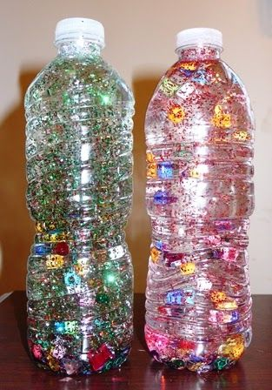

You know your child best and whether or not they can use this on their own or only when you are there (tape or glue the lid so there are no spills).

Feelings

Your child says their stomach hurts or they are crying but they can’t tell you why….
Once you know they are physically alright you might want to consider how they are feeling emotionally.
Here are some things you can do that could help:

Balloon breath: Breath in, count to 5 and breath out count to 5.
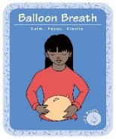

Comfort them with a hug, their favorite stuffy or have them use their calming bottle.

Listen to what they tell you about how they feel.


Stay calm yourself.

Tell them when something is changing.

Give them a warning, that something new is going to happen,
like “5 more mintues then tidy up time”.
Book Resources

Wilma Jean the Worry Machine by Julia Cook
https://www.youtube.com/watch?v=Yfva5ltdpEw

This book is about a little girl who feels worried and how she can feel better.
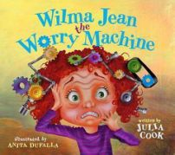

Wemberly Worried by Kevin Henkes
https://www.youtube.com/watch?v=tkuXc0htNGk

This book is about a little mouse who feels worried about lots of things including returning to school.

