Week of June 15-19

Spend time playing with your child

Ask your child to choose a game or activity they enjoy and spend some time playing together.


I Spy in the sky Game…

Find shapes in the sky by laying down on your backs together and looking up. Choose different objects to search for in the clouds. Talk about how you feel as you spy cloudy treasures.

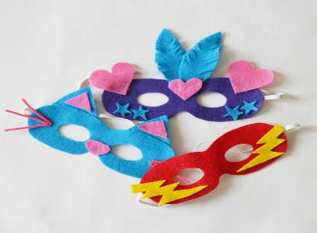
A mask made just for me

You will need:
• Markers • Paper • Sting
Create a mask and decorate it however you like.
Use the mask when you feel like you need to take a break, need some time to cool down, or when things get overwhelming.

My Breathing Shapes

Using the images below, follow the lines with your finger as you breathe in and out. Use as many patterns as you would like. Create your very own on a piece of paper with crayons or insert shapes you like on your tablet.

Book Resources

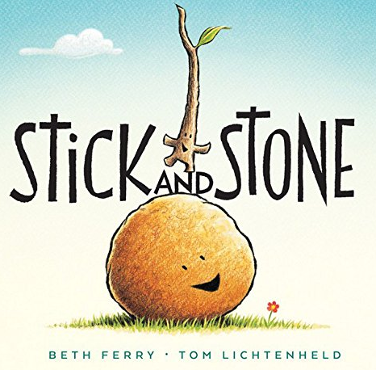

When Stick rescues Stone from a prickly situation with a Pinecone, the pair becomes fast friends. But when Stick gets stuck, can Stone return the favor? Author Beth Ferry

Listen to the story here: https://www.youtube.com/watch?v=ntwNEBNt3DY

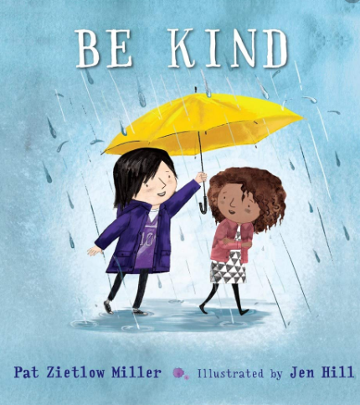

What exactly is kindness? What is it to be kind? Is it being helpful? Being polite? Does it have to be a big act to be more kind? Well maybe the smallest act is the most powerful. Let's have a look at this meaningful book BE KIND by author Pat Zietlow Miler and illustrator Jen Hill.

Listen to the story here: https://www.youtube.com/watch?v=kAo4-2UzgPo

