Week of June 1-5
Spend time playing with your child

Ask your child to choose a game or activity they enjoy and spend some time playing together.

The feelings game:


Find different objects around your house, put them into a bag (you could use your knapsack). Take turns with someone else. Are you able to figure out what it is?
- Is the object hard or soft?
- Big or small?
- What shape is it?
- What is the texture like?

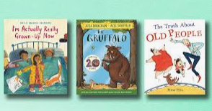
Read your favourite book:
- Why do you like the book?
- If you had to come up with a different title, what would it be?
- Do you find anything funny in the story?
- What parts make you happy?
- What parts make you sad?

The Listening Exercise:


- Ring a bell, hit a pan, and listen closely to the vibration of the ringing sound.
- Remain silent and raise their hand when you no longer hear the sound.
- Remain silent for one minute and pay close attention to the other sounds you hear once the ringing has stopped.

