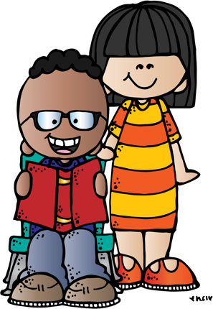
Reading BINGO

Make a fort and then read in it | Record yourself reading and play it for someone | Make a picnic then read a book outside | Listen to an audio story on audible.com
Read in the bathtub | Read the directions to a game and them play it | Read next to a window | Read to a stuffed animal
Read laying upside down | Make a snack and eat it while you read | Read a book you love again | Read a non-fiction book
Read wearing sunglasses | Read a book about animals | Read a recipe and then make it | Read while you eat ice cream

