Grade 8 History – Confederation Final Quiz
Part 1: Definitions - Explain the meaning of each term in the context of Canadian Confederation.
TERM  Tories  Clear Grits  Confederation  British North America  Rep by Pop  Emigrate  Intercolonial  Annex  Legislative Assembly | MEANING  ___________________________________________________________  ___________________________________________________________  ___________________________________________________________  ___________________________________________________________  ___________________________________________________________  ___________________________________________________________  ___________________________________________________________  ___________________________________________________________  ___________________________________________________________

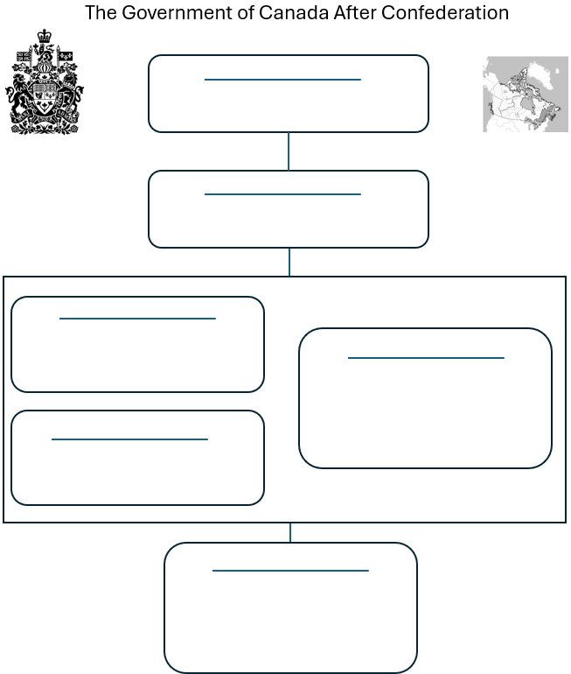 | Place the following terms on the Government of Canada flow chart, then provide a few words to explain the purpose or role of each.  Prime Minister  Cabinet  The People of Canada  House of Commons  Queen or King of England  Governor General

Explain at least one advantage and one disadvantage that Confederation might provide for each region.
Colony | Confederation Advantages | Confederation Disadvantages
Canada
East
Canada
West
P.E.I.
Nova Scotia
New Brunswick
Newfoundland

Label 20 features on this pre-confederation (1867) map of Canada. One mark per feature.
You may include colonies, cities, landmarks as well as geographical features.
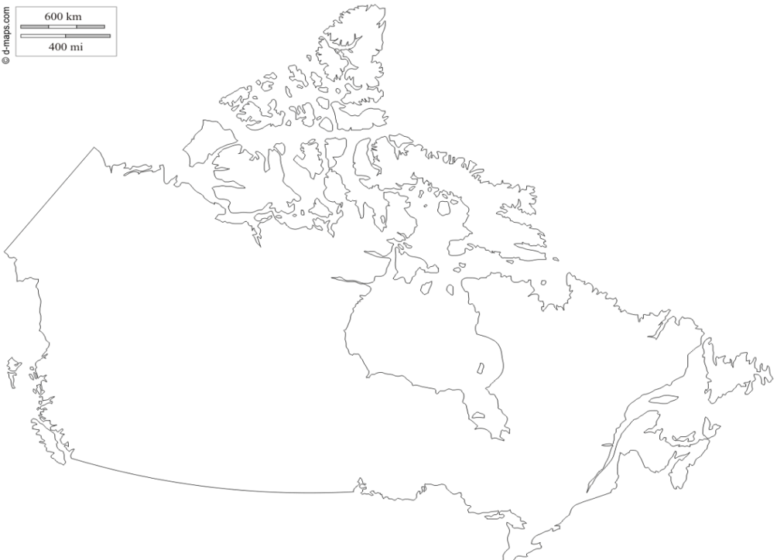
A Story of Us: Expansion
Who was John A. Macdonald?
______________________________________________________________________________
How did John A. Macdonald propose to unify the nation?
______________________________________________________________________________
______________________________________________________________________________

What resistance did John A. Macdonald encounter to his plan?
______________________________________________________________________________
______________________________________________________________________________

What was one of the challenges and setbacks faced in the construction of the transnational railway and how was it overcome?
______________________________________________________________________________
______________________________________________________________________________

Study Resources:

Expansion | Canada: The Story of Us, Full Episode 5

