New France and British North America – Practice Quiz (Draft) and Study Notes
Definition Match:
Match the terms on the left to the definitions on the right by placing the matching letter on each line.
Seigneur: _____  Habitant: _____  Filles du roi: _____  Missionary: _____  Haudenosaunee: _____  Inuit: _____  Metis: _____  Pelt : _____ | A. Indigenous people of Labrador and the far north.  B. Indigenous people of the region now known as Manitoba  C. Fur and skin of an animal used to make household items and clothing  D. a man who was granted land by the king of France  E. the poor farmers who rented the farm land from the seigneurs.  F. Someone who goes, or is sent to another country to convert others to their religion or to do charitable work  G Indigenous people of the land now known as Ontario and the north eastern United States.

Add 10 features to the map below from our research about 1700s British North America and New France.
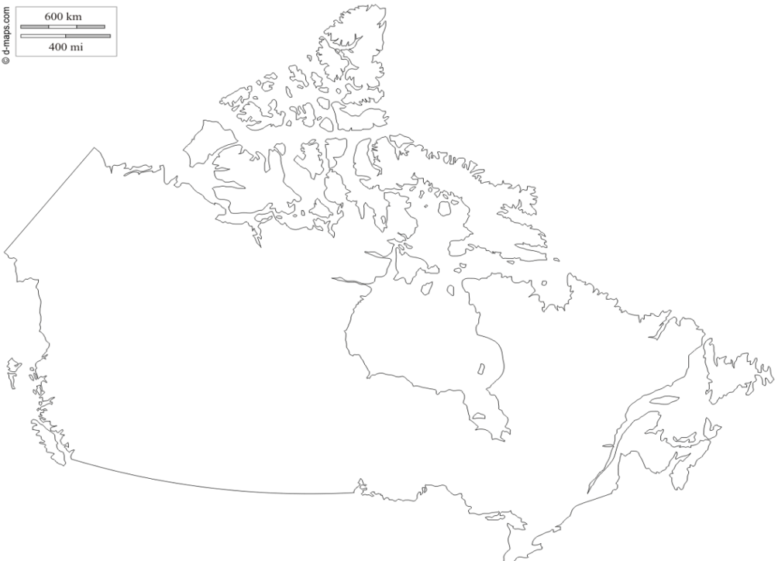
Briefly explain the Importance of each
Samuel de Champlain
Acadians
Rupert’s Land
What was the Seven Year’s War?

Describe the events of the Battle of the Plains of Abraham

Describe, in one or two paragraphs, who the Acadians were. Be sure to include information about where they came from, approximately when they arrived in the land we now refer to as Canada, and where they settled.

Explain the circumstances of the Acadian’s leaving their homes in 1755 (also known as the Acadian Expulsion).

Choose one of the treaties we have studied in class (Treaty of Paris, Royal Proclamation or the Quebec Act).
Summarize the purpose and any main points from this document (one mark per point)

*** Earn up to three bonus marks by explaining the purpose and main points of a second treaty.

History Study Pack
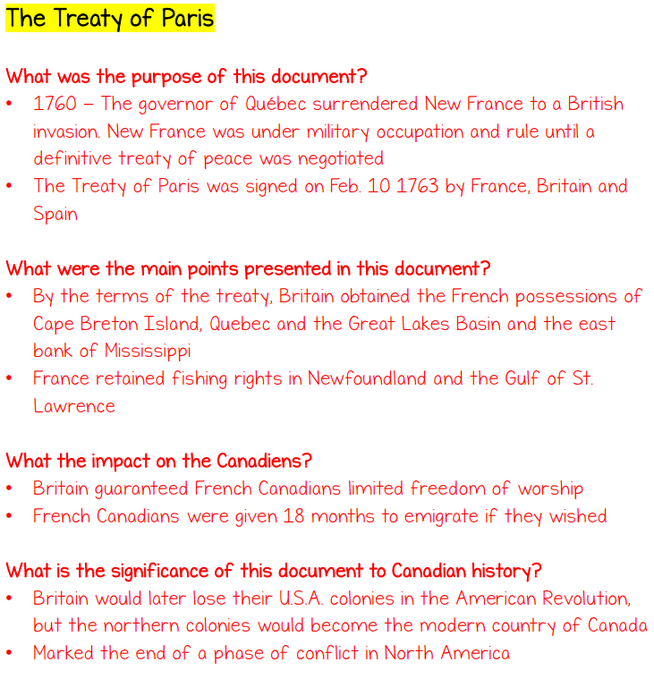 | 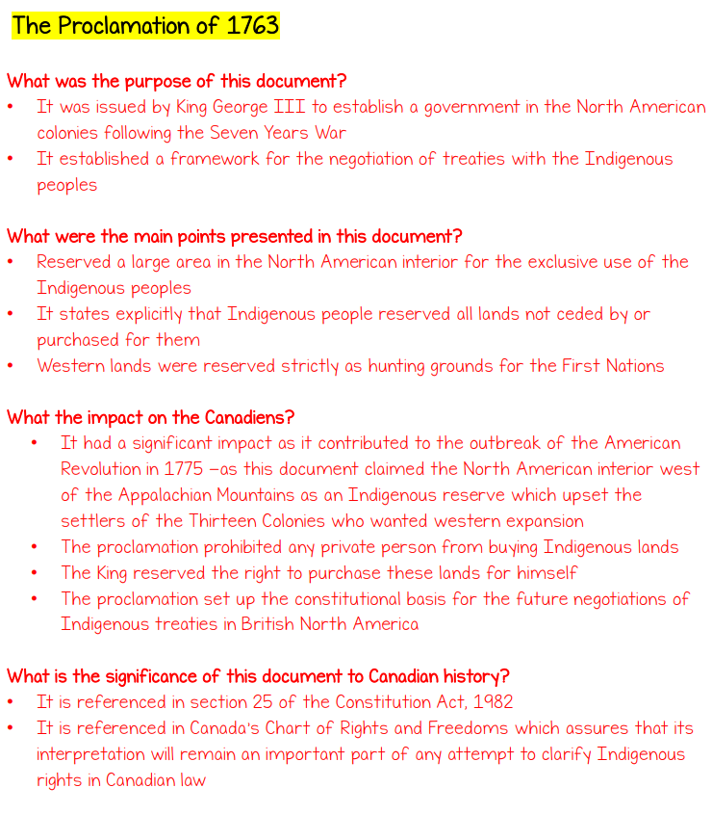
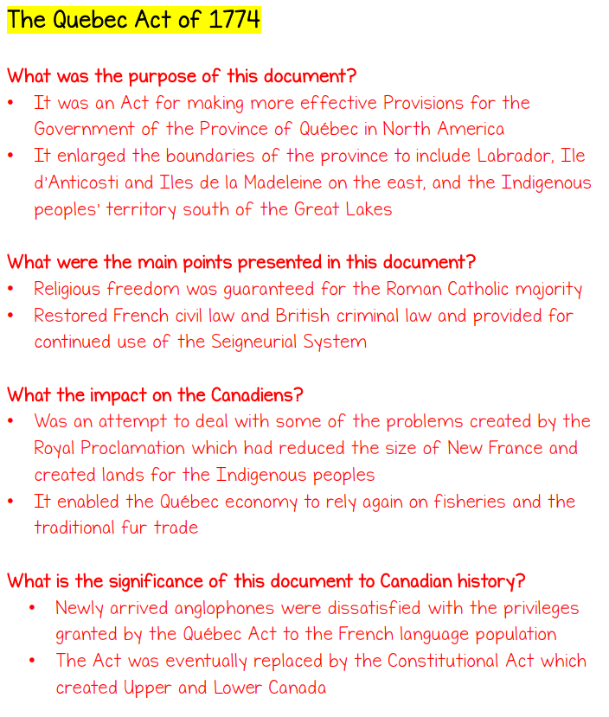 | 