Name:___________________ Class:________
France and British North America – End of Unit Quiz /36
PART A
Definition Match: Match the terms on the left to the definitions on the right by placing the matching letter on each line (8 marks).
General Wolfe: ______  Lower Canada: _____  Hudson’s Bay Company: _____  Upper Canada: _____  Haudenosaunee: _____  Inuit: _____  Metis: _____  Montcalm: _____ | - Indigenous people of Labrador and the far north.  - Indigenous/French/multiracial people of the regions now known as Manitoba, Alberta and Saskatchewan.  - One of the first Canadian companies that got its start in the fur trade.  - A French general who died during the battle of the Planes of Abraham  - British general who died during the battle of the Planes of Abraham  - English speaking region, also known as British North America  - Indigenous people of the land now known as Ontario and the north-eastern United States.  - French speaking region, also known as New France

Add 10 features to the map below from our research about 1700s British North America and New France (10 marks).
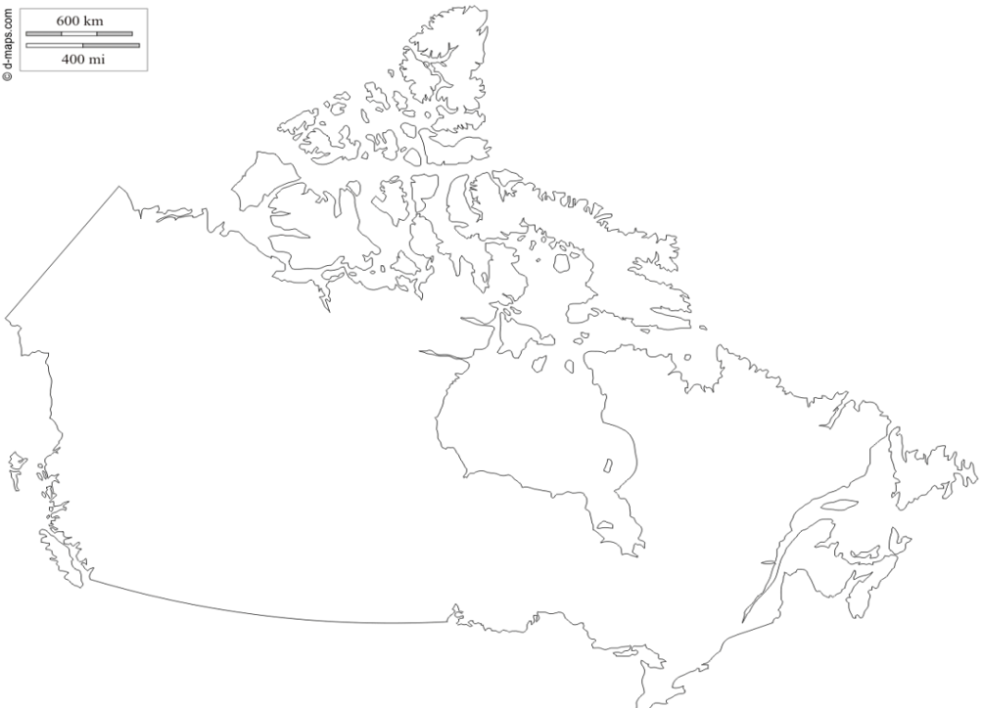

Briefly explain the Importance of each (6 marks).
Samuel de Champlain: _______________________________________________________________________________
__________________________________________________________________________________________________
Rupert’s Land: ______________________________________________________________________________________
__________________________________________________________________________________________________
Seven Years War: ___________________________________________________________________________________
__________________________________________________________________________________________________

Place the events of the Battle of the Plains of Abraham in order. Write at least one point to describe each phase of the battle (6 marks).
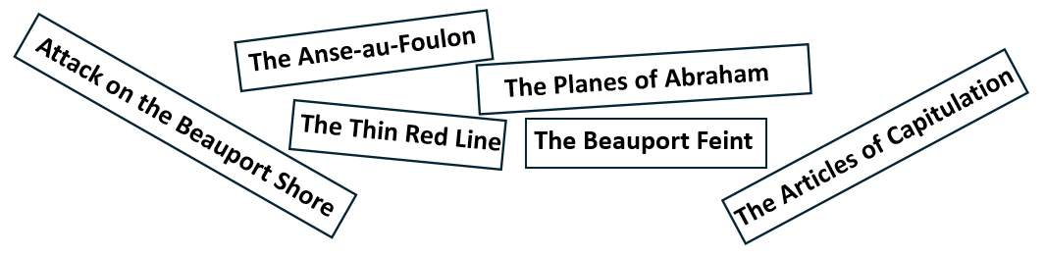
- ______________  _________________  _________________ | - ______________  _________________  _________________ | - ______________  _________________  _________________
- ______________  _________________  _________________ | - ______________  _________________  _________________

From what we have studied since September, what do you think the First Nations Peoples might see as the benefits of working with the French? What might they see as some disadvantages (6 marks)?
Benefits of working with the French | Disadvantages of working with the French

BONUS QUESTION (2 marks max)

Name and describe (at least) one treaty made between an Indigenous community within the land we refer to as Canada and the British Crown. Be sure to include year of signing, location/region of treaty and any advantages or disadvantages provided to the Indigenous group in question.
______________________________________________________________________________
______________________________________________________________________________
______________________________________________________________________________
______________________________________________________________________________
Finished early?
Draw, label and colour a cool picture the Battle of the Plaines of Abraham. If it’s fantastic, I might throw a bonus mark your way!

Describe, in one or two paragraphs, who the Acadians were. Be sure to include information about where they came from, approximately when they arrived in the land we now refer to as Canada, and where they settled (4 marks).
_______________________________________________________________________________________________
_______________________________________________________________________________________________
_______________________________________________________________________________________________
_______________________________________________________________________________________________
_______________________________________________________________________________________________

Explain the circumstances of the Acadian’s leaving their homes in 1755 (also known as the Acadian Expulsion
(2 marks).
_______________________________________________________________________________________________
_______________________________________________________________________________________________
_______________________________________________________________________________________________

New France and British North America Study Pack

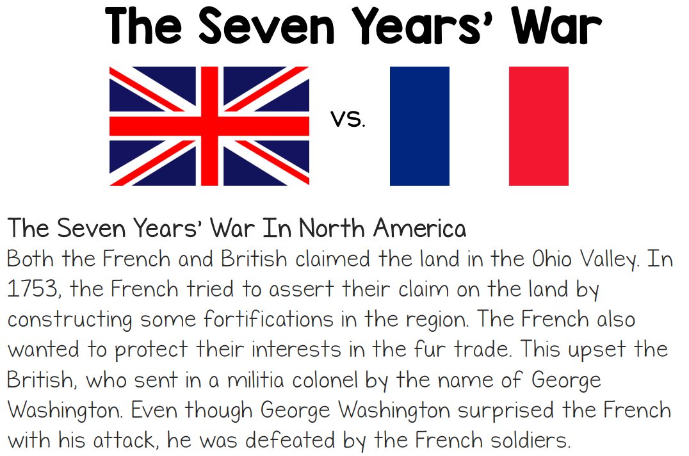 | 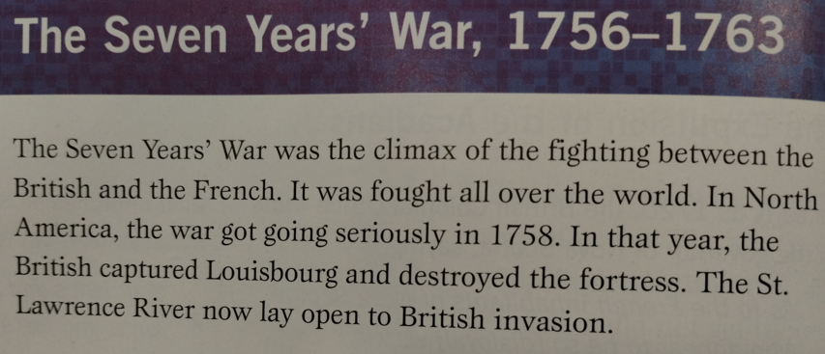  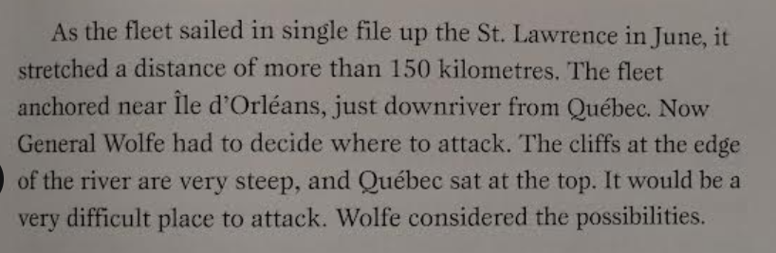

ACADIANS
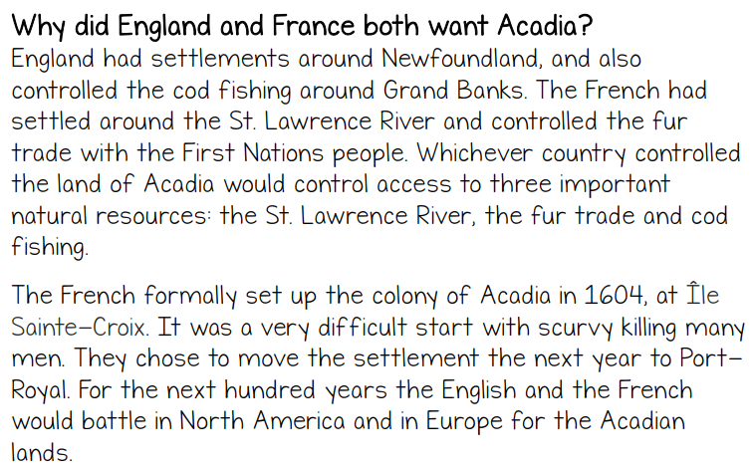 | 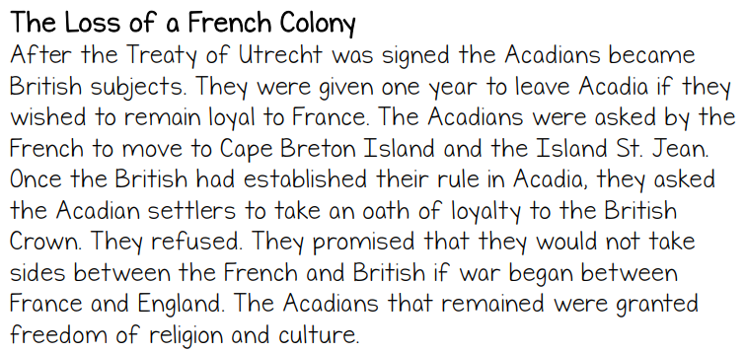

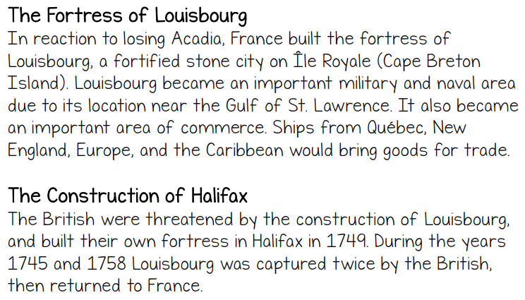 | 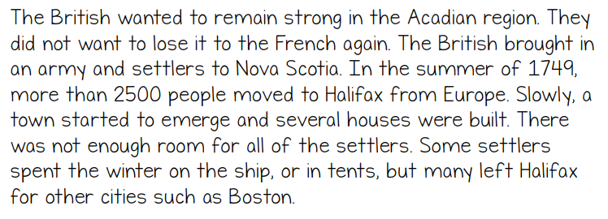  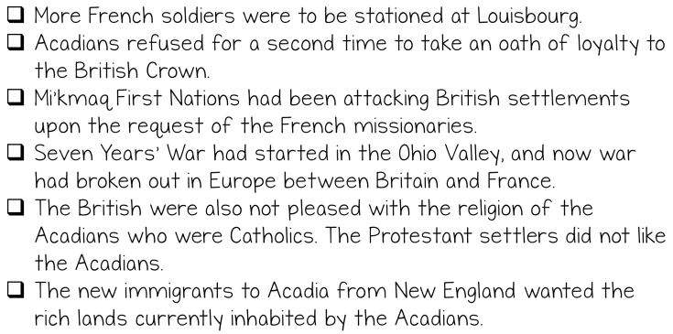

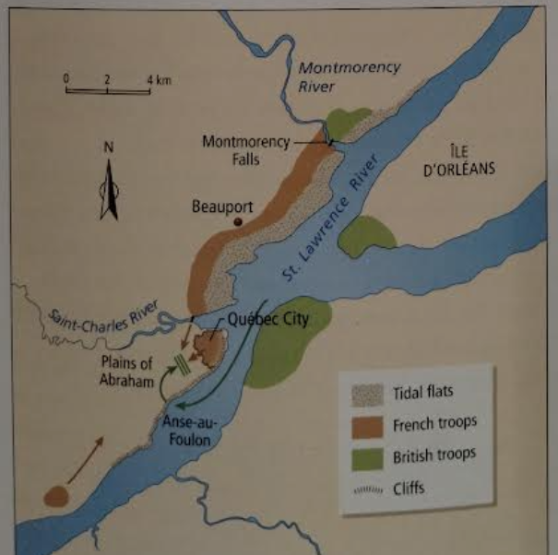 | 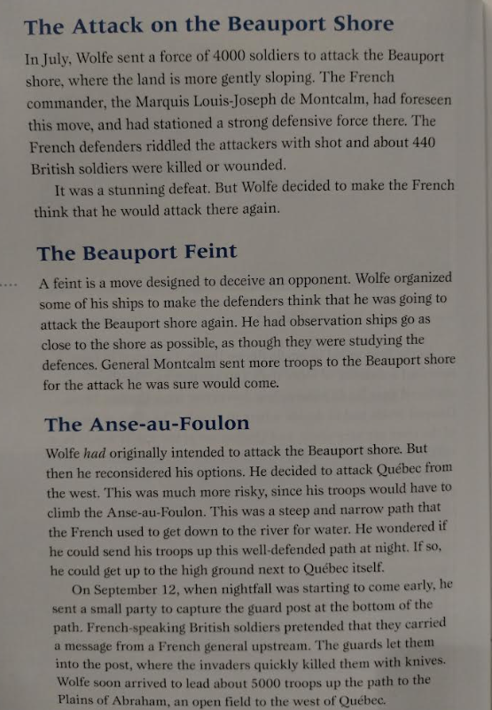

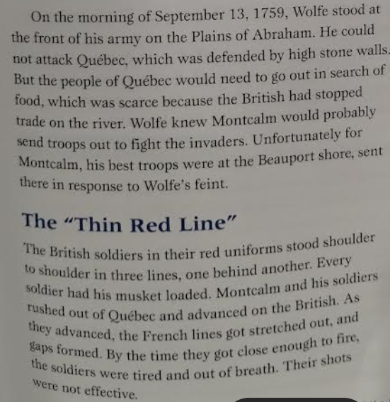 | 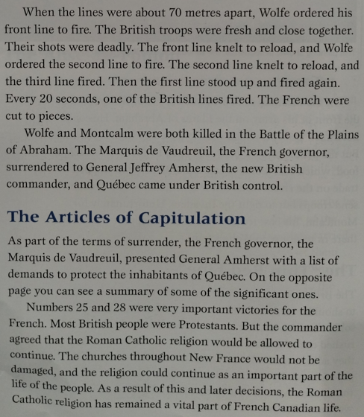

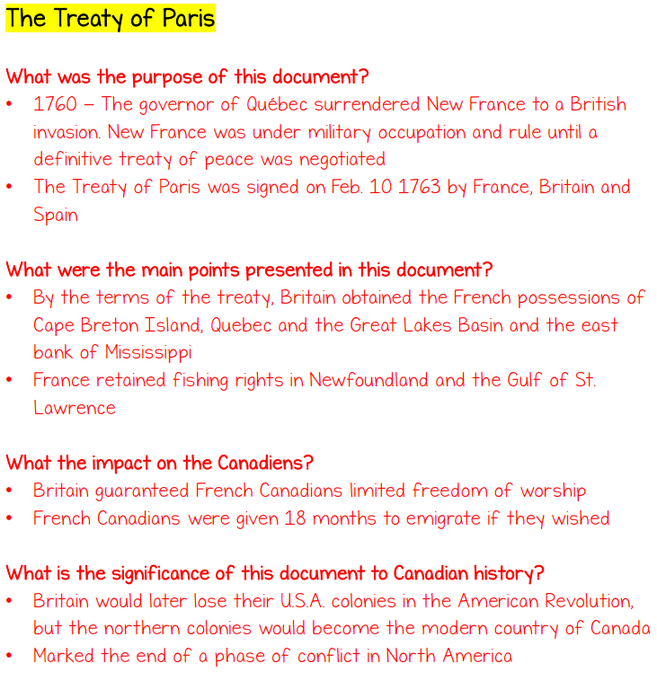 | 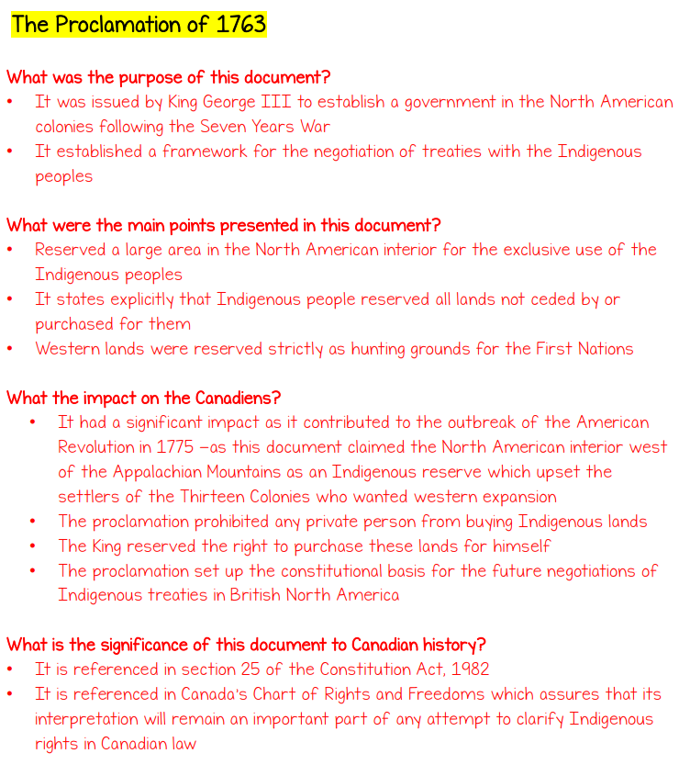
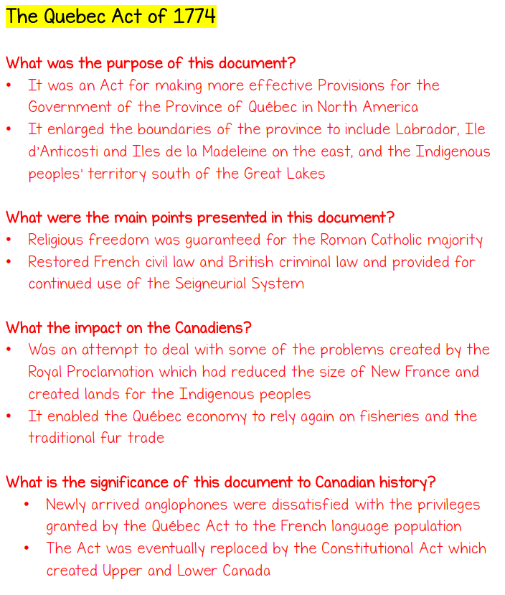 | 