Name:______________________________
Stem-and-Leaf Plots + Graphing Assignment
Choose one of the following INDIVIDUAL assignments.
(Not to be completed with a partner unless specified by Mr. Adeney.)
Option A
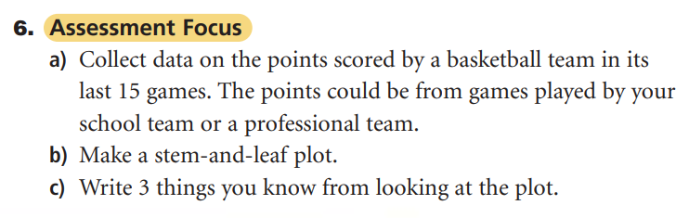
d) graph the data
OR
Option B
- Choose one Canadian city and research the monthly precipitation data
for the years of 2022 and 2023 (for a total of 24 moths).
- Make a stem-and-leaf plot from the data
- Write the mean, median, mode and range of for the data.
- Graph the data on grid paper – include a title, labelled axis, colour, legend.
 | Below Expectation | Approaches Expectation | Meets Expectation | Exceeds Expectation
Product
- Well designed, easy to read; used a ruler
- fully labeled, coloured, organized
Process
- On task; worked effectively on your own
- asked clarifying questions when needed;
- assignment completed and submitted on time
Content
- All need information included: stem-and-leaf, mean, median, mode,
- you showed your work/explained your thinking
- All data is fully accurate, double checked

