Name:__________________________
Ratio, Rate and Fractions Review (part 1)
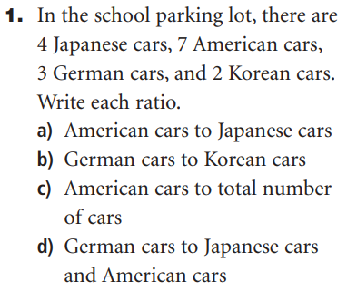 | 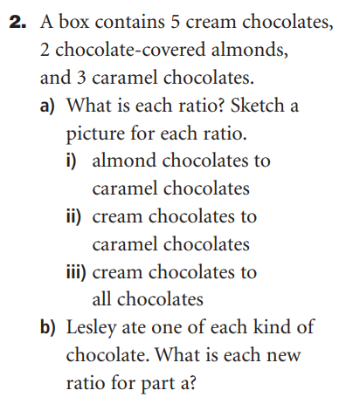

3.  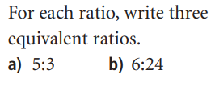 | 4.  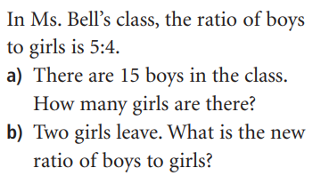

5.  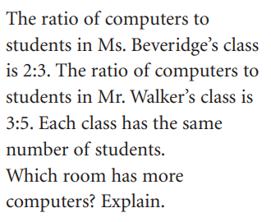  (or show your work) | 6.  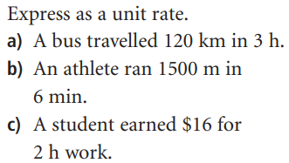

7.
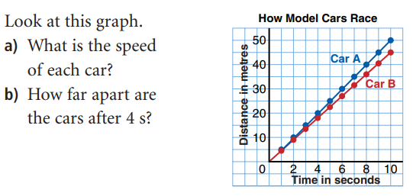
Ratio, Rate and Fractions Review (part 2)
Remember to express each answer as a proper fraction in lowest (reduced) form.
8. (You may use fraction strips if they are helpful for you.)  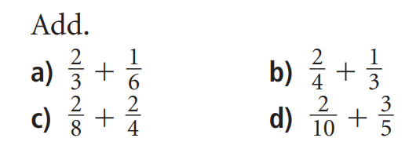 | 9.  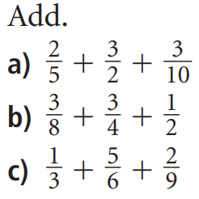

10.  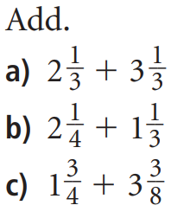 | 11.  Subtract (use fraction strips if they are helpful).  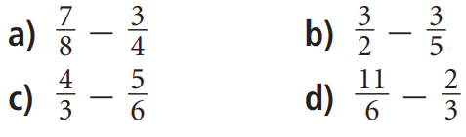
12.  Subtract  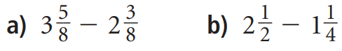 | 13.  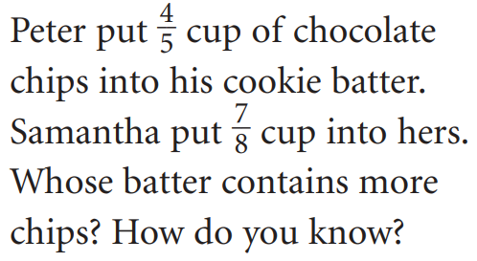

14.  Multiply  - 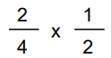 b) 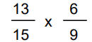 | 15.  Multiply  a) 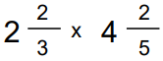 b) 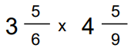
16.  Divide  - 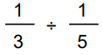 b)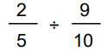 | 17.  Divide  - 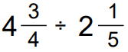 b) 