Healthy Active Living at the HWDSB | 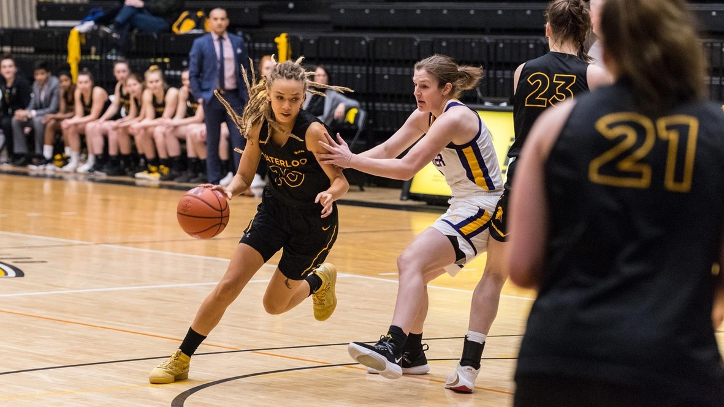
At HWDSB, Positive Culture and Well-being is a top priority. Our schools work to make physical activity and healthy eating a reality inside and outside the classroom. Here are some guidelines that may help families support these goals:  Physical Activity  Know the terms and Establish your rate of Physical Exertion  Moderate-intensity - physical activity is rated five or six out of 10, with 10 being an individual’s personal capacity. Examples include: dancing, brisk walking, playground activities.  Vigorous-intensity -physical activity is usually a seven or eight on a scale of 10. Examples include: running, fast cycling, fast swimming, rollerblading.  Sedentary behaviour - requires very little movement, such as prolonged sitting, extended time spent watching television, searching the Internet, playing video games and motorized transportation. | Research tells us that being active for at least 60 minutes a day can help children:  - Improve their health  - Do better in school  - Improve their fitness  - Grow stronger  - Have fun playing with friends  - Feel happier  - Maintain a healthy body weight  - Improve their self-confidence  - Learn new skills

  - 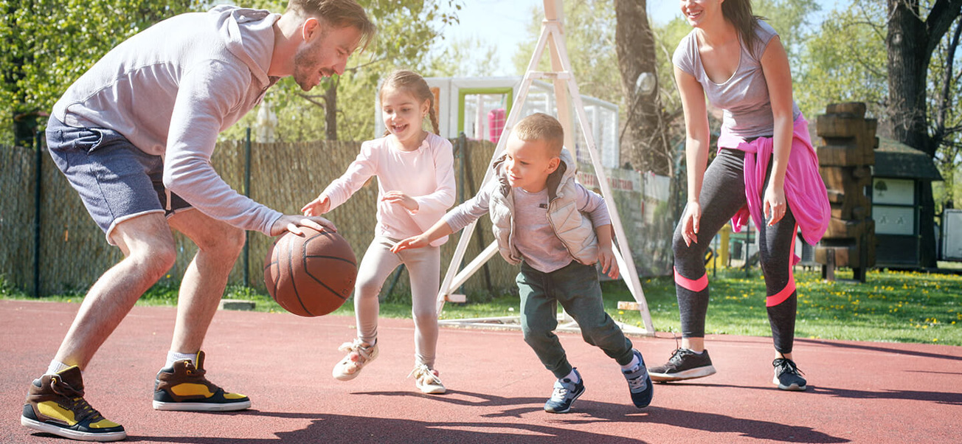
To get started right away, just tap any placeholder text (such as this) and start typing to replace it with your own.

Physical Education Program in the HWDSB
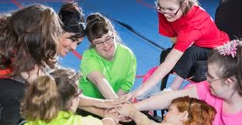
Fundamental Principles in Health and Physical Education- Ministry of Education
- Health and physical education programs are most effective when they are delivered in healthy schools and when students’ learning is supported by school staff, families, and communities.
- Physical activity is the key vehicle for student learning.
- Physical and emotional safety is a precondition for effective learning in health and physical education.
- Learning in health and physical education is student-centred and skill-based.
- Learning in health and physical education is balanced, integrated, and connected to real life


Ministry of Education -Foundations for a Healthy School
1.Curriculum, Teaching, and Learning
2. School and Classroom Leadership
3. Student Engagement
4. Social and Physical Environments
5. Home, School, and Community Partnership

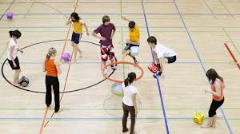

“What is necessary for some is good for all”
Written by Mr. Forman
Supporting every learner and reaching every student is a shared belief of all educators. Ultimately this is our goal for every lesson we deliver, and it is our hope that this brings out a high level of student achievement. We also strive to reduce gaps in student achievement, and it is our intent to help all learners feel included in a safe caring environment. When designing lessons that are inclusive and accommodating for all learners it becomes difficult to differentiate for all learners needs. Keeping in mind the overarching theme, “What is necessary for some is good for ALL”, is a great way to differentiate a lesson. When designing a lesson that accommodates all learners needs, it is important to begin with the very basics in skill development and allow learners to progress to greater levels at their own pace. What is necessary for some is paramount when planning for the success of students that need a modified program, however those accommodations and modifications are broad principles that are good for all students. Flexibility, Safety and Different modes of delivery provide precise levels of support and therefore are good for ALL learners. Universality and equity as well as tiering instruction will accommodate different levels of skill that suit individual needs but are good for all learners. It is important to plan for cultural perspectives to promote an inclusive environment and that is necessary for some students, but a very great learning opportunity for ALL. “What is necessary for some, is good for ALL”

