Summer Reading Activities

Kindergarten to Grade 8

Dear Parents/Guardians,


Summer is quickly approaching! Children who do not read or have access to appropriate books or resources during the summer lose their reading momentum and this can affect their reading progress. All children fall victim to the ‘summer slide’ if not provided with summer reading opportunities. So how do we prevent the summer slide or even accelerate reading growth? Keep reading!



K-12 Online Reading Materials Through HWDSB System Learning Commons

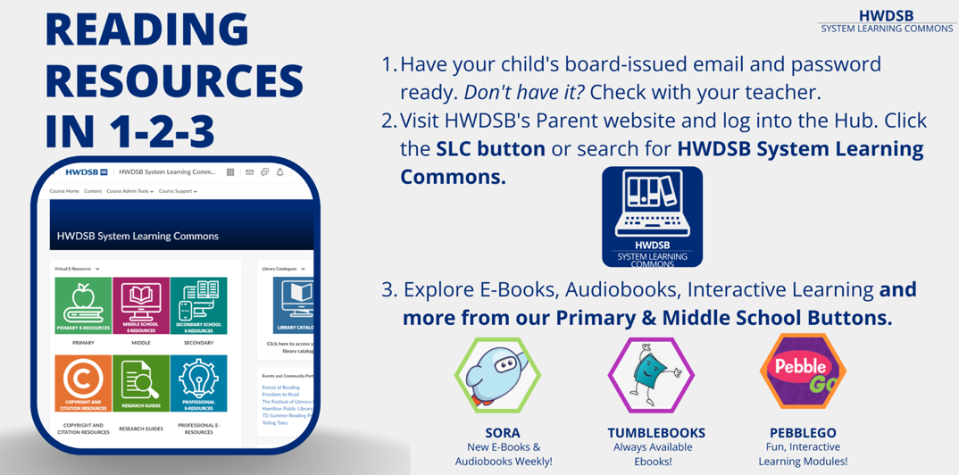
Accessing the following HWDSB materials is simple! First you must log on to the Hub with your username and password.
Once you are on your Hub Page, navigate to the Waffle and select the HWDSB System Learning Commons course.
Under the Virtual Resources drop-down menu, you can select the Primary or Middle School e-resources. Select the module and open the drop-down menus to explore all that the SLC has to offer! Most resources should automatically login when you sign into the Hub.

Here is a YouTube tutorial on how to use the HWDSB System Learning Commons:

https://www.youtube.com/watch?v=cTF-dBdHFtw

What Resources are Available on the HWDSB System Learning Commons (SLC)?

- Sora (K-12):

The Sora student reading app from Overdrive contains a collection of eBooks, eMagazines and audiobooks selected for students K-12. Sora is available 24/7, 365 days a year, and can be accessed by iPad, Laptop, or a smartphone. There are hundreds of different books to choose!

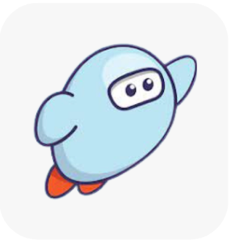

https://www.youtube.com/watch?v=d_cj2KFgOg4 (video tutorial for SORA)
- Tumble Book Library (K-8):


Tumblebooks is one of our other most used databases for eBooks. This resource gives elementary students lots of options in formats and can be great to use in the classroom. Tumblebook Library is geared towards student in K-8, using your online browser to access ebooks, storybooks, read-alongs, graphic novels, nonfiction and more.

- Capstone (K-4+):


Capstone Elementary is an ebook collection of elementary math titles. These items are focused on basic math concepts such as patterns, counting, probability, measuring, and real-life math scenarios. There are 15 titles that range from K-4 concepts and are fun and engaging for students to use.

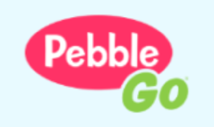
- PebbleGo (K-3+):

PebbleGo is an educational app geared towards students from kindergarten to Grade 3.
There are three modules that PebbleGo has for students to explore: Animals, Science and Social Studies. Each module has a variety of topics within. For example, Animals has sorted their topics through their classification such as Mammals, Invertebrates; Animal Behavior; and Habitats.

Additional Resources, Clubs, and Games for Summer

Some of these sites are geared toward parents (see the **asterisks**), while others can be accessed independently by students. For student-independent websites, I always recommend that students’ parents visit the website with them to help students get set up correctly.

Hamilton Public Library Summer Reading Club 2026! (K-8)**
Summer Reading Club 2026 | HPL
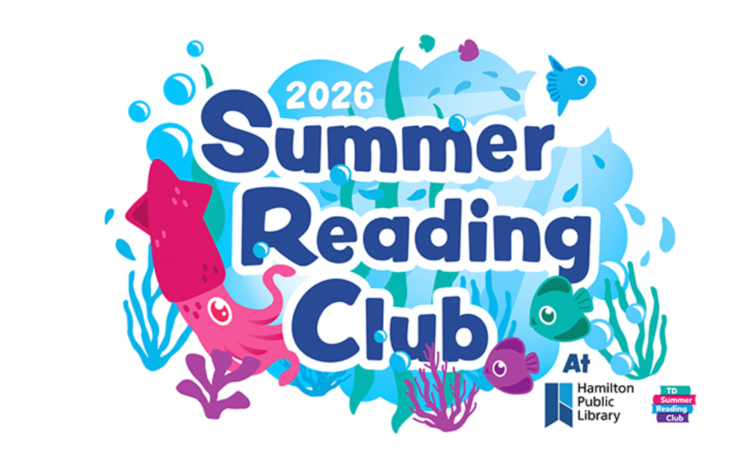



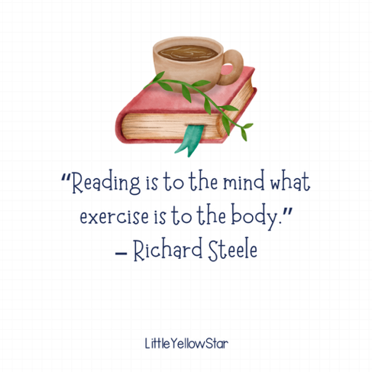
Websites with FREE Reading Content (K-3+)
https://www2.scholastic.ca/scholasticblog/category/reading-tips/
http://www.startwithabook.org/ – From Reading Rockets, this site is parent-friendly and has suggestions for books and learning activities for the summer**
http://pbskids.org/games/ – Reading and math games that are great for preschool through FDK
https://kids.nationalgeographic.com/videos/ – Fun informational videos from National Geographic.
http://www.readingrockets.org/article/reading-adventure-packs-families – Reading and math packs (in English and Spanish) that families can print and use with K-3 students**
http://www.starfall.com/ – Reading and phonics games
http://www.abcya.com/ – A variety of educational games for K-5 (you can easily access the exact grade level(s) you need!)
https://www.getepic.com/ – Students can listen to or read high-quality digital books at home!
https://www.timeforkids.com/ – Informational articles that kids can read independently or that families can read together
https://www.familyeducation.com/school-learning/summer-learning – A great, parent-friendly collection of ideas and tips for learning during the summer**

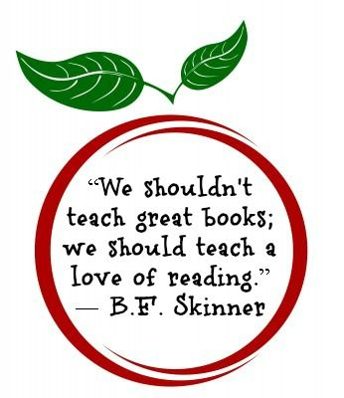

List of FREE decodable books (K-3+)

Decodable books encourage children to sound out words using decoding strategies rather than guessing from pictures or predicting from other cues. They can be introduced once beginning readers have learned some simple grapheme–phoneme (letter-sound) correspondences and can blend from left to right.
- Right to Read---FREE Decodable Texts—There are so many decodable texts here!
- https://ufli.education.ufl.edu/wp-content/uploads/2023/02/UFLI-Foundations-Decodables-ALL.pdf
- Just Right Reader online resources (they also have print books if you enjoy them!).
- https://justrightreader.com/pages/decodables-e-library
- https://www.readinga-z.com/phonics/decodable-books/ (*this one requires payment)
- https://www.reallygreatreading.com/product/decodables (*this one requires payment)

Have a safe and enjoyable summer!

Happy reading!

Sincerely,

Adapted from https://www.hpl.ca/articles/summer-reading-club-2024?gad_source=1&gclid=CjwKCAjwr7ayBhAPEiwA6EIGxL4KGCmOUwVdQGqtDLNz7g4Q-k-w1Pa6SqYyOMAiAuQjhbpIdzJCuBoCQDYQAvD_BwE

https://learningattheprimarypond.com/blog/websites-for-summer-learning-activities/

https://www.readingrockets.org/topics/parent-engagement/articles/get-ready-summer-ideas-teachers-share-families

