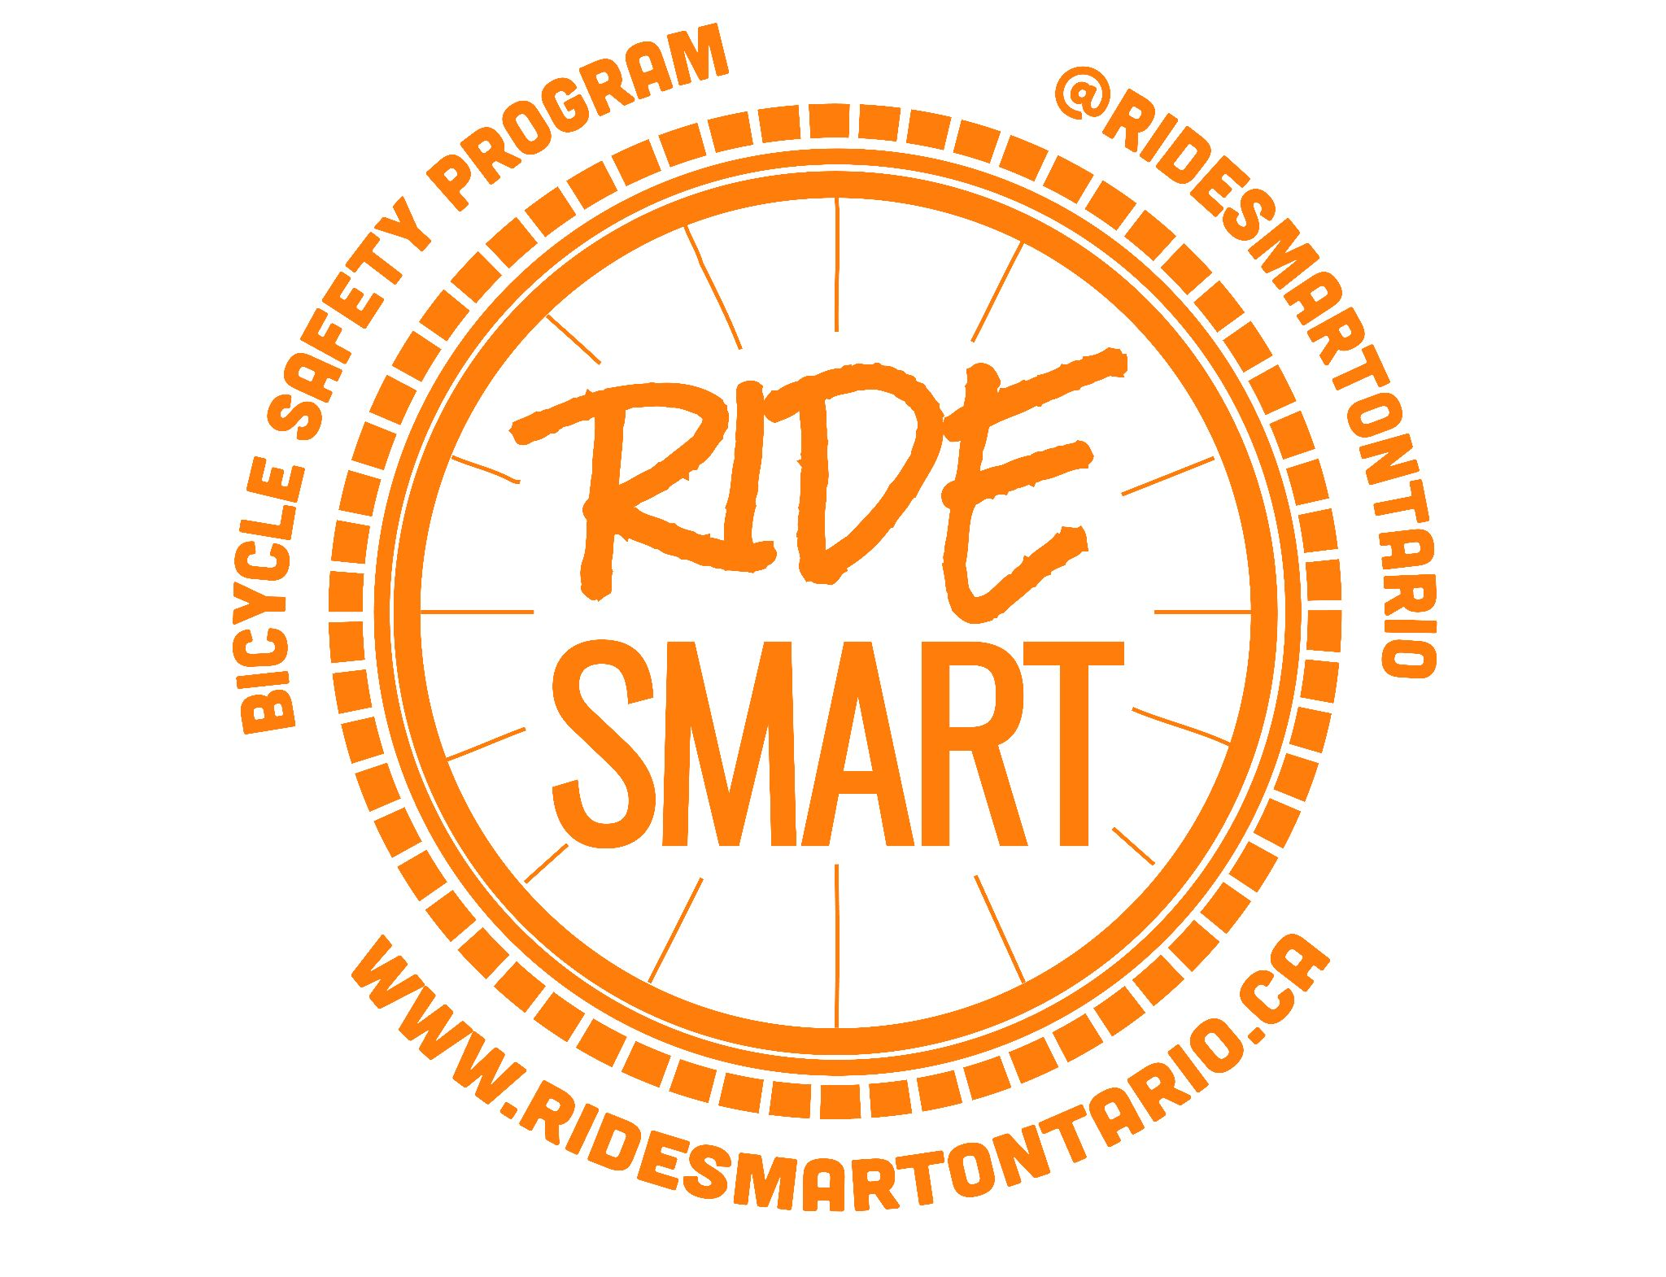
Dear Parents/Guardians,

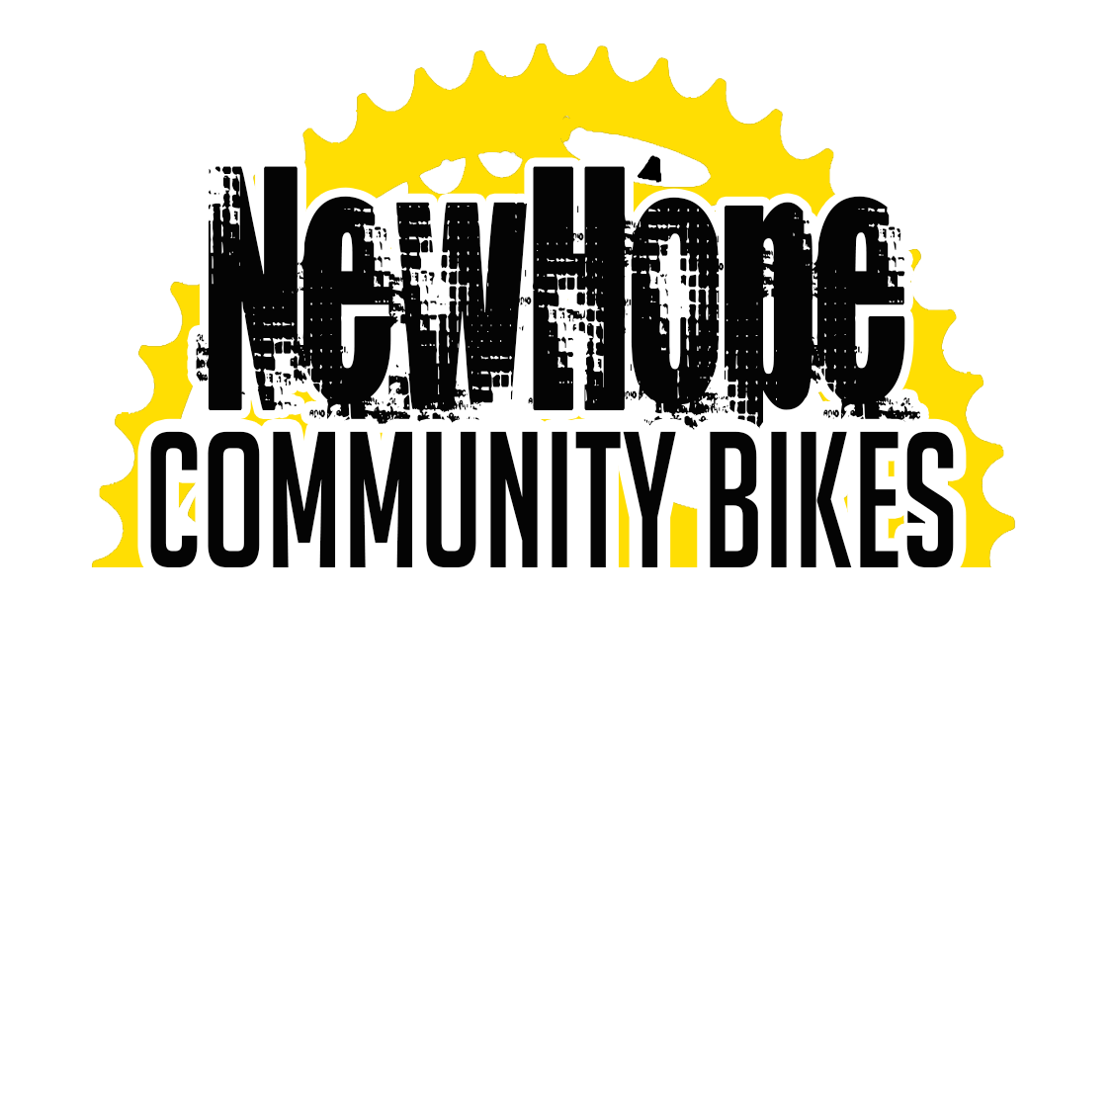
As an extension of your child’s physical education program, the Ride Smart bicycle safety program will be taking place at _______________________on _______________________________. Ride Smart is an education program designed to develop practical lifelong skills through safe cycling that is coming to your school! Ride Smart is a series of lessons aimed at providing children with the necessary knowledge and skills for safe, responsible biking and promoting physical activity. Ride Smart lesson plans incorporate some classroom activities as well as active participation in lessons using bicycles. The program is designed to be safe, fun and encouraging for all students from beginner to advanced. Full details about the program and a video preview can be found at www.newhopecommunitybikes.com/ride-smart.html.

If your child has a bicycle helmet we ask that he or she bring it to school on the days of the program.

If your child does not have a bicycle or a helmet, he or she will still be able to participate in the program with helmets we provide. Bikes will also be provided for the program. Students will use program bikes for their class time as it ensures all bikes are in proper working order and reduces time needed to get bikes from storage. We will also provide FREE after school tune-ups for the whole family on _________________________ so bring your bikes to the school between 3:00 and 4:30pm.

Program Benefits
- All equipment provided including brand new bikes for use throughout the program.
- Bring your bike for FREE after school repairs for the whole family.
- Learn life long skills for safe cycling.
- Ride our fun skill building pump track features - rollers, teeter-totters and weaving bike pathways
- Help make your school a leader in cycling to school!

This permission form must be fully completed to allow your child to participate in the program. Please return it by _______________________________________.

If you have any questions or concerns about the program please do not hesitate to contact New Hope Community Bikes directly.
I, ___________________________, am the parent/guardian having full legal responsibility for decisions regarding my minor child/ward ________________________. (Full name) I give permission for their participation in the Ride Smart cycle safety program as outlined above.
Signature: __________________________ Date: ______________

