Kinder News – Room 145
Volume 1, Issue 4 January 2013
Remember to keep practicing putting on and doing up jackets and other outdoor clothes (snowpants, hats, scarves, mittens) to help your child further develop independence at school. Please label your child’s belongings to help us out and send a pair of indoor shoes if your child wears boots to school.

Also please send an extra pair of clothes in your child’s backpack incase accidents happen.

Don’t forget to complete and hand in your homework each week. It is a great way to introduce our letter of the week!!

Remember to return your child’s library book each week so that they can check out a new book.

Please remember to visit our blog often to see what we are doing in the classroom. You can subscribe with your email address and be updated when new blogs are posted. Come check us out at: http://kinderkorner.commons.hwdsb.on.ca/
A look back at December
In Language we reviewed the letters E, F and G. Our favourite was the drawings of the kid’s family!! It was so nice to see the family’s names on the pictures too!
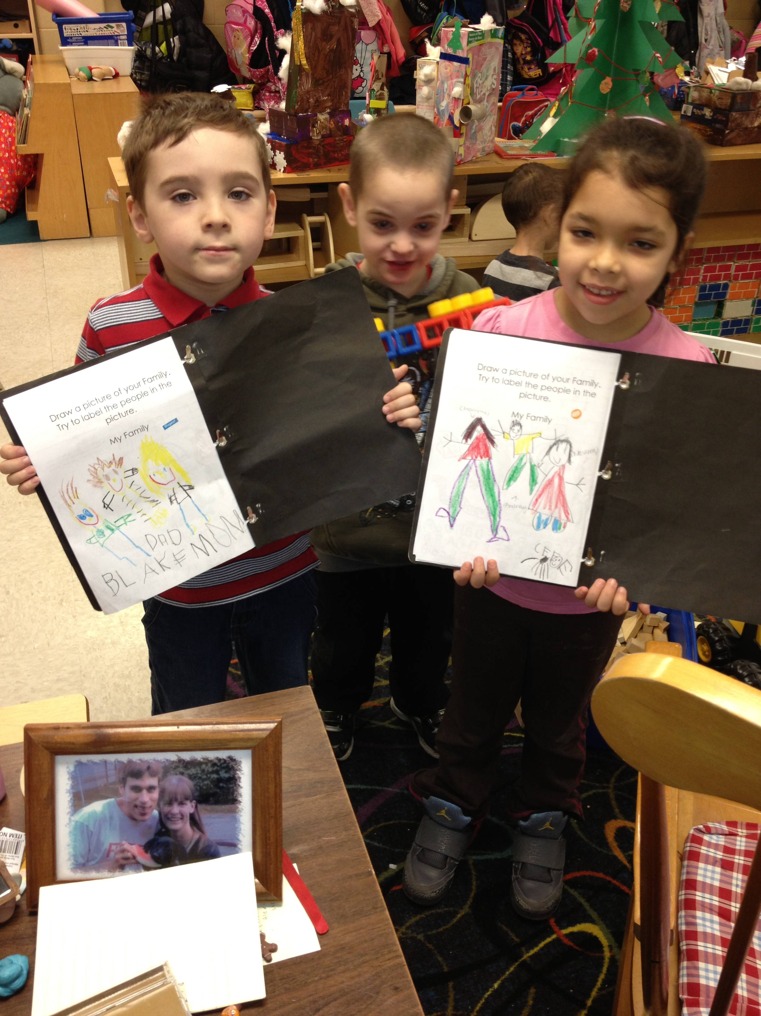
Our focus on the fairytale “The Gingerbread Man” was a hit!! We compared different versions of the story finding many similarities and differences in each. Thank you for the donations of the beautiful junk!! The children loved building gingerbread houses and ice castles with them. On Joy Day the children even got to decorate their own gingerbread cookie. Yummy!!

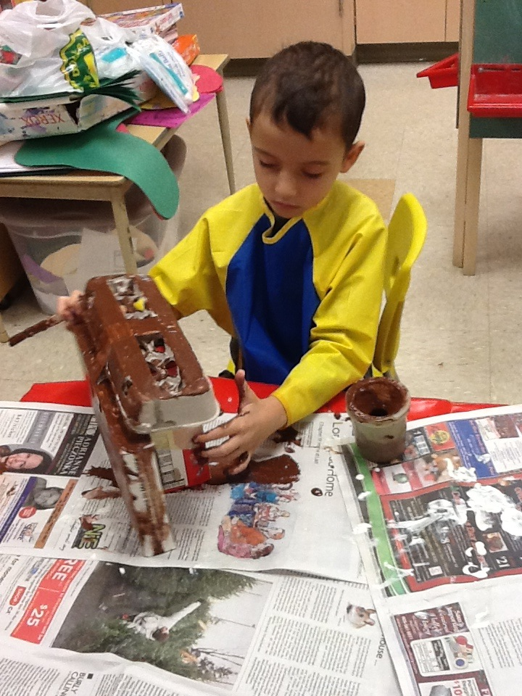

In Math we enjoyed making graphs!! The students collected information, placed objects onto graphs, coloured in graphs based on information gathered and interpreted the information from the graph.
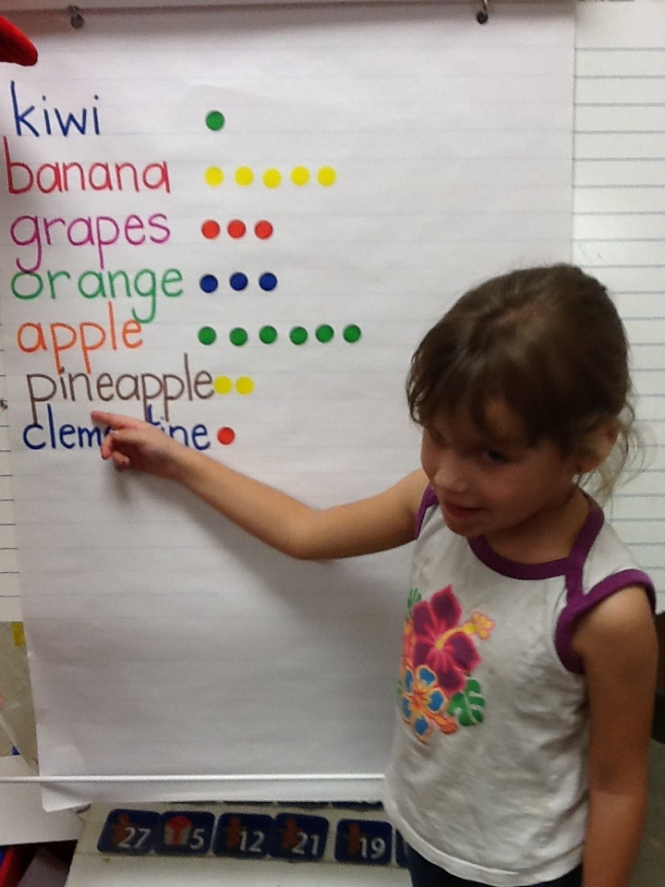

Pajama Day and our annual Turkey Lunch were so much fun!! The best was the visit from Santa!!

Dates to remember in january

Monday, January 7th is the first day back after the holiday break.
Friday, January 25th is a P.A. Day. No School.
Please remember that pizza days and sub
days are cancelled until further notice.
The school store is also closed.

JANUARY NEWS

JK Parent Observations
The JK parents will be invited to come into the class for an hour at the end of the day to observe what is going on in our Full Day Kindergarten program. Look for invitations coming home early in January with your scheduled observation visit.
We look forward to seeing you!!

Language
In January we will continue our “Letter of the Week”, focusing on the letters H, I, J and K. Don’t forget to check the homework for the letter of the week show and tell that happens each Monday. The class has done a great job of incorporating the letter of the week into their play, creating things at the art table, writing centre and building centre.

To help us with our reading and writing skills we are beginning our word family focus. We will begin with the “at” family (bat, cat, sat, etc). We will learn that by changing the beginning letter/sound to a “family”, we can create a list of rhyming words.

We will also be focusing on the fairy tale “The Three Little Pigs”. We will reinforce learning about 3D figures by building the three pig’s houses in the block centre as well as retelling the story through acting it out and various smartboard activities.

Math
We will continue to review graphing as well as start our focus on 3 dimensional shapes (cylinder, cone, cube, sphere). We will learn how to identify, compare and describe these 3-D shapes in the classroom and in the real world around us. If you have 3D beautiful junk (boxes, paper towel/toilet paper rolls, etc.) we would love to have them!! At home point out different 3D figures as well as the 2D shapes found in them (e.g. a cube has 6 square sides).

Dramatic Play Centre
The children have decided to turn our dramatic play centre into a pet store in January. If you find any pet flyers around the house we would love to have them. The children will take on the various roles of cashier, customers, vetrinarian, and the pets too!!!

Science
We will introduce and learn about the changes that happen in Winter through investigations. Hopefully we will get some snow to do some fun and exciting hands on experiments. We will focus on the scientific process of making predictions, conducting the experiment and making observations of what happened.

Mrs. James, Mrs. Dubeau and Miss. P.

