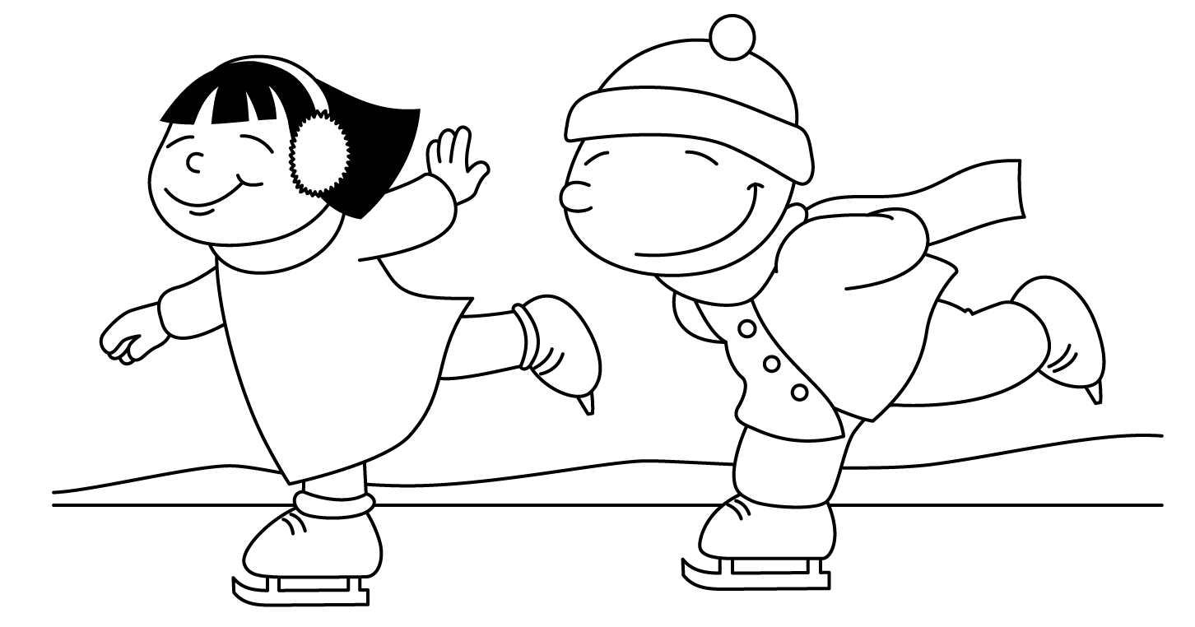

MONTH of JANUARY
Sunday | Monday | Tuesday | Wednesday | Thursday | Friday | Saturday
30 | 31  Junior Kindergarten parent observations are this month.  Watch for invitations coming home at the beginning of the month.  Report Cards will be going home in February for all kindergartens. | 1 | 2 | 3 | 4 | 5
6 | 7  Gym and Library  Show and Tell  Letter H | 8  Gym  Show and Tell  (Robbie and Bella) | 9  Gym and Library  Show and Tell  (Sierra C.) | 10  Social Skills  Show and Tell  (Zelly and Timothy) | 11  Gym  Show and Tell  (Edi) | 12
13 | 14  Gym and Library  Show and Tell  Letter I | 15  Gym  Show and Tell  (Eli and Yahya) | 16  Gym and Library  Show and Tell  (Mackie) | 17  Social Skills  Show and Tell  (Nazif and Arwynne) | 18  Gym  Show and Tell  (Zachary and Noah) | 19
20 | 21  Gym and Library  Show and Tell  Letter J | 22  Gym  Show and Tell  (Skylar and Fatima) | 23  Gym and Library  Show and Tell  (Omar) | 24  Social Skills  Show and Tell  (Jack and Braydon) | 25  P.A. DAY  NO  SCHOOL | 26
27 | 28 JK Parent Obs.  Gym  Show and Tell  Letter K | 29  Gym and Library  Show and Tell  (Eliza and Cornel) | 30 JK Parent Obs.  Gym  Show and Tell  (Alphonsa) | 31 JK Parent Obs.  Gym and Library  Show and Tell  (Adam and Blake) | 1  Social Skills  Show and Tell  (Valeza and Nevaeh) | 2 Groundhog Day

