February Newsletter
Kinder News 2026

Dear Parent(s);
February is a very busy month in our classroom. We will continue our work on our Writer’s Workshop Journals, Groundhogs Day, winter, Lunar New Year, and celebrate Valentine’s Day.

Upcoming Events:

Sub Day: Online sub orders begin on February 1st and are due NO LATER THAN Thursday, February 5th. Sub Day is Tuesday, February 17th.

Lollipop/Valentine Candy Grams on Sale: Lollipops were available to order ONLINE at the end of January 25-30th! Please make sure that you send in your child’s list of people s/he would like to send their candy grams to ASAP! Lollipops will be handed out the week of Valentine’s Day.

Valentine Dance: Cash online opens February 2-6. The dance will be on Friday, February 13. Students who do not pay will go outside during that time.

Kindergarten Registration for September 2026 Begins: February 2, 2026, parents who have a new JK child who will be attending kindergarten in September are asked to register their child. If you know of someone (a friend or neighbour who has a child turning 4 before the end of December 2026) they are asked to register as soon as possible. This helps with our organization of classes for next School year. If your child is already attending school, you DO NOT need to do anything for next fall, s/he is already included in our planning for the upcoming year.



Valentine’s Day Party: Friday, Feb. 13th. Dress in White/ Pink / Red. We will have a Valentine’s exchange first thing in the morning. Please have your child ONLY SIGN THEIR OWN NAME on 30 Valentine’s, so that each child receives cards. If you are also giving a treat with your cards, please secure them onto the valentines at home. Please put all 30 Valentine’s in a SEPARATE labelled Ziploc bag and send to school inside their Mailbag. This will save us time.

For our party, we will be having our Party in a Bag. Please make sure all food does not contain nuts/tree nuts(traces of nuts) or gelatine.

100th Day of School: Tuesday, February 10th , we will be celebrating the 100th day of school. Stay tuned for more info on the Week at a Glance.

Report Cards: Please check your child’s mailbag on Friday, February 13th, as we will be sending home your child’s first term report card. Please sign pg 3 and return it with the report envelope. You are to keep the rest of the report card.

Family Day is Mon. Feb. 16th: in Ontario, Alberta, Saskatchewan, South Africa & Australia:
Family Day is a statutory holiday that takes place on the third Monday of February. Plan something fun as a family and spend quality time with those you love. Let your child give input or even choose the activity.

Pink Shirt Day: We will discussing bullying awareness and standing together against this on Wednesday, February, 25 by having EVERYONE wear a pink shirt!



Needed:

**EMPTY KLEENEX BOXES for our special craft**
Decorations for our Valentine’s boxes + Craft Centre
Items for our BucketFiller Prize Box
Peel & stick hearts,
Writing paper & envelopes for our writing centre, stickers for stamps

Outside Play:
Every day we will be outside for at least thirty minutes. Please be certain your child has labelled velcro indoor shoes to keep at school for the winter, Labelled hat, mittens, coat, warm winter boots and snow pants. Snow pants must be sent everyday please! Winter is not over until Spring. All students need to go outside during this time as there is no one inside who can supervise. If you would like to keep your child indoors, you will need to keep them at home.

Healthy Lunch Ideas for the Early Learner:
*yogurt, tubes, pudding, cheese (cubed), jell-o, apple sauce, cottage cheese
*turkey kielbasa (not too strong tasting) cut into small slices with rice crackers & cucumber slices
*tuna sandwiches or try veal bologna cut into 4 small pieces
*apples (small), grapes, raspberries, blueberries, strawberries, melon (cut small)
*carrots, cucumbers & celery with a side dipping container of Ranch Dressing
*raisins, dried fruit, Fruit To Go’s are always popular
*thermos of hot chocolate and mini marshmallows packed separately
*thermos of vegetable soup or chicken noodle soup with Ritz Crackers or Fishy Crackers

March Break: Starts March 14th and goes to Sunday, March 22nd, 2026.

Writer’s Workshop Journals
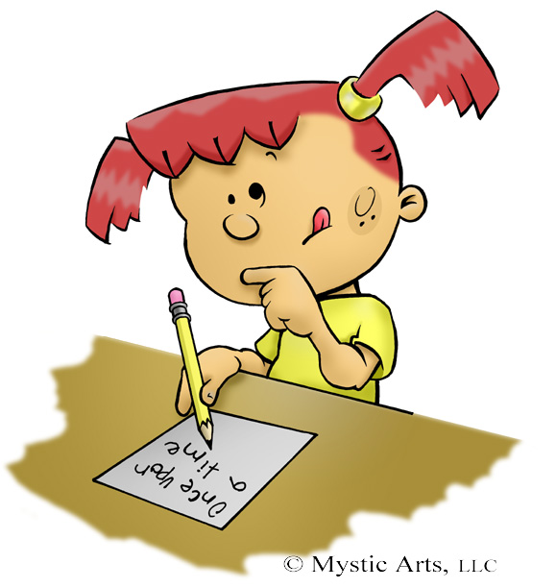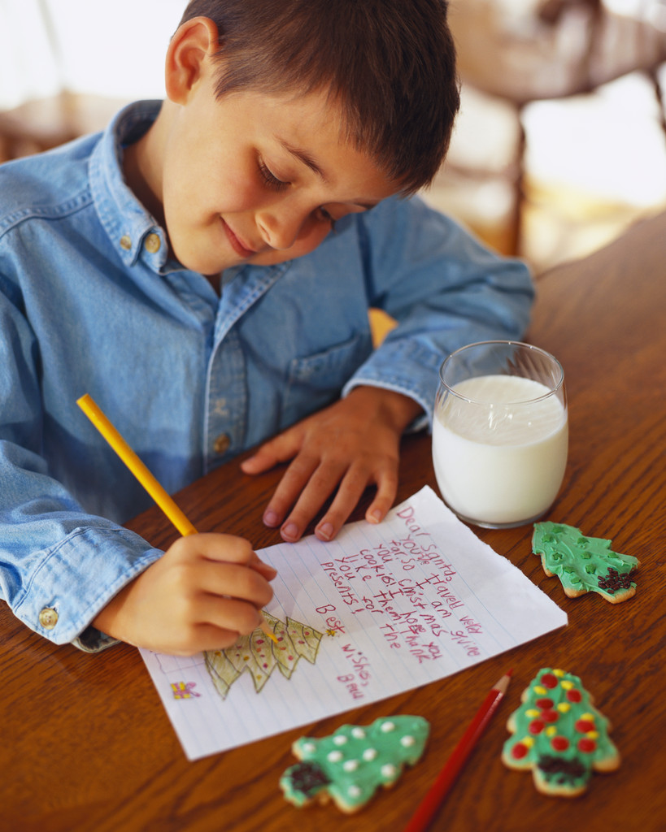

The Senior Kindergarten students have been “writing machines” in kindergarten, both in our play and in our daily journals. Our goal is that children feel confident to try and write by sounding out letters, words and drawing a meaningful picture. We have also been encouraging the children to utilize materials around the room such as our Popcorn Words, the word walls and labels around the classroom. We have been practicing proper pencil grip, good posture and sharing our ideas with our “elbow partners” before writing. The children’s illustrations have also really evolved since the start of the year, such as being more detailed and colourful and often tell the story without words. Well done everyone! The Junior Kindergartens have just started their very own writing journals! They are very excited to have a journal like the SKs!!!
Listed below are the drawing/writing stages.

Drawing/Picture Writing
In the drawing and picture writing stage, children begin to express their thoughts and feelings, the pictures are usually unrecognizable.
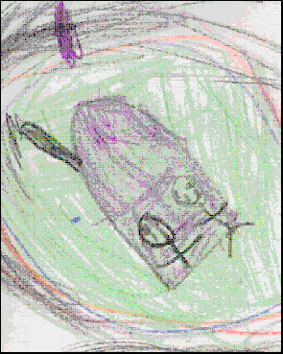

Scribbling
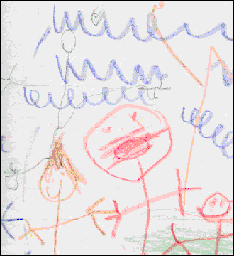
At this stage, the child begins to draw somewhat recognizable shapes and may tell about the picture. The child may try to imitate writing, as well.

Random Letters
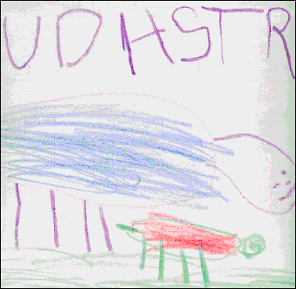
The child begins to print his or her own name and may put strings of letter with his/her picture. They may attempt to read the message, but it is probably still unrecognizable
Semi-phonetic (Early Spelling)
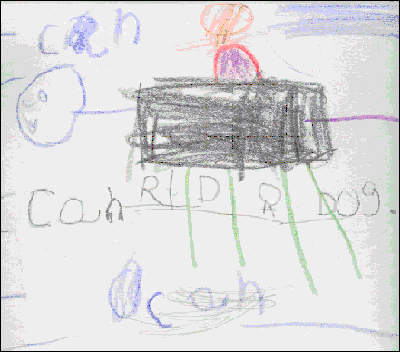

The child begins to use some letters to match sounds, often using a beginning letter to represent the whole word. They may begin to use left to right progression, but letter reversals are still common.
Phonetic
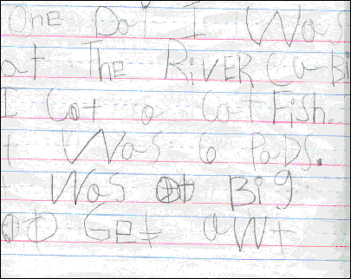
At this stage, children begin to write words with beginning and ending sounds. They also begin to spell some high frequency words correctly. Vowels may be inserted into words, but usually aren’t the right ones.
Transitional Spelling
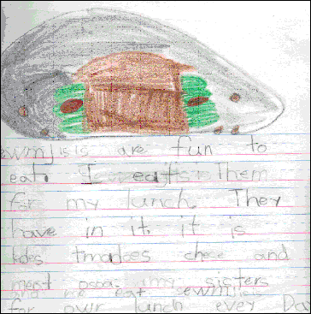
At this stage, children are writing words the way they sound. They are beginning to leave spaces between words and spell many high frequency words correctly. They use punctuation marks, sometimes correctly. They begin to write one or more sentences.
Conventional Spelling
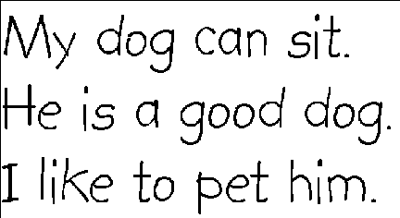
At this level children spell most words correctly, though phonetic based spelling still comes into play when they must spell longer words. They begin to use punctuation marks correctly and use capital and lower case letters in the correct places.

Hope you and your family have a great February!!!

The Kinder Team

