October Newsletter
Kinder News
2025

Dear Parent(s);
September was a busy month of remembering school routines & rules, making new friends, and saying goodbye to moms and dads again. We have started learning small sight vocabulary and weekly songs on our Projector Board. We have been practicing identifying our first names (SKs are practicing printing their first and last name) and writing them on our name cards, so please spend a few minutes every day encouraging your child to print his/her name using a capital letter at the beginning and the rest in lower case letters. If your child has mastered his/her first name, encourage them to spell their last name. The expectation for our senior kindergarteners (Y2) is that your child can already identify most of the letters of the alphabet, can verbalize the sounds that each letter makes, can identify many numbers to 30 (or beyond), can sing the Popcorn Song independently and can identify approx. half of the popcorn words or more (randomly). For our new junior kindergarteners (Y1), we are beginning to work on those skills.
NOTE: We did notice that some of our students from last year have dropped a bit in their scores. We have almost completed our testing for our Senior Kindergarten students for the upcoming Communication of Learning Story-Initial Observation Report (November). Once completed, please watch for their their next steps assessment package to be sent home so you can begin to practice and review the specific skills identified for your child.

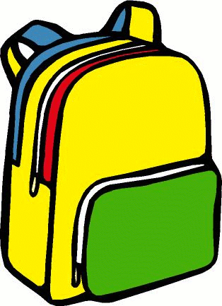
Thank-you to all of the parents that have been sending their child with a large backpack everyday and a water bottle.
We will be discussing and observing the changes in the season of Autumn and the pumpkin growth cycle.

We will also be counting down to Halloween. We are really looking forward to seeing all the costumes that the children are already telling us about.

Personal Items
Please label anything and everything. We have a difficult time finding the owners of items especially at the beginning of the year. Feel free to check our lost and found if you are missing something or send us a quick note/email and we will try our best to locate it.

Birthdays this month: Amaira October 4th

Halloween Party
We will be having our Halloween Party on Friday, October 31st. It is a very exciting time for children, so the “Party” is more of a laid-back affair. Please have your child wear his/her costume to school. Please do not send any masks, weapons or fragile costume pieces. Please include a change of clothes that day, in case your child would like to change. If your child does not want to wear a costume, they may want to wear the colours black & orange. More info will be posted closer to the time.

Halloween Dance
Kinders will be attending the Halloween dance on this day. Please pay $3.00 online. This includes 2 glow sticks.

Halloween Parade
We will also be having a Halloween parade so please make sure that your child arrives on time as we will be starting fairly quickly after arrival and attendance. More info to follow.

Nutritional Break Snacks
We would like to promote good nutrition for our class snack time, therefore please keep the candy at home for the weeks following Halloween.


Scholastic Book Orders
Thanks to so many of our families for supporting our classroom by buying high interest, teacher chosen books from various catalogues in September. We usually buy each child a book for Christmas, so the items ordered help off-set the cost and make literacy inclusive to all the children. If you are starting to think about Christmas shopping for children in your family, be sure to put books at the top of the list. All ordering is now online and ships directly to the school so there is No shipping fee. Stay tuned for our new November flyer coming home soon.

Outside Play
Just a reminder that as the weather gets cooler, please remember to dress your child appropriately for playing outdoors (approx. 40 min.). Please have your child practice putting on his/her things INDEPENDENTLY! When purchasing boots, always choose VELCRO. Laced boots are not safe. We are already starting to develop a Lost & Found. Please label all items that come to school.

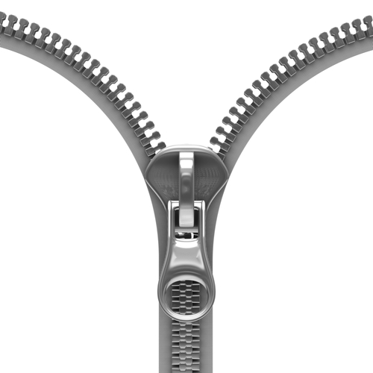
Zippers
Now is a great time to start practicing zippers with your child. We will be celebrating those students that can do up their zipper independently by putting them in the Zipper Club! More info to follow. Please make sure that whatever jacket you send your child in, your child is able to put it on and do it up independently (of course we will help them get it started). Please do not send in jackets that need to be buttoned unless your child is able to do this. Please picture doing this for every child…25 times. Thanks in advance!

Home Connection
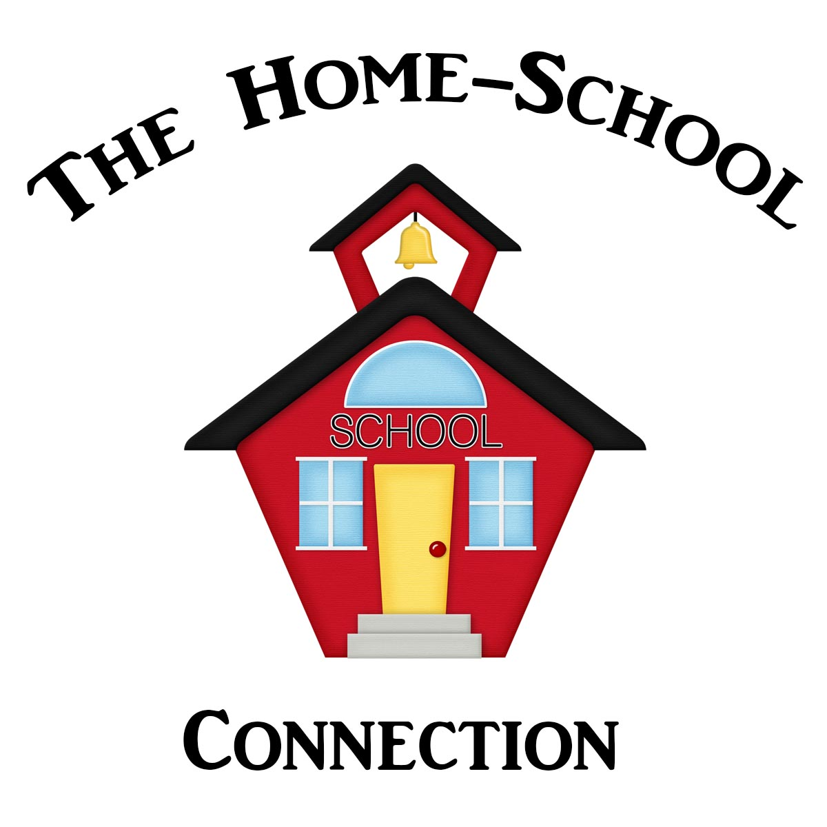
Now posted on our KINDER BLOG under the tab At Home Reading Poems: We will be posting our B.E.A.R. reading poems that we use with the students so you can print out and read with your child. Starting a collection of these familiar poems is a great way to boost your child’s reading skills and confidence. B.E.A.R. stands for: Be Excited About Reading. Please feel free to let your child personalize theses poems with stickers, underlining popcorn words or colouring some of the pictures. Let’s make reading fun and non-threatening.

Kindergarten Blog Website
Thank you for the great response and support with our kindergarten blog. This is a great way to stay informed with the frequent updates right to your email box. We find that having photos of what is happening in the classroom is a great way to encourage your child to communicate what is happening in school. It is typical and also difficult for early learners to retell events from school after a long day. As a parent, I understand that it can be disheartening to hear that one’s child can not remember what they did all day. Rest assured your child has been highly stimulated all day with well thought out programming.

D.R.A.
Reading assessments will be starting soon in our classroom for the senior kindergartens (Y2). This is a very helpful tool in helping us to determine what level of reading your child is at. We will let you know so you can visit different websites that have levelled readers for your child to practice. Soon we will be sending home our home reading books to practice. We have already noticed some wonderful growth in a lot of the children’s abilities since the Spring. Fabulous!

Needed
*rainbow fish crackers
*craft items for Halloween
*nature items (gourds, pumpkins, sunflowers, etc.)
*small items for our Bucketfilling Prize Box

The 5 Day Cycle
Tiffany Hills E.S. is on a 5 Day Cycle for receiving gym and library. As a result, the day in which your child receives one of these will change. For EASE and convenience, I am asking all parents to send a labelled pair of Velcro running shoes to leave at school (when it becomes boot season) so your child does not miss gym. Thanks for your assistance and understanding.

Toys at School
Please remind your child not to bring his/her toys to school. We have had some issues with toys either getting broken, lost or becoming a distraction.

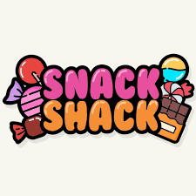
Upcoming Events:

Snack Shack
Please see flyer that was posted on the blog earlier. Friday, October 10th is the last day to order online.

World Teacher Day
Saturday, October 5th is World Teacher Day

Holiday
Just a reminder that there is NO SCHOOL on Monday, October 13th. Happy Thanksgiving to all of our families who celebrate!

No Aftercare
Just a reminder to those families who use aftercare for their child. There will be no after care on Friday, October 17th. Please make sure that you pick up your child after school

Sub Day
Please order your child’s sub online by October 9th. Sub Day
will be on Tuesday, October, 21st at 2nd break. Please remember to send food in for the first break.

Pizza Day
Pizza day starts on Wednesday, October 22nd for those who preordered online.

Class Picture Day
Thursday, October 30th is our class picture day. Please make sure your child is present so they can be part of our class photo.

PA Day: No school on Friday, October 24th.

We hope your Thanksgiving celebrations are great!
The Kinder Team

