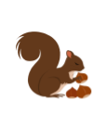
In November We Say


Good day to the squirrel,
Good day to the acorns,

Good day to the sky above.

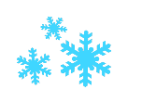
Good day to the poppy,
Good day to the frost,

Good day to the world we love.

