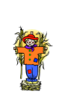
In October We Say

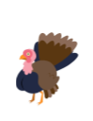
Good day to the scarecrow,
Good day to the turkey,
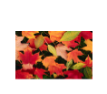
Good day to the brightly coloured leaves.
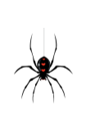
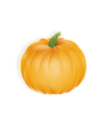
Good day to the spider,
Good day to the pumpkin,
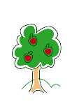
Good day to the apples in the trees.

