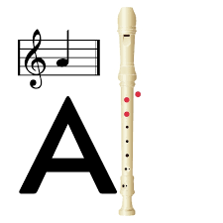
Level 1 –
White Belt
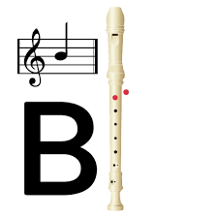
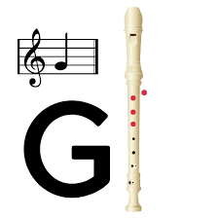

Yellow Belt
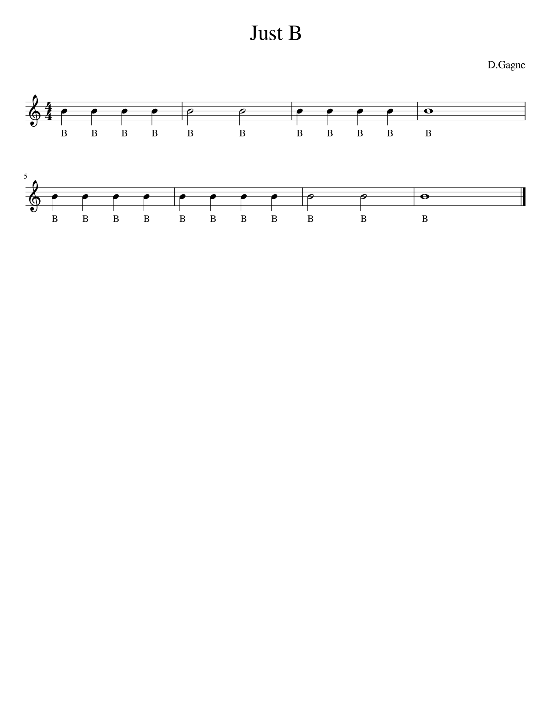
Level 1 -

Quarter notes Half notes Breath whole note

Don’t forget to practice at least 5-10 minutes at day! Always work on at least 2 or 3 songs at a time.

