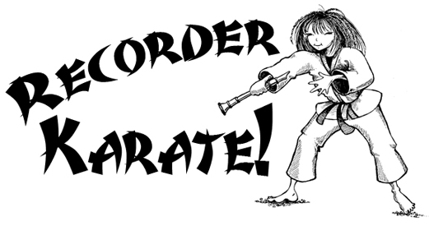
LEVEL 1 2024

White Belt – BAG
Yellow Belt – Just B
Orange Belt – Hot Cross Buns
Green Belt – Lucy Locket
Purple Belt- Mary Had A Little Lamb
Blue Belt – Jingle Bells
Red Belt – Old MacDonald
Brown Belt – Happy Birthday to You
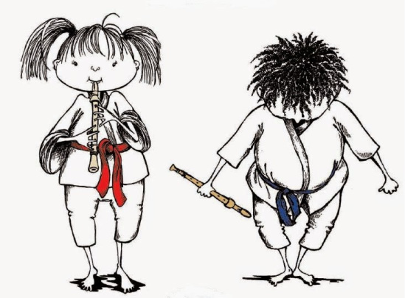
Black Belt – Ode to Joy


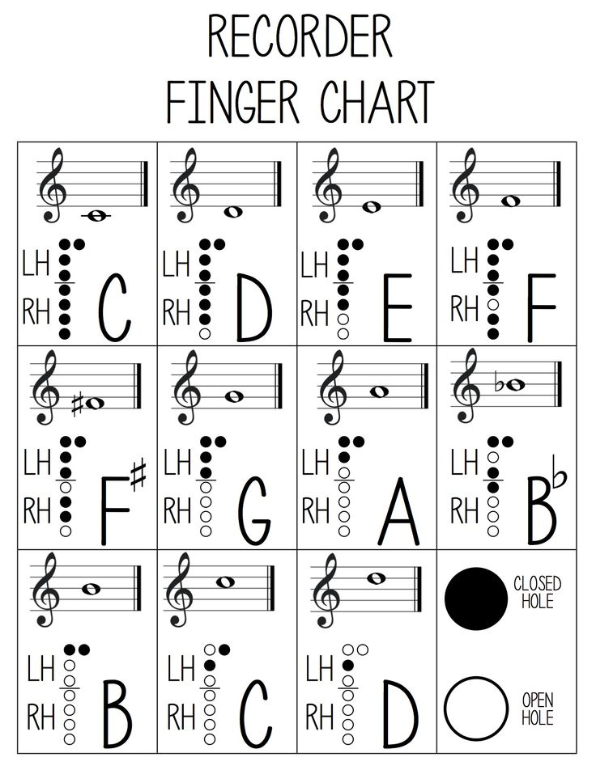

Recorder Checklist
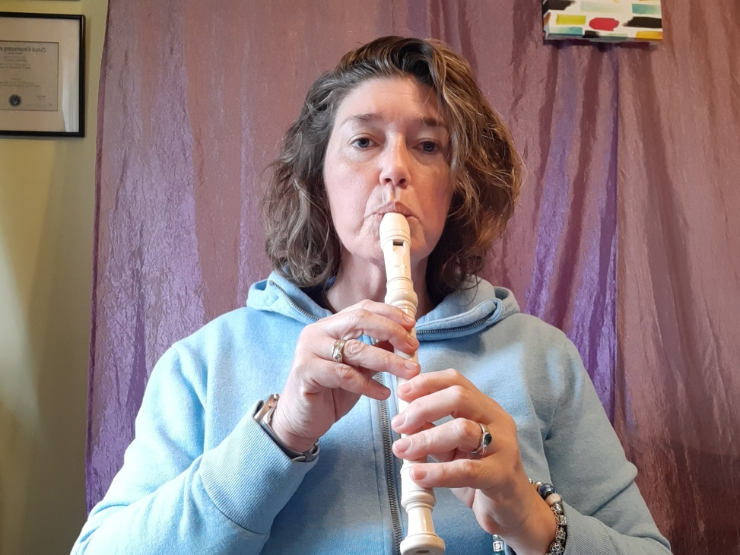

Left hand

- Is your left hand closest to the mouthpiece? (If you are having troubles remembering which is your left hand try wearing a bracelet or watch to remind you which hand is your left.) LEFT HAND ON TOP!
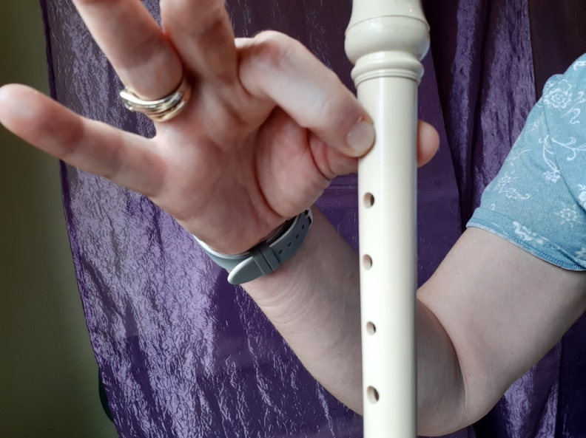

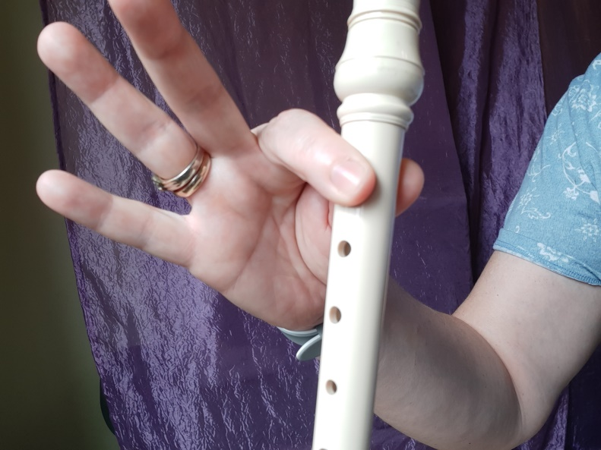
- Did you cover the holes with FAT, FLUFFY, FULL FINGER PADS, not the finger tips?


- Do you start every note with a soft whispered “Do”?
- Did you breathe gently into the Recorder? Don’t blow hard! This is a SMALL instrument you don’t need a BIG sound!

- Your Tongue must touch the end of the recorder inside your mouth.
What it feels like!
What it looks like!
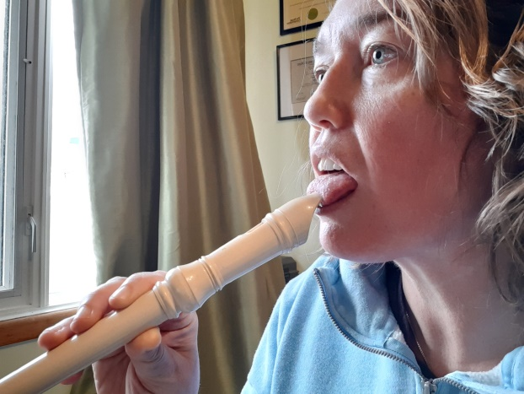
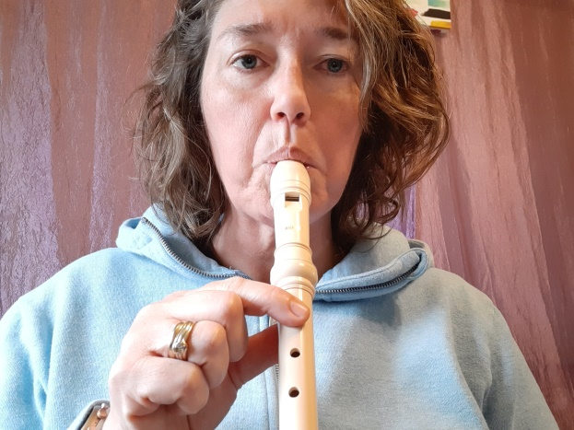

(This is very hard to show because I can’t show you the inside of my mouth. ☹ My tongue is touching the hole at the end of the recorder and is right where my top teeth meet the roof of my mouth.)
Place your Thumb and pointer Finger of you LEFT HAND at the top of the Recorder!
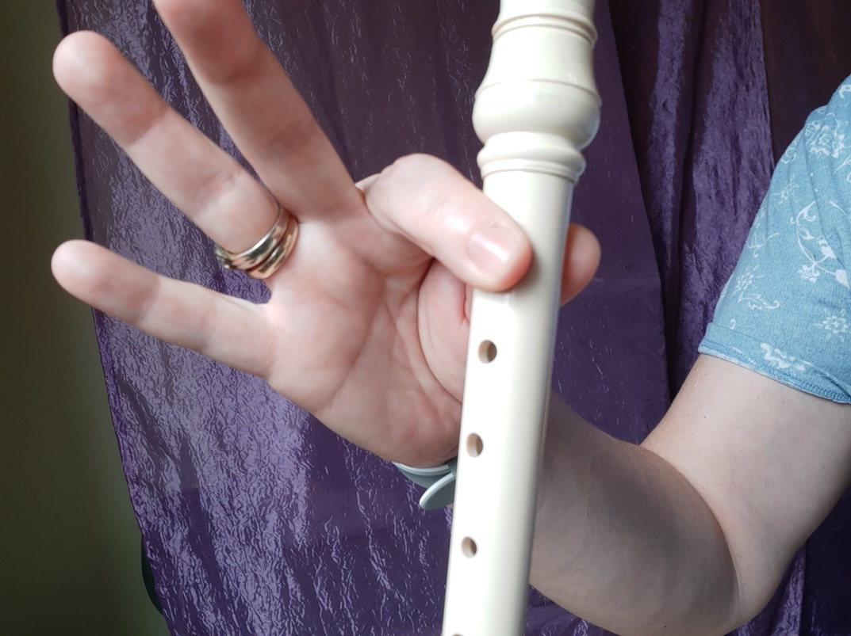

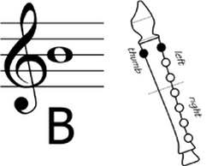
This is B the first note that you will learn

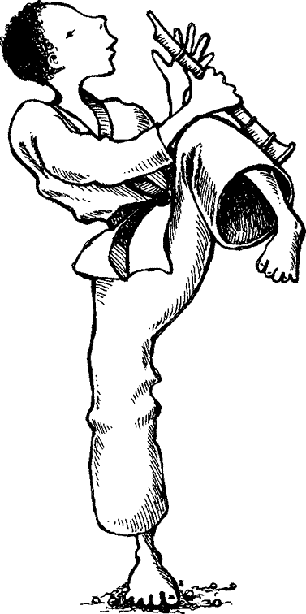
Recorder Rap
My recorder is ready- I’m just waiting to begin.
If I need a little practice, I will play it on my chin!
I’ll do a quick check that the left hand’s at the top.
Blow warm gentle air.
Keep it steady – don’t stop!
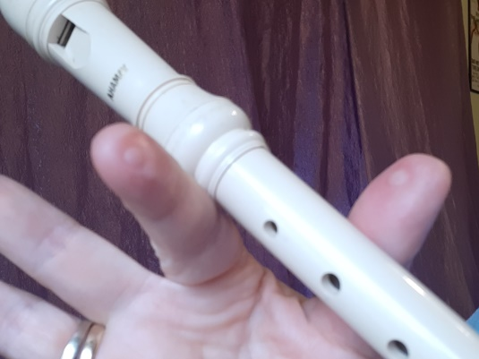
Use the pads of your fingers –
not the tips and you’ll see.
Some nice recorder warts if
you cover carefully.
Start each note with the tongue
– say do do do.
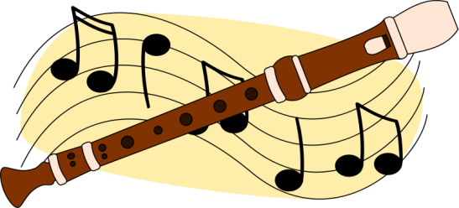
You’ll all be great recorder players when you are through.

White Belt

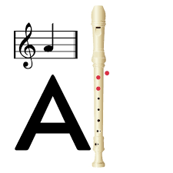
Level 1 –
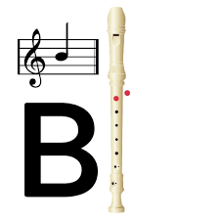
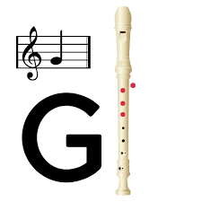

Yellow Belt
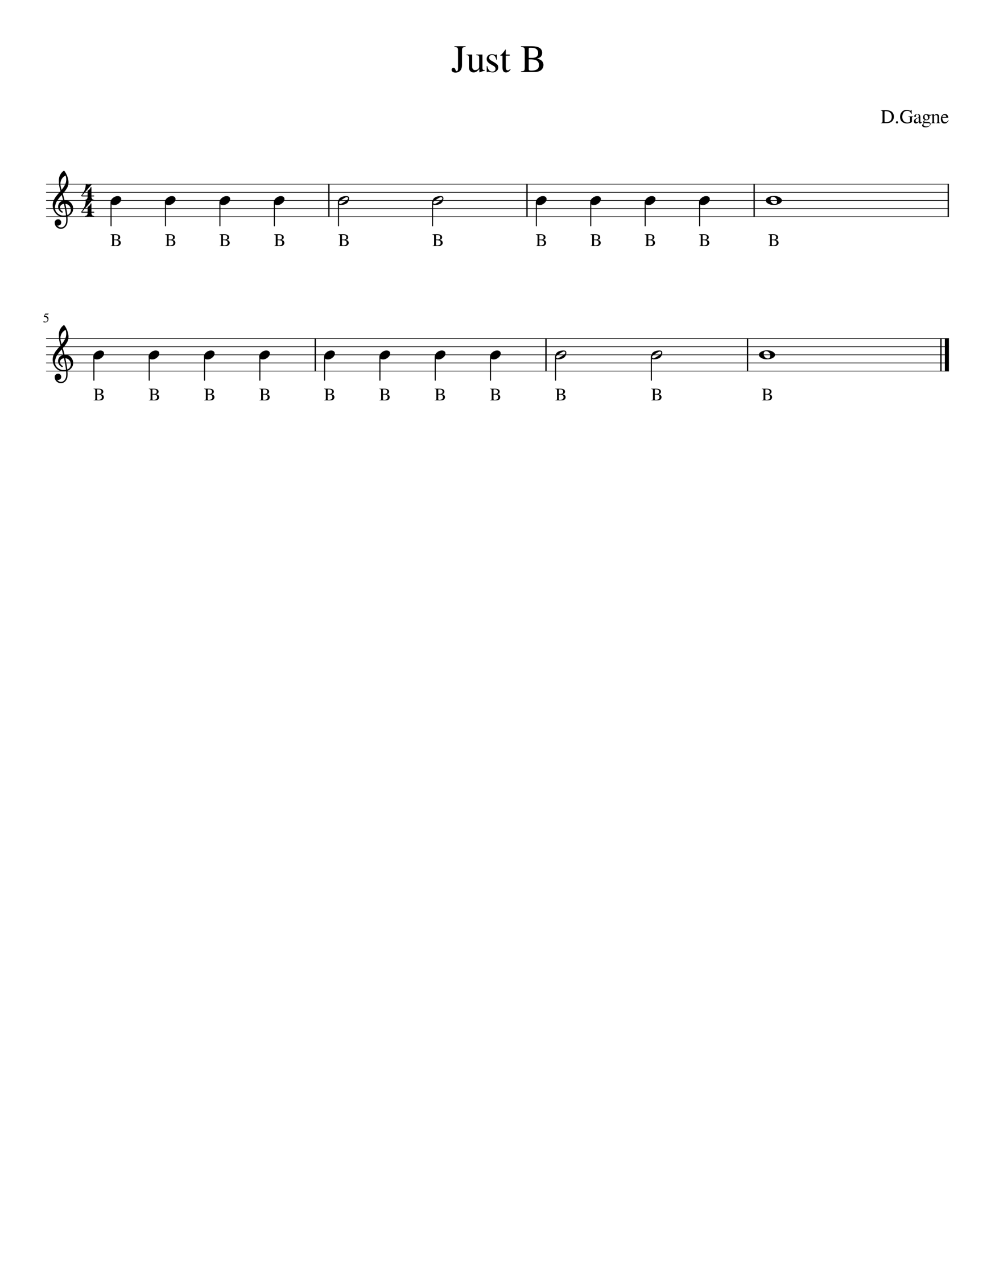
Level 1 -

Quarter notes Half notes Breath whole note

Don’t forget to practice at least 5-10 minutes at day! Always work on at least 2 or 3 songs at a time.

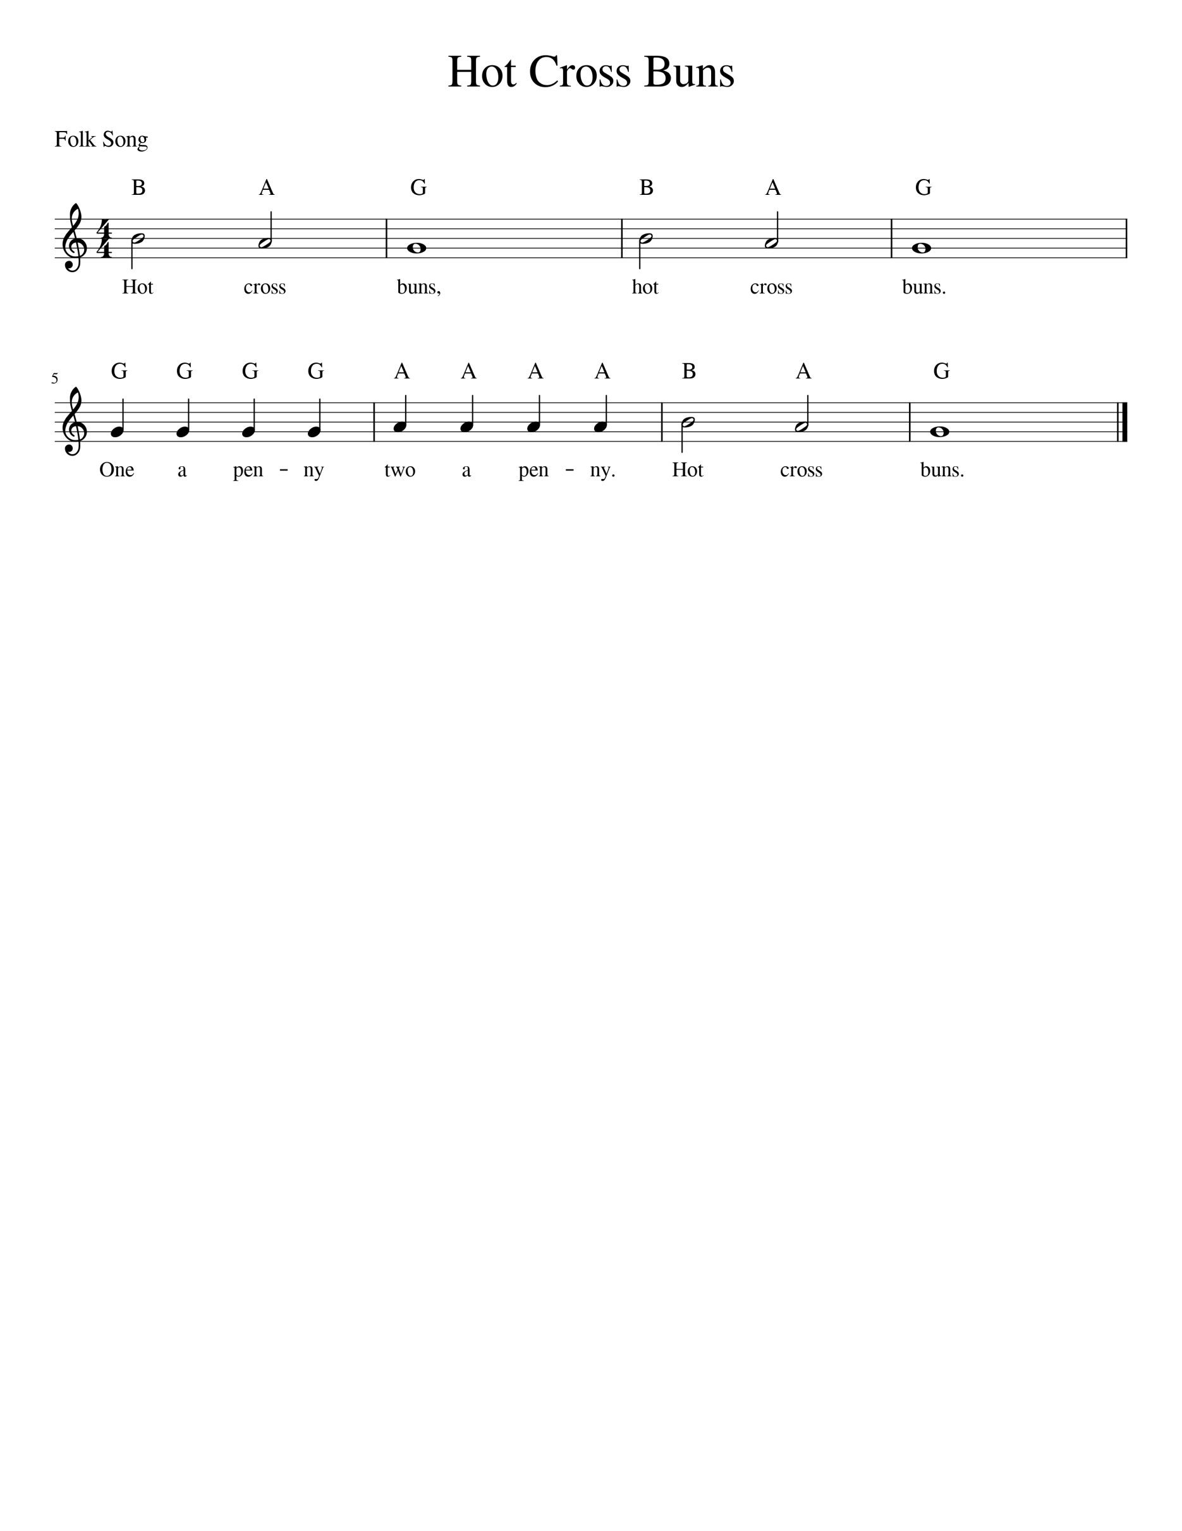
Level 1 –
Orange Belt

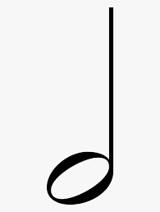

- Half Notes get 2 Beats –so the first 2 notes (B and A) are 2 beats each!

- Whole notes get 4 Beats – so the 3rd note (G) is worth 4 beats!
- Quarter Notes get 1 beat – So the 4 G’s and 4 A’s are worth 1 beat each. Make sure you only play 4 G’s and then 4 A’s.

Level 1 -
Green Belt
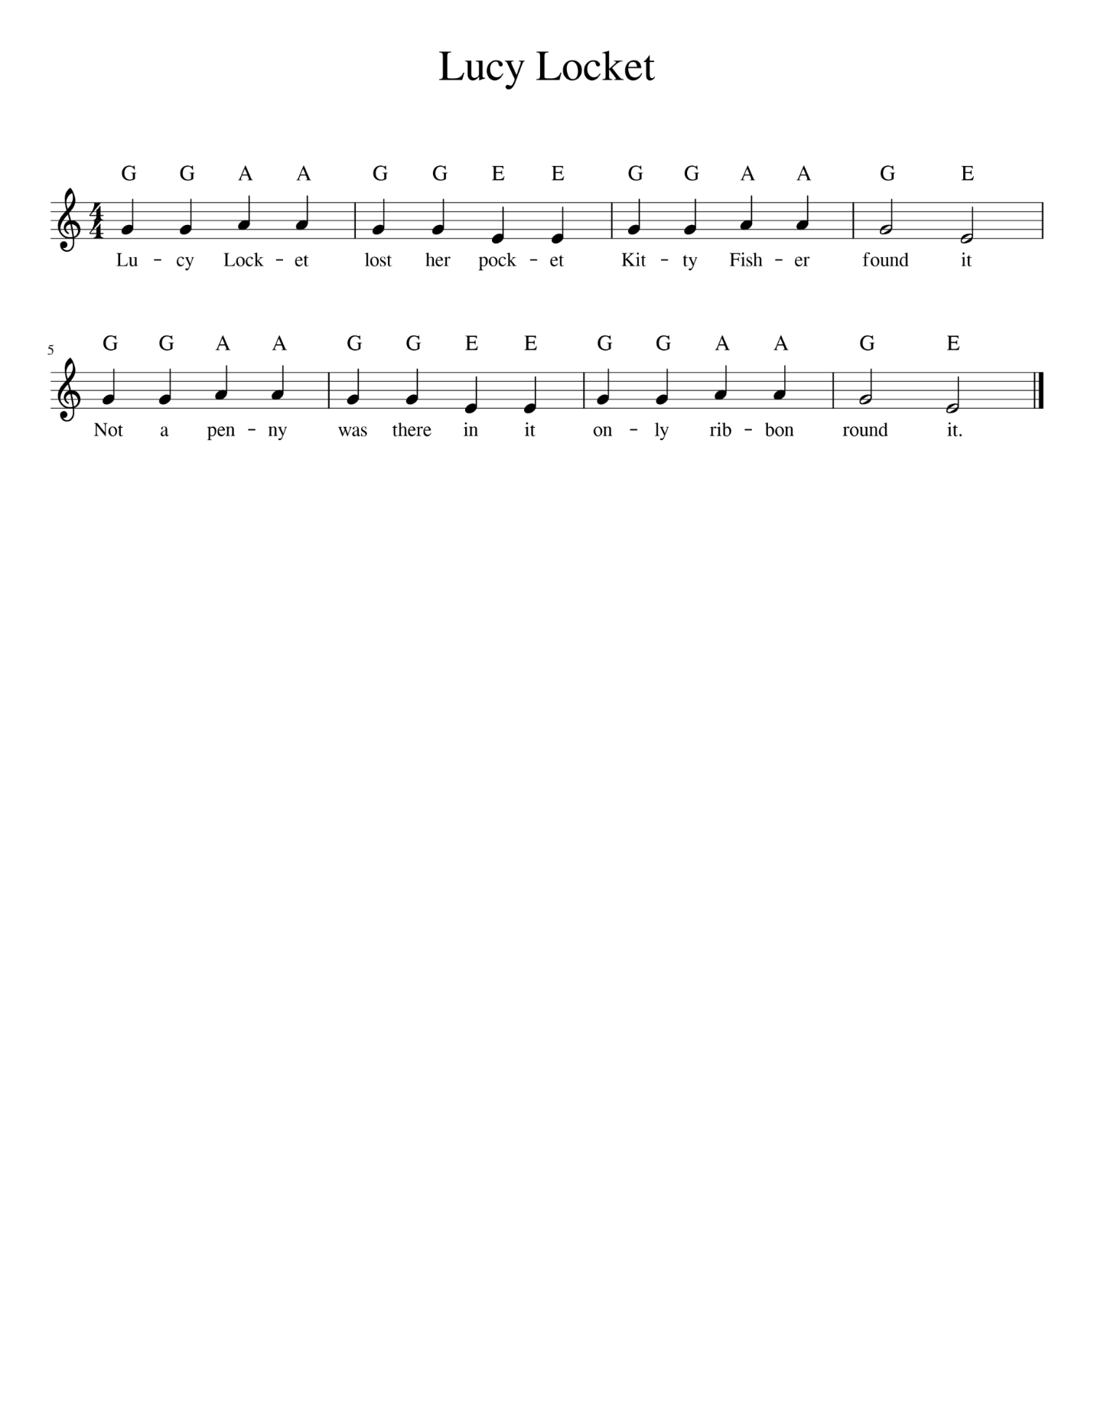

- The Time Signature – 4/4. This means there are 4 beats in a bar and a quarter note gets 1 beat.
- Watch out for our new note E! Make sure your right hand is ready to go! Get them ready before you start the song!
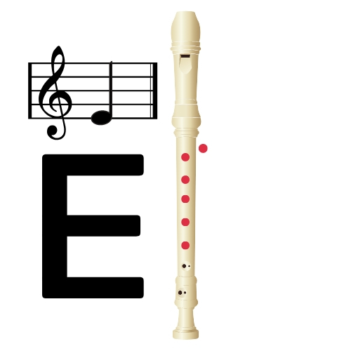
- Look at the top line – look at the bottom line! What do you notice???
- Remember to breathe after 2 bars!



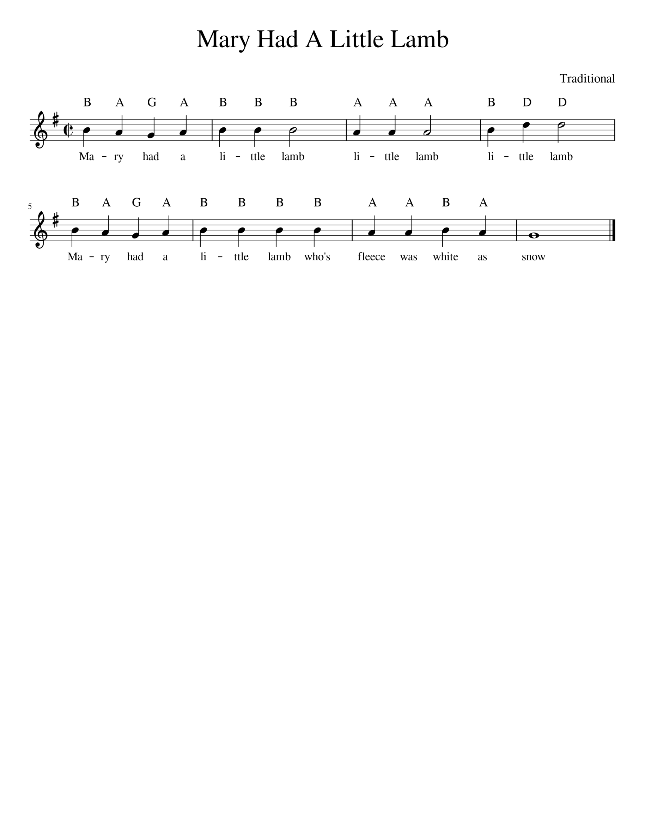
Level 1 -
Purple Belt

- Watch out for the high D note in the 4th bar.
- Practice playing B and then D to get the jump right.
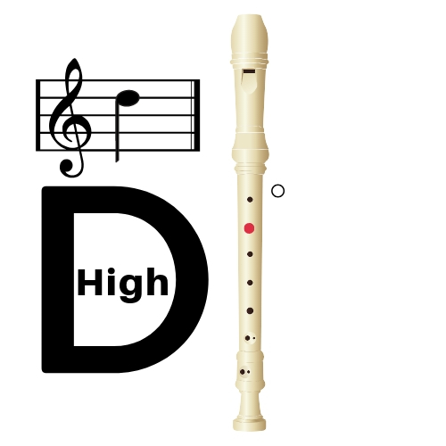
- Bars 1 and 2 repeat on bars 5 and 6!

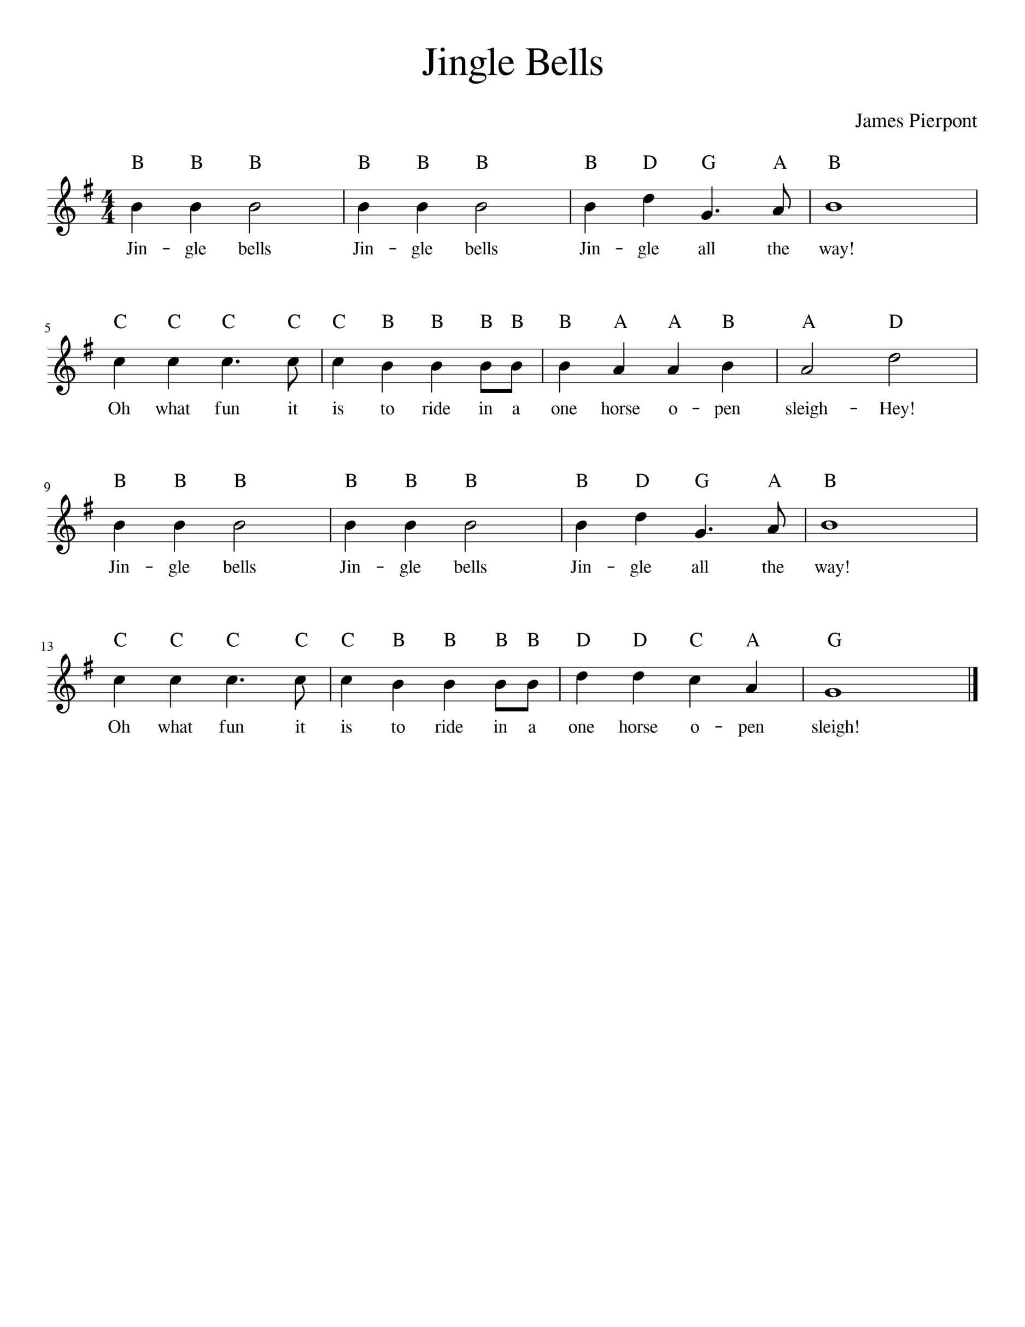
Level 1 -
Blue Belt

- Watch the 3rd bar of the first line- there are big jumps from the B-D-G. Also the G is a dotted- quarter note and you must hold it for 1.5 beats! The A is an eighth note and is short, only a half of a beat.
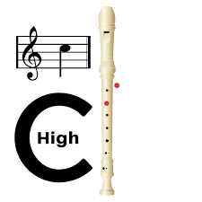
- The 2nd line has 5 C’s! Watch the 3rd C as it is a dotted quarter note. Look out for the Bs too. Notice that the 1st and 3rd lines are similar!
Level 1 –
Red Belt
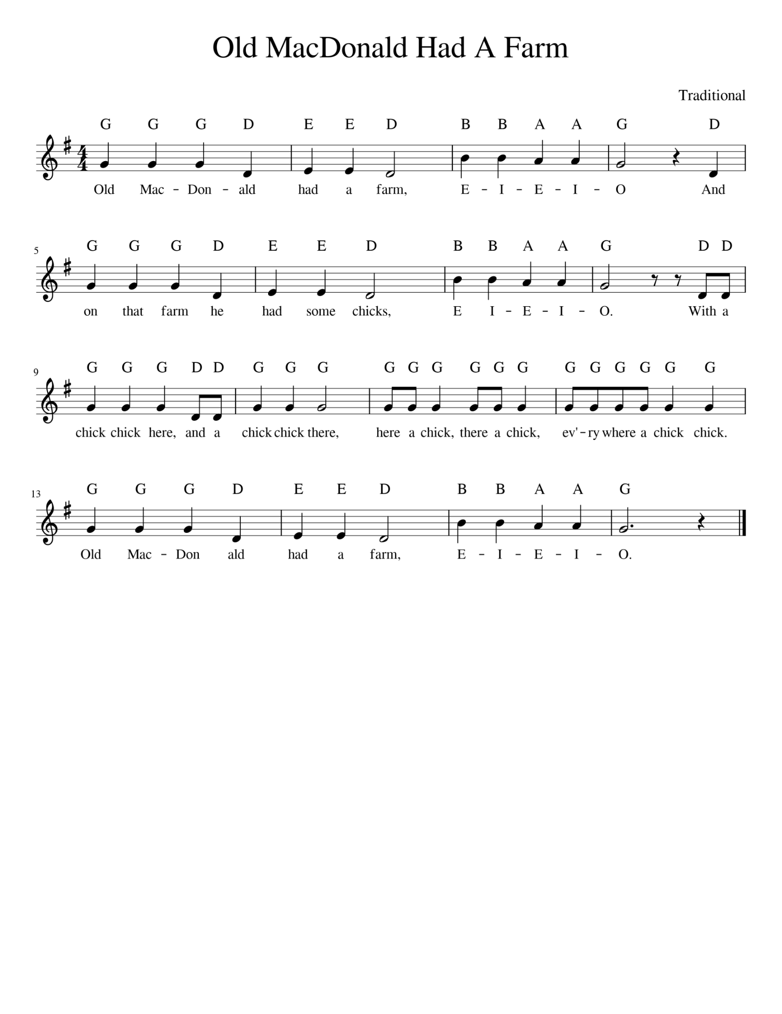

- Watch the low D in this piece. Practice playing low D and then go back and forth from low D to G.
- This song sounds just like the song when you sing it! Make sure your “here a chick, there a chick…” sounds like the song.
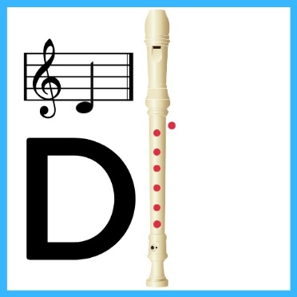

Level 1 -
Brown Belt
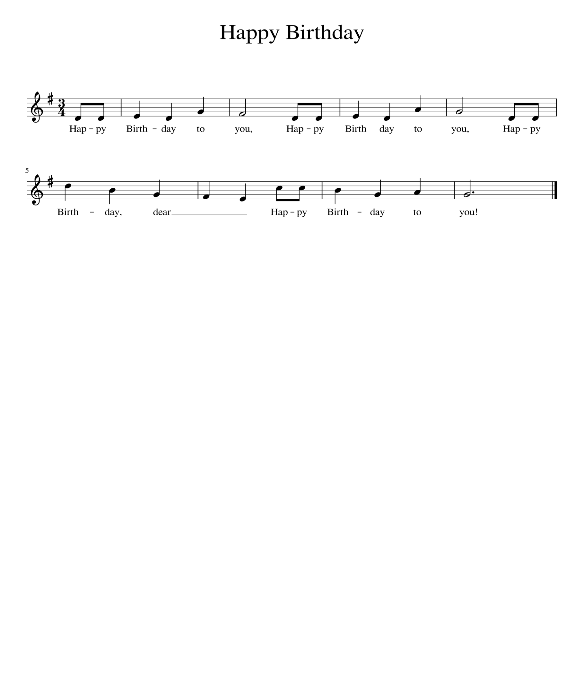

- Now it is your turn to write out all of the notes. Make sure to use your chart on the 2nd page if you are having problems!
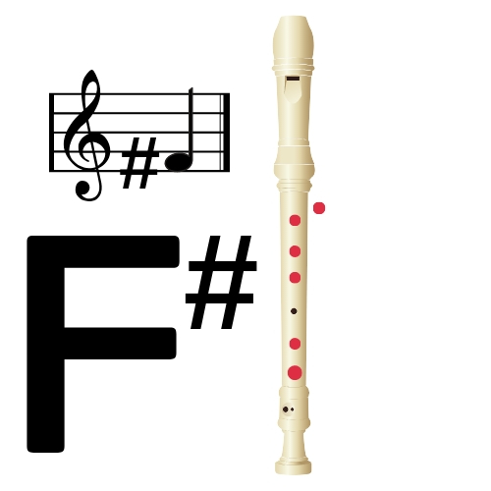
- All F’s are F# sharps!!! Circle them all to make sure you don’t forget one!

Level 1 –
Black Belt
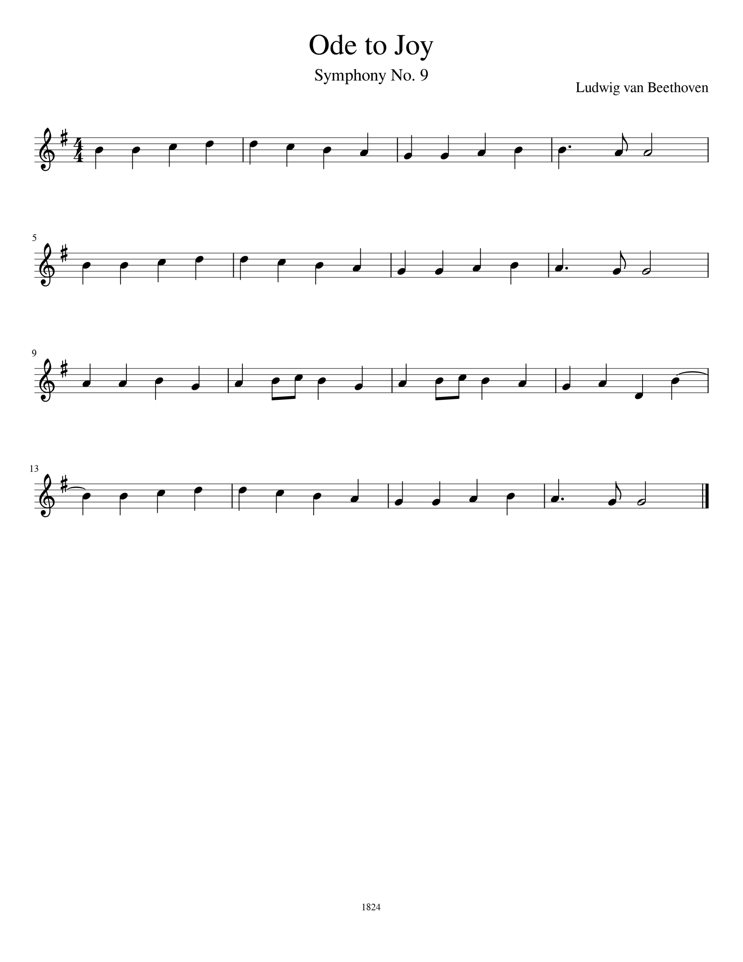

- Watch the 3rd line of this song. The eighth notes are tricky! Practice the bar over and over starting slowly,
- There is a low D on the last bar of the 3rd line. Make sure your fingers are ready!

