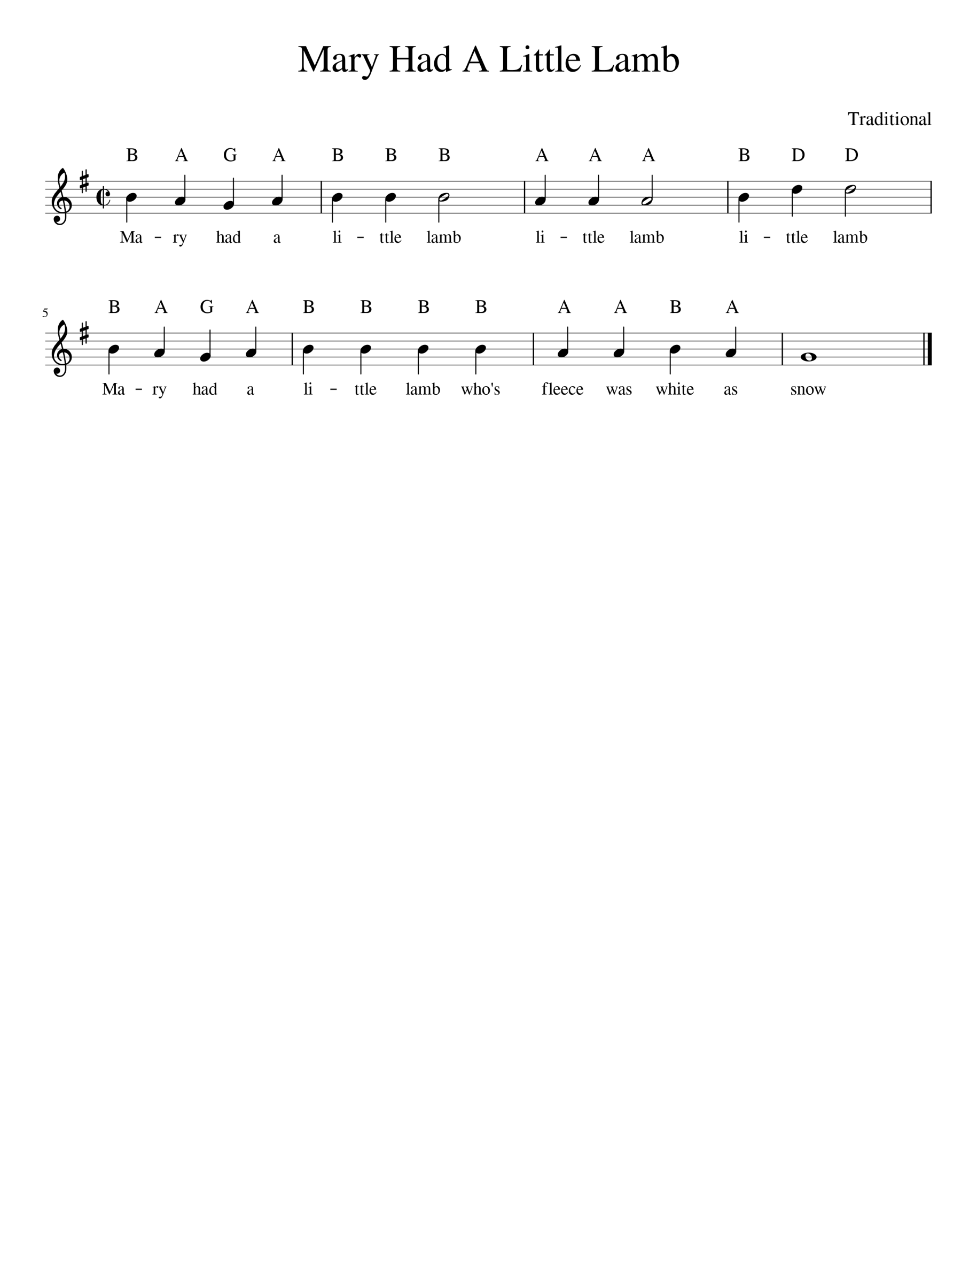
Level 1 -
Purple Belt

- Watch out for the high D note in the 4th bar.
- Practice playing B and then D to get the jump right.
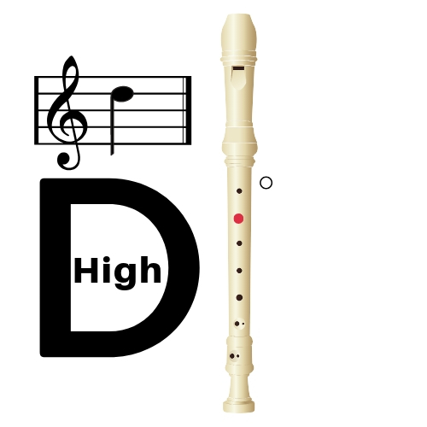
- Bars 1 and 2 repeat on bars 5 and 6!

