Level 1 -
Green Belt
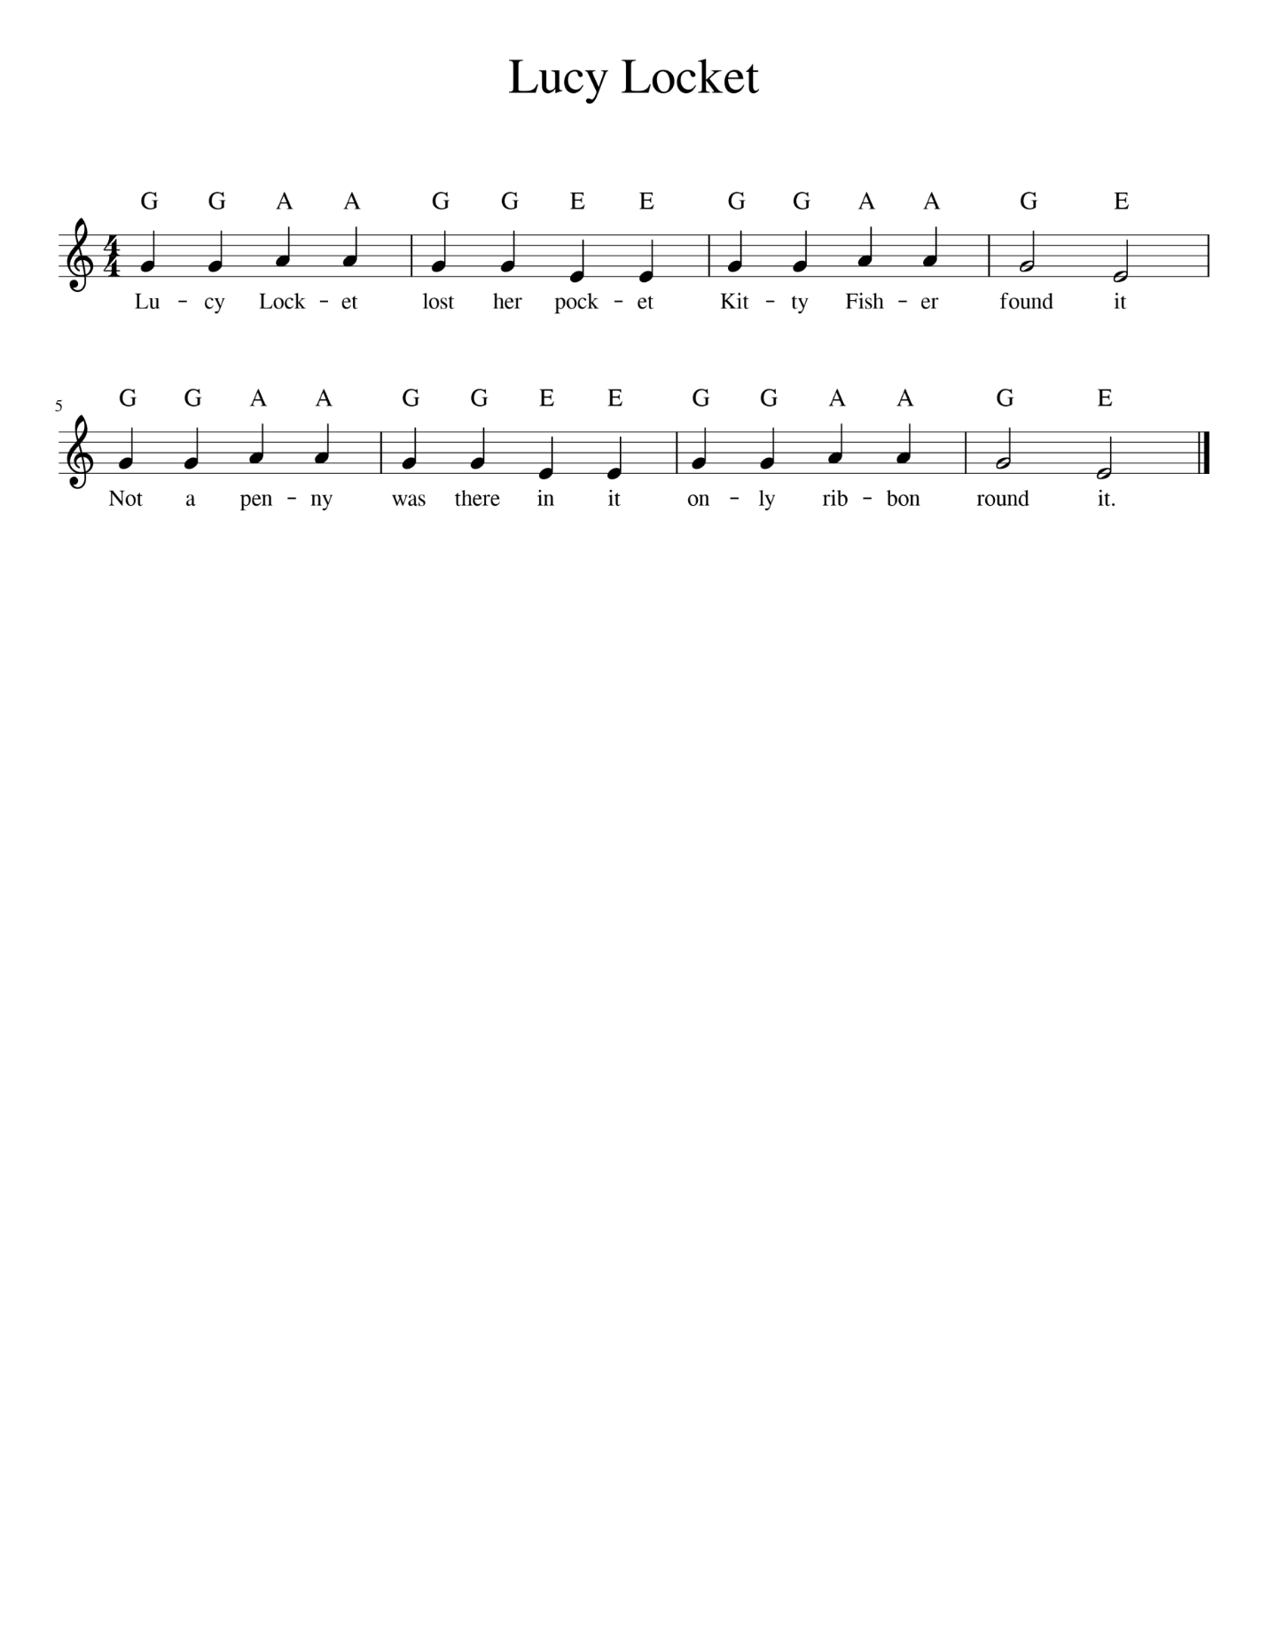

- The Time Signature – 4/4. This means there are 4 beats in a bar and a quarter note gets 1 beat.
- Watch out for our new note E! Make sure your right hand is ready to go! Get them ready before you start the song!
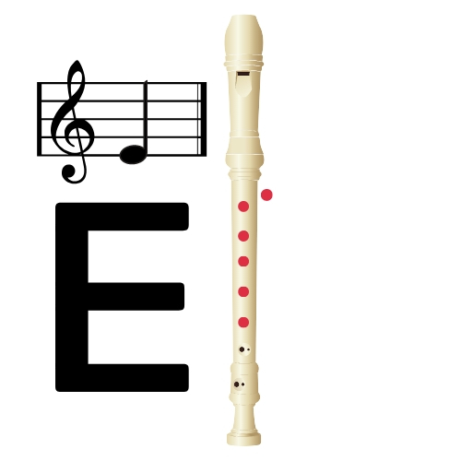
- Look at the top line – look at the bottom line! What do you notice???
- Remember to breathe after 2 bars!

