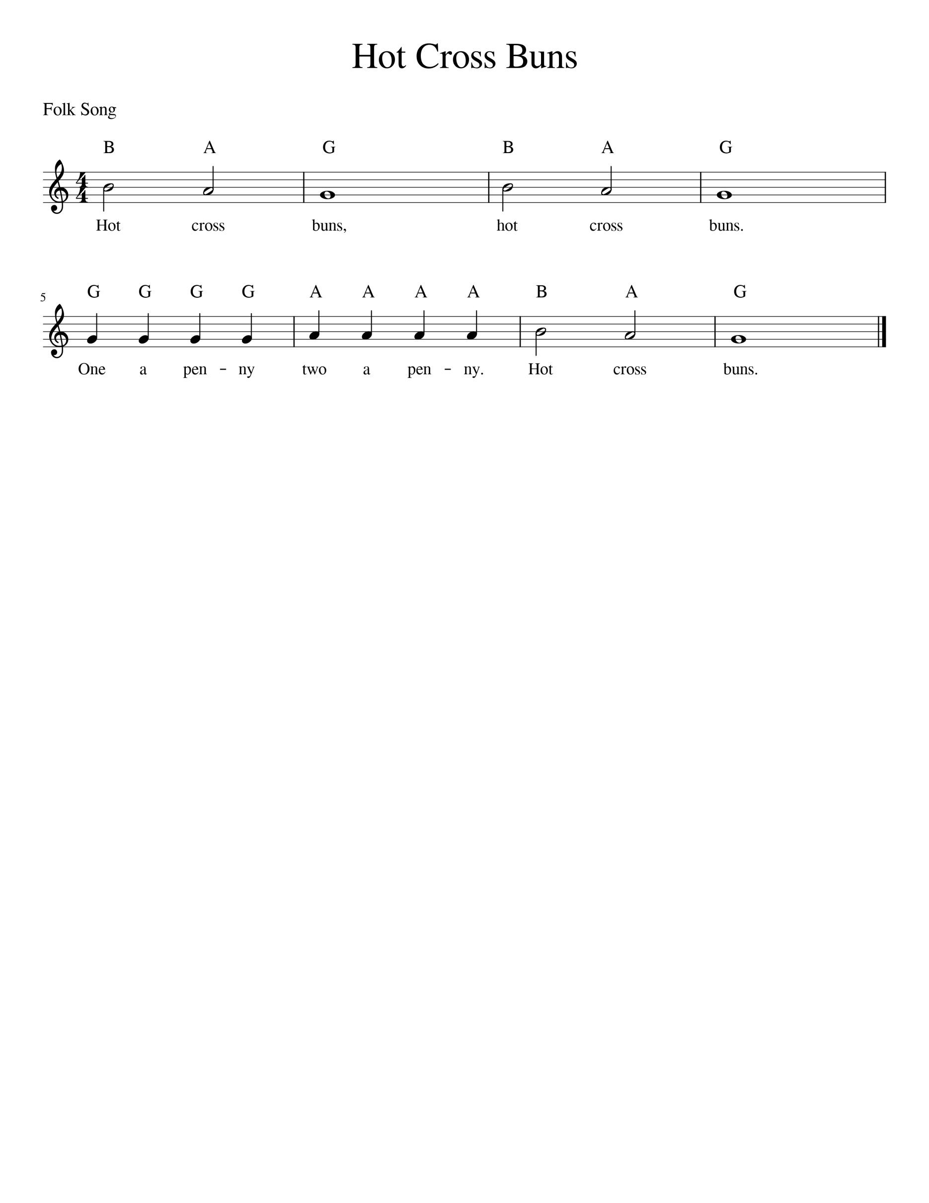
Level 1 –
Orange Belt

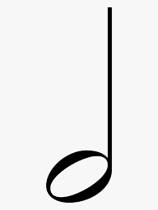

- Half Notes get 2 Beats –so the first 2 notes (B and A) are 2 beats each!

- Whole notes get 4 Beats – so the 3rd note (G) is worth 4 beats!
- Quarter Notes get 1 beat – So the 4 G’s and 4 A’s are worth 1 beat each. Make sure you only play 4 G’s and then 4 A’s.

