Asynchronous Learning Choice Board

January, 2022

Go on a nature scavenger hunt with a parent or caregiver. Before you go on your adventure, create a ‘bingo’ board with what you might see on your walk.  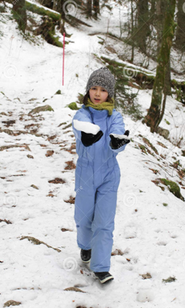 | Send an e-mail to a family member.   | Did You Know?  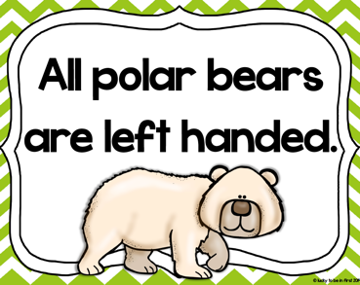  I’ll bet you didn’t already know that! Now, using your computer device, see if you can find out more information about this.
Read a book. You may choose a book from our Home Reading Online Program or simply read a book you have at home.  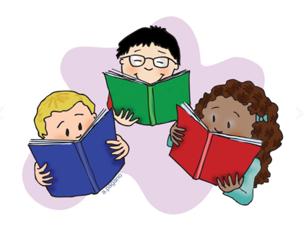 | Make a paper snowflake. Click on the link below:  Make a Paper Snowflake   | Listen to the story by clicking on the link below:  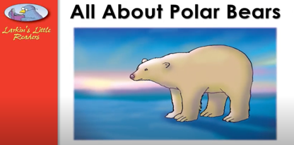  https://youtu.be/jABFE5ECR8M  Write down five facts you learned about these amazing animals.
Do a puzzle together! It is a great activity for a winter’s day.  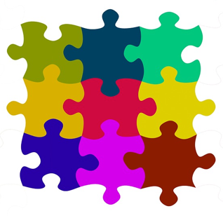 | Visit the Art Hub at the link below:  Draw a Polar Bear  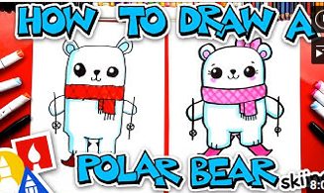 | Can You Solve the Math Problem?  Mrs. Lewis’ class at Tiffany Hills School donated warm hats and scarves. They donated 28 hats and 13 scarves. How many more hats than scarves did they donate?  