Mrs. Lewis
Tiffany Hills School
2021-2022

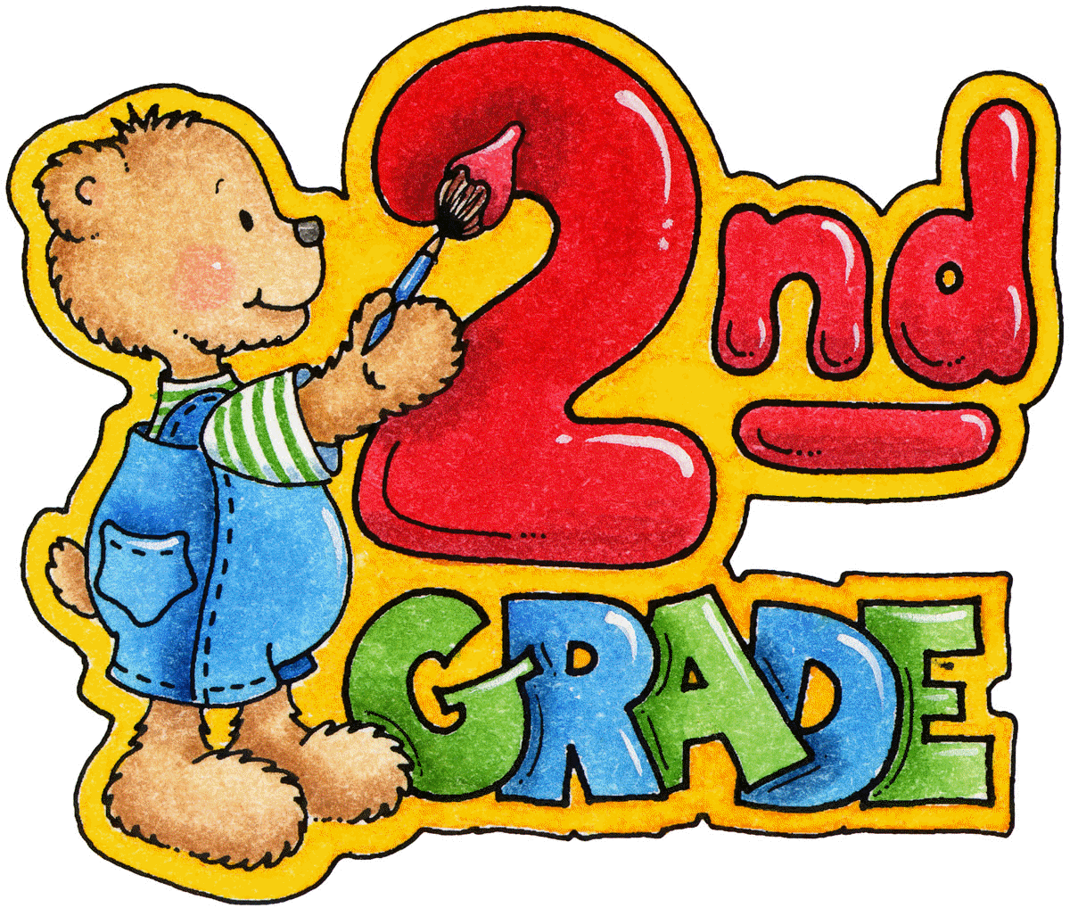

Welcome to Grade 2 in Room 218! I am thrilled to be in the classroom and so looking forward to getting to know your child in the upcoming months. Many of you may recognize my name or myself, as I have been at TH since it opened its doors five years ago. While I have taught a variety of subjects and grades during my teaching career, I have always had a special fondness for Grade Two.

Once again, this year will continue to be a ‘COVID’ impacted classroom. Similarly to last year, the manner in which students will be taught as well as the physical layout of the room will have modifications. Having said that, supporting your child’s health and well-being will ALWAYS be my number one priority as we begin a new school year.

Here are some important pieces of information that I am currently aware of. Please understand that some of these items/particulars may change.

Daily Screening
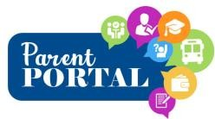
Each morning, you must complete a mandatory Daily Wellness Screening Test for your child, by using the ‘Covid Screening Checklist’. This is located in the Parent Portal and assesses your child’s health before coming to school.

Reporting an Absence or Early Dismissal

This may be done through School Messenger or by contacting the school directly @ (905) 304-6223.

Entry/Dismissal

Designated cohorts on the blacktop will continue at the present time. It is very important that your child comes to school daily with everything that they will need inside their backpack (e.g., indoor shoes once the colder weather arrives). Access to the school will be limited to individuals who are not students or staff. Extra clothing/shoes (labelled) should be placed in your child’s backpack. Toys and personal items must remain at home! Please be aware that the bell times for Tiffany Hills School have changed (i.e., 9:15 – 3:35). Ensuring your child arrives to school on time each day is greatly appreciated!

What Your Child Should Bring Daily

An extra mask

Reusable Labelled Water Bottle: The students will be expected to take their water bottle home daily for washing and refilling.

Lunch/Snacks: All students are asked to bring a litterless lunch. Reusable food containers should be labelled and easily opened by the student. Anything not eaten/garbage will return home with your child at the end of the day. I also support this strongly as it is a good environmental choice.

Classroom Supplies: Your child will be supplied with their own personal bin for the
school year. The following supplies are also recommended for each student that can be left in their bin for their own personal use. All supplies should be clearly marked with your child’s name.

• one pencil case
• 3 highlighters (each a different colour)
• crayons/pencil crayons
• pencil sharpener (that holds shavings)
• washable markers
• glue stick
• ruler with centimetres and millimetres
. scissors
• small package of Facial Tissues for personal use
• small container of hand sanitizer for personal use

Please Note: All Items must be able to fit in the provided container (6 litres).
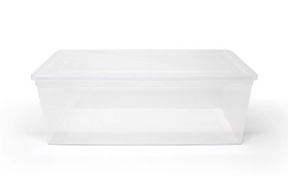
Gym/Daily Physical Activity (DPA)

In order to limit the number of items your child brings to school, it would be very helpful if your child wore running shoes and comfortable clothes to school daily.

Parent/Teacher Communication

Blog Mrs. Lewis’ Classroom

https://jalewisgrade2.commons.hwdsb.on.ca

Please ensure you have signed up to receive all posts. This is my primary mode of communication to parents, rather than a monthly paper newsletter

My board email address

jalewis@hwdsb.on.ca

General inquiries can also be directed to Tiffany Hills School at 905-
304-6223.

Curriculum/Expectations

For the next several weeks, the students will be getting reacquainted with their peers, making new friends, as well as getting used to being back in the physical classroom with a new teacher. Once things have become more settled, I will begin assessing your child’s reading level and math skills. As well, the board has developed and introduced a new mandatory 6-week daily program called ‘Reimagining Wellness’. The goal of this initiative is to help ensure that students feel safe and supported as they begin a new school year.

Student Information Package

This year, required forms for your child can be accessed in the Parent Portal. Please complete these as soon as possible.

Please do not hesitate to contact me if you have any further questions or concerns.

Mrs. Lewis

