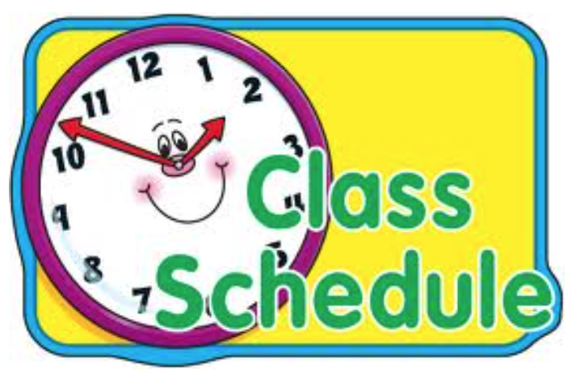

Thursday, January 14, 2021

BLOCK ONE

Period 1: 9:00 – 9:40 Literacy

Period 2: 9:40 – 10:40 Music/Drama (Mrs. Price)

Nutrition Break #1 10:40 – 11:20

BLOCK TWO

Period 3: 11:20 – 12:10 Literacy

Period 4: 12:10 – 1:00 Math

Nutrition Break #2 1:00 – 1:40

BLOCK THREE

Period 5: 1:40 – 2:40 Math
EMPOWER GROUP

Period 6: 2:40 – 3:20 Science

