Assignments for the Week of: May 11 -15
Anything written in blue and underlined is a hyperlink and should be clicked on to connect with a website.
*Note that we are including more than 5 hours worth of work for next week. We have included a lot of extra work. Feel free to complete as much as you can. Try to do a bit from each section.
MS Teams | This week we will be having a meeting and we expect that each student will attend a meeting. Meeting times have been based on times that parents gave us for meeting availability.
Reading | Independent Reading (20 mins) using resources such as books at home, online e.g., Epic, Raz Kids.
Reading | Focus/Lesson: Research – Choose a non-fiction book from Epic or Raz Kids that is about an animal. You need to gather at least 5 interesting facts about your animal.  See videos below for a refresher on how to write proper sentences and paragraphs.  Practice:  Grade 1 – Write your 5 facts in 5 complete sentences. Remember your 5 Star Sentence writing rules.  Grade 2 – Write a paragraph about your animal. Make sure to include specific details about your animal and use proper sentence writing format and paragraph format (Remember the hamburger model from last week).  *Submit this work by email.  **Extra challenge: If you haven’t completed this challenge yet. Give it a try. Write one adjective for each letter of the alphabet
Reading | Focus/Lesson: Reading challenge  The grade 1/ 2 classes are challenging each other.  Let’s see which class can do the most reading this week.  Parents/students use the attached reading log to keep track of the reading you are doing at home.  Submit the reading log on Friday and we (Miss Westoby, Ms Mamone, Mrs. Pessoa) will tally up times and let the winning class know by Monday.
Writing | Grade 1 - Watch this video about writing a proper sentence. Video  Grade 2 - Watch this video about writing a proper paragraph. Video
Grade 1:
Watch this video
Make a list of 5 things that are in your community (i.e. park, school, Tim Hortons).

Make a legend with 5 symbols, one for each place and draw a map of your community.

See Miss Arbuckle’s example below.

Grade 2:

*You need to have completed number one before you can move onto number 2.

- In your browser search up Kids in other countries. Select the link shown below.
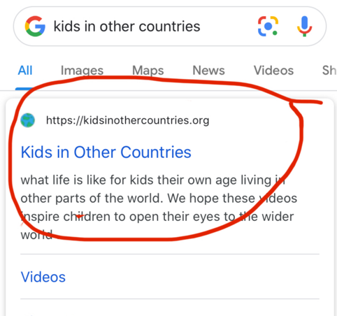

Pick from one of these children from the website and compare your life with the child’s life.

- Sadia from Bangladesh
- James from the Philippines (up until 10:11)

Complete the attached Venn diagram when comparing your lives. You should make comparisons which may include food, housing, jobs, celebrations, school, and free time.

- When you have completed the above assignment watch the following video about the climate until 1:01. After, follow the link to the country you learned about last week and read the section on climate.

Philippines

Bangladesh

Once you have watched the climate video and read about the climate in your country, draw a picture of what the climate looks like with a picture of your student from last week in the clothes they wore and what their house looked like. Then complete the following sentences to go with your picture.

The climate in the country of __________ is mostly ___________.

The ____________ (student’s name from the video) wears _____ (types of clothing).

The houses in __________(country name) are made out of. ___________________.

*Submit this work by email.
Media | Take the facts that you have learned about the animal you researched and create a presentation about it. It should include pictures as well as information about your animal. For some examples check  You can:  - Create a poster  - Make a video  - Create a presentation using Explain Everything Check out this example  - Create a slide show (Google slides). To check out this example, select Giant-Pandas to view the slideshow.  - Create a book in Book Creator – Check out this example  - Write a poem  - Find your own creative way to share about your animal  *Submit your work on Animal Presentation Page in our class in MS Teams.  Check back during the week to see your friends Presentations and comment on it.
Numeracy | Independent practise using Prodigy
Numeracy  Fractions | Mini-Lesson:  Grade 1 – Watch the following video about Temperature  Grade 2  If you need to….  Watch this video about subtracting two-digit numbers with regrouping.  Watch the following video up to 4:33 for my examples of subtracting with regrouping.  Practice: Complete the attached math sheet. If you are unable to print, please copy the questions onto a piece of paper.  *Submit this work by email.
Numeracy  Fractions | Mini-Lesson: Time  Grade 1 and 2  Here is about time. Time video  Here is a second video about time. Time video 2  Once you have watched this video, complete the worksheets below  *Submit this work by email.  Give these Kahoots! a try to test your skills.  Grade 1 Kahoot  Grade 2 Kahoot
Physical Education | BINGO cards are due on Friday.
Music | See music work below.

