Assignments for the Week of: April 20 -24
Anything written in blue and underlined is a hyperlink and should be clicked on to connect with a website.
*Note that we are including more than 5 hours worth of work for next week. We have included a lot of extra work. Feel free to complete as much as you can. Try to do a bit from each section.
Reading | Independent Reading (20 mins) using resources such as books at home, online e.g., Epic, Raz Kids.
Reading | Focus/Lesson: Watch the video to 2:25 about verbs - Verbs  Here is another video you can check out Verbs2  *Remember to dance along with this video.  - What are verbs? (tell your parent or older sibling what you have learned)  Practice/Response: 1) Make a list of 12 verbs that you find in the books you are reading. Write these verbs in ABC order.  *Submit this work by email.
Reading | Focus/Lesson: Listen to Mrs. Malcolmson telling us about the characteristics of Fairy Tales  Also see the chart below. We have also given you a list of all the Fairy Tales that you brainstormed last week. I wonder if you can come up with some more.  As you listen to the two Fairy tales this week, try to pay attention to the characteristics within each story.
Reading | Focus/Lesson: Listen to Mrs. Westoby read Cinderella  Practice/Response: In your own way, answer the following questions  - What is the setting?  - Are there good and evil characters? Who are they?  - Are there magical elements in the story?  - Are there talking animals?  - Is there a lesson in this story?  *Submit this work by email.
Reading | Focus/Lesson: Listen to Miss Westoby read The Three Billy Goats Gruff  Imagine you are one of the Billy Goats, come up with two ways that you would cross the bridge. Please write this in complete sentences. *Submit this work by email.
Writing | Choose one of the topics below (for two days) and write about it.  - I am proud of myself because….  - Tell about one thing you do really well.  - My favourite stuffed animal or toy is…..  Underline the verbs in your writing.
Writing | On a separate day, choose one of the two pieces of writing and complete the following.  BUMP UP YOUR WORK  Go back and reread your work and check to make sure you have  - capitals at the beginning of sentences  - finger spaces between words  - punctuation at the end of sentences  - correct spelling  - complete ideas  *Submit this work by email.
Writing | Additional work:  Check out this video Mrs. Malcolmson made of her Heart Map  Check out the Heart maps for Mrs. Malcolmson, Miss Westoby and Mrs. Pessoa below.  Complete your own Heart Map.  You can use these ideas when you are stuck for an idea to write about.
Media  Literacy | Make a wanted poster for the troll from The Three Billy Goats Gruff  Check out this one. Wanted Troll  Make sure to include:  - large title of wanted  - picture of the character  - reward  - description of what he looks like
Numeracy | Independent practise using Prodigy
Numeracy | Mini-Lesson:  1)Watch this video about adding and subtracting to 20. Add and Subtract  Practice: Complete the attached worksheet of adding and subtracting up to 20.  2) Watch this video Double digit adding (Start at 2:40 to see adding with regrouping)  Here is another video about Double digit adding with regrouping  Practice: Complete the attached math sheet. If you are unable to print, please copy the questions onto a piece of paper.  For more practise sheets you can also go to worksheetfun.com  *Submit this work by email.
Numeracy | Additional:  To practise some word problems you can try the link below.  Single digit Math Word Problems  Two digit Math Word Problems
Fractions | Mini-Lesson:  Watch Mrs. Pessoa’s fractions video  - Show your own example of how you divided something equally with another person.  - If you try Mrs. Pessoa’s challenge of sharing the fishy crackers with 3 people and then with 4 people, show your work.  *Submit this work by email.

In addition to the work above we have included some Science work below.

- Earth Day is on April 22, 2020.

- Make a list of some things that you can do to help our planet.
- Create a poster that gives an earth friendly message (i.e. Don’t litter! Take care of our earth, Reduce, Reuse, recycle)

- Check out some of the videos on this site. Virtual Field Trips or San Diego Zoo
*We are enjoying watching the videos of the different animals at the San Diego Zoo.

***Remember to check the blog for work provided by Mr. Ellis and Miss Arbuckle. Look at the specific pages for each of the subjects they teach to your child.

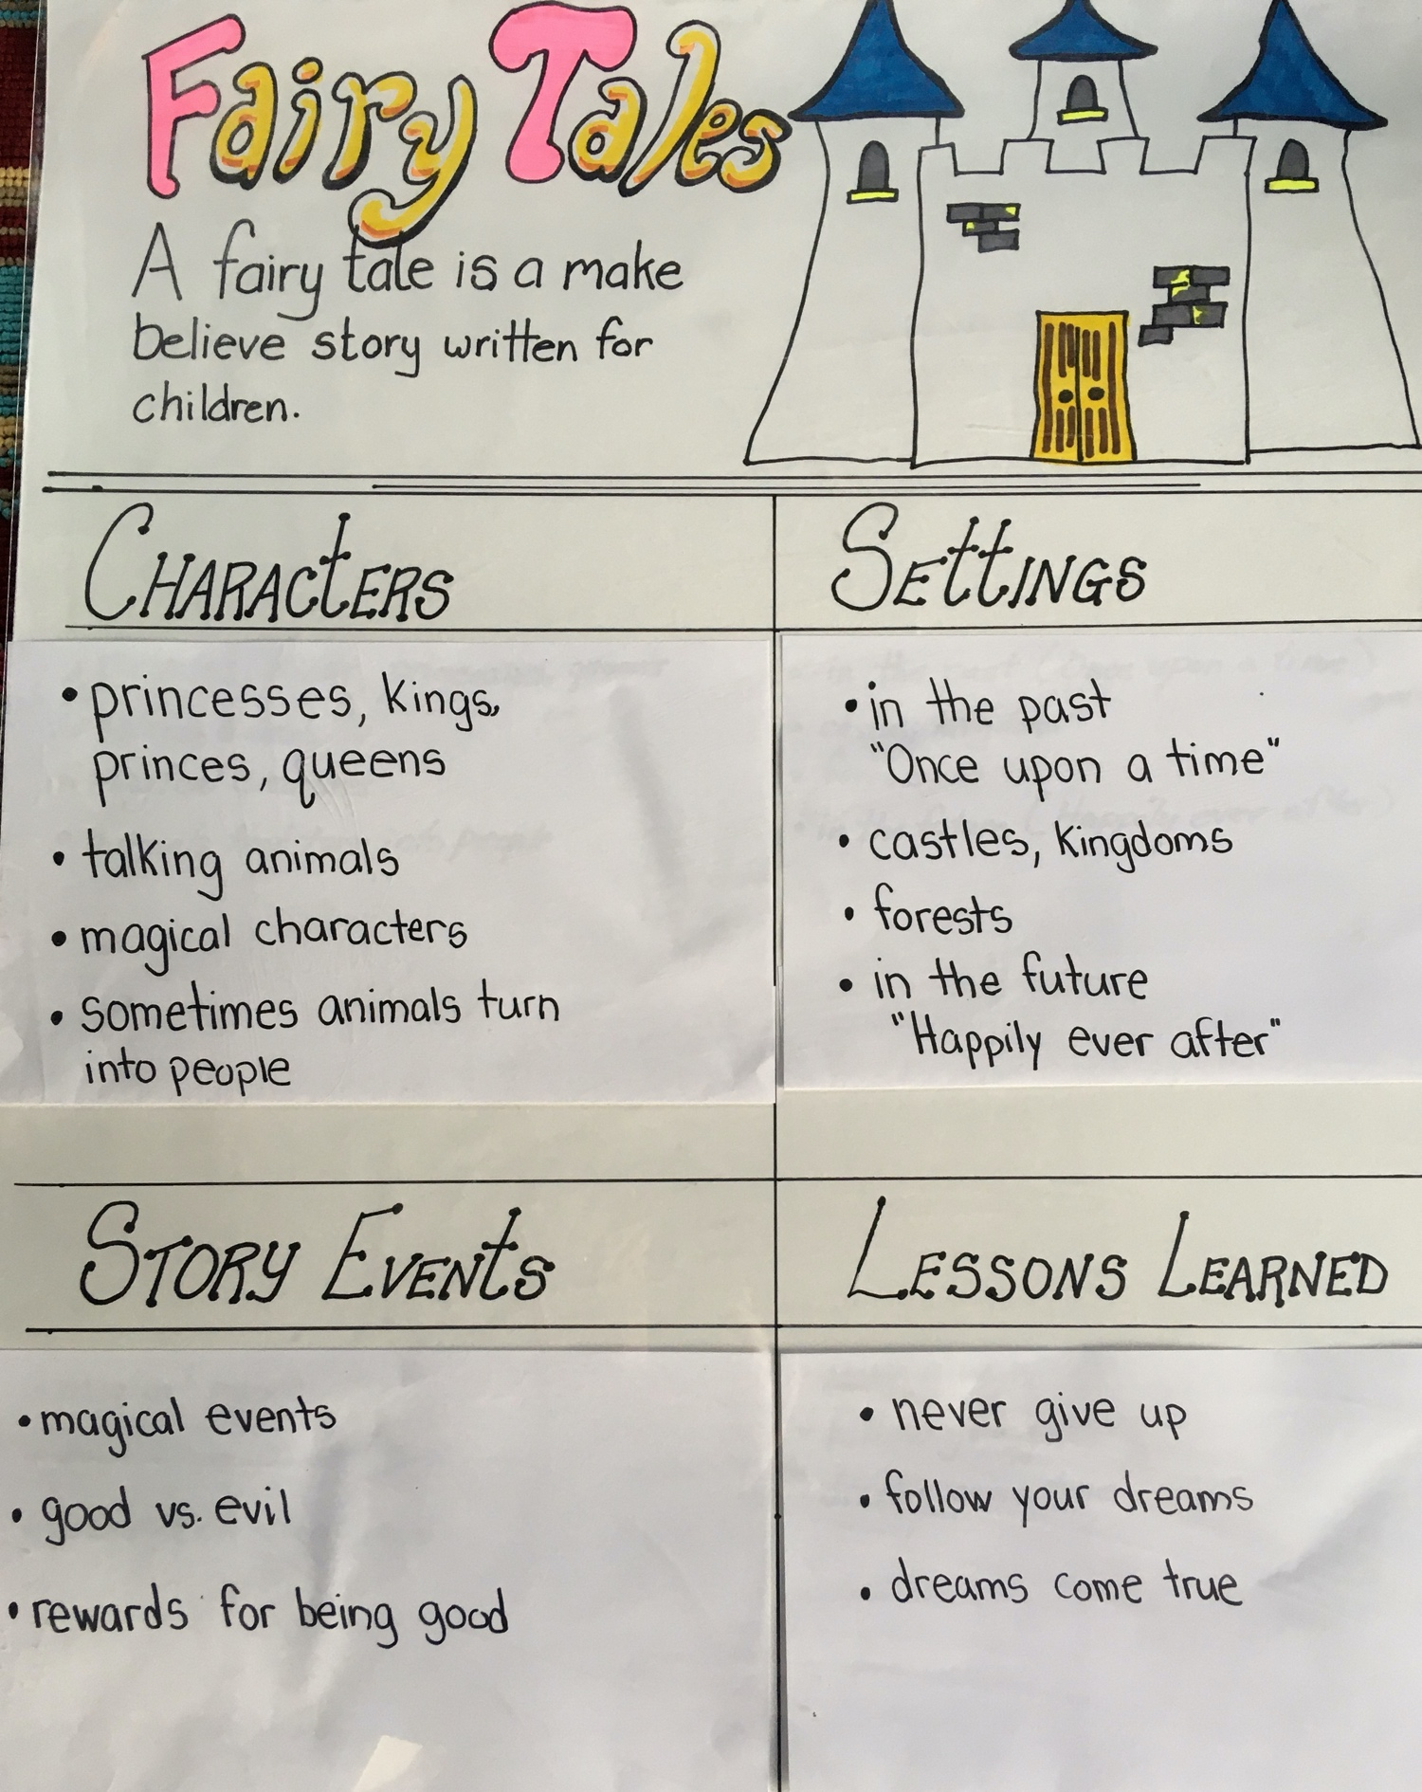

Fairy Tales

Snow White
Cinderella
Little Mermaid
Frog Prince
Snow Queen
Sleeping Beauty
Little Red Riding Hood
Beauty and the Beast
The Three Little Pigs
Happy Prince
Goldilocks and the Three Bears
Princess and the Frog
Rapunzel

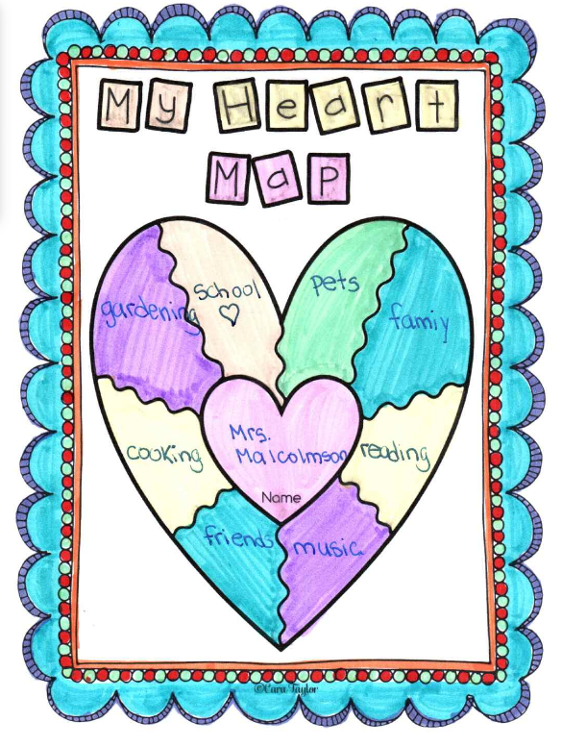

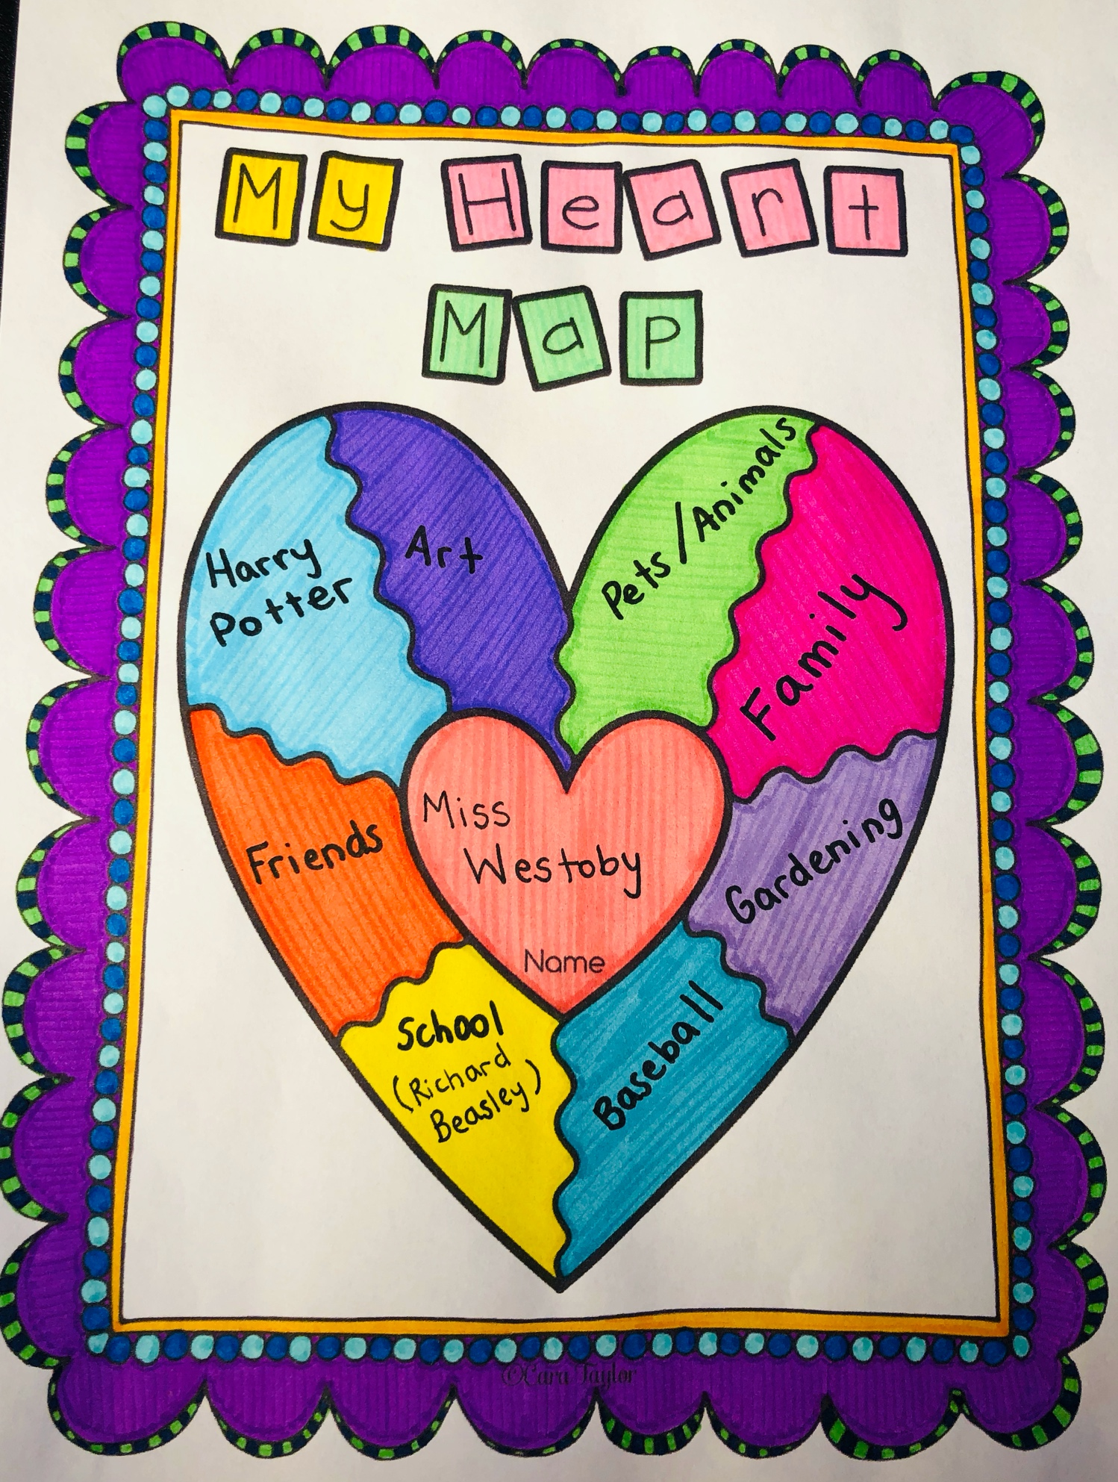

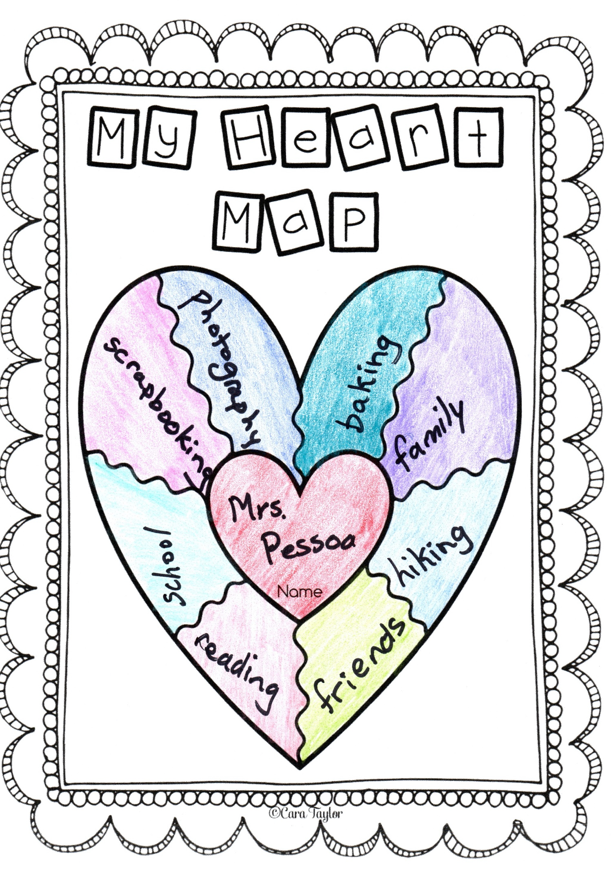

Adding and subtracting

2 8 6 9 18
+7 -4 +7 +9 - 8

7 14 5 15 11
+7 - 4 +7 - 9 - 8

9 14 6 7 16
- 7 - 3 +9 +4 - 8

15 12 4 7 10
- 3 - 6 +9 - 3 - 5

19 10 2 8 15
- 10 - 3 +9 +4 - 7

Adding with regrouping

24 36 48
+17 +27 +35

58 45 52
+13 +45 +29

27 52 19
+47 +29 +29

54 46 23
+37 +38 +68

34 59 76
+48 +26 +19

