Assignments for the Week of: _________
Anything written in blue and underlined is a hyperlink and should be clicked on to connect with a website.
*Note that we are including more than 4 hours worth of work for next week. We have included a lot of extra work. Feel free to complete as much as you can. Try to do a bit from each section.
Reading | Independent Reading (20 mins) using resources such as books at home, online e.g., Epic, Raz Kids.
Reading | Focus/Lesson: Watch the video to 2:57 about nouns - Nouns  – What are nouns? (tell your parent or older sibling what you have learned)  Practice/Response: 1) Make a list of 12 nouns that you find in the books you are reading. (4 people, 4 places, 4 things). Submit this work by email.
Reading | Focus/Lesson: Listen to Mrs. Westoby read The Three Little Bears  Practice/Response: Please complete the following story map about The Three Little Bears. If you are not able to print this, you can write on a piece of paper/notebook you have at home.
Reading | Focus/Lesson: Listen to Robert Munsch tell the story The Paper Bag Princess. If you search CBC Robert Munsch, then select the one we have indicated below.  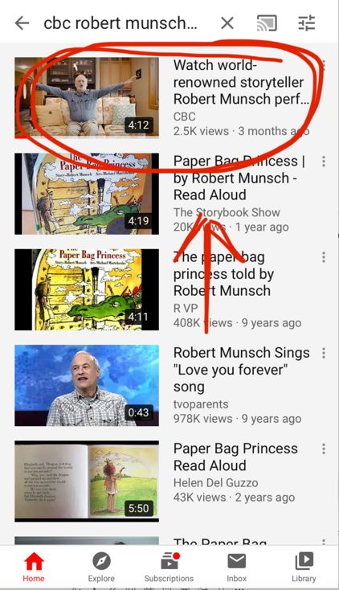  Practice/Response: Please complete the following story map about The Paper Bag Princess.
Reading | Focus/Lesson: Listen to the two stories again. Talk to a parent or older sibling and make a list of what makes a Fairy Tale a Fairy Tale.
Writing | Choose one of the topics below (for two days) and write about it.  - Planet earth is special because….  - I often dream about….  - Describe your bedroom…..  Underline the nouns in your writing.
Writing | On a separate day, choose one of the two pieces of writing and complete the following.  BUMP UP YOUR WORK  Go back and reread your work and check to make sure you have  - capitals at the beginning of sentences  - finger spaces between words  - punctuation at the end of sentences  - correct spelling  - complete ideas  Email your complete work.
Writing | Additional:  Each day write a journal. You can write about what you are doing, how you are feeling or anything else that comes to mind.  (some ideas include family, hobbies, pets,
Media  Literacy | Record a video of yourself telling us the names of all the fairy tales you know and email this video to your teacher. I will make a list of all of the Fairy Tales you come up with and add it to a post on our blog.
Numeracy | Independent practise using Prodigy
Numeracy | Mini-Lesson: Grade 1 - Watch Mrs. Malcolmson’s single digit addition lesson  Grade 2 - Watch this video Double digit adding (watch only to 2:40 mins)  Practice: Complete the attached math sheet. If you are unable to print, please copy the questions onto a piece of paper. For more practise sheets you can also go to worksheetfun.com
Numeracy | Review: On the attached 100s chart, complete the following:  - In red, colour the numbers you land on when skip counting by 2s.  - In blue, colour the numbers you land on when skip counting by 5s.  - In green, colour the numbers you land on when skip counting by 10s.  Take a picture of your work and email it to the teacher.
Fractions | Mini-Lesson:  Watch this fractions video Fractions up until the 4:00 min point  Get started thinking about Fractions. Explore/ think about ways in your everyday life where you have to share equally (ie. Sharing your toys with a brother or sister, sharing your favourite snack).

Name_____________________________ Date _________________
Title _____________________________________________________
Author _____________________ Illustrator ____________________

Characters Setting

This story taught us…..
In the beginning…
In the middle…
At the end….
This story was mainly about…
100’s Chart
1 | 2 | 3 | 4 | 5 | 6 | 7 | 8 | 9 | 10
11 | 12 | 13 | 14 | 15 | 16 | 17 | 18 | 19 | 20
21 | 22 | 23 | 24 | 25 | 26 | 27 | 28 | 29 | 30
31 | 32 | 33 | 34 | 35 | 36 | 37 | 38 | 39 | 40
41 | 42 | 43 | 44 | 45 | 46 | 47 | 48 | 49 | 50
51 | 52 | 53 | 54 | 55 | 56 | 57 | 58 | 59 | 60
61 | 62 | 63 | 64 | 65 | 66 | 67 | 68 | 69 | 70
71 | 72 | 73 | 74 | 75 | 76 | 77 | 78 | 79 | 80
81 | 82 | 83 | 84 | 85 | 86 | 87 | 88 | 89 | 90
91 | 92 | 93 | 94 | 95 | 96 | 97 | 98 | 99 | 100

