Assignments for the Week of: June 8 - 12

MS Teams | Check for meeting times for the coming week.
Reading | Independent Reading (20 mins) using resources such as books at home, online e.g., Epic, Raz Kids.
Reading | Focus/Lesson: Visualizing – watch the video to learn about Visualizing  Have an adult read this poem to you and then draw a picture of what you think the green giant looks like.  Green giant  *Submit this work by email.
Reading | Draw a picture that follows the directions below.  Take a look at the example below to help you!  *Submit this work by email.
Writing | Focus/Lesson: Editing/Revising  Correct the sentences. (see below)  Play this game below to practise with editing and revising work.  Sentence doctor Game  *Submit this work by email.
Writing/Oral | Paint a picture for me with words about what you see when you go outside.  Check out the example paragraph below about my backyard. Press Ctrl and click on the words to have it read to you.  *Post your work on the Show and Tell channel.
Numeracy | Independent practise using Prodigy.
Numeracy | Mini-Lesson:  Grade 1 – Practice Doubling  Using your chalk, draw a hopscotch on the ground.  Write doubles questions in each of the spaces. You need to say the answer as you hop on the square. Take pictures of yourself and your hopscotch game. See photo example below.  Grade 2 - Multiplication – Watch this video  Take your chalk and solve the attached questions. Make arrays with your chalk and take pictures of your work.  *Submit this work by email.
Measurement | Mass/capacity – Capacity Video  Elephant Mass Song  Some more information and videos about Mass and Capacity  Complete the experiment activities below.  **Links from worksheets found here: https://hwdsb.tv/media/mass-experiment-instructions/ https://hwdsb.tv/media/capacity-experiment/  Check out this game. Pan Balance
Social Studies | Grade 1  Grade 2
Health | See activity below.  *Submit this work by email.
Physical Education | See activity below (Jedi June)

Visualizing Example: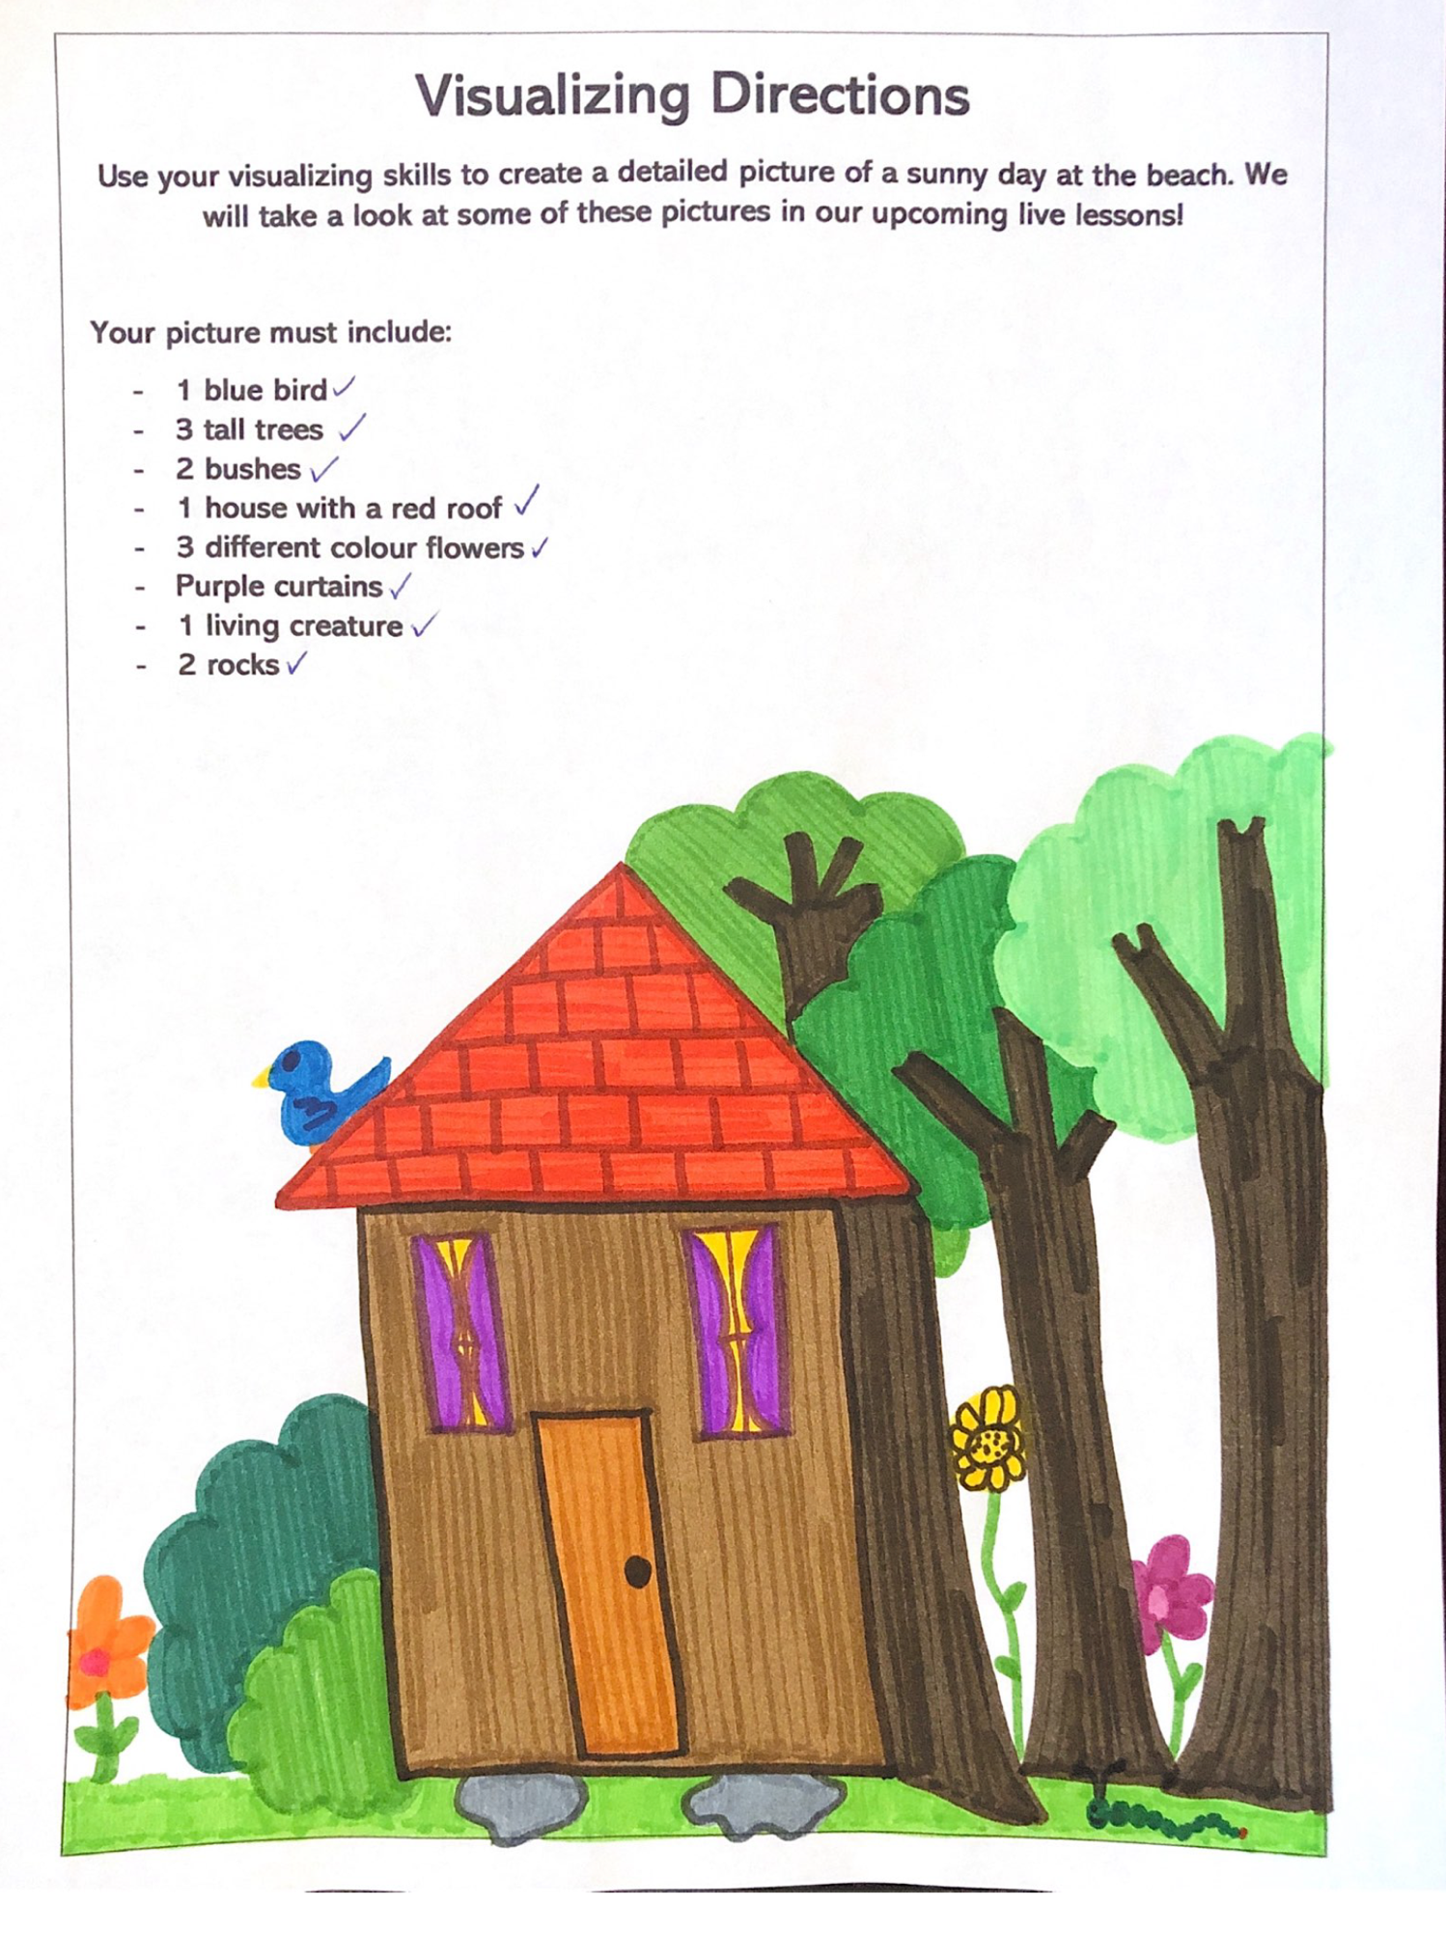

Visualizing Activity:

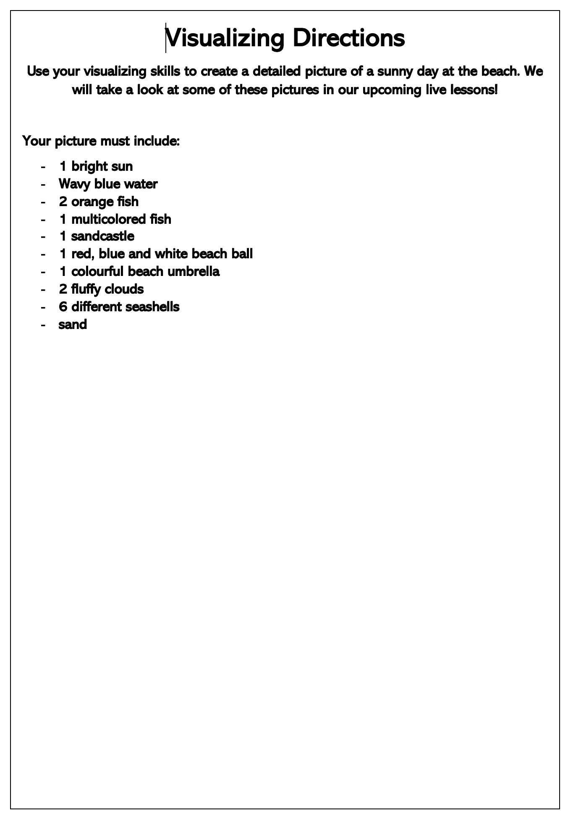

Visualizing my backyard:
I really like being in my backyard. Imagine this! I am sitting in my comfy patio chair. I look out to my two bird feeders and there is a whole lot of activity around them. I see three goldfinches, two cardinals, a mourning dove and a few sparrows. They are all trying to get to the seeds in the feeder. Once they get some seeds they fly to the tree behind my fence and wait for their next turn. On the fence I see two squirrels. They look really funny because they are lying flat on the fence as through they are sunbathing. Through my fence I see a chipmunk coming through to get some of the seeds as well. Can you visualize my backyard?
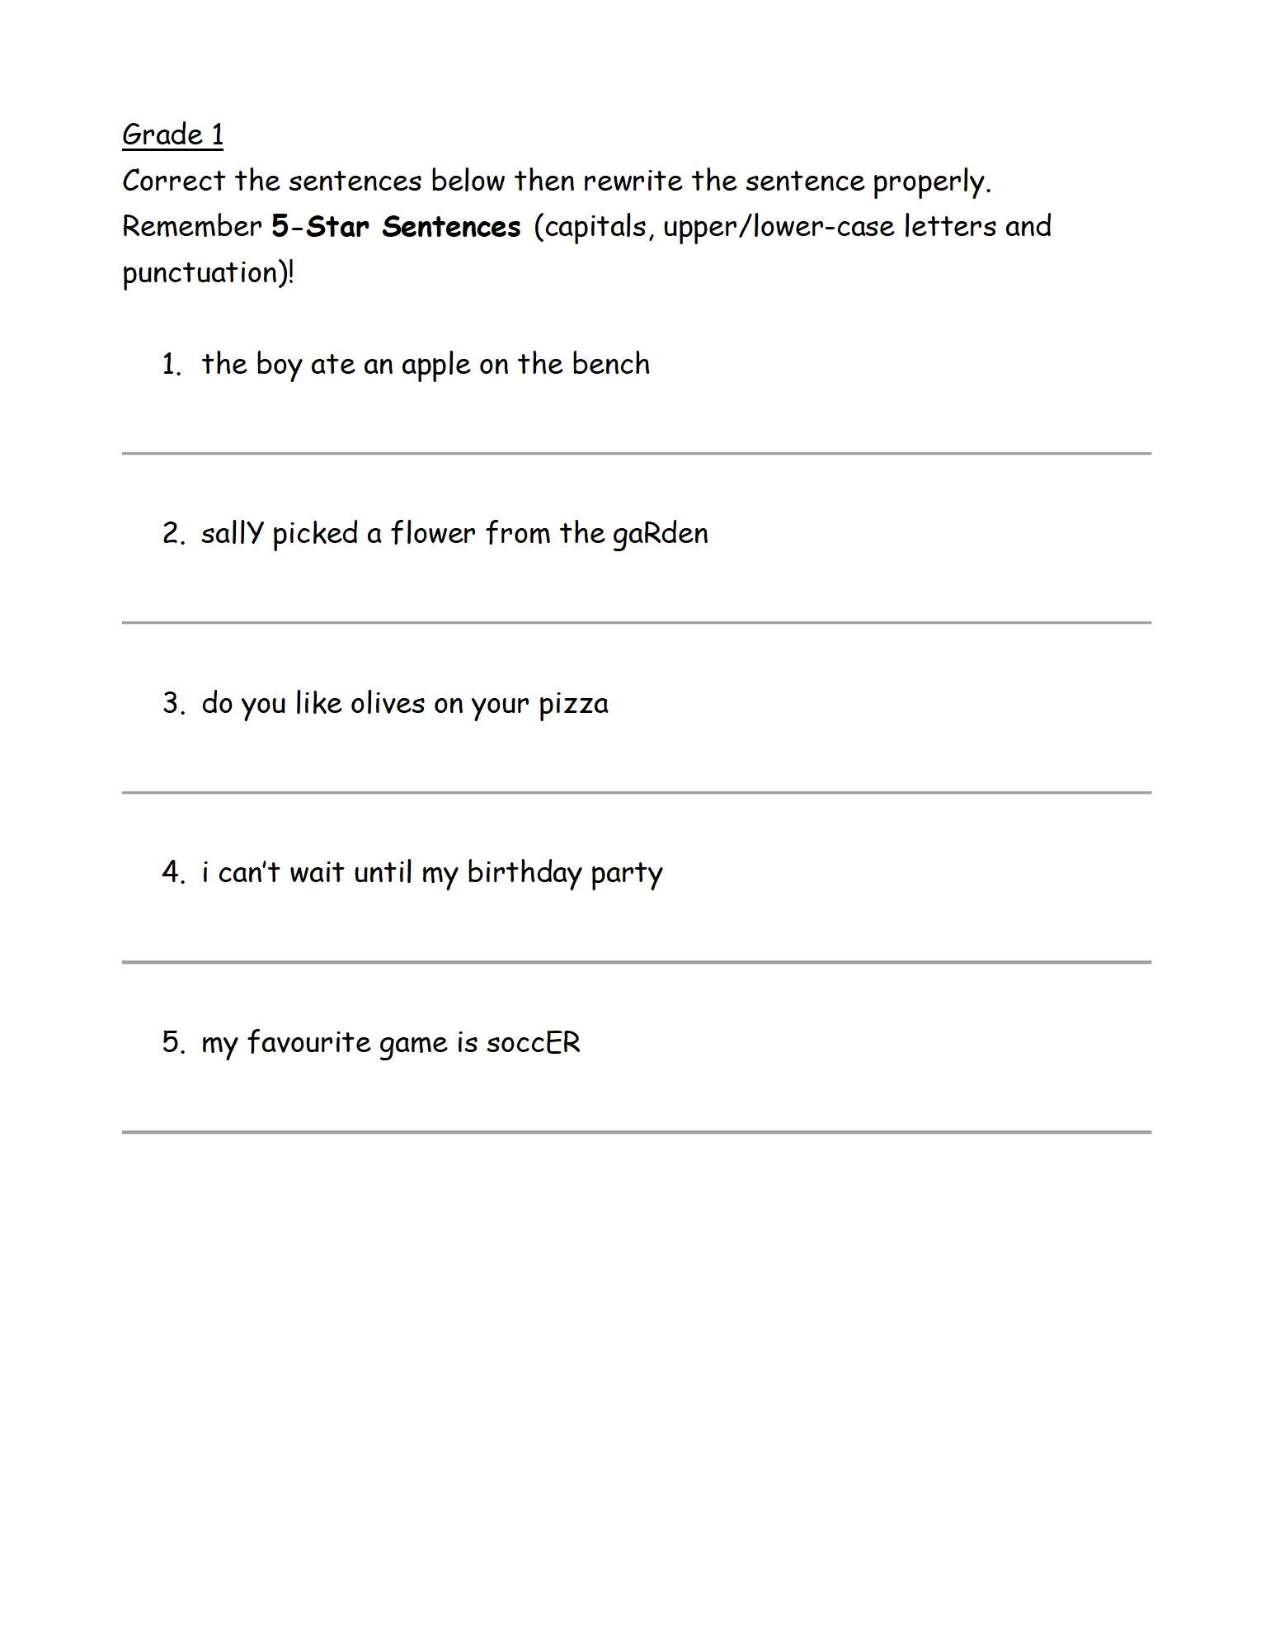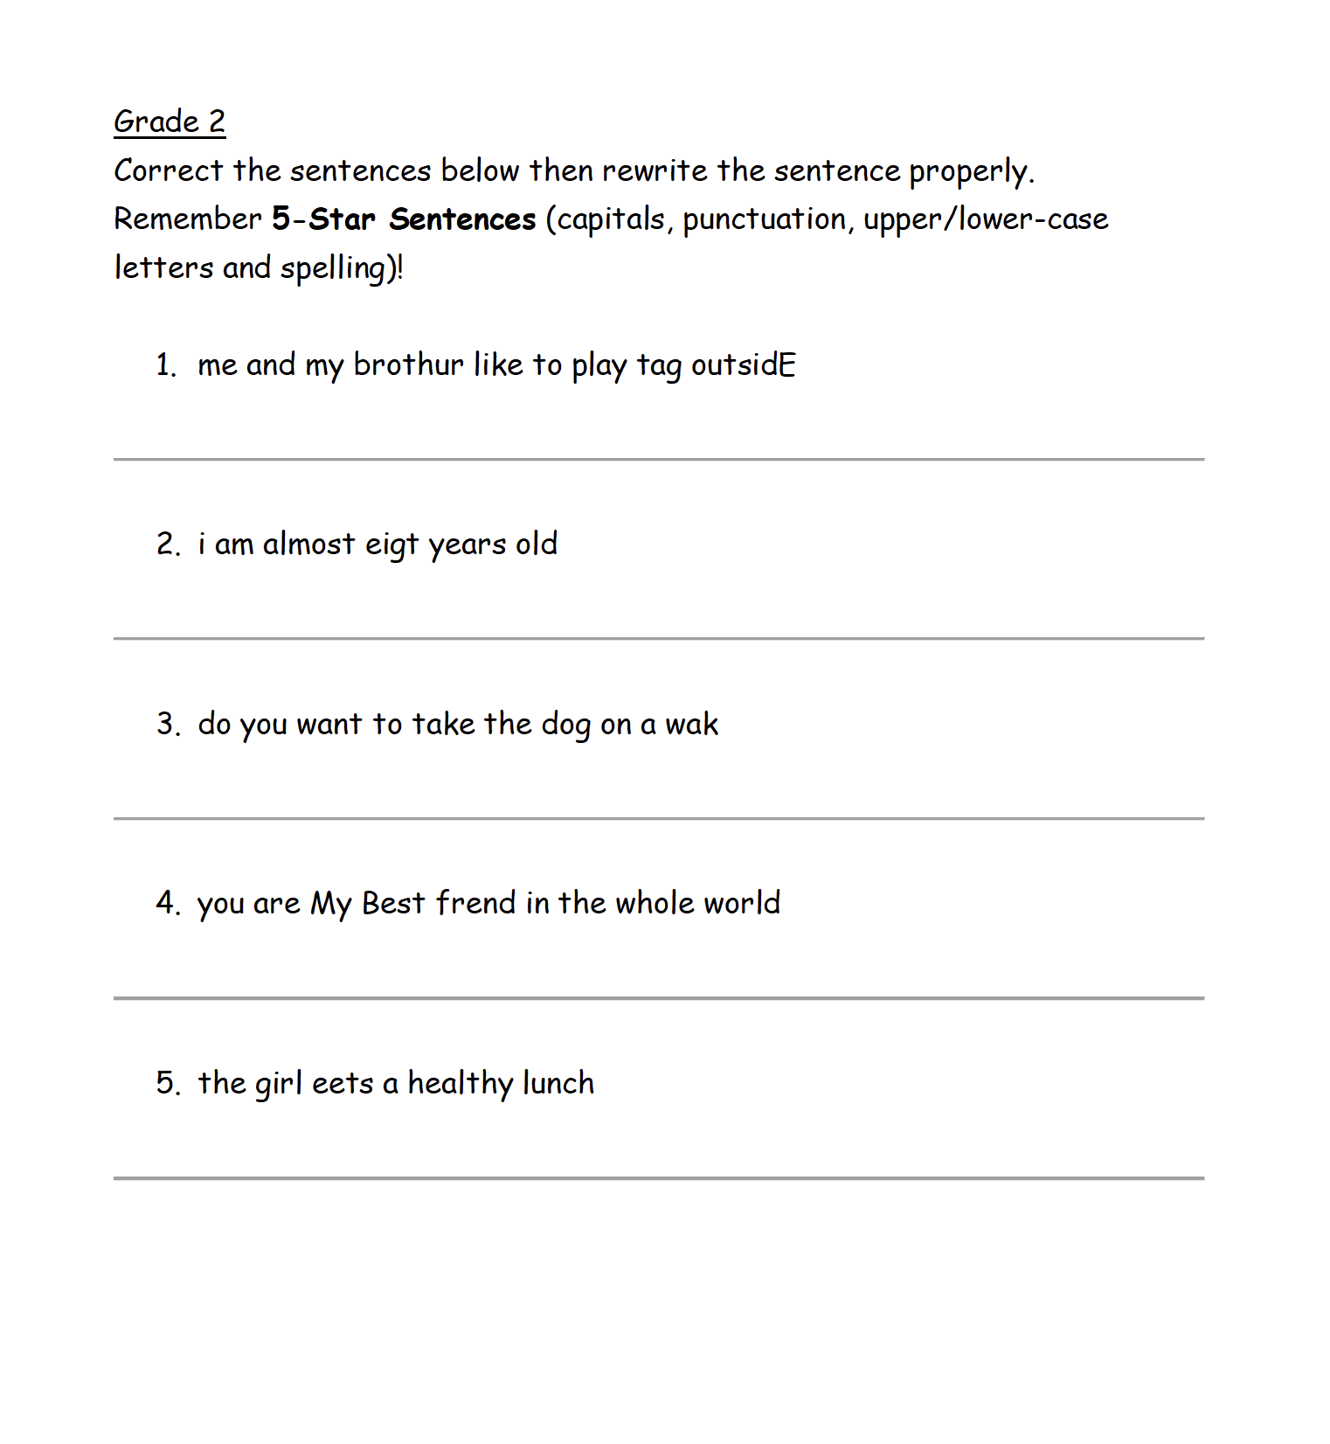

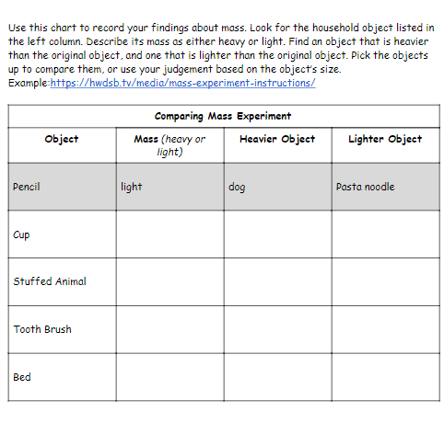

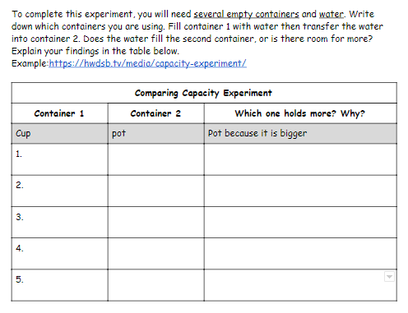

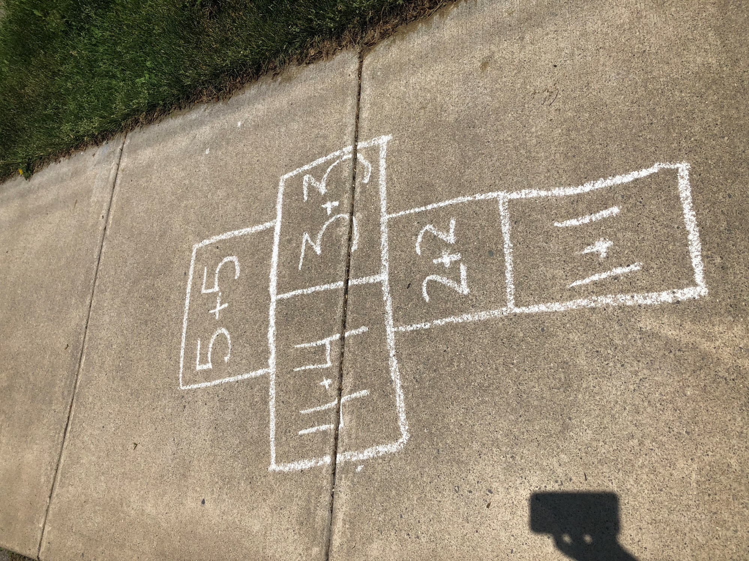
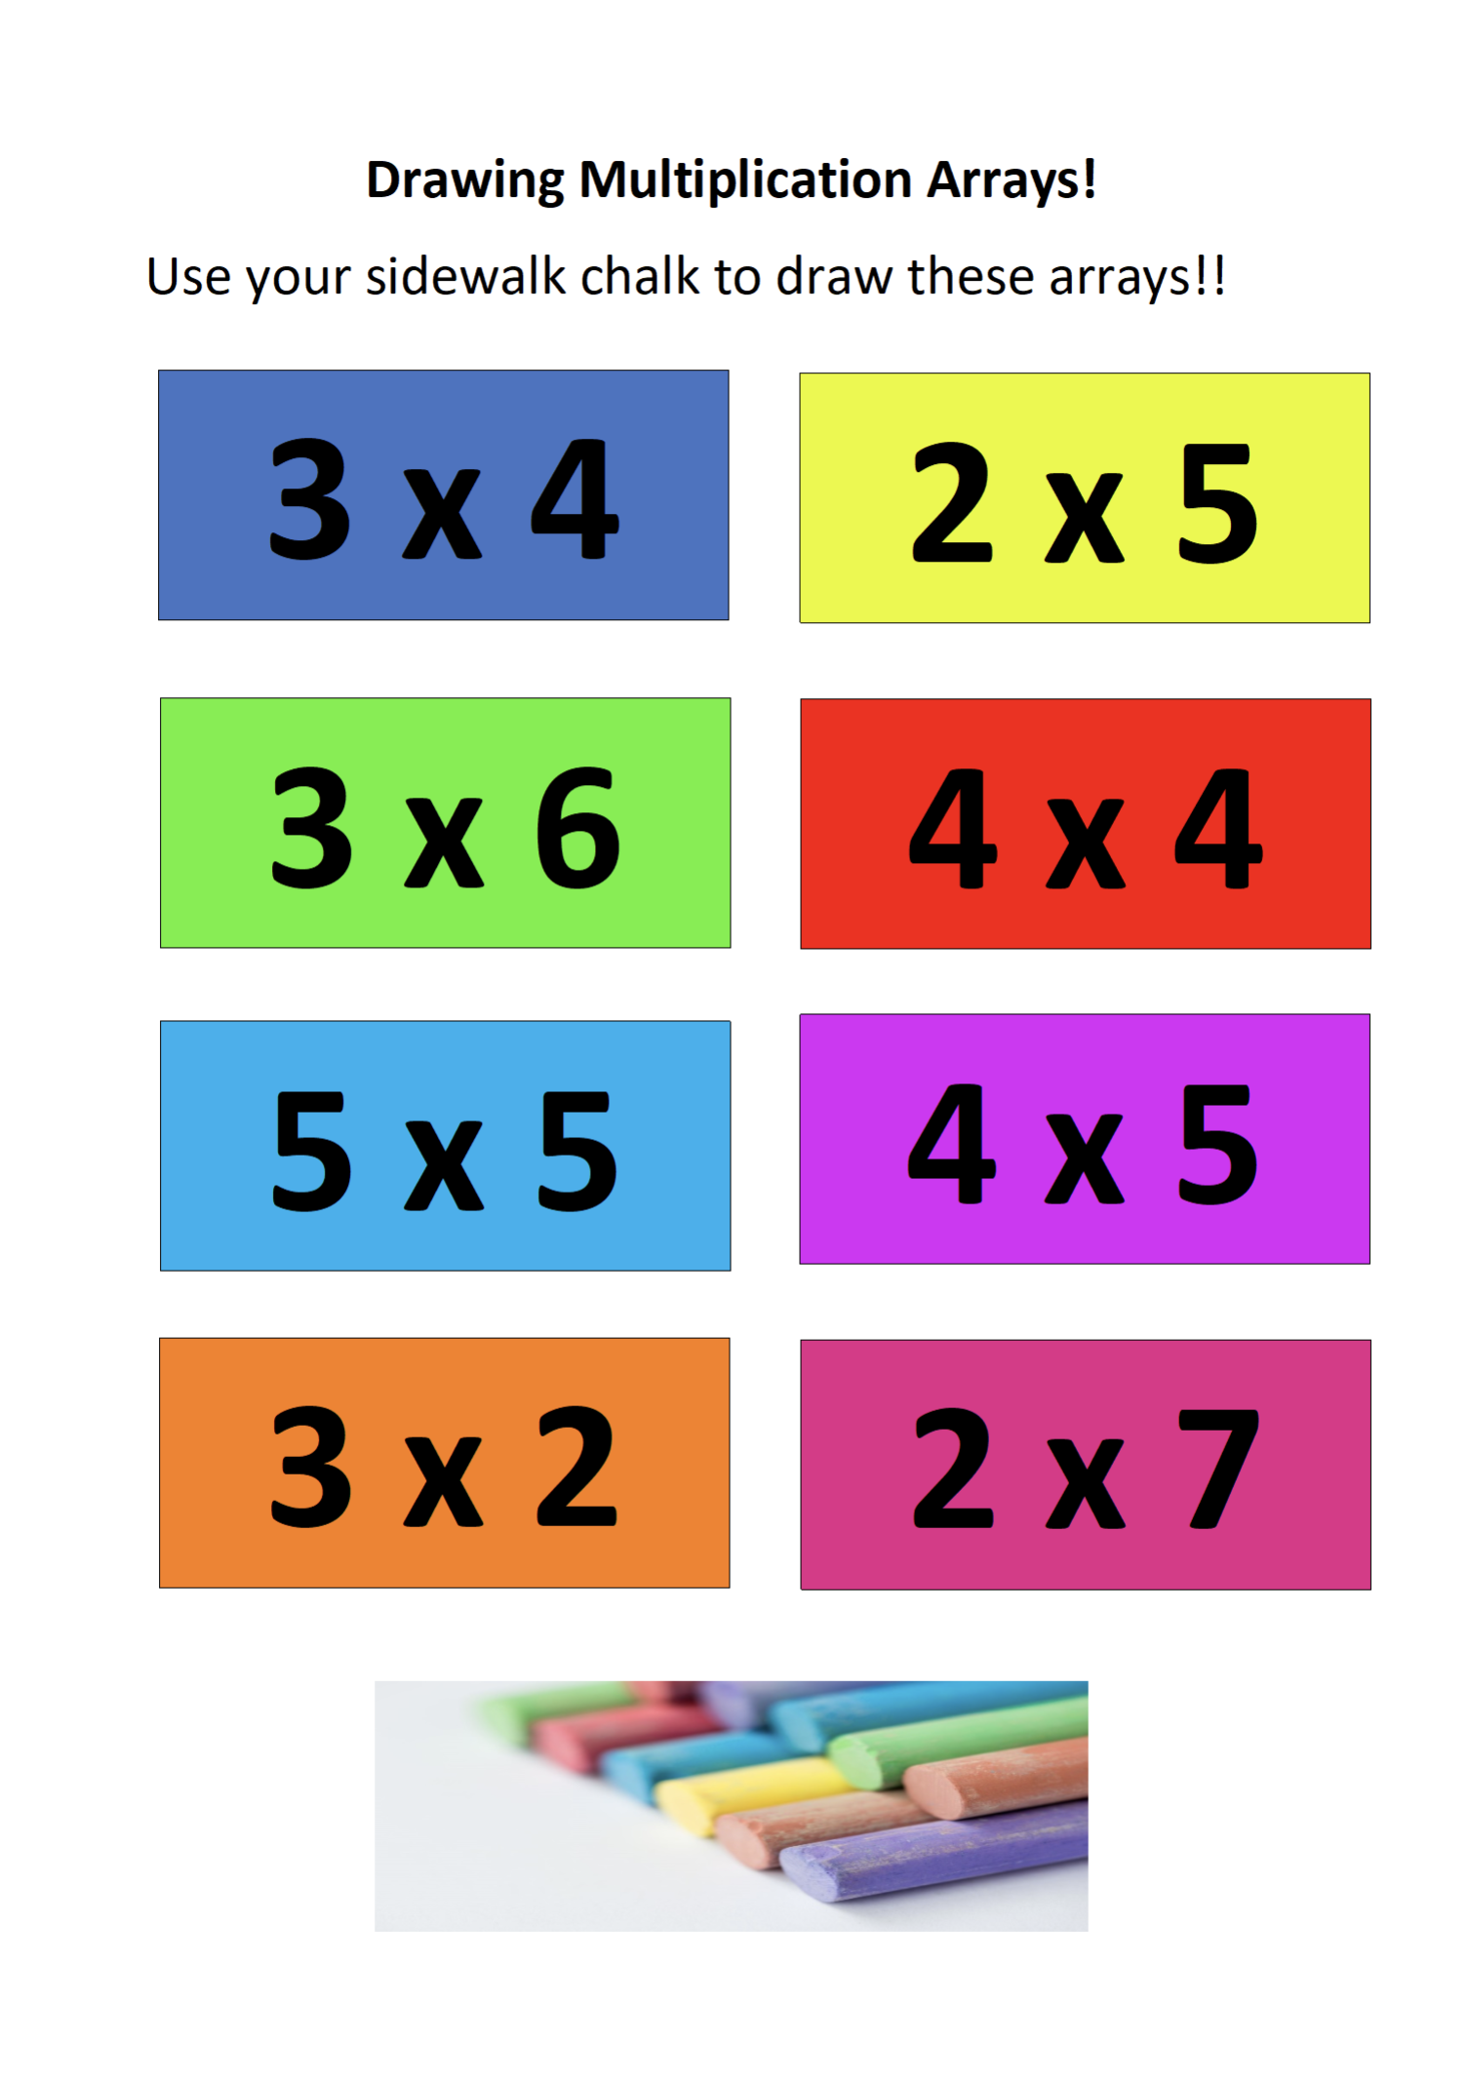

Health
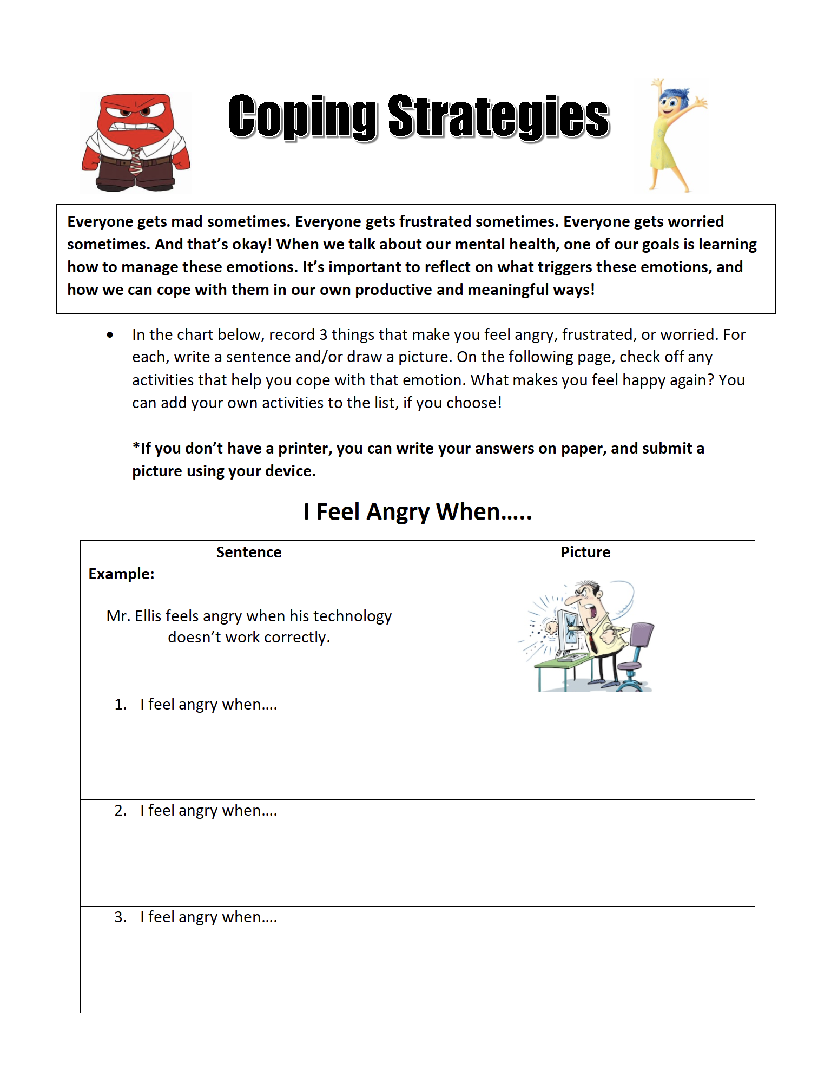

Health
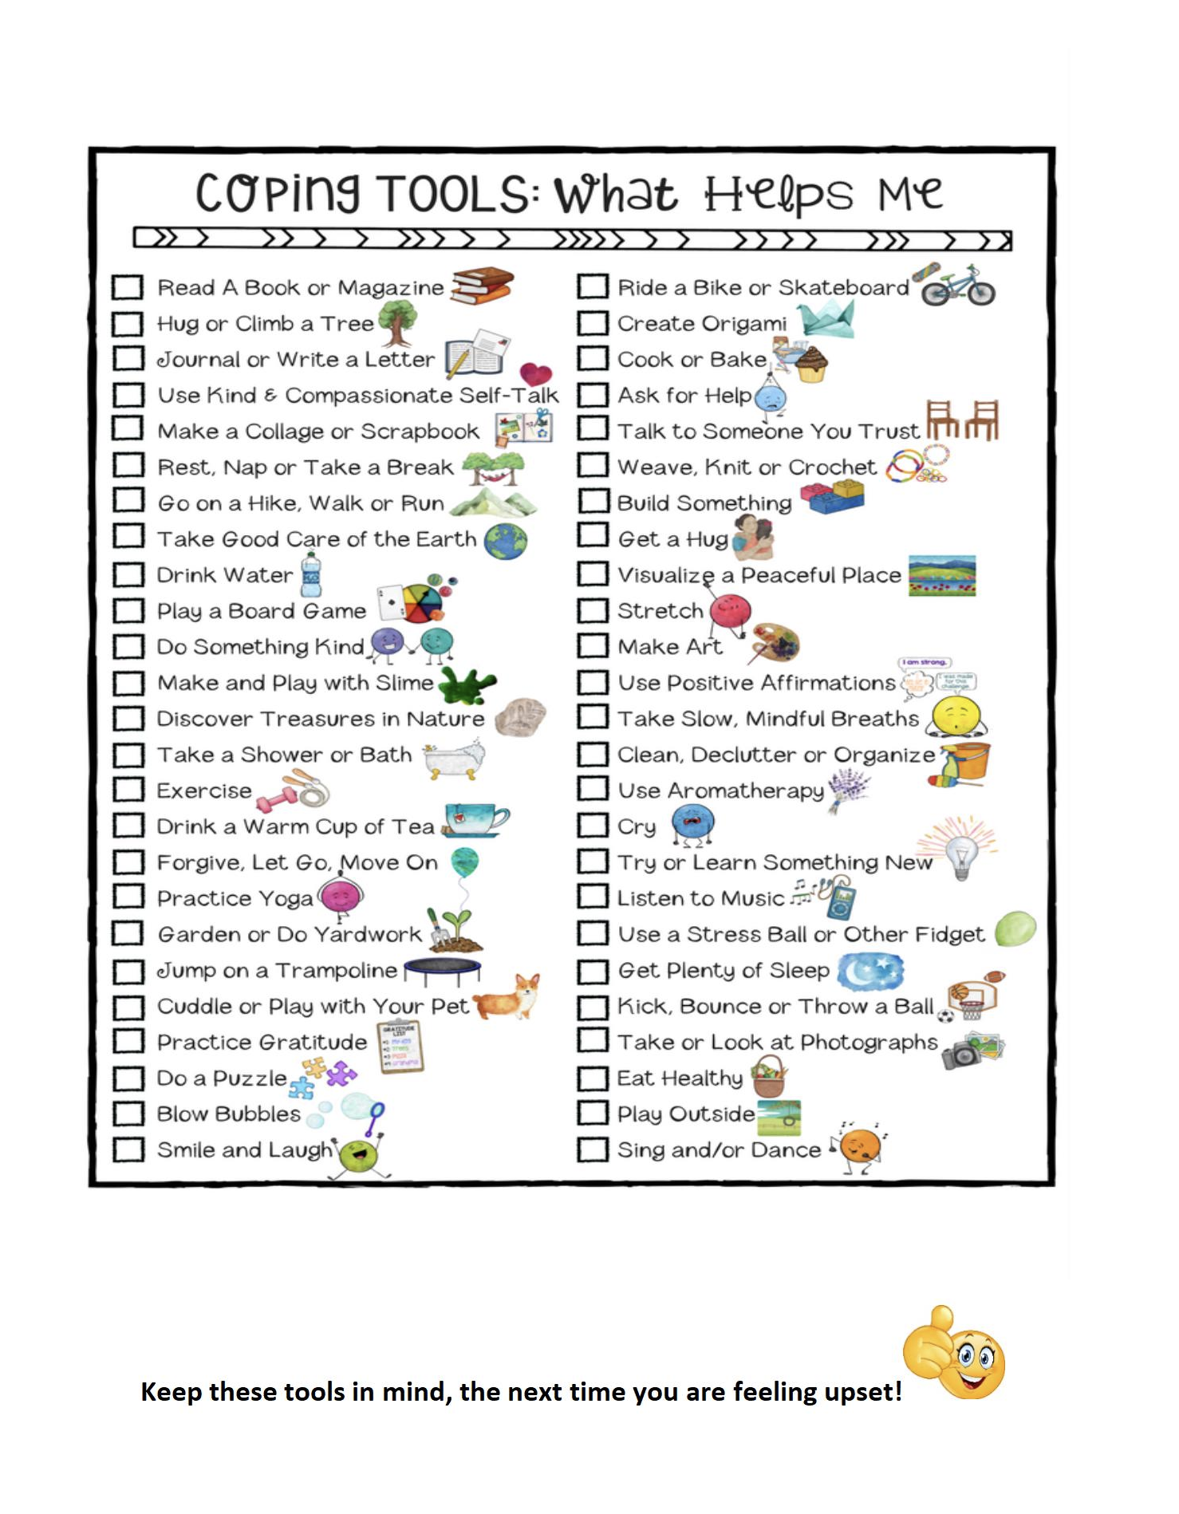

Physical Education both grade 1 and 2
Start Wars day was in May, but we can still train to be a “Jedi in June.”
This training will really increase your fitness level. If you practice every day, you will see yourself getting better and better as the month goes on.
Don’t forget to always warm up and stretch before exercising! Rest between rounds for a few minutes if you need to. Make sure you have a clear area, so you don’t bump into anything. Also be sure there is a parent in the area to supervise.
Before you start the training, please watch the following videos and learn how to do the exercises correctly.

Jumping Jacks https://www.youtube.com/watch?v=c4DAnQ6DtF8
Calf Raises https://www.youtube.com/watch?v=UV8gOrHmuKc
Plank Jacks https://www.youtube.com/watch?v=3VpkyIcnT64
Squats https://www.youtube.com/watch?v=R0vJBTrzLac

Lunges https://www.youtube.com/watch?v=UpyDdQjBTa0
Jump Squats https://www.youtube.com/watch?v=Azl5tkCzDcc
Side Kicks https://www.youtube.com/watch?v=4BSRusbjebw
Plank Knee Tuck https://www.youtube.com/watch?v=LyRBm9Rc5K8

At the end of June, please email a photo of your coloured-in Jedi training sheet. You could also send us a video of yourself performing the exercises for the highest level of Jedi you achieved.
Ms. Westoby = Madame Wolf twolf@hwdsb.on.ca
Ms. Mamone= Madame Wolf twolf@hwdsb.on.ca
Mrs. Pessoa = Mr. Ellis cellis@hwdsb.on.ca

