Assignments for the Week of: June 22-26
Last week of school!

MS Teams | Check for the End of Year Party Meeting!
Literacy | Independent Reading (20 mins) using resources such as books at home, online e.g., Epic, Raz Kids.
Literacy | Grade 1 / 2 Reflection  Use this link to access FlipGrid- a program for you to record a video of yourself answering the given questions that gets sent directly to your teachers and is completely private! Watch an instruction video here.  *check MS Teams for your FlipGrid Code!!
Literacy | Listen to this story- On The First Day of Summer Vacation  Make a summer Bucket List using the template below.  Check out the examples below!
Math | Independent practise using Prodigy.
Math | Math Review - complete the review sheet below that covers all of the concepts we studied during distance learning.  Math Riddles  Solve the riddles below. Take pictures of your work and post them in Show and Tell!  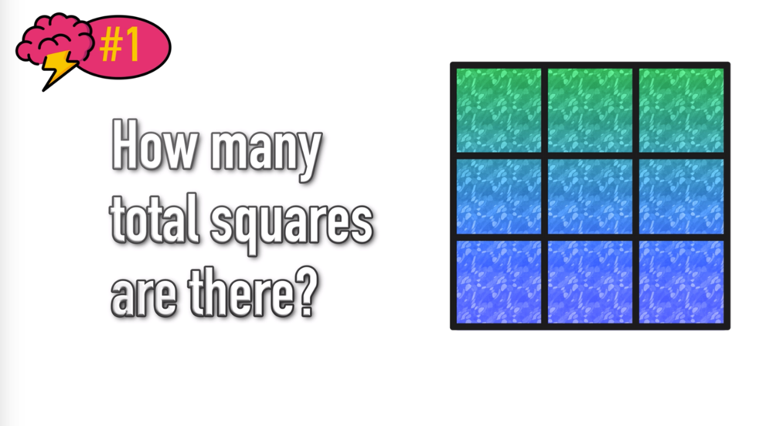  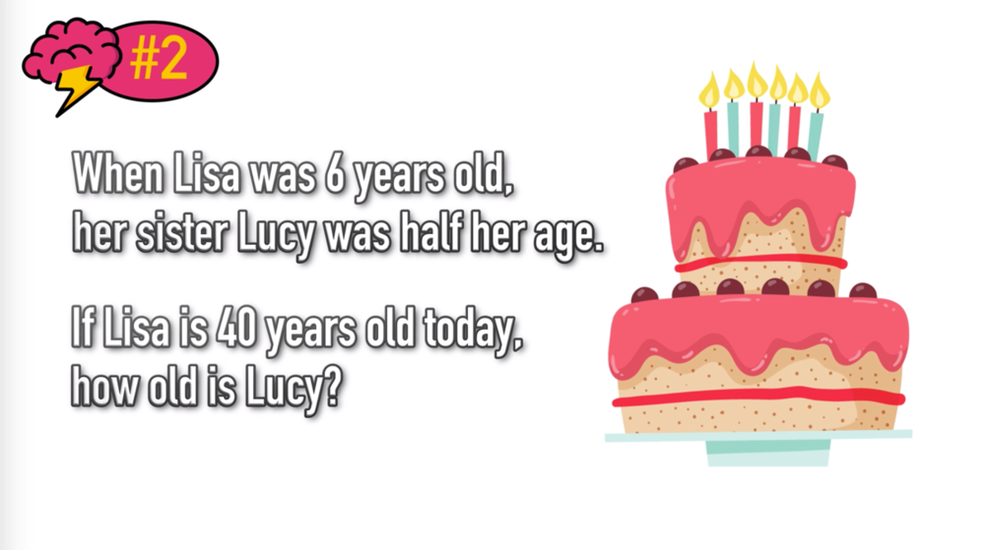  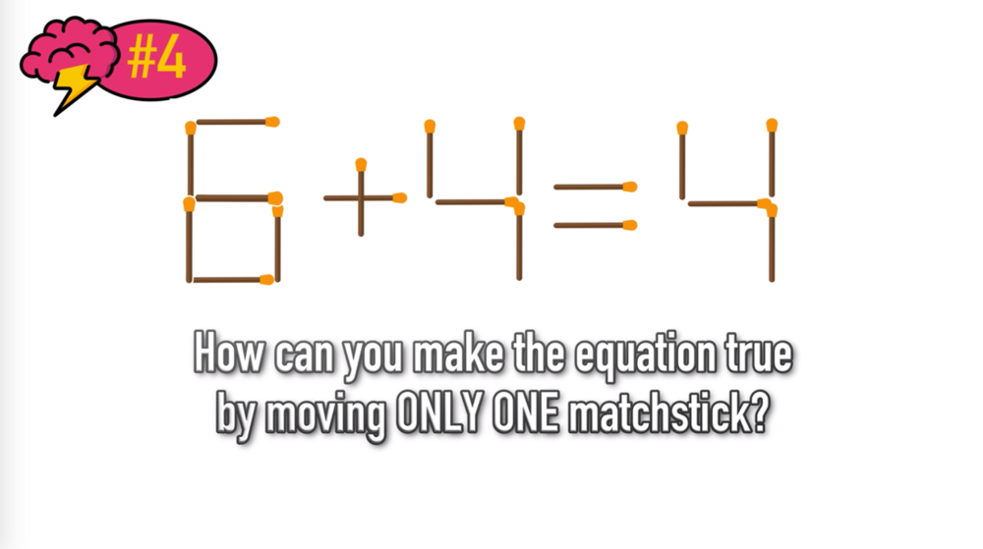
Social Studies | Grade 1 - https://drive.google.com/file/d/1lwk63cQWICV7iXsP5Qohhy2CTiMQAJKJ/view?usp=sharing  Grade 2 - https://drive.google.com/file/d/1JJ7qnFnTOPQI9pmAEO9j40__HlgkCPoh/view?usp=sharing
Phys. Ed. | Jedi June continues!

Summer Bucket List

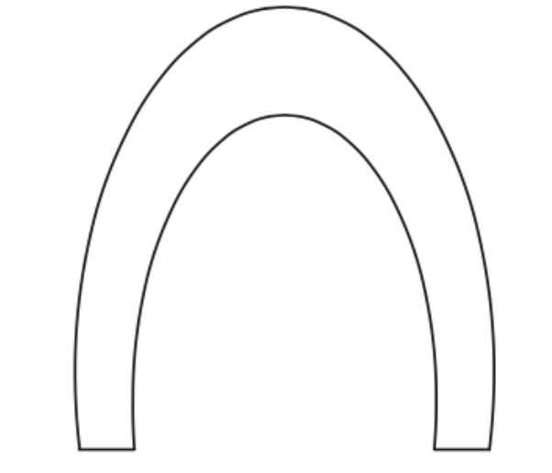


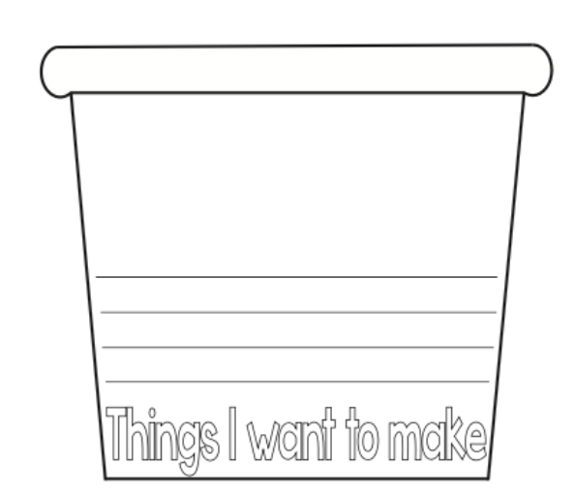

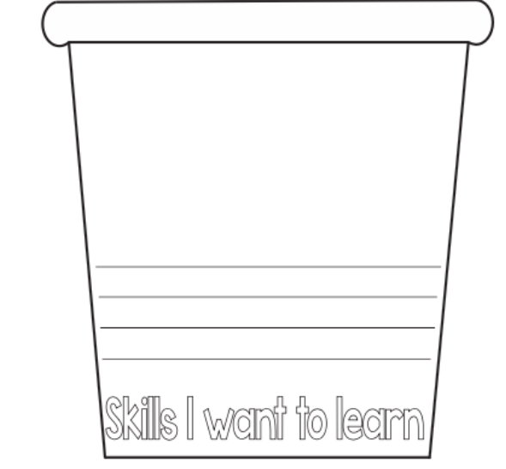

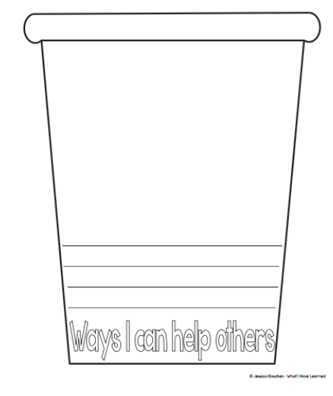

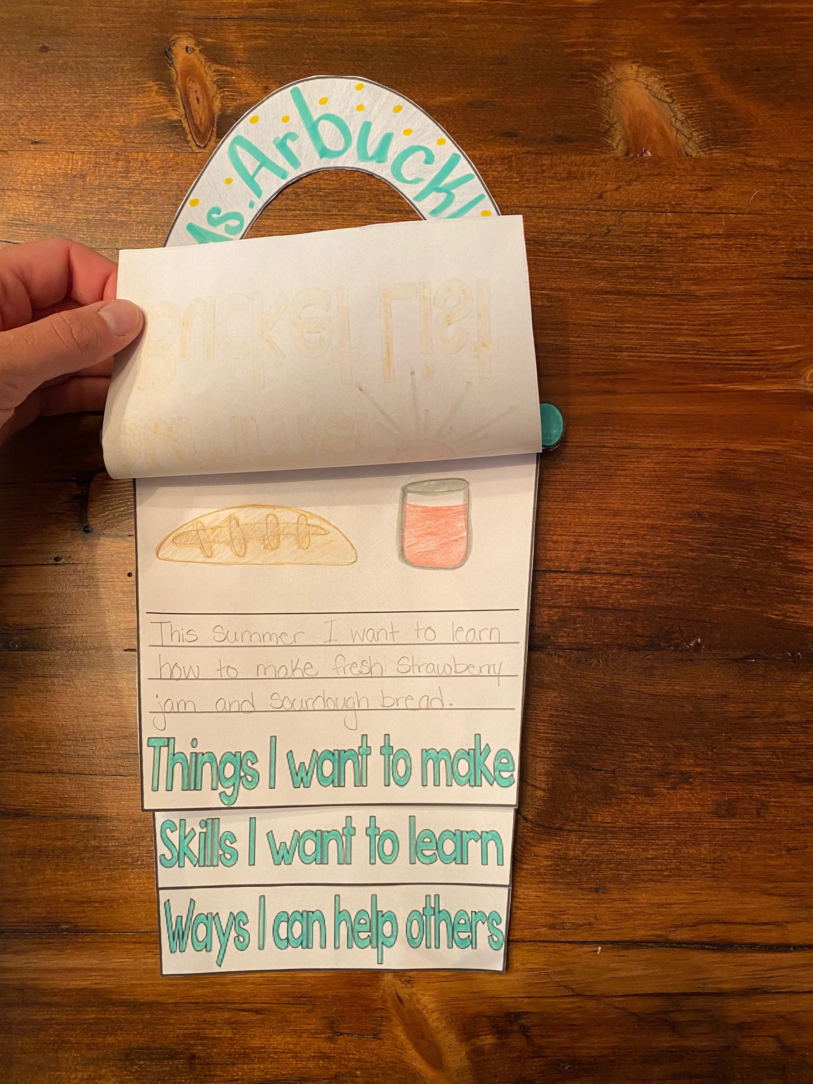
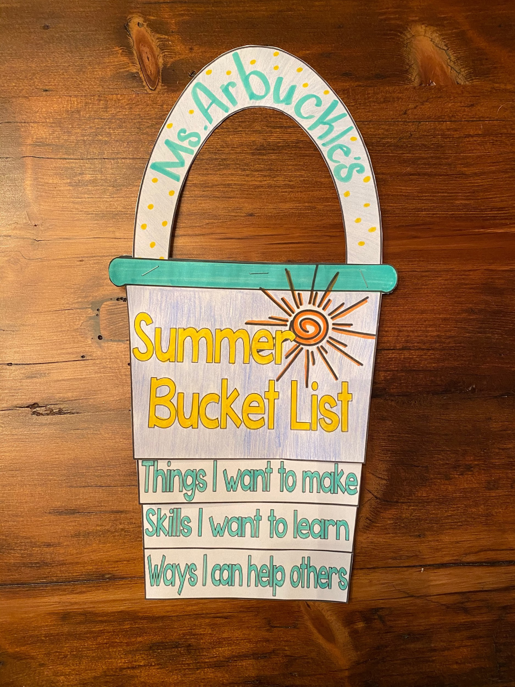
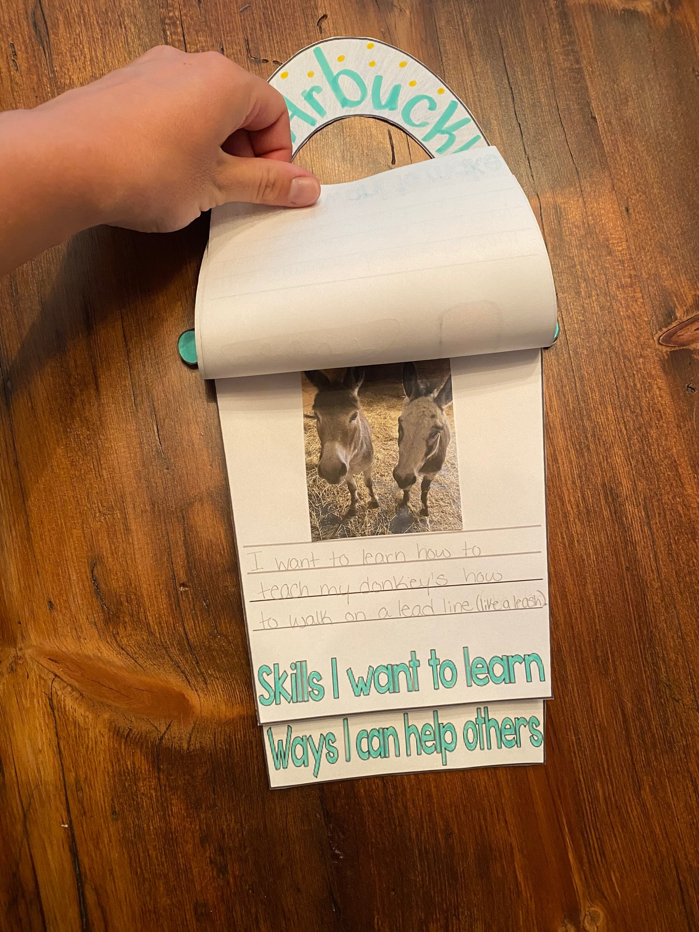
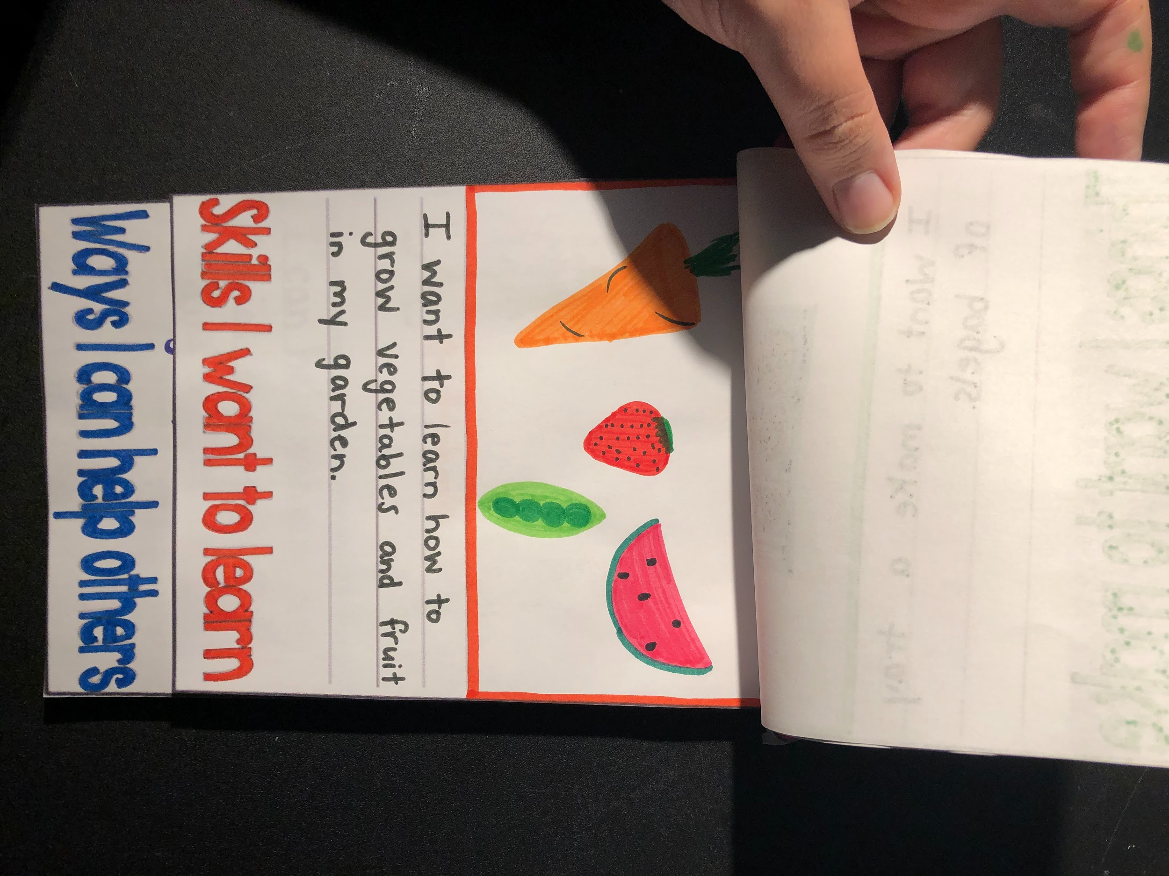
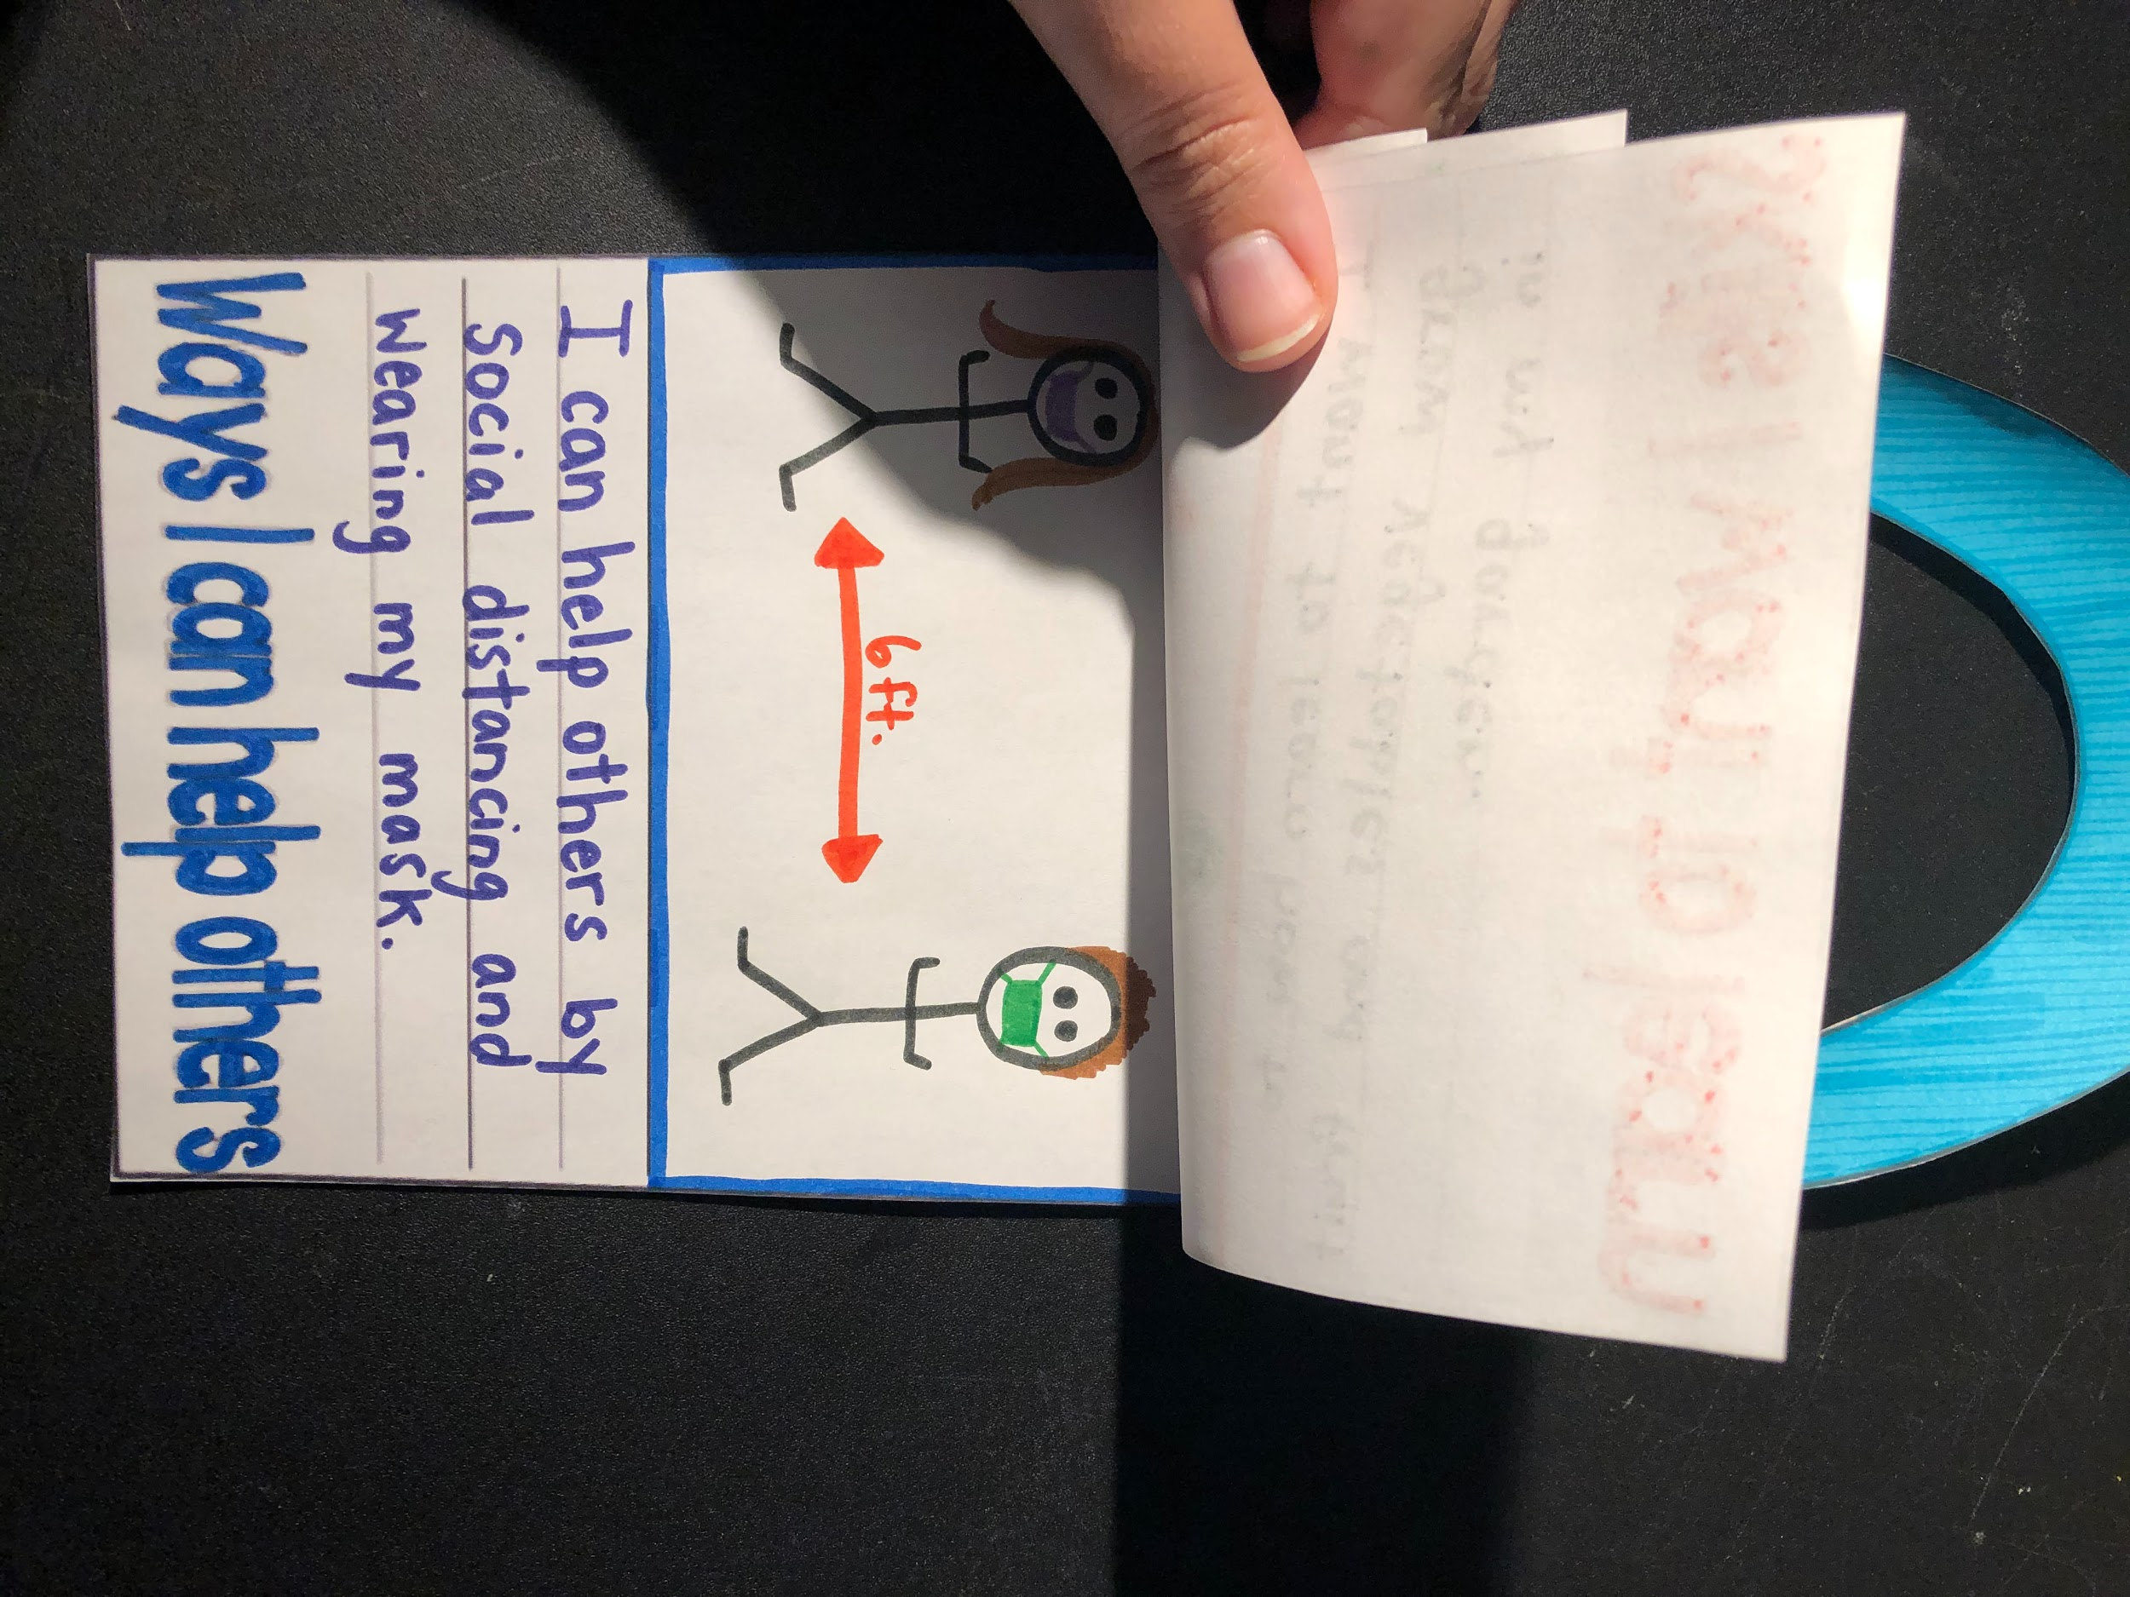
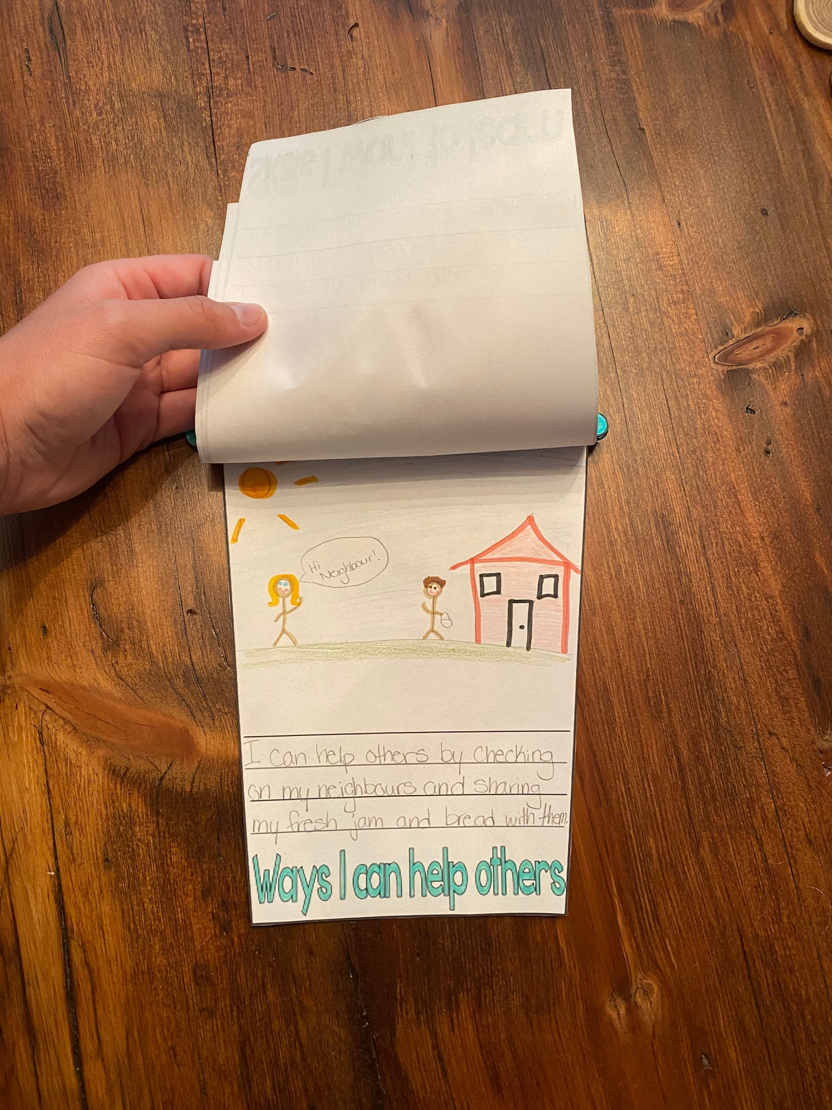
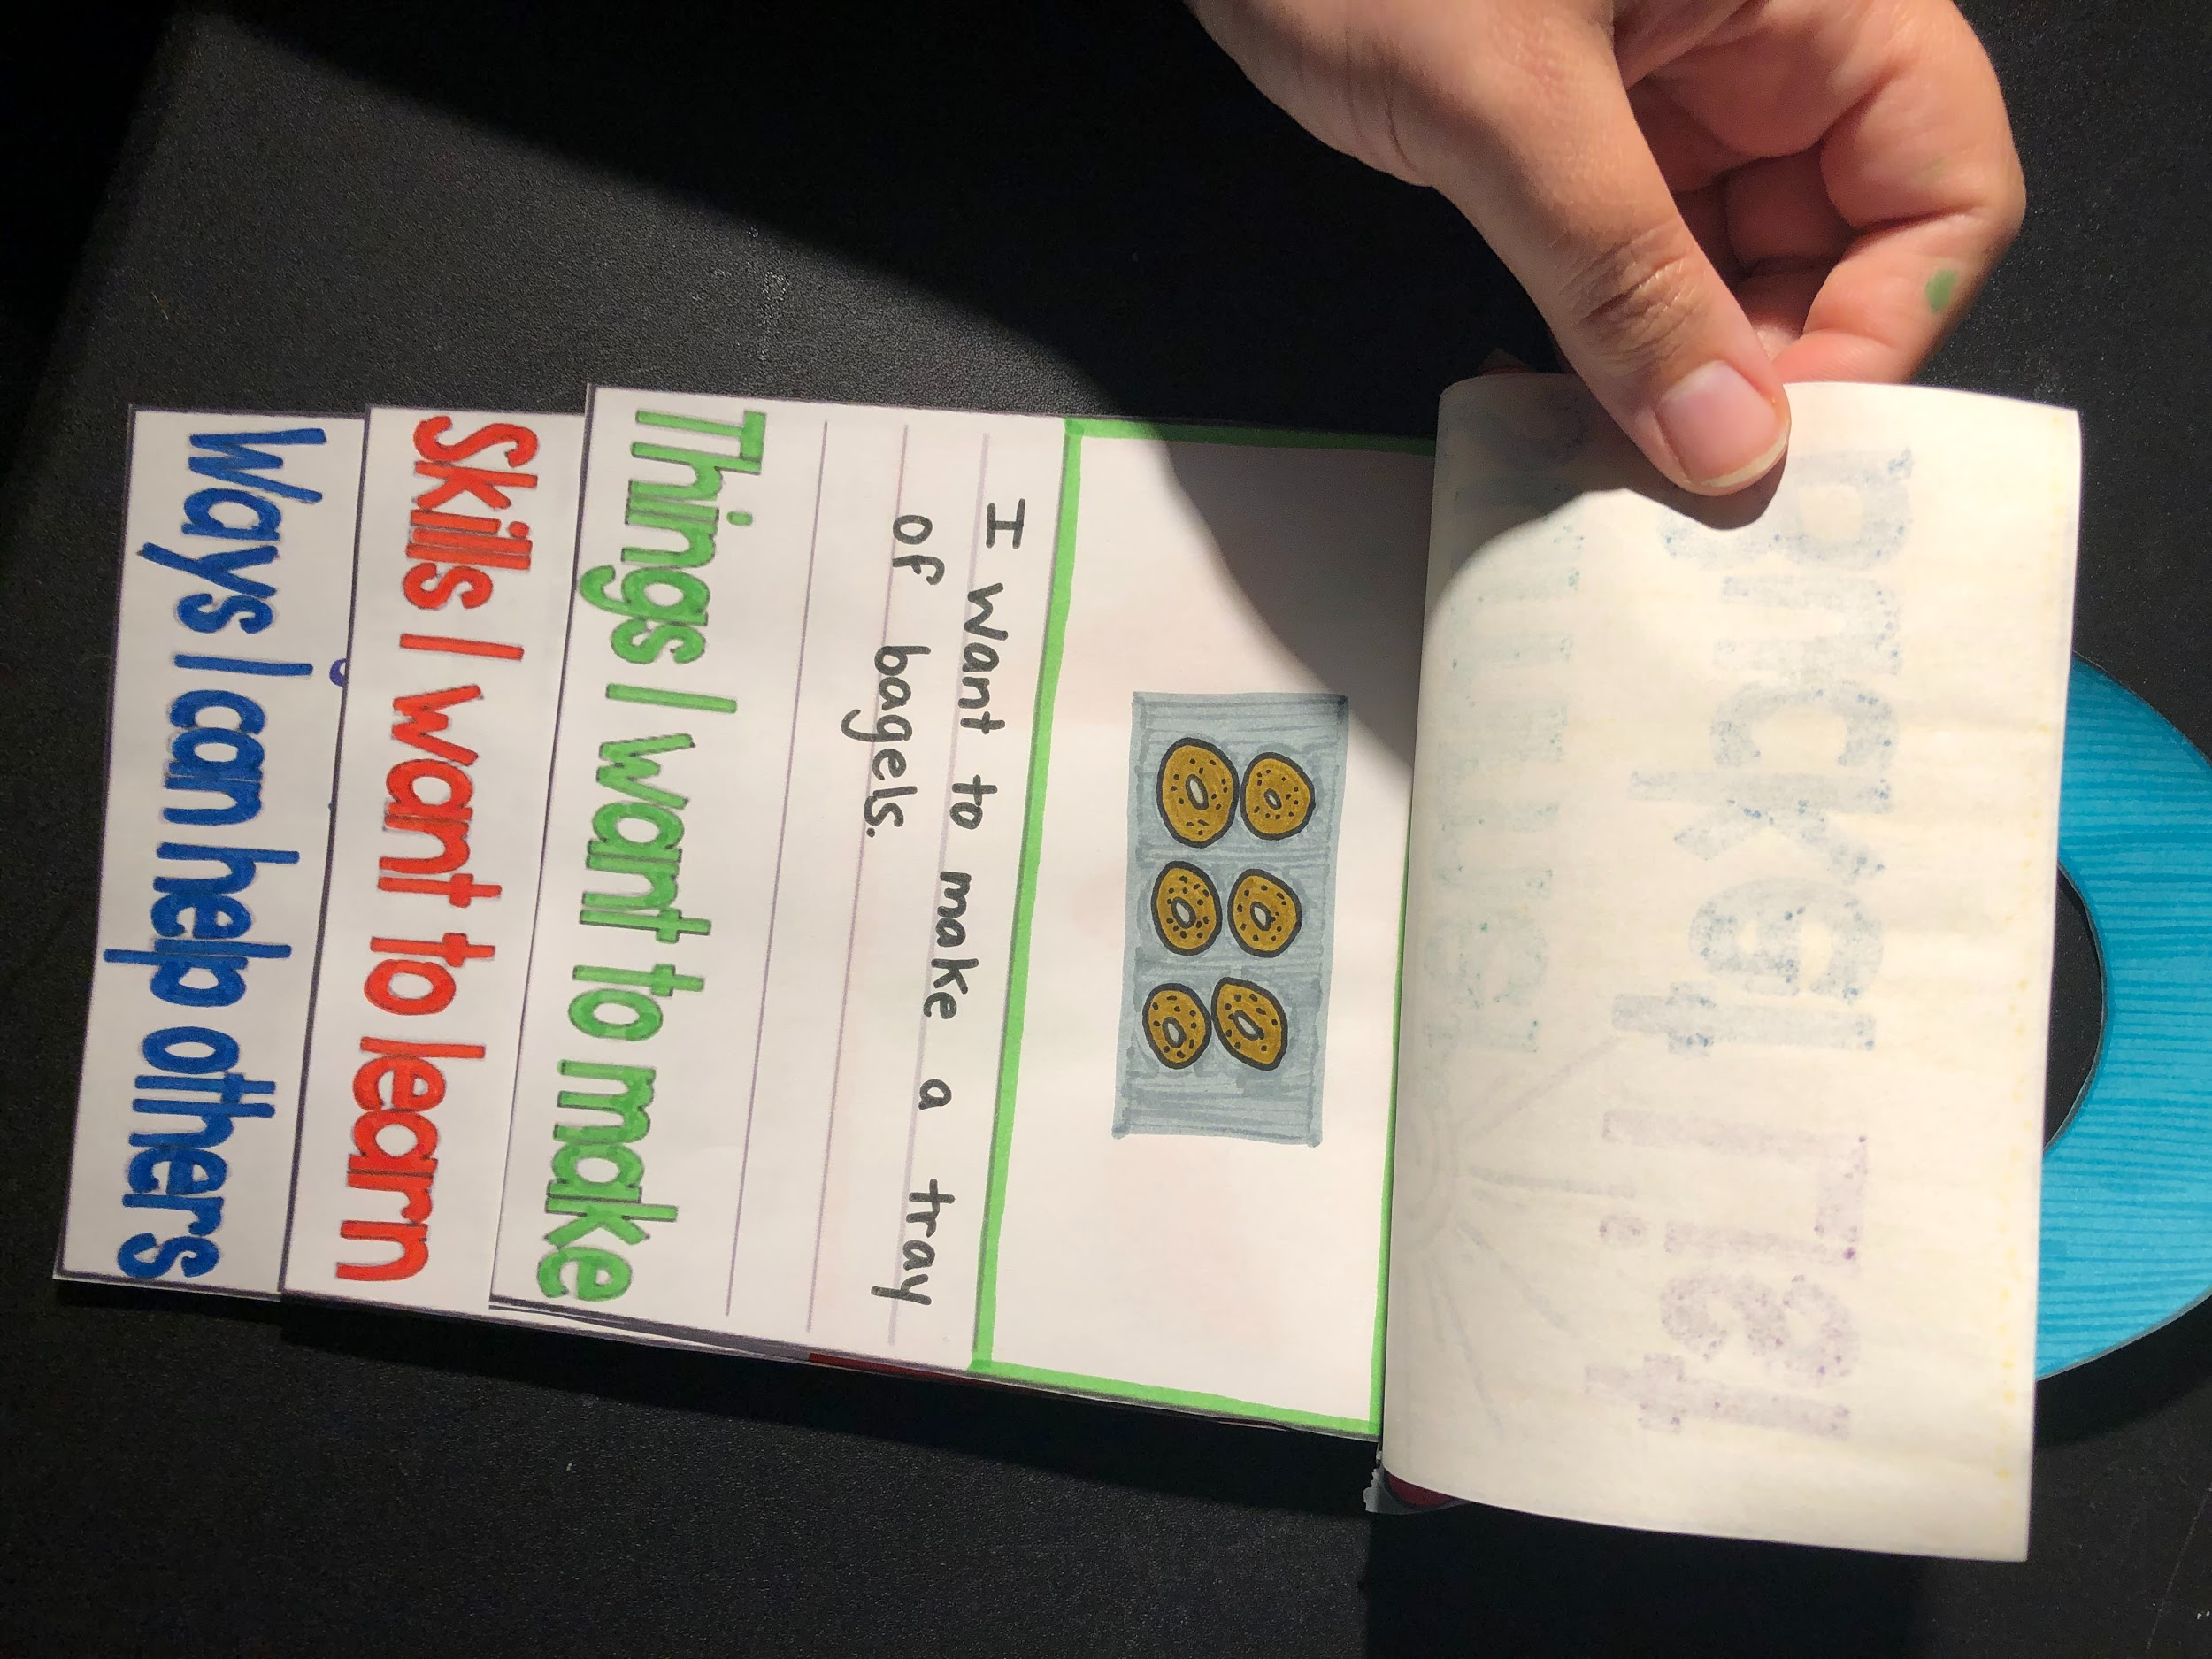
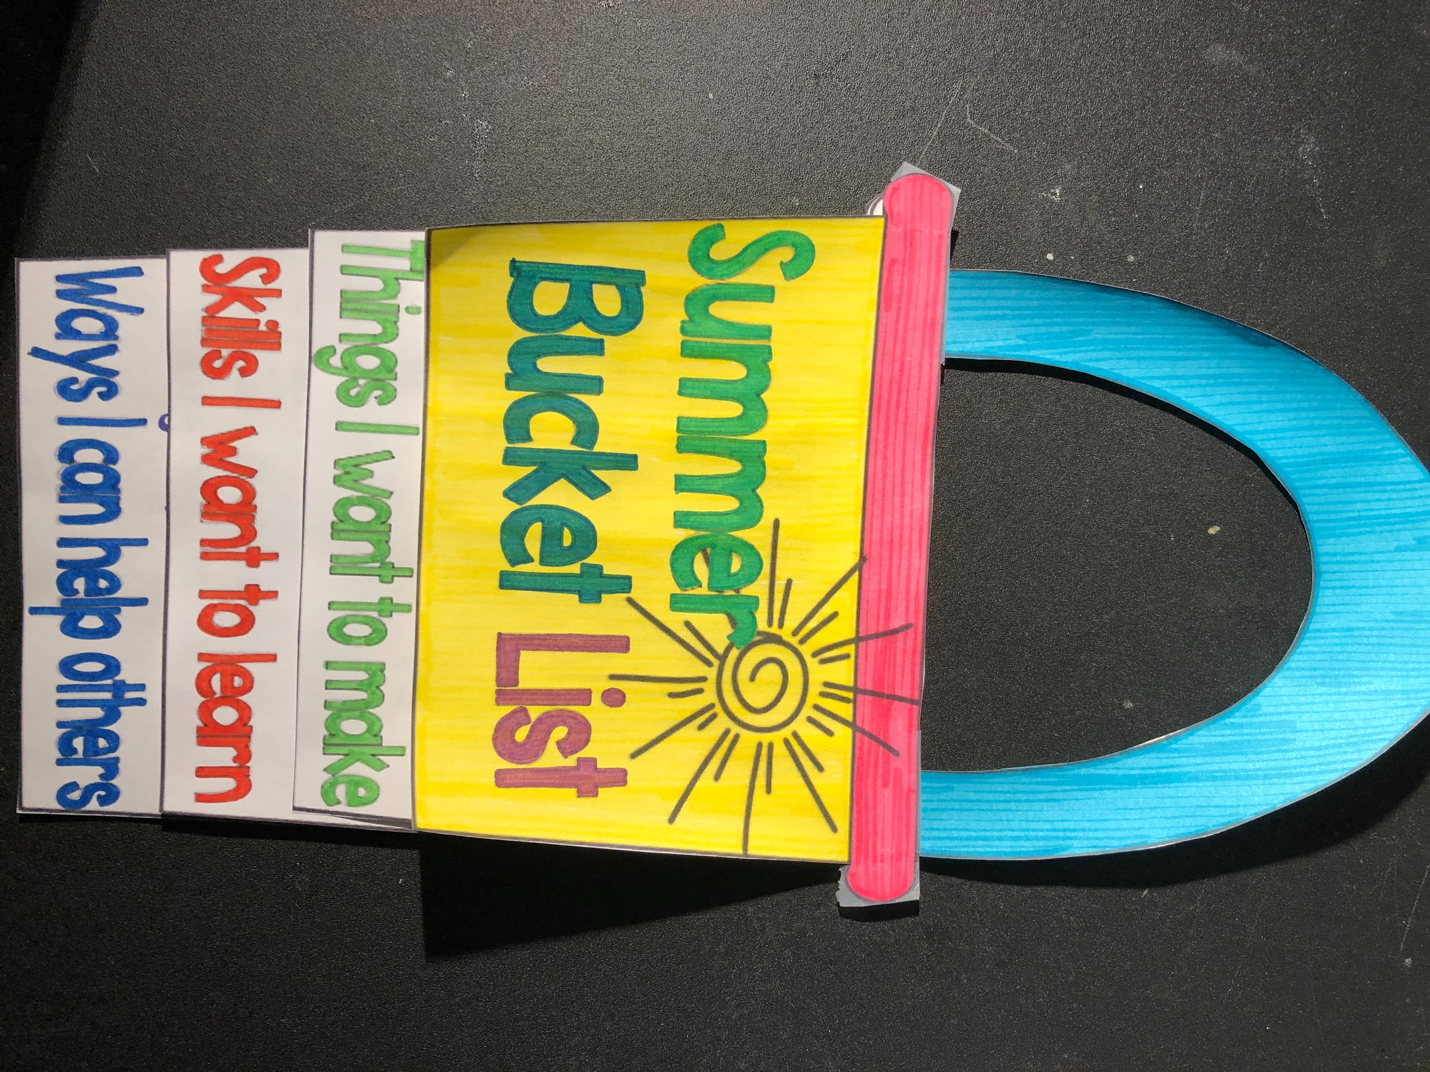
Summer Bucket List Examples
No printer? No problem! Make your own like Ms Mamone
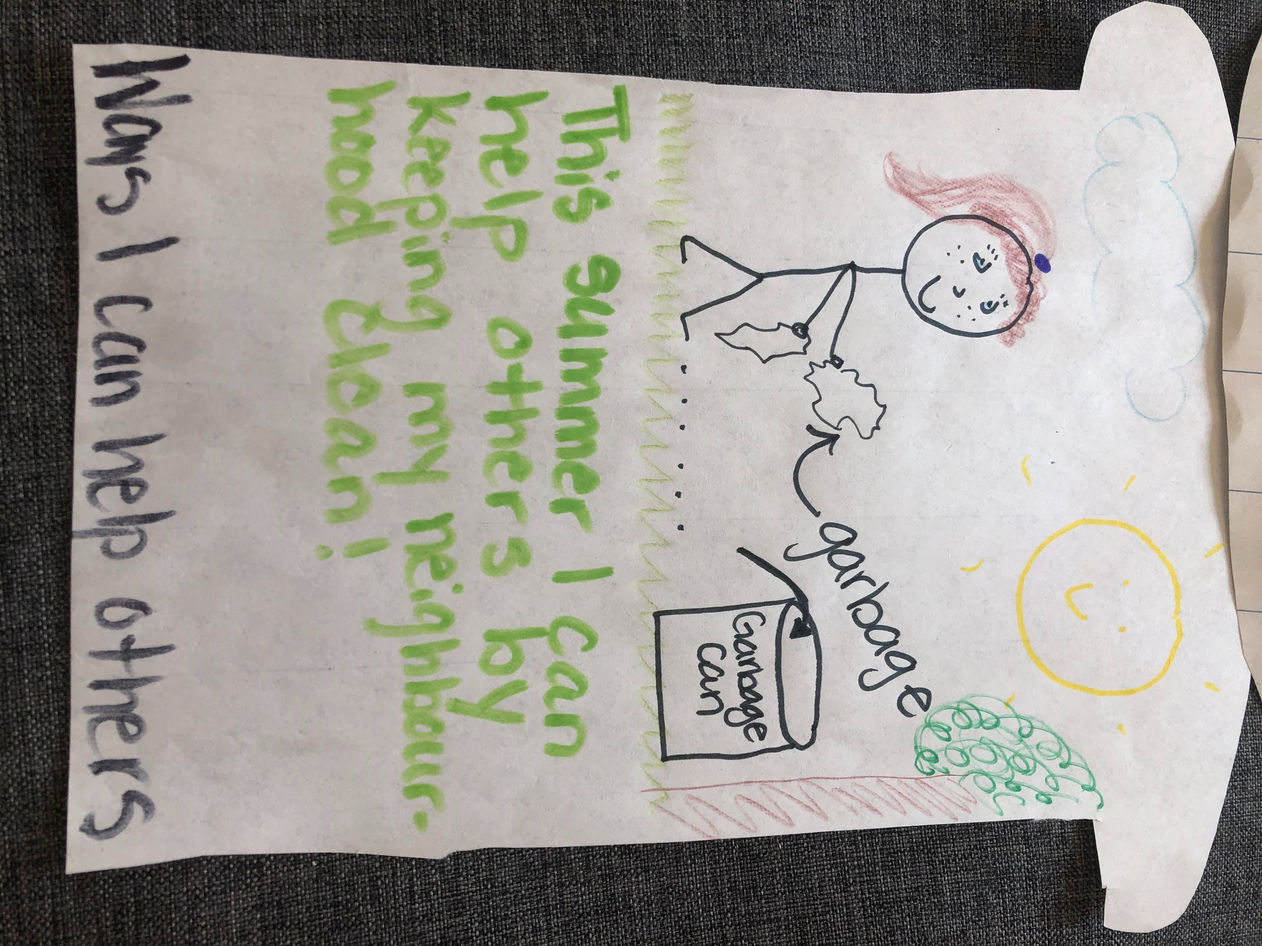
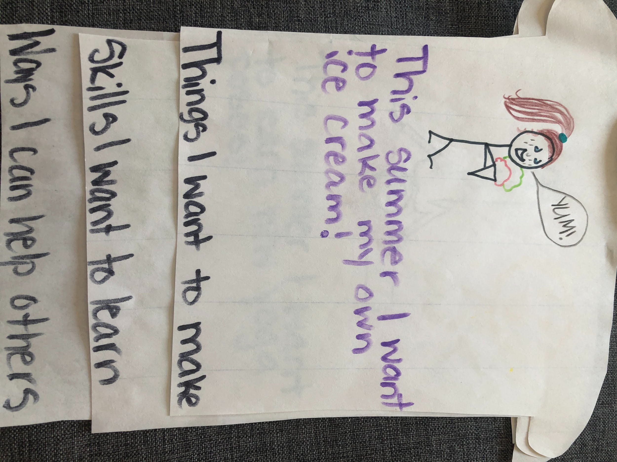
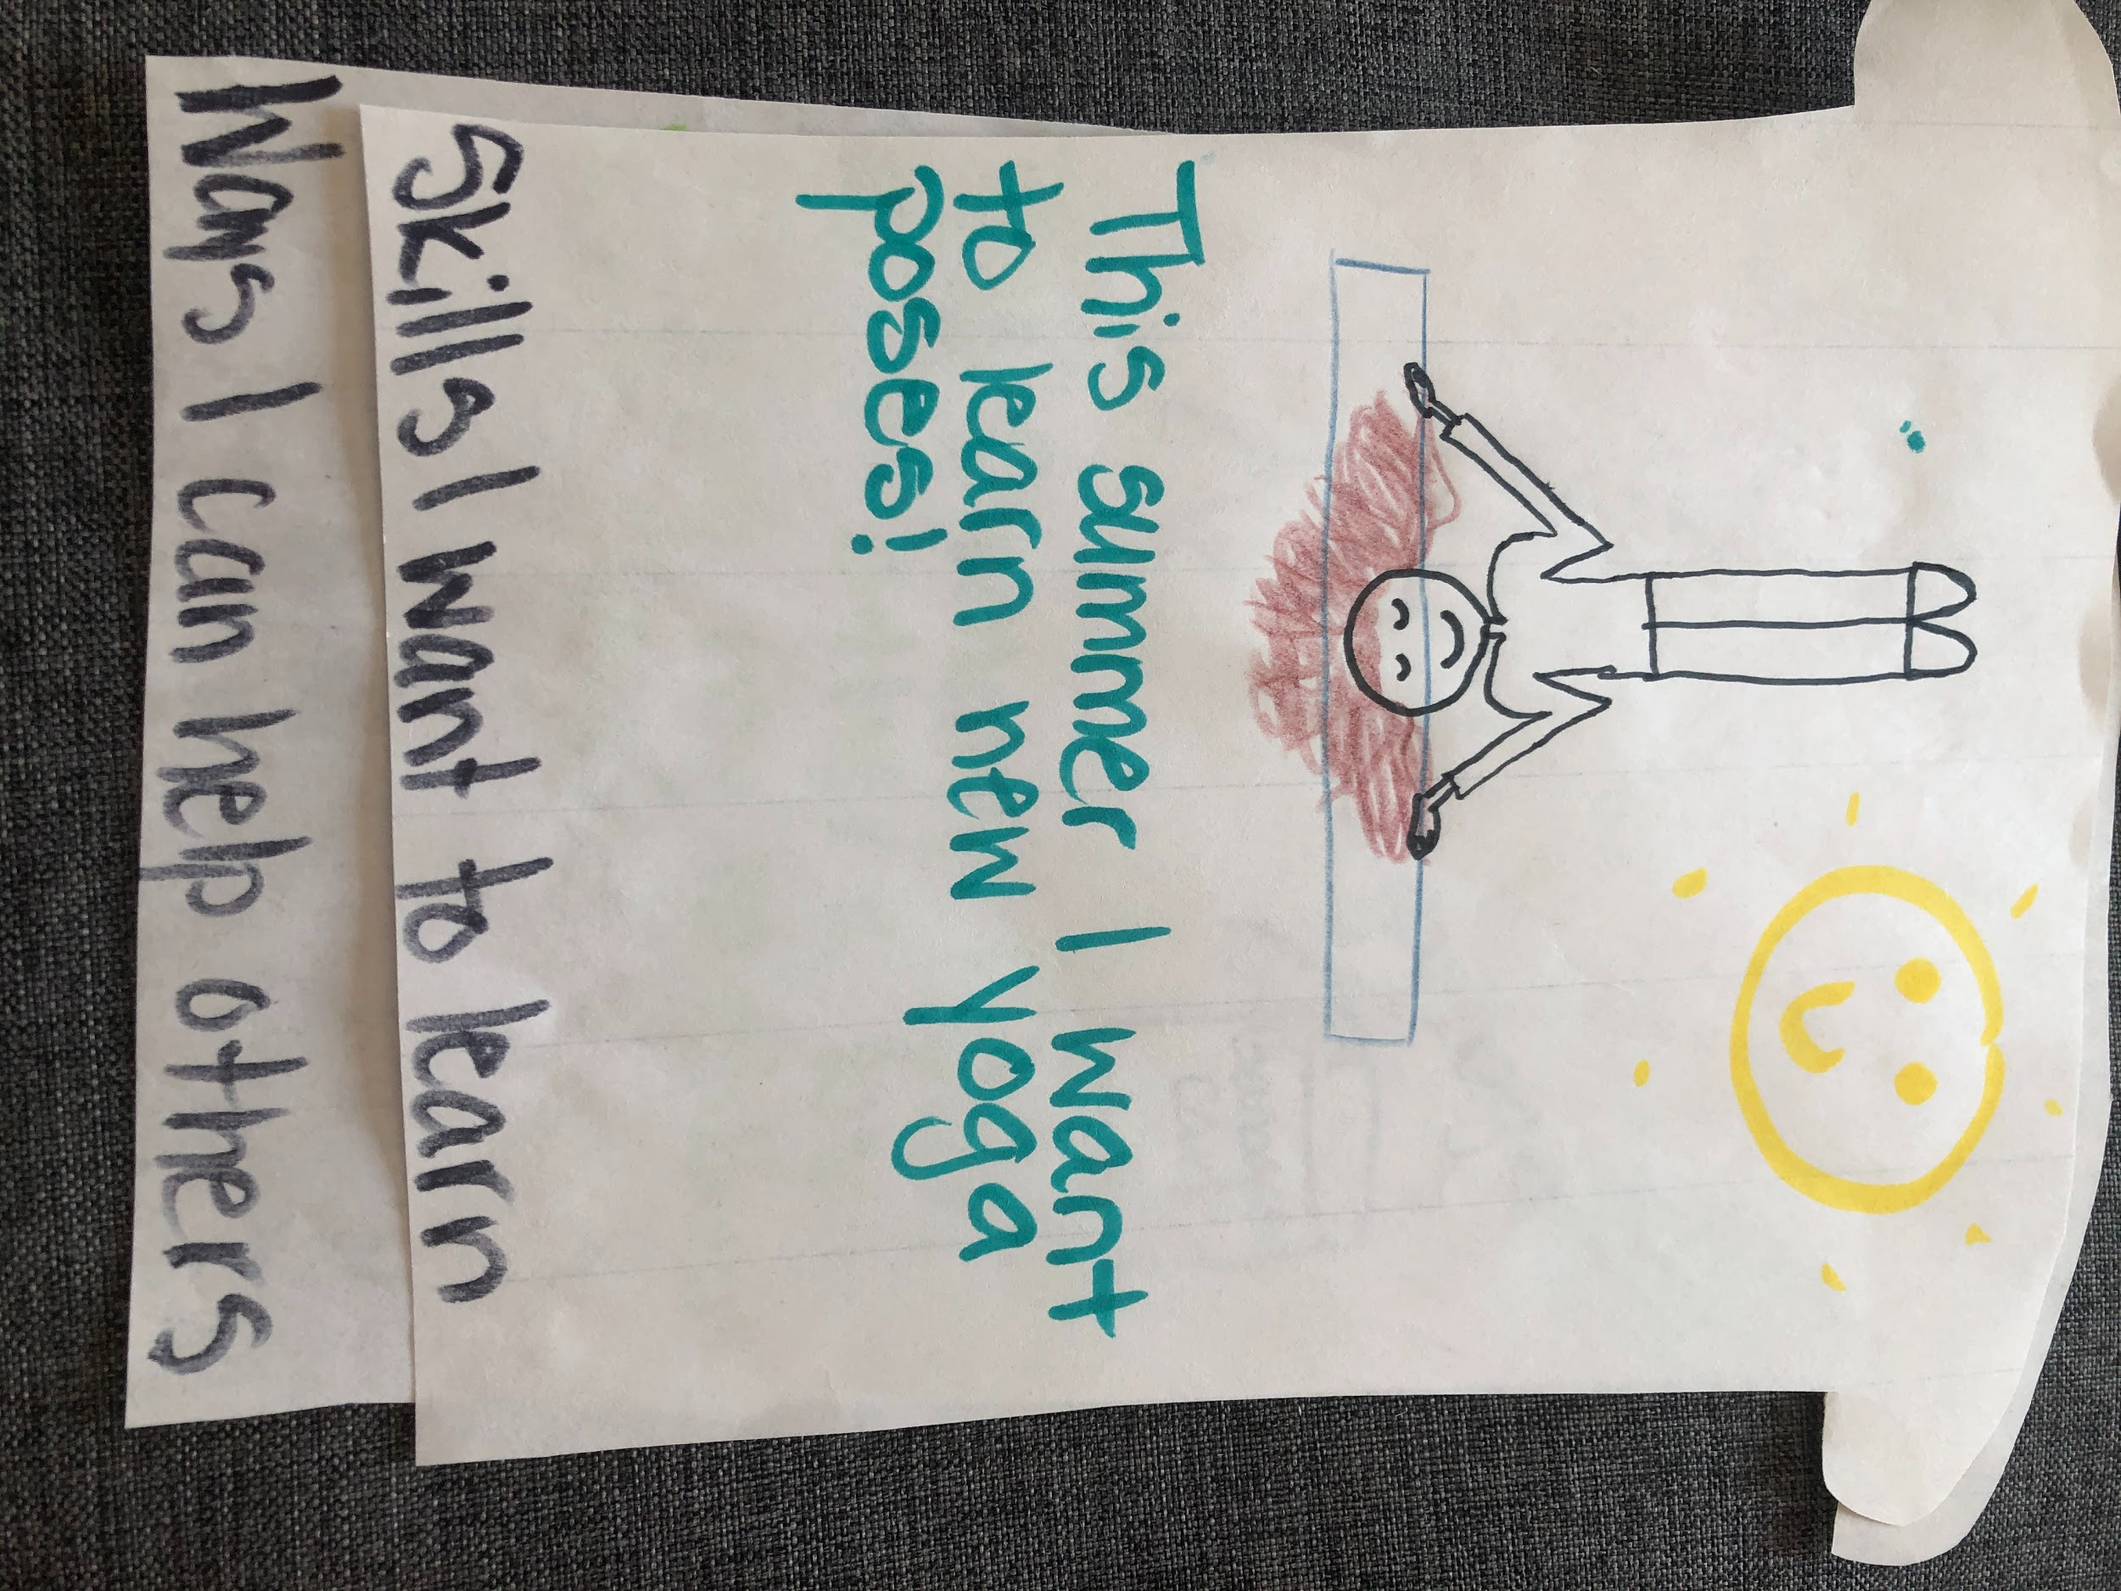
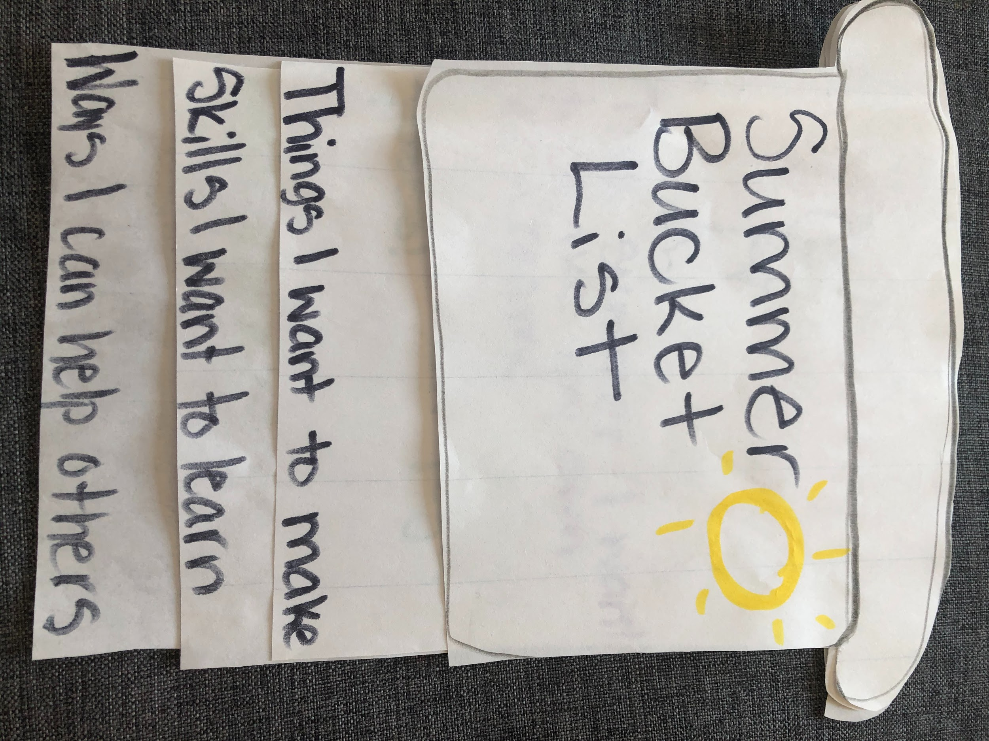

Math Review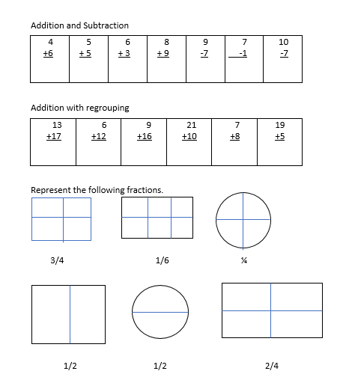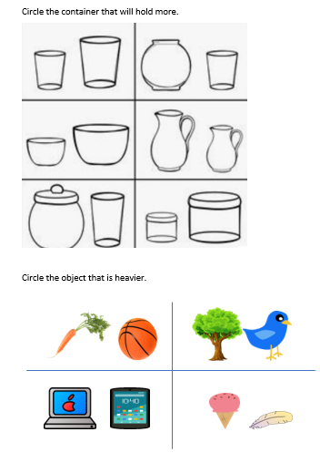
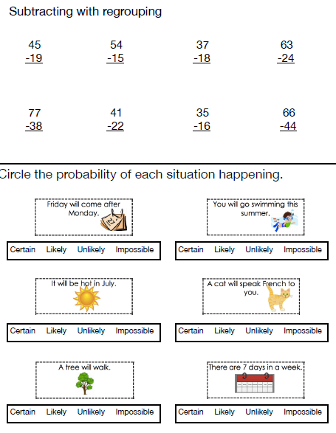
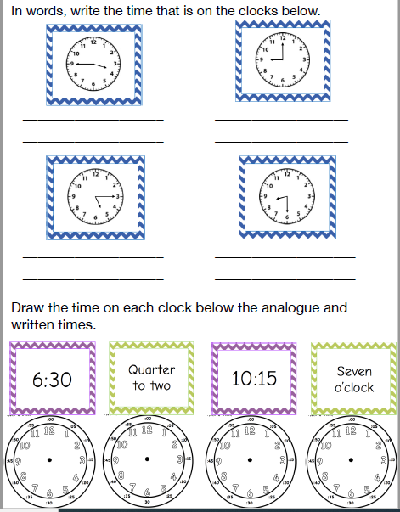

Algebraic Equations

4 + _____ = 10 9 - ____ = 5

5 + _____ = 8 14 - ____ = 10

12 + _____ = 19 _____ - 7 = 7

Problem Solving

Laura bakes 12 cookies. She eats 4 cookies. How many cookies are left?

Meghan blows 5 bubbles. Katie blows 7 bubbles. Alexis blows 9 bubbles. How many bubbles did the girls blow altogether?

Multiplication
Draw an array to represent the multiplication question then write the answer.

3 x 4 =

Division
Share the apples equally between the 3 horses. Complete the division equation.
12 ➗ 3 = _____






