Assignments for the Week of: June 15-19
Only 2 more weeks of school left! Let’s make the most of it!
MS Teams | Check for meeting times for the coming week.
Reading | Independent Reading (20 mins) using resources such as books at home, online e.g., Epic, Raz Kids.
Reading | Focus: Book Report  Read a book from Raz Kids, Epic or a book you have at home. Complete the book report below. (If you don’t have a printer you can create your own!)  *Submit this work by email.  Special Meeting Opportunity: Guest starring Ms. Scott!  Log onto MS teams Tuesday ay 10:00am for some extra reading fun. You will get to listen to and help read a story and do games and activities afterwards.
Writing | Focus: Reflection Writing  Grade 1:  On a piece of paper or on the computer - write 5-6 sentences on your favourite things about grade 1. (Favourite days, activities, subject, memory, something you learned, or new friends, etc.).  Grade 2:  On a piece of paper or on the computer -write 1 paragraph on your favourite thing about grade 2.  (Favourite days, activities, subject, memory, something you learned, or new friends, etc.).  *Submit this work by email.
Writing | Focus: Word Work + Numbers!  Outdoor Scavenger Hunt- Complete the scavenger hunt sheet below.  *Submit this work by email.
Media | Focus: Science / Literacy / Media  Use your chalk to draw your favourite animal OR your favourite character from a book / TV show / movie.  Take a picture of your creation and submit it to your teacher by email.  We will use these pictures to create a PicCollage of your work!
Math | Independent practise using Prodigy.
Numeracy | Lesson:  Grade 2 – Division – watch this video up to the 43 second mark to learn what division means. Then watch this video to learn how to divide equally.  Complete the Equal Sharing worksheet below.  Grade 1 – Calendar– watch this video.  Complete the calendar worksheet below.  *Submit this work by email.  Additional Activity: Complete the blank calendar by filling it in with your birthday month’s information for the year 2020. See Ms. Westoby’s example below.
Data Manage-  ment | Focus: Probability – watch this video about probability and how to use your bubbles for some math fun! Here is another video to review the Probability terms.  Grade 1 and 2:  Complete the 2 worksheets below.  Next, complete the experiment worksheet.  Finally, go outside to blow some bubbles and have some math fun! Feel free to record yourself and send it to your teacher OR upload it in the Show and Tell tab.
Social Studies | Grade 1 –  https://drive.google.com/file/d/11Dx-XlQv7Y9jcTPwMVICcynXc-KsXc4z/view?usp=sharing  Grade 2 - https://drive.google.com/file/d/1C1tMnT73O437rt12cxpHlcqlmpkMXf6h/view?usp=sharing
Physical Education |   Jedi June continues!  New This week:  Dance Week!

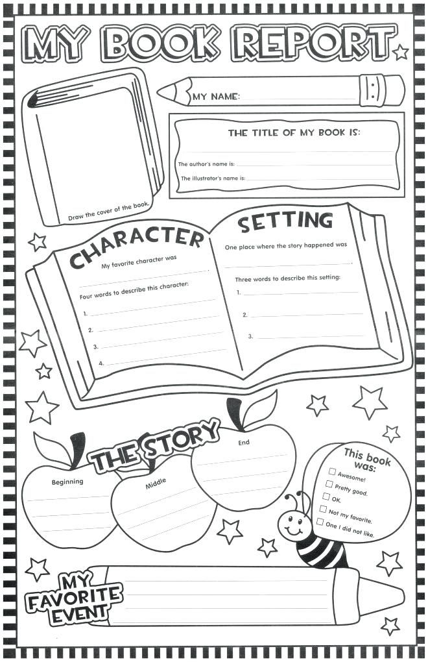

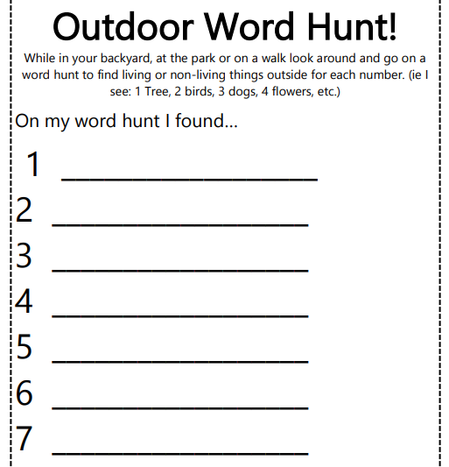

Equal Sharing!
Solve the following problems using numbers, pictures and words.
Joshua shares15 pieces of candy into 3 equal groups. How many pieces of candy are in each group?

Malcolm divides 20 cookies into 5 equal groups. How many cookies are in each group?

Liam has 16 Pokémon cards. He shares them into 4 equal piles. How many cards are in each pile?

Metra made a tray of 12 cupcakes. She wanted to share them equally between Mia, Brady, Jack and herself. How many cupcakes would each friend get?

Ms. Mamone, Mrs. Pessoa and Ms. Westoby have 24 iPads to share between their classrooms. How many iPads will each classroom have?

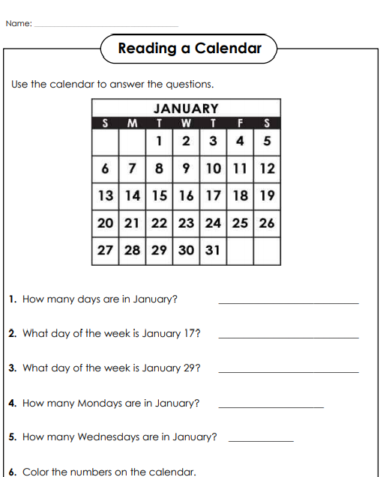
Colour weekends blue and weekdays yellow.

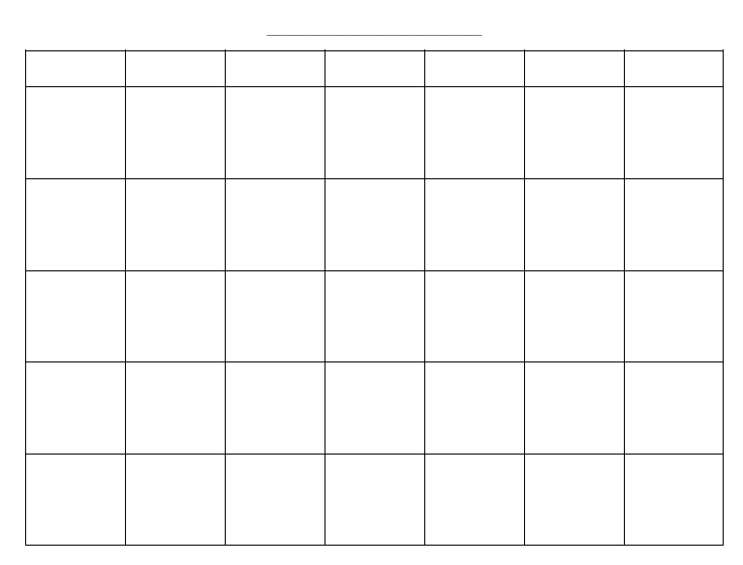

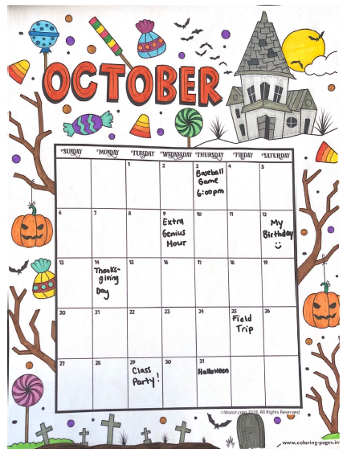

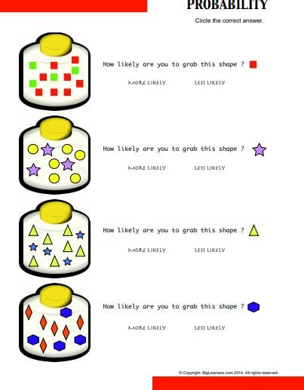

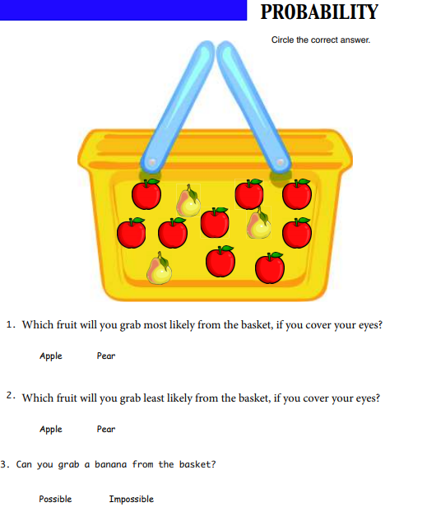

Probability Experiment
Use the words in the word box below to identify the probability of the following events happening.
- The weather is warm in the summer. __________________________
- You attend a class meeting on Teams next week. __________________________
- Mrs McLaughlin flips a coin. Will it land of heads or tails?_______________________
- You will see snow in the winter. ________________________
- Your parents will let you have chocolate cake for breakfast. ____________________
- Halloween will take place in January._________________________
likely | possible | unlikely
impossible | certain | Equal chance

Probability Experiment
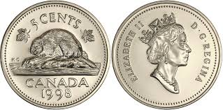
Tails Heads
For this experiment you are going to flip a coin 20 times.
Before you start. What do you think the probability is that you will get exactly 10 heads and 10 tails?
____________________________________________________________________
Now, flip the coin 20 times and fill out your results in the tally chart below
Heads | Tails
How many times did you get heads?_____________________
How many times did you get tails? ______________________
Use the tally chart of your coin flips to represent your data on a bar graph!
Title: ___________________________________________________________
Heads | Tails

Write one sentence to explain your results.

Physical Education both grade 1 and 2
Start Wars day was in May, but we can still train to be a “Jedi in June.”
This training will really increase your fitness level. If you practice every day, you will see yourself getting better and better as the month goes on.
Don’t forget to always warm up and stretch before exercising! Rest between rounds for a few minutes if you need to. Make sure you have a clear area, so you don’t bump into anything. Also be sure there is a parent in the area to supervise.
Before you start the training, please watch the following videos and learn how to do the exercises correctly.

Jumping Jacks https://www.youtube.com/watch?v=c4DAnQ6DtF8
Calf Raises https://www.youtube.com/watch?v=UV8gOrHmuKc
Plank Jacks https://www.youtube.com/watch?v=3VpkyIcnT64
Squats https://www.youtube.com/watch?v=R0vJBTrzLac

Lunges https://www.youtube.com/watch?v=UpyDdQjBTa0
Jump Squats https://www.youtube.com/watch?v=Azl5tkCzDcc
Side Kicks https://www.youtube.com/watch?v=4BSRusbjebw
Plank Knee Tuck https://www.youtube.com/watch?v=LyRBm9Rc5K8

At the end of June, please email a photo of your coloured-in Jedi training sheet. You could also send us a video of yourself performing the exercises for the highest level of Jedi you achieved.
Ms. Westoby = Madame Wolf twolf@hwdsb.on.ca
Ms. Mamone= Madame Wolf twolf@hwdsb.on.ca
Mrs. Pessoa = Mr. Ellis cellis@hwdsb.on.ca

