Assignments for the Week of: May 25 -29
As you know the Premier Ford has decided to keep school buildings closed for the remainder of the current school year, however, we will continue with Distance Learning. Each week, on Friday, we will send home the learning/ homework for the coming week.
MS Teams | Check for meeting times for the coming week.
Reading | Independent Reading (20 mins) using resources such as books at home, online e.g., Epic, Raz Kids.
Reading | Focus/Lesson: Inferring – watch the video to learn about Inferring  Complete the chart below.  *Submit this work by email.
Let’s get outside! Complete the ABC scavenger hunt below.

*Submit this work by email.
Writing | Focus/Lesson: Journal writing  Pick one of the following topics to write a journal entry.  - Write about a time when you felt lucky.  - Think about your time at school. What was your favourite time in grade 1 or grade 2?  - Write about a time when you got to do something that only kids can do. How do you think your parents felt?  *Submit this work by email.
Media | Check out the two Pic Collages below, one of non-living things and one of living things.  Make your own Pic Collage of living or non-living things.  *Post your Pic Collage in Show and Tell.
Numeracy | Independent practise using Prodigy
Numeracy | Mini-Lesson: Problem solving strategy – RUCSAC video  Here is another problem solving example - RUCSAC video2  Practice: Work on the word problems below.  *Submit this work by email.
Numeracy | Mini-Lesson:  Grade 1 – Doubling mini lesson – Check out this video  Grade 2 - Multiplication – Watch this video  Complete the practise sheets below.  *Submit this work by email.
Numeracy | Bubble Math – Make a bubble wand and bubbles.  *If you need to know how to make a bubble wand or the bubble mixture there are some instructions below.  Pick a number and try to blow or swipe that many bubbles.  Were you able to make that many bubbles?  Did you make more or less?  How many?  Try again.  *Post a video or picture of your bubbles on the Show and Tell page in Teams.
Social Studies | See activity below.
Music | Music assignment with Mr. Ellis video  See the information below for instructions.  *Share your instrument on the Show and Tell channel.
Physical Education | See activity below.

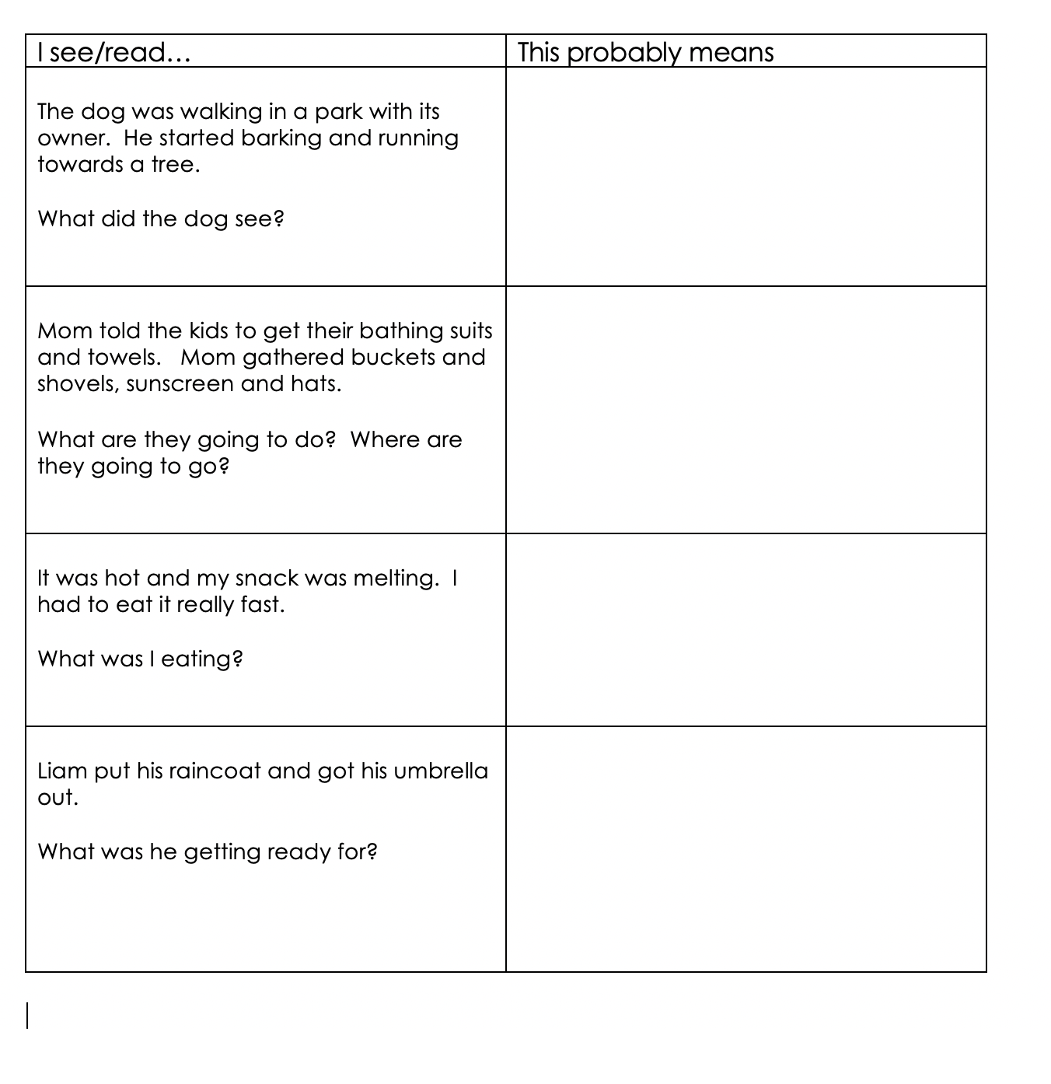

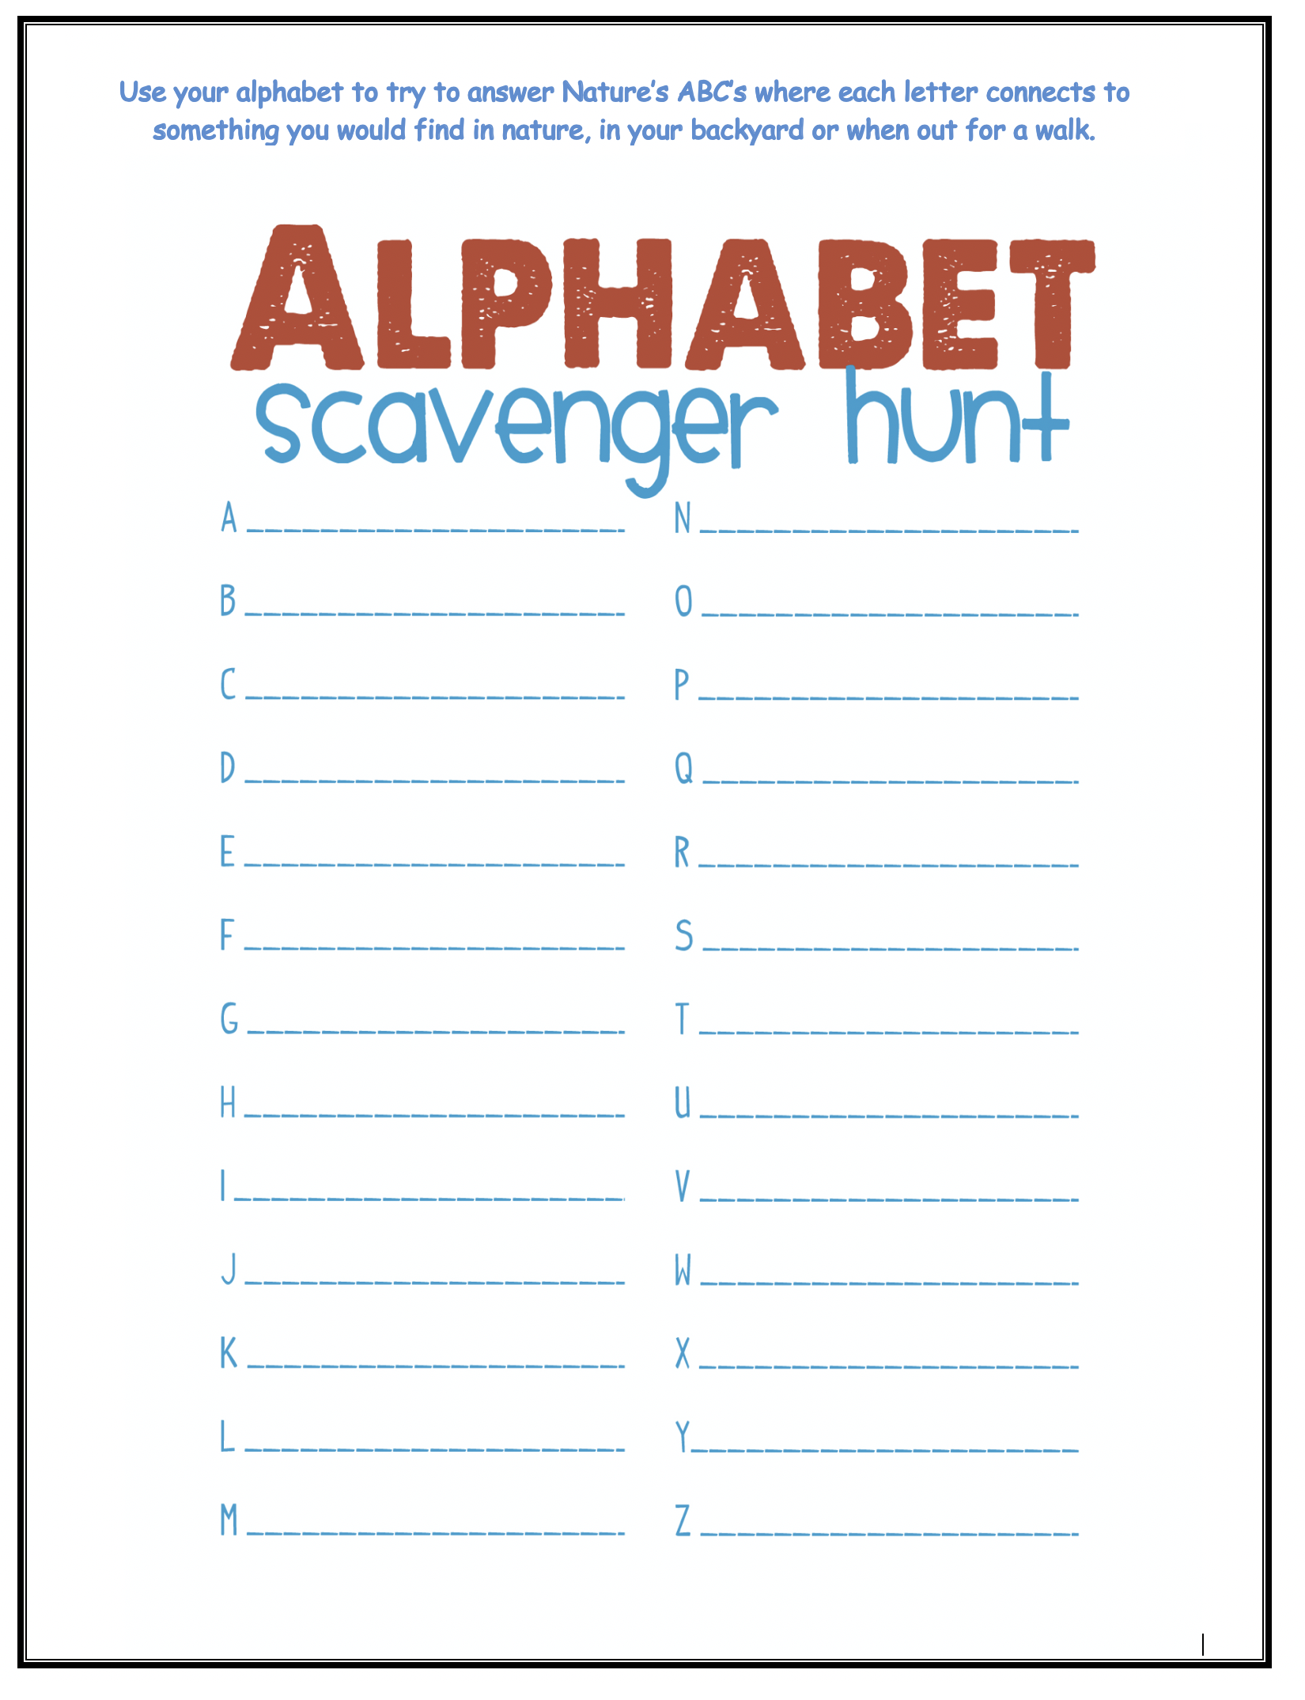

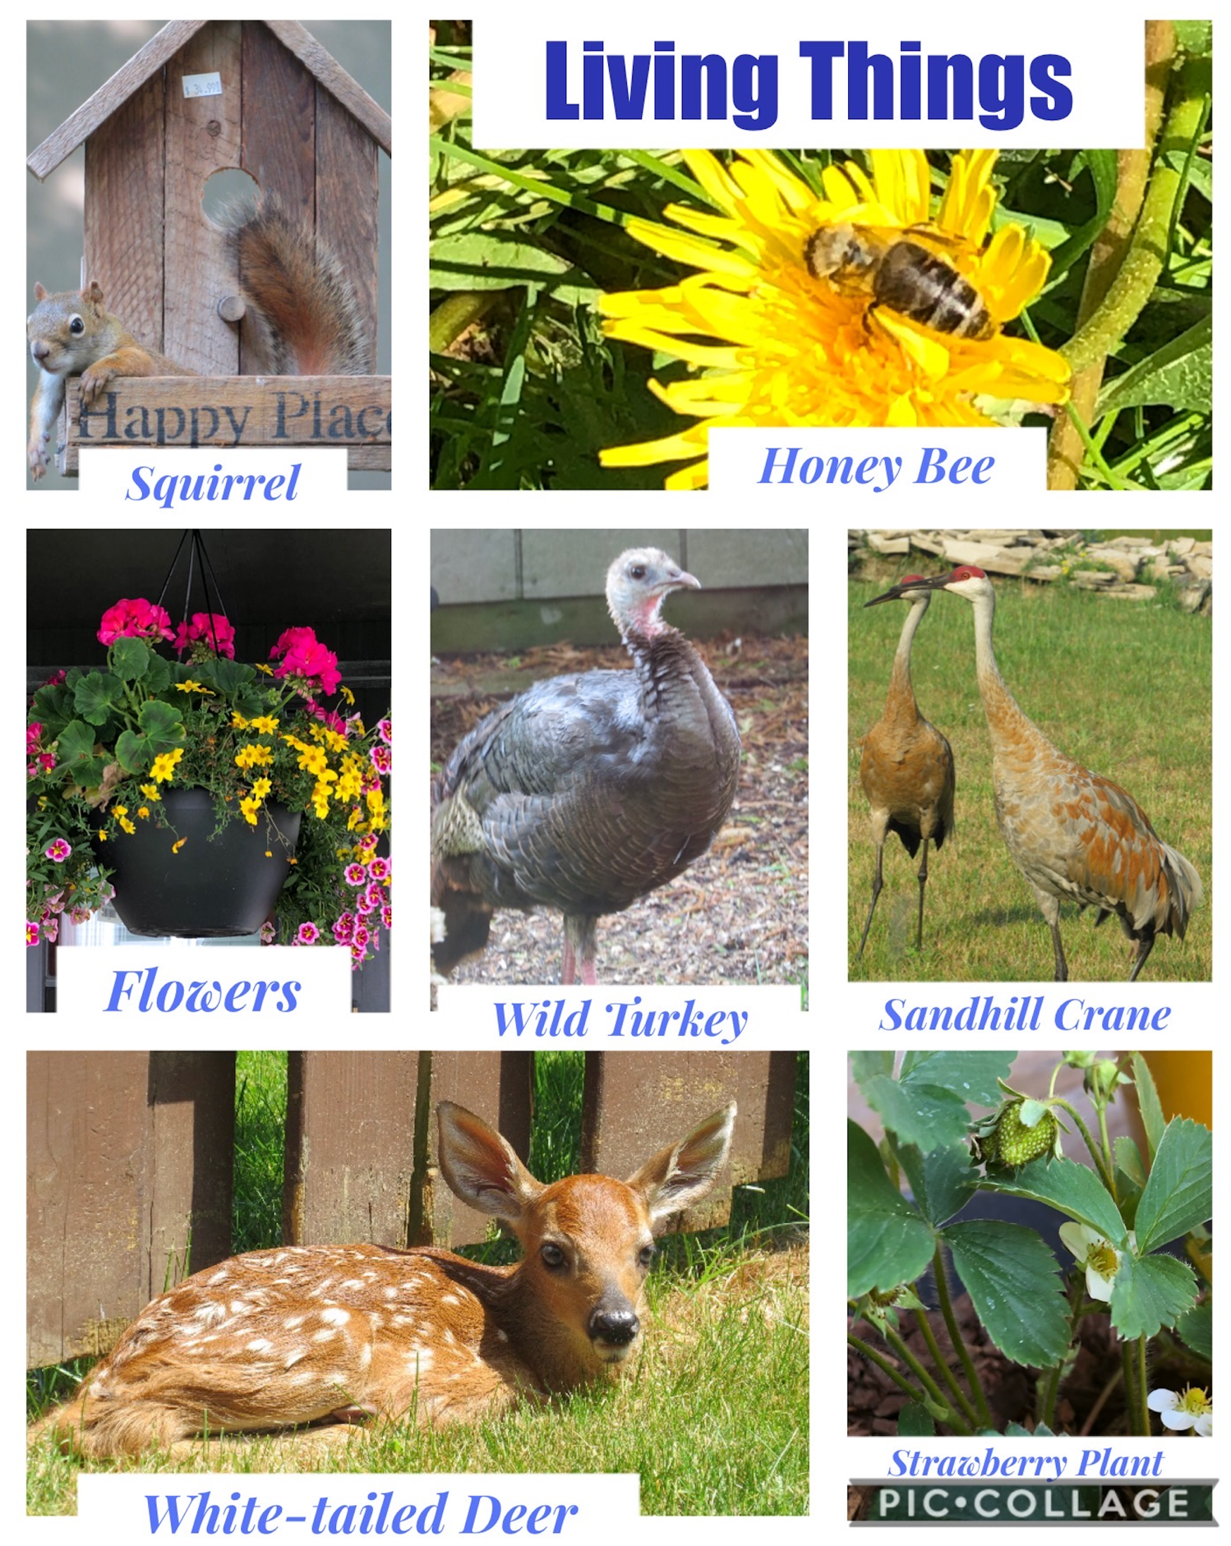

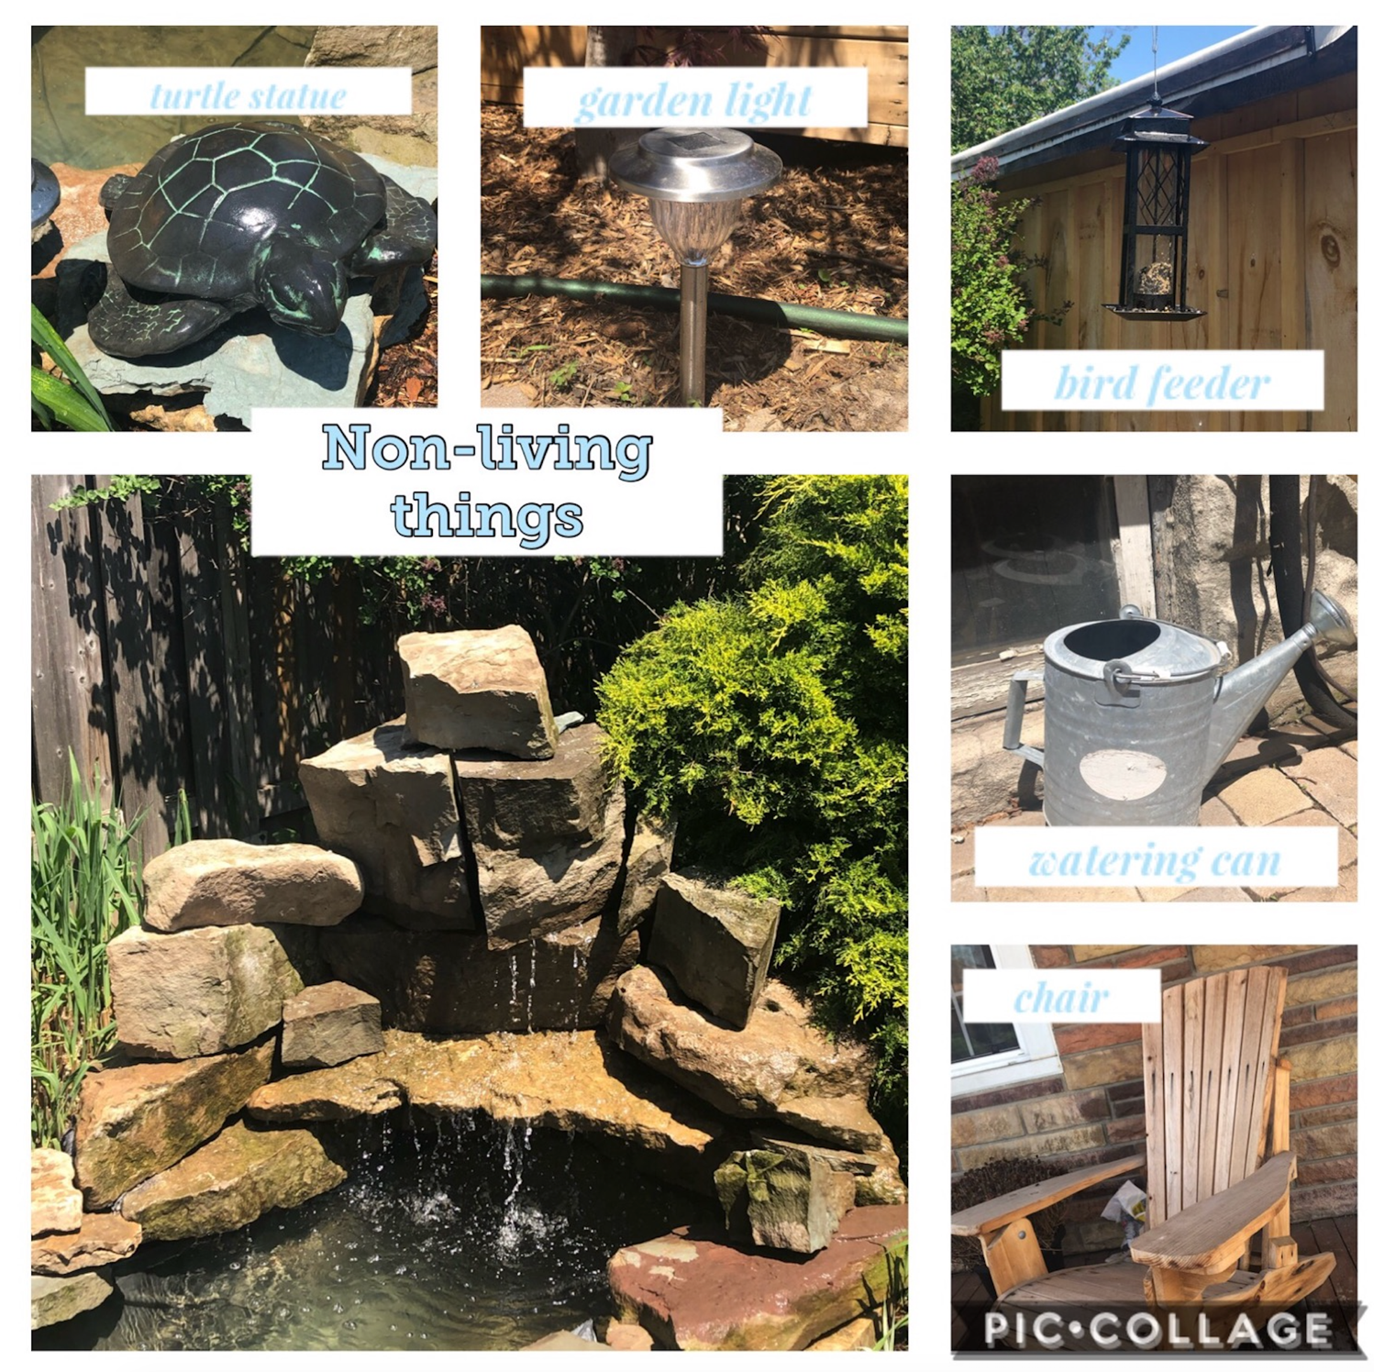

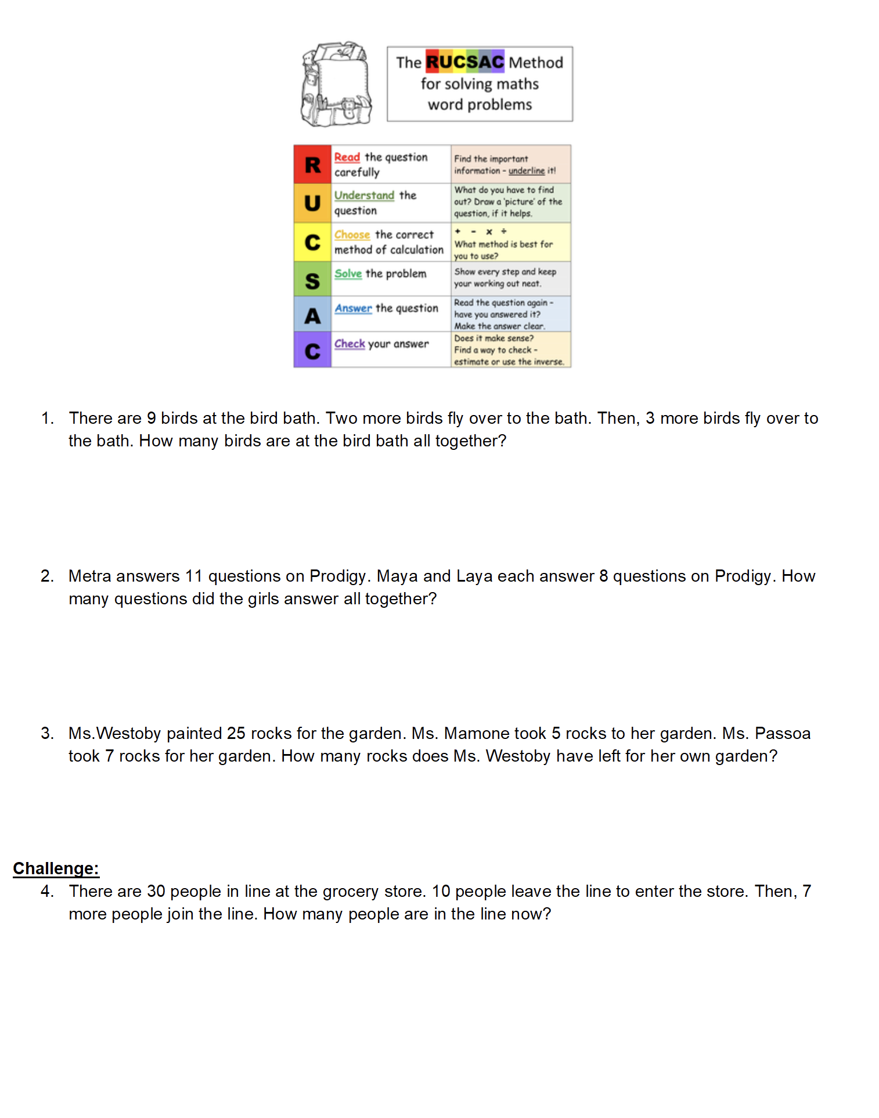
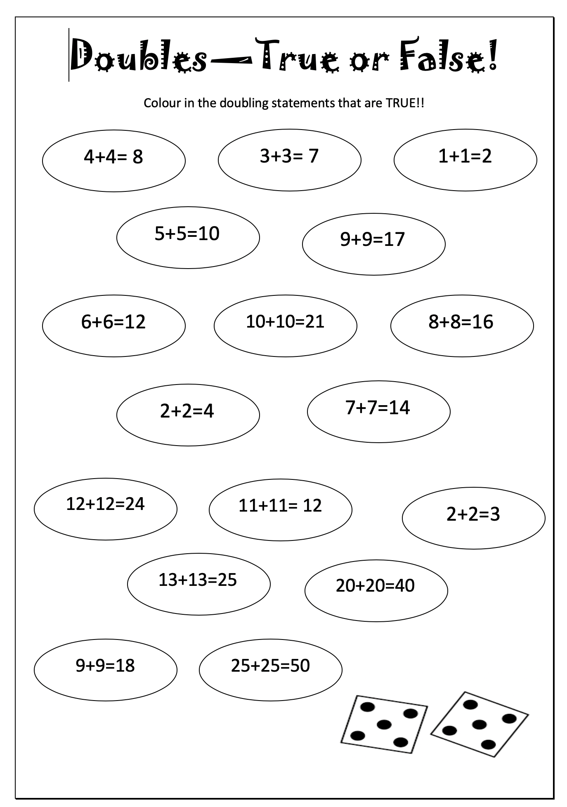
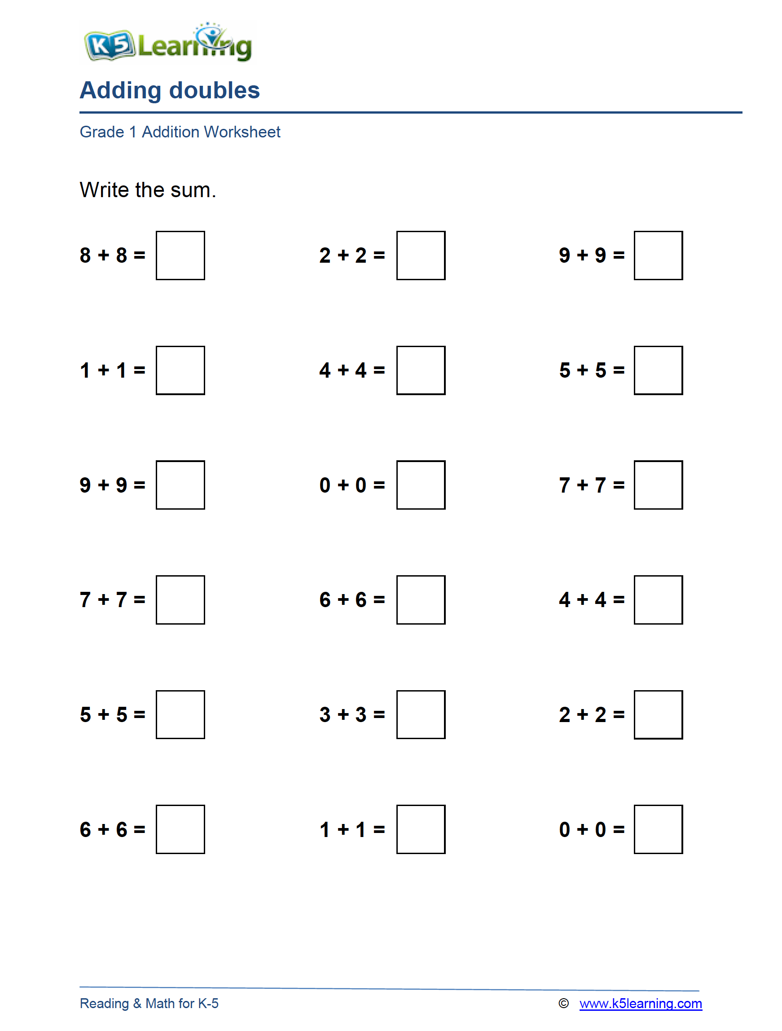

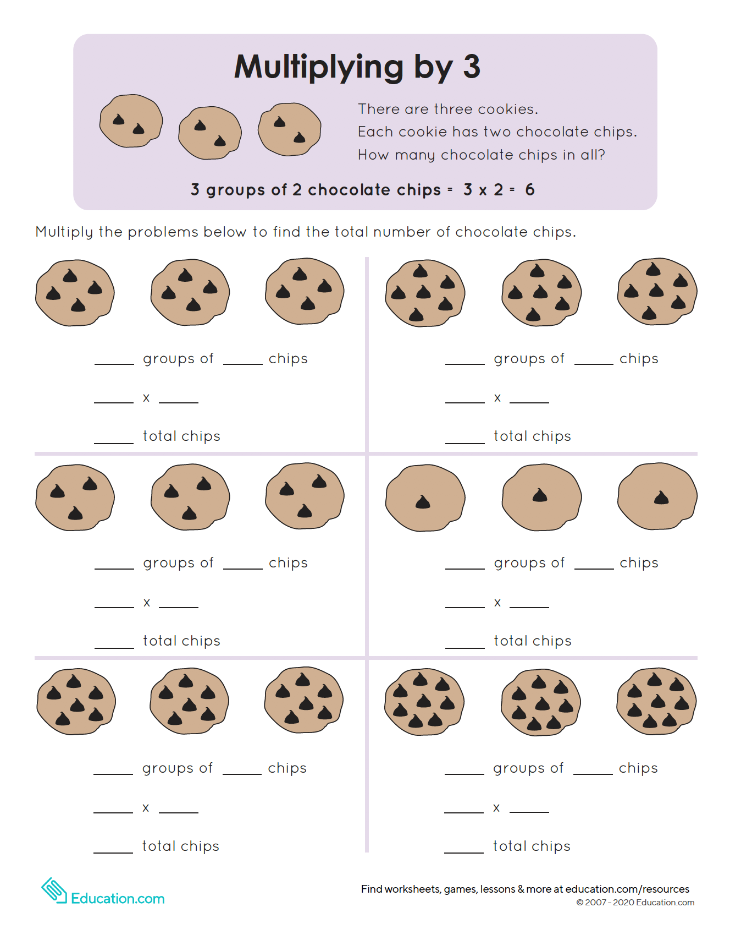

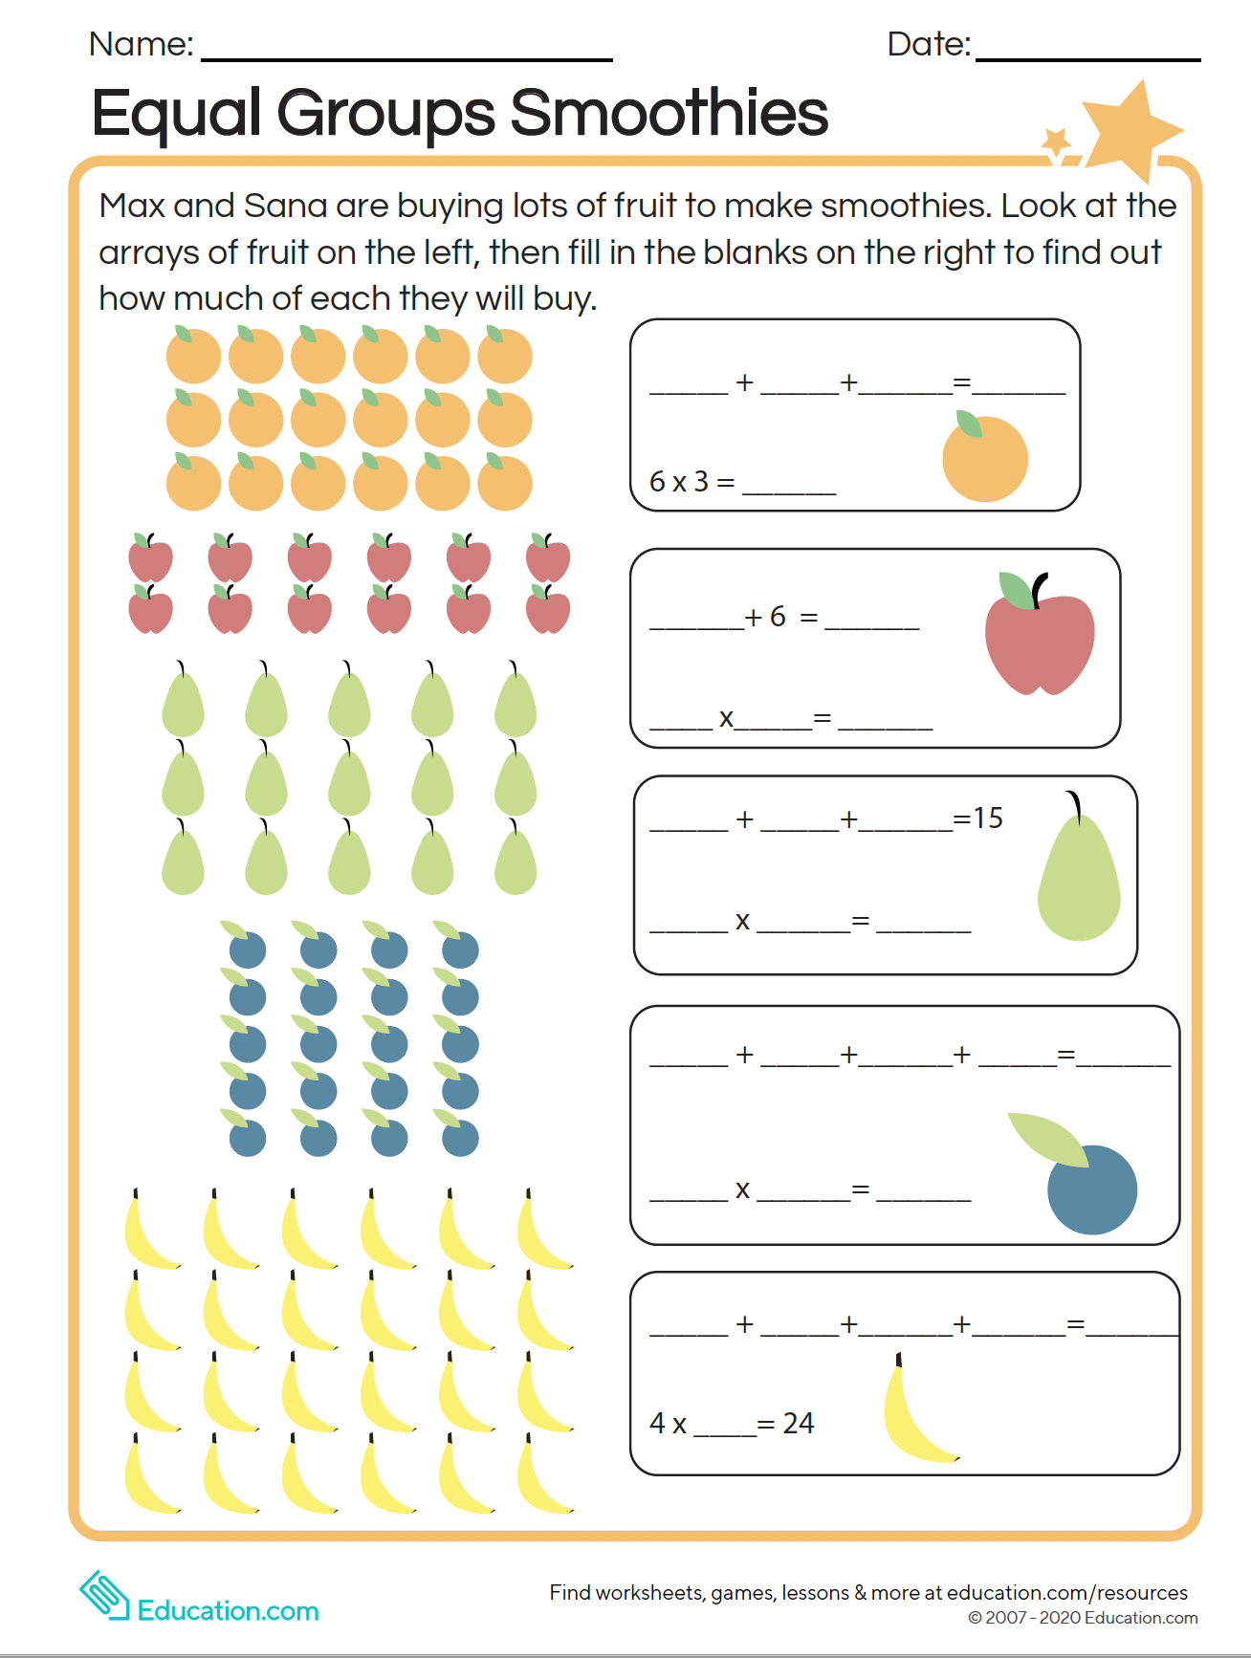

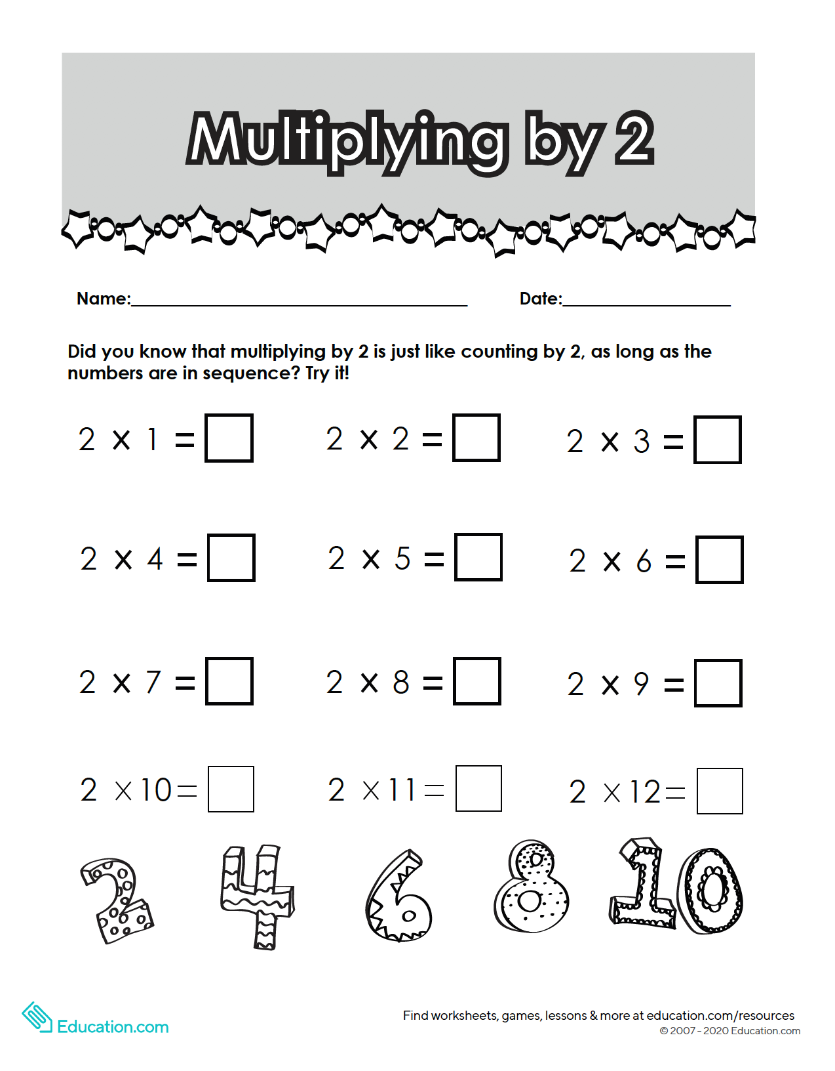
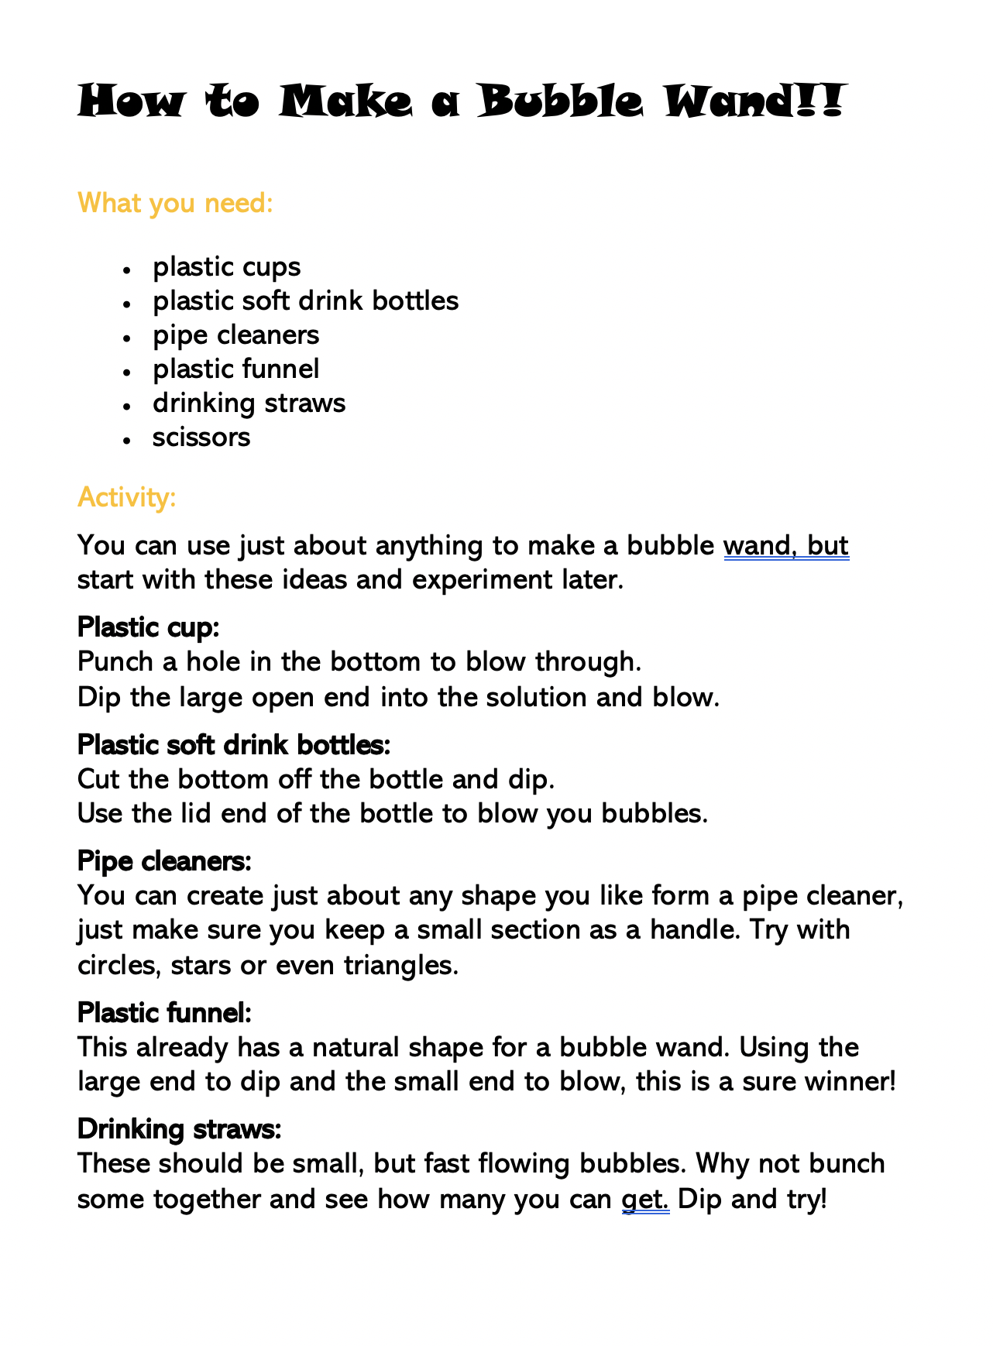
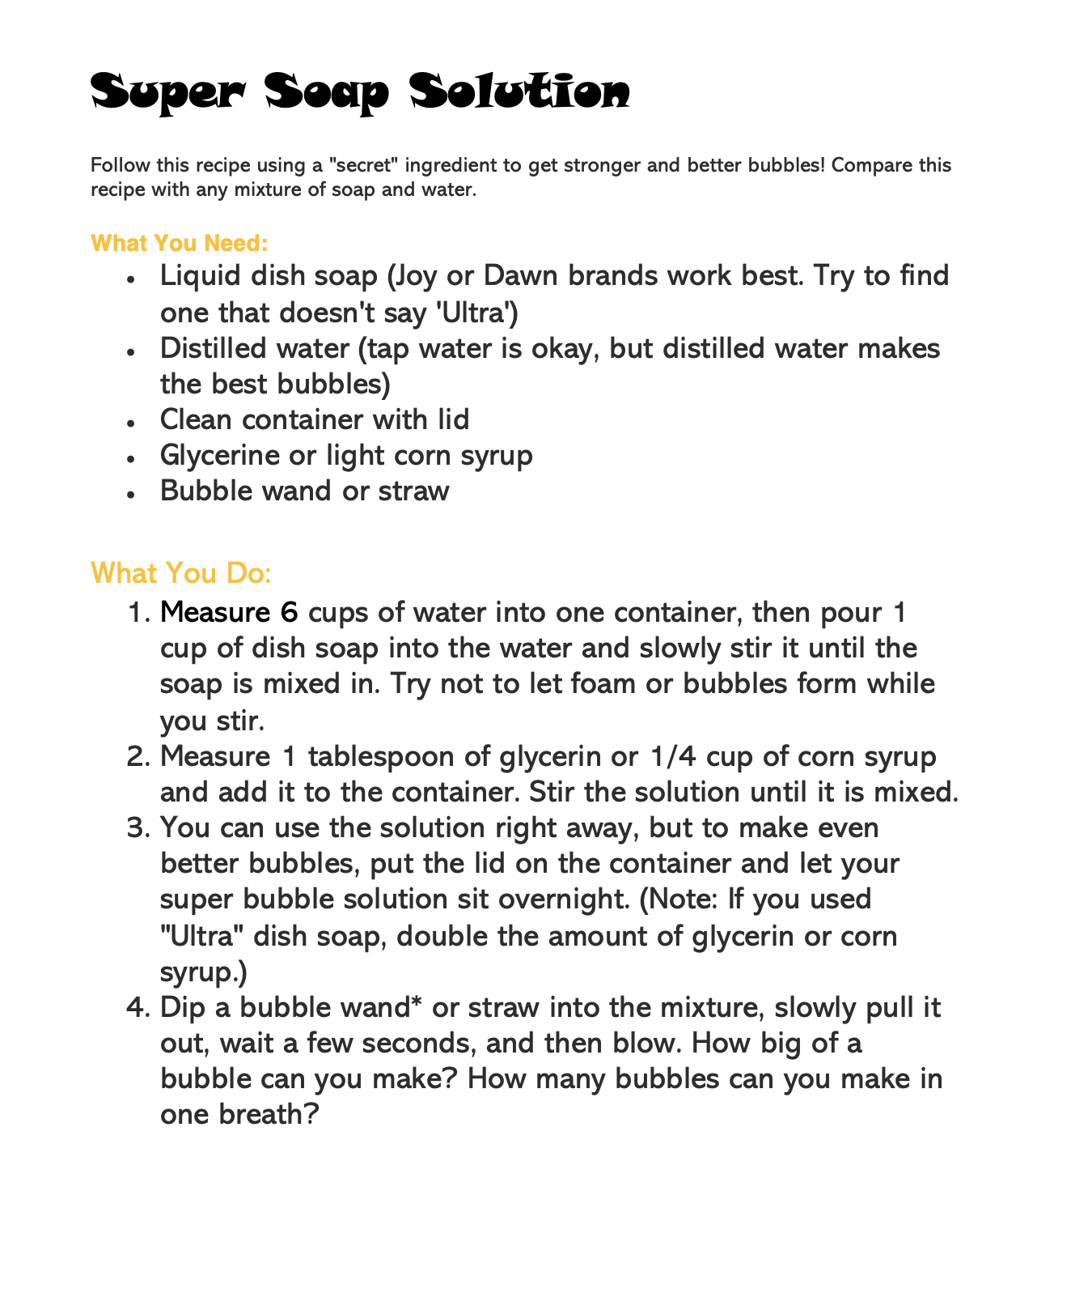

Grade 1
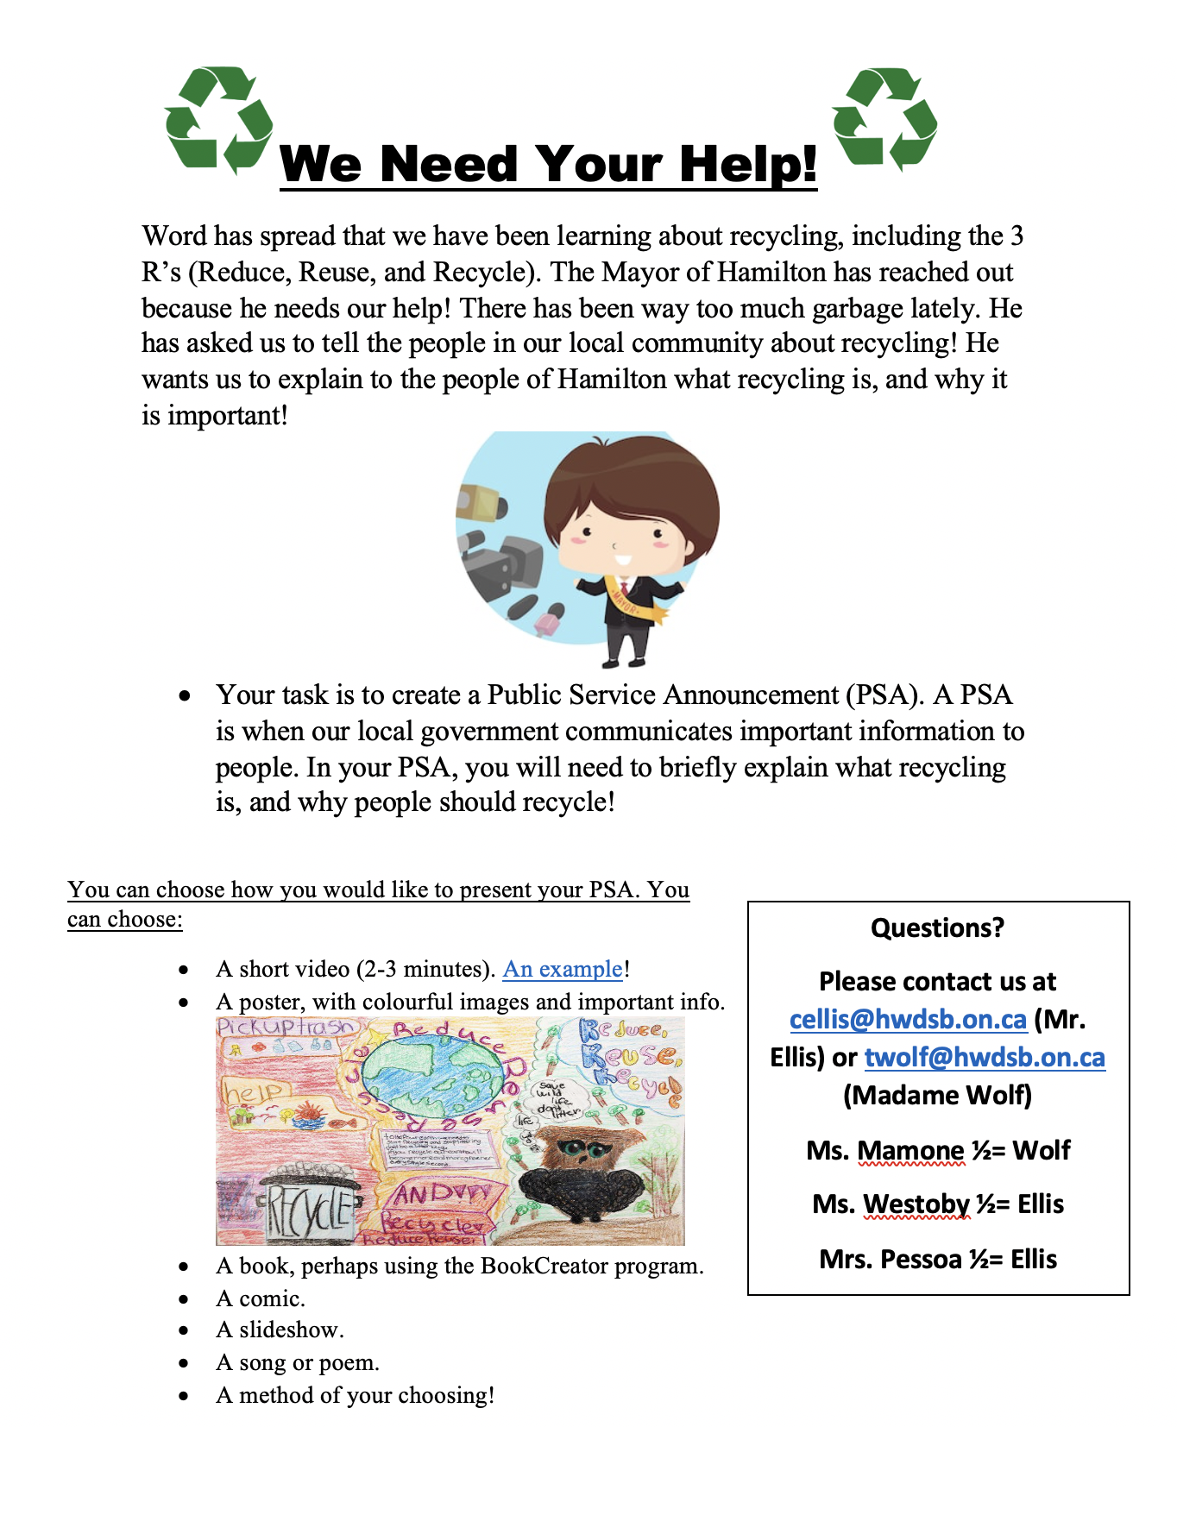

Grade 2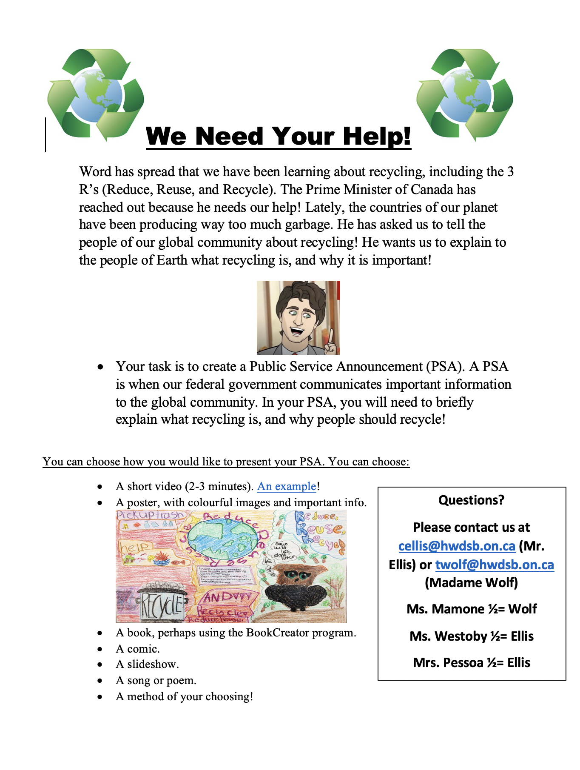

Music both Grade 1 and 2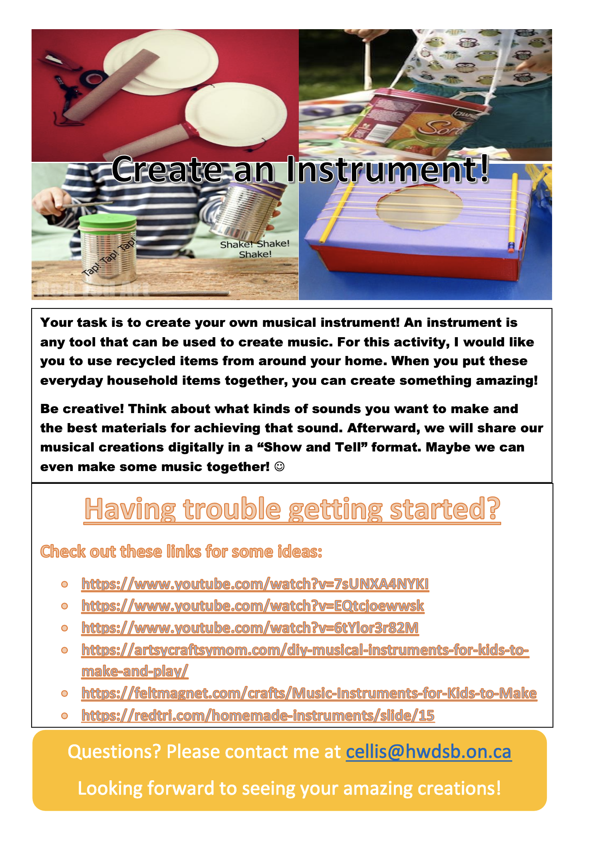

Physical Education both grade 1 and 2
