Assignments for the Week of: May 4- 8
Anything written in blue and underlined is a hyperlink and should be clicked on to connect with a website.
*Note that we are including more than 5 hours worth of work for next week. We have included a lot of extra work. Feel free to complete as much as you can. Try to do a bit from each section.
Reading | Independent Reading (20 mins) using resources such as books at home, online e.g., Epic, Raz Kids.
Reading | Focus/Lesson: Sorting nouns, verbs and adjectives  Practice: Complete the worksheet below where you will be sorting nouns, verbs and adjectives  *Submit this work by email.  **Extra challenge: If you haven’t completed this challenge yet. Give it a try. Write one adjective for each letter of the alphabet
Reading | Focus/Lesson:  Features of non-fiction text – Non-fiction text features  Listen to Miss Westoby read this non-fiction book  Try this Quizlet to test your knowledge  *Submit this work by email.
Writing | Grade 1 - Watch this video about writing a proper sentence. Video  Grade 2 - Watch this video about writing a proper paragraph. Video  Practise:  Gr 1 – Write 4 sentences about yourself  Gr 2 - Write a paragraph about yourself. See the hamburger planned and model and the checklist below to help you with your writing.  *Submit this work by email.
Grade 1
Watch this video
Draw a map of what your bedroom or your kitchen looks like. Use some of the following words to write at least 4 proper sentences to describe where things are: in front, behind, beside, underneath, to the left, to the right.
See Miss Arbuckle’s example below.

Grade 2: In your browser search up Kids in other countries. Select the link shown below.
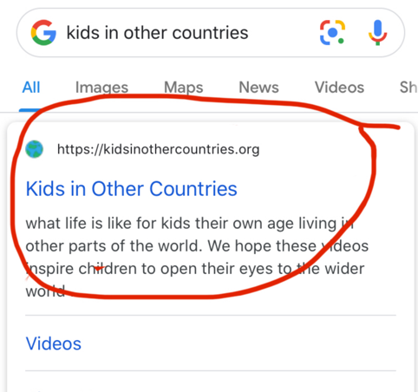

Pick from one of these children from the website and compare your life with the child’s life.

- Sadia from Bangladesh
- James from the Philippines (up until 10:11)

Complete the attached Venn diagram when comparing your lives. You should make comparisons which may include food, housing, jobs, celebrations, school, and free time.

*Submit this work by email.
Media | **NOT SET UP YET FOR MS. MAMONE’S CLASS - PLEASE DISREGARD FOR NOW**  Log into MS Teams.  Find the Norms and like it with a thumbs up.  Send me an email of times that you and your child are available for a meeting with me this week.
Numeracy | Independent practise using Prodigy
Numeracy | 1) Grade 1 – practise your skip counting by 2s, 5s and 10s.  Extra practise: PebbleGo  Login:covid19  Password HWDSB  2) Watch this video about subtracting two-digit numbers with regrouping.  Watch the following video up to 4:33 for my examples of subtracting with regrouping.  Practice: Complete the attached math sheet. If you are unable to print, please copy the questions onto a piece of paper.  For more practise sheets you can also go to worksheetfun.com  *Submit this work by email.
Numeracy | Mini-Lesson: Time  Miss Westoby is sharing a book about time  This video shows you how an analogue clock works. Watch until 2:30 Video  Complete the attached worksheet.  *Submit this work by email.  Extra practise:  Check out this game to practise telling ABC.ya  Scholastic ideas for telling time
Physical Education | See the activities below.

