The View Out My Window Date: _____________
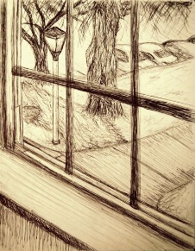
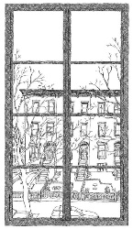
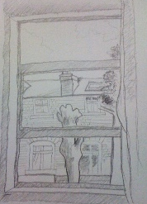
Draw what you see outside your window.
Then describe it in words at the bottom.

___________________________________________________
___________________________________________________
___________________________________________________
___________________________________________________

