A Whole New Schedule Date:_______________
Make a chart to show how you spend your homeschool days!
Time | Activity
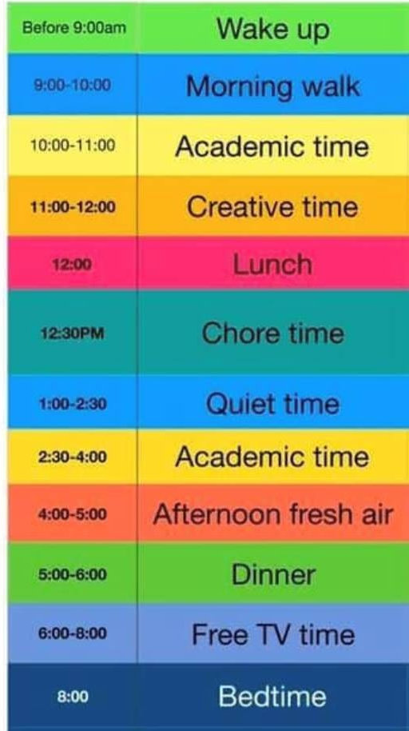
If you want, you can colour your chart too!

