At Home School Challenges – Week Seven
Primary Grades JK, SK, Grade 1 and Grade 2

Dearest Parents
Once again, these are only suggestions for use at home. They are not going to be assessed. I was thinking of easy things you could try to keep the children moving and healthy. Please use them if you think they would be fun and helpful. If you are too overwhelmed by life then please disregard (no pressure). Be safe and hope to see you all very soon.
If you’d like to send me any pictures or comments please email me at slowery@hwdsb.on.ca
– Mrs. Lowery

Movement Challenge
We would be doing our run, jump and throw unit if we were at school right now so this month we will focus on these skills. We will start with throwing. If we were outside, we would be doing overhand throwing to see how far we could throw the ball. The steps would be to start with legs shoulder width apart, bending knees, having the ball in your hand, putting the ball over and behind your head. Bring your arm past your ear and release the ball so it’s pointing at the horizon. Keep your eyes on the target and point at the target on release. (If you release the ball too early it will go straight up and straight down, if you release it too late it will go down to the ground.)

This lesson is mostly for underhand throwing but you can take the games outside and do some overhand throwing too.
https://teachingtools.ophea.net/lesson-plans/hpe-home/unit-1-target-games/week-1-lesson-1-sending-receiving-objects

This has a good break down on how to do a proper overhand throw.
https://www.youtube.com/watch?v=daIJZxM7QfA

This one has a good break down on the steps.
https://www.youtube.com/watch?v=2QfQZOm7LNI

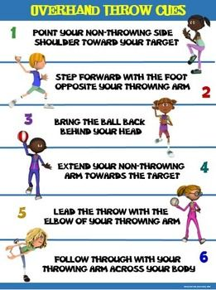

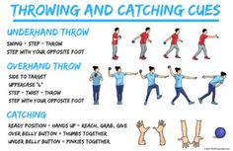

Health Challenge

Washing your hands has always been important to be healthy, but now more than ever; we are reminded that proper hand washing keeps germs away. Here are a few very good videos to show children how to hand wash properly to get rid of all the invisible germs that lurk on our hands. I like these videos because they have great instructions that can be memorized in a song!

Sorry parents for this earworm but its very easy for children to remember.
https://www.youtube.com/watch?v=L89nN03pBzI

When to wash them and how in a rap!!
https://www.youtube.com/watch?v=OZ3oSvfiwU4

This one has great technique
https://www.youtube.com/watch?v=S9VjeIWLnEg

Great technique and very catchy tunes to memorize the technique.
https://www.youtube.com/watch?v=zxlQn7KaCNU
https://www.youtube.com/watch?v=LaePayB_pC4

Fitness Challenge

As I said, we would be starting run, jump, throw and the fitness component of this is running endurance. Now I’m sorry it coincides with this heat wave!! The best times to run are early in the morning or in the evening to avoid the heat. You can run around in your back yard. When you are running a long distance you need to let your legs to all the work. Relax your shoulders and breath in and out deeply to get that fresh oxygen to your lungs. Your lungs then send it to your muscles.

This week see if you can run for 3 minutes in your back yard. If you have to stop then walk quickly. Remember to breath deeply in and out.

Your form is similar not matter what your age.

