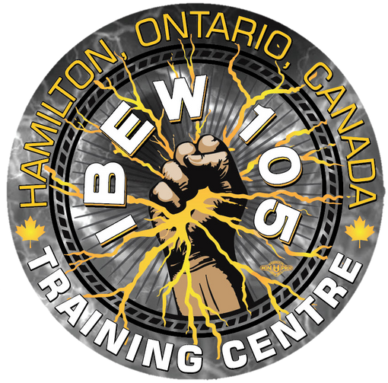
Entry Pointz: Foundations Of Electrical Construction Program
INTERNATIONAL BROTHERHOOD OF ELECTRICAL WORKERS
LOCAL UNION 105, HAMILTON, CANADA
THEO DAVIS, TRAINING DIRECTOR

Program Information

The collaboration between the Entry Pointz Foundations of Electrical Construction Program and community partners, with the support of Skills Development Fund (SDF) funding, aims to assist the International Brotherhood of Electrical Workers Local 105 (IBEW) in attracting prospective candidates for its courses.
Successful completion of the entry level electrical and safety courses may lead to apprenticeship opportunities in the field. Moreover, the program provides introduction to electrical and safety training, which can enhance employability and make candidates more appealing to potential employers, thereby benefiting individuals seeking gainful employment.

We selected our partners meticulously, in line with our dedication to making deliberate efforts to create new pathways for individuals who have not had straightforward access to the trades.

The Entry Pointz Program aims to accomplish the following objectives:

Deliver training for First Aid/CPR AED
Provide training for Global Harmonized WHMIS
Develop a fundamental comprehension of safety requirements and Personal Protective Equipment (PPE) Deliver training for Electrical Theory and Practical Skills
Gain certifications such as Working at Heights and Electrical Hazard Safety
Learn to operate machinery and earn a Power Elevating Work Platform Operator & Rough Terrain Forklift Operator Certifications
And much more

To achieve these goals, we will utilize a combination of theoretical classroom instruction, Virtual Reality (VR), and practical. Our project managers and lead trainers will also serve as mentors during the training process, offering guidance through in-person meetings or Zoom sessions. Upon obtaining the certifications throughout the program, individuals will have enhanced their chances of securing employment in the electrical and/or construction industry.

The cost of this program is free to your organization and your clients and PPE will be provided.

The estimated value of this program is over $8000 and includes all you need to start your new career path!

Application Requirements:

Resume
500-word typed essay explaining why you should be chosen and what you will bring to the classroom.
Applicants must provide proof of meeting the educational requirements by submitting their high school transcripts. These transcripts should demonstrate completion of one Math, one English, and one Physics course as outlined in the chart below. These foundational subjects are essential for success in trade school programs. If you lack any of the required courses, you can still apply and work towards obtaining the necessary credentials either through night classes or virtual learning.
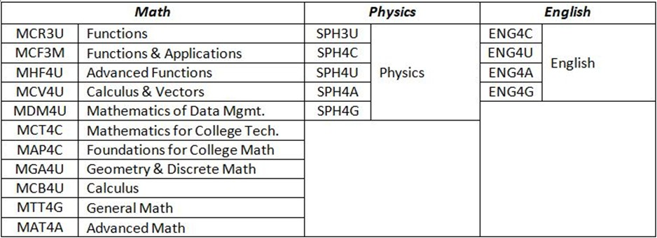

*For those Applicants who have not completed their high school education in Ontario, the Alliance will accept a Comprehensive Secondary School Assessment (course by course assessment) Report from such services as International Credential Assessment Services of Canada (ICAS) found on the government of Canada website.
Please Note: Applicants who already have a Registered Training Agreement (RTA) and have 1000 hours or more of trade-related experience are not eligible to apply to this Introductory Program.

Keys To Success:

Physical fitness and stamina for lifting, carrying, climbing, standing and manual dexterity A strong work ethic and a commitment to learning
Ability to work with others Punctuality and reliability

Attendance and punctuality are essential for success in our program.
Participants must be willing to work outdoors in all weather conditions and be able to do strenuous activity.

Start the Application Process:
Please email: entrypointz@ibewlu105.com
Subject heading: “Application for The Entry Pointz Program” Leave your name and how you found this program.

We will contact you and check that you are eligible.

If so, you will be asked to send in the required documents as listed above in the application requirements section.

This program has a maximum of 10 students and qualified applicants will be pushed through to the aptitude test and interview process thereafter.

